**FOSM Project to Remove the Decayed Post and Beam in the Balsam Glade Picnic Area Shelter**

**and to Begin Processing the Replacement Parts at the Guard Station, Wed., Sept. 6, 2023**

Sam Beard

**On Wednesday, Sept. 6,** four FOSM volunteers removed a 33-inch-long post, a 6-foot beam and eight short posts from the Balsam Glade picnic area shelter. They were rotten and needed to be replaced. We completed removing these parts by 10 am and returned to the FOSM Guard Station.

Eric Russell used the small battery-powered chain saw to cut two of the 6-inch diameter poles into eight 24-inch pieces that will be made into short posts under the horizontal beams on the shelter. Sam Beard then applied Wood Life preservative to the best end of each of the eight short posts. He

applied a third coat of this preservative to all the new wooden pieces including the 12-inch diameter (nominal) post.

The diameter of the concrete-lined hole in the shelter floor is about 11.75 inches. The actual diameter of the new large post is a little under 12 inches.

The preservative on all the wooden parts will be dry by Thursday morning, and the volunteers can apply two coats of brown paint on top of the preservative.

The volunteers working today were Eric Russell, Don Carnicom, Cliff Giles, and Sam Beard.

**On Thursday, Sept. 7,** Joelle Hertel, Sim Cook, and Sam Beard applied two coats of USFS brown paint on the following replacement parts for the restoration of Balsam Glade Picnic Area shelter: 6-foot horizontal beam, eight short posts to go under all eight horizontal beams, and 12-inch diameter tall post. Results of this work are presented in the photographs below (after the 9/6/23 photographs).

Project photos are presented below.

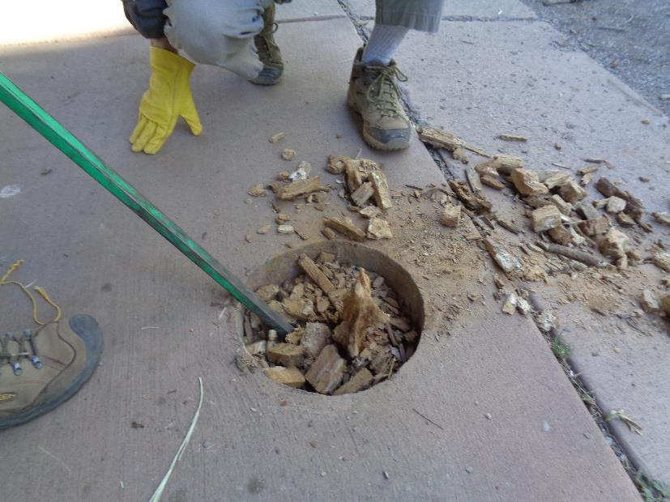

Wood below the large post was just square pieces with volumes of 1 cubic inch to 2 cubic inches. All photos by Sam Beard.

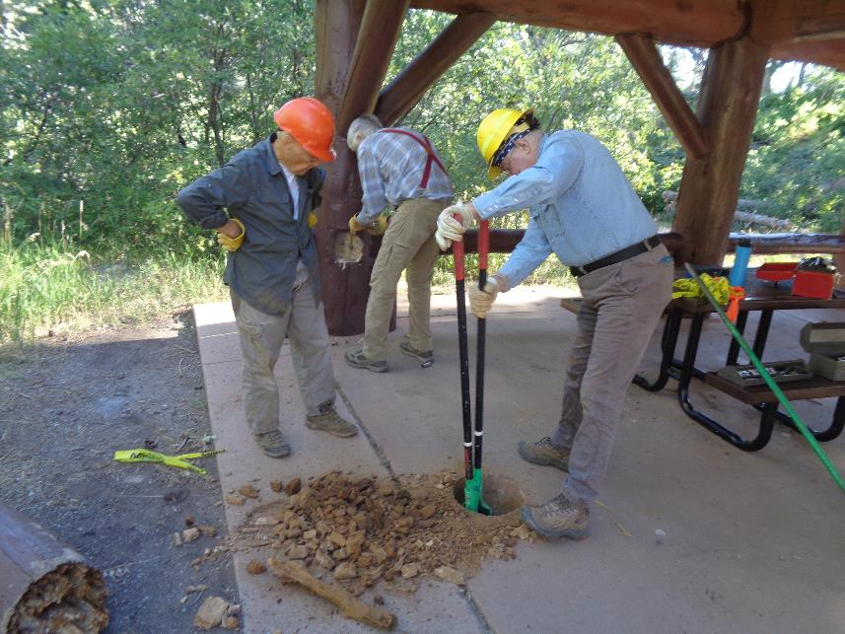

Removing more rotten wood from the hole. In the background, Cliff is unscrewing a ½-inch by 12-inch lag screw from the large post.

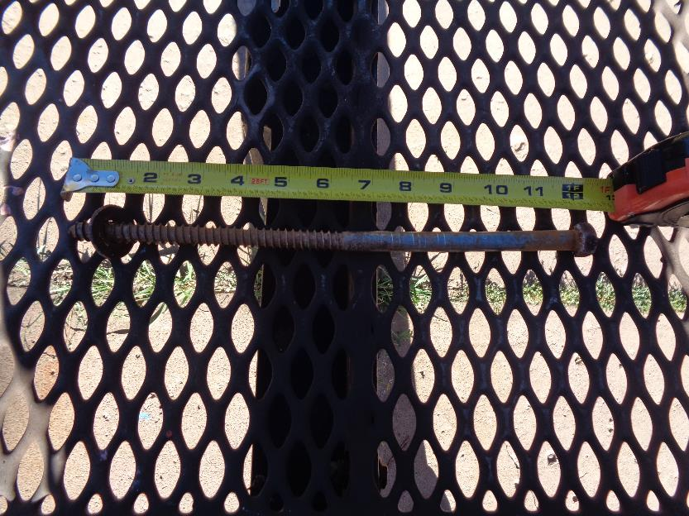

All the joints were secured with ½-inch by 12 -inch lag screws.

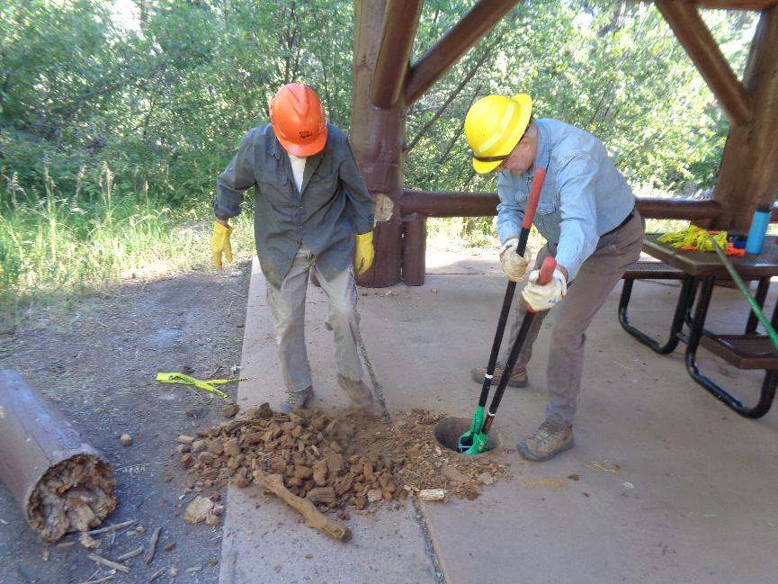

Removing more rotten wood.

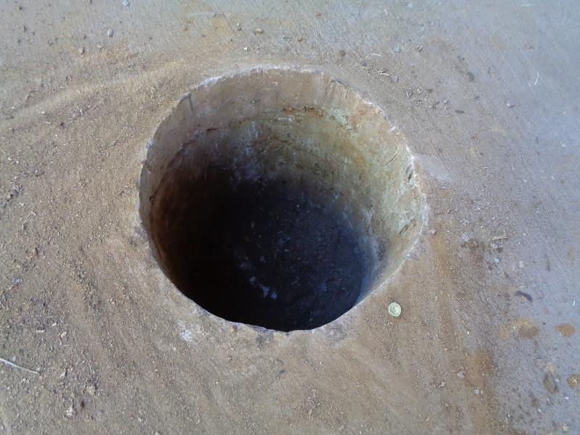

The hole is lined with concrete on the sides and on the bottom. The diameter at the top was 11.75 inches. The depth was 17.5 inches

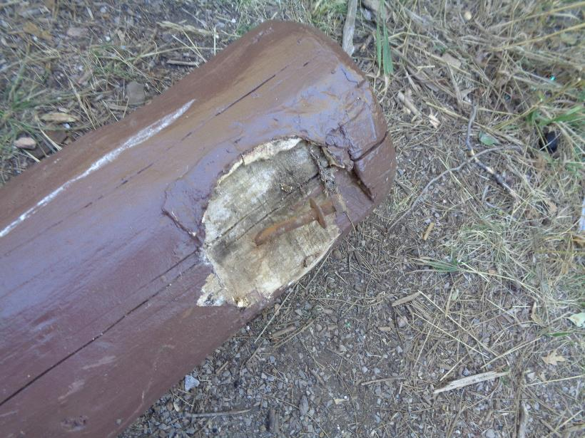

Bent ½-inch by 12-inch lag screw that attached the beam to the post.

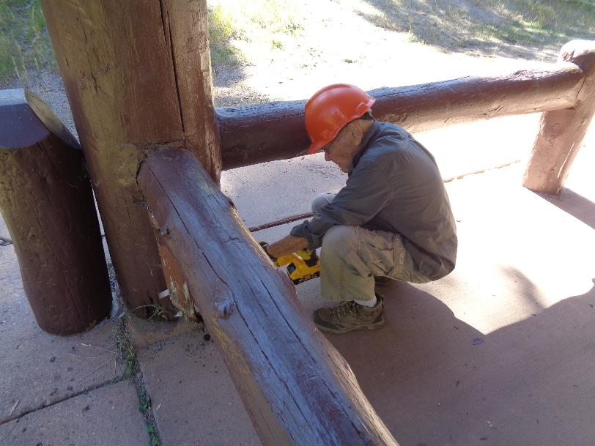

Don Carnicom cutting the lag screws that secured the short post to the large column. We actually unscrewed four of the 12-inch

lag screws securing two of the short posts. These screws were rusty, very difficult to unscrew, and required too much time to unscrew.

We then decided to use the reciprocating battery-powered saw to cut the lag screws at the short posts.

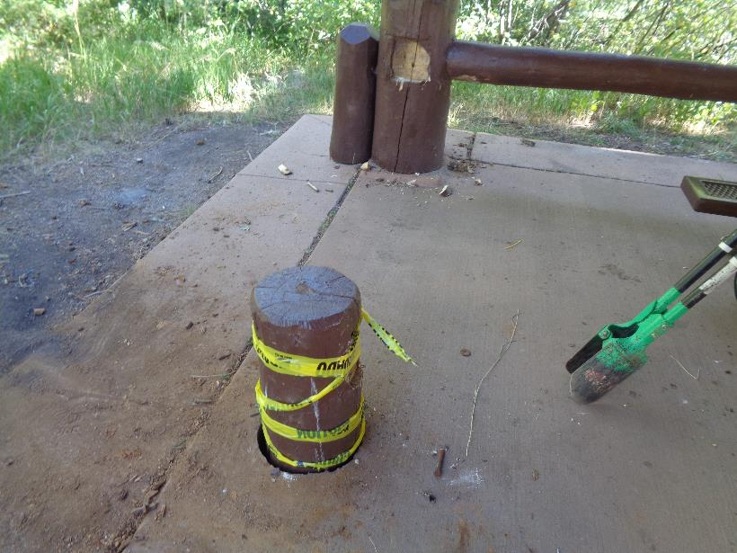

We put the original post back in the hole and flagged it so that no visitor would step in the hole. Note that the short post under the horizontal beam in the background has been removed. When we removed it, we could see that the bottom of the short post was rotten.

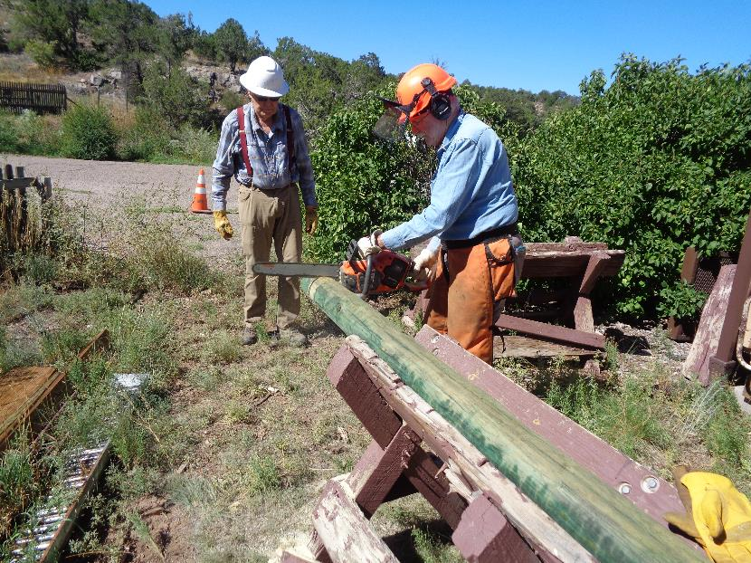

Eric cutting the poles into 24-inch pieces.

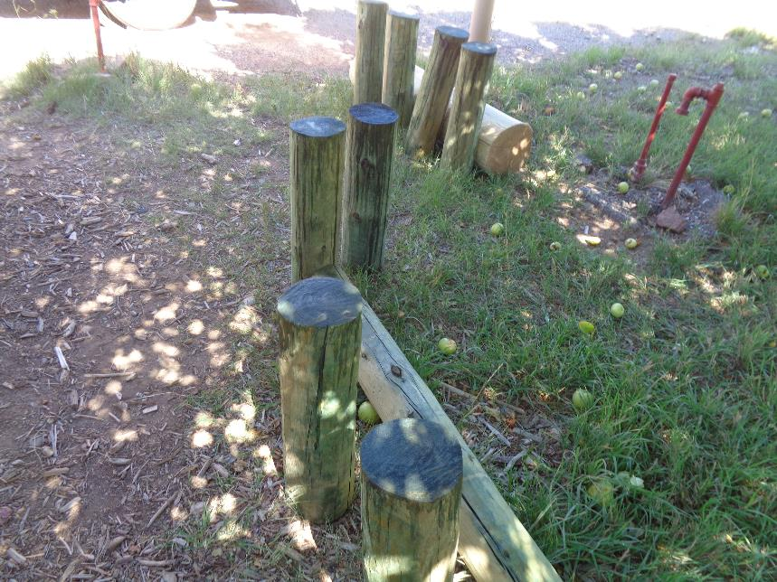

Three coats of preservative have been applied to the best end of each short post that will go down when they are installed.

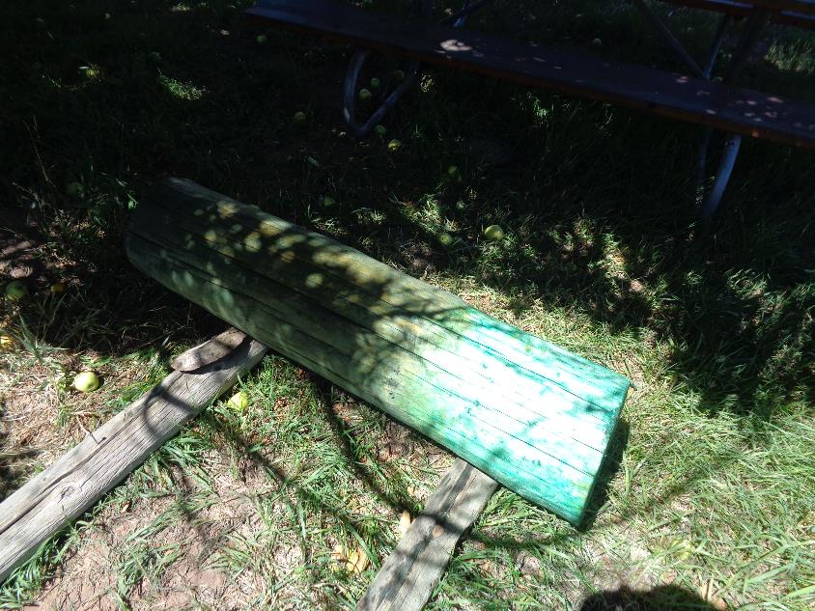

The new large post with three coats of Wood Life preservative on it.

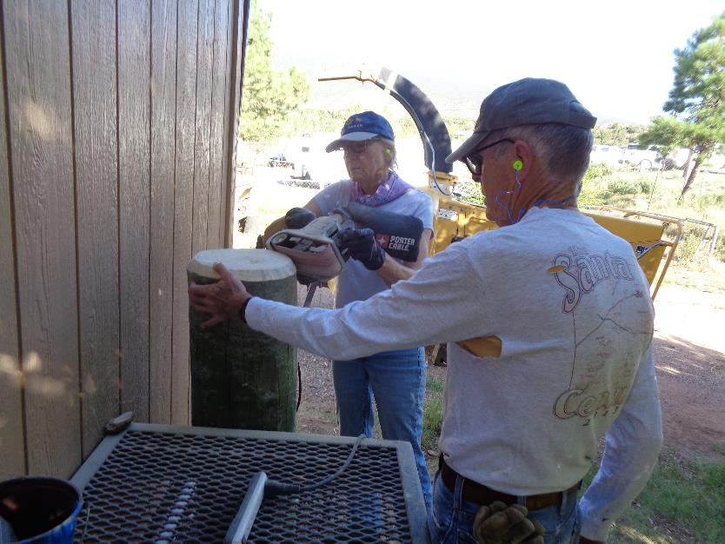

Sim Cook holding the new 12-inch diameter post while Joelle Hertel uses a belt sander to put a bevel on the top edge on September 7.

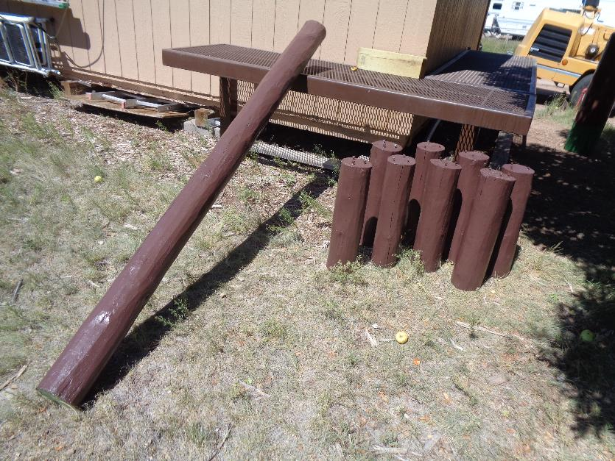

Replacement beam and eight short posts for the Balsam Glade PA shelter restoration. Three coats of Wood Life wood preservative

were applied to all of the replacement wooden parts. The active ingredient in this preservative is copper naphthenate.

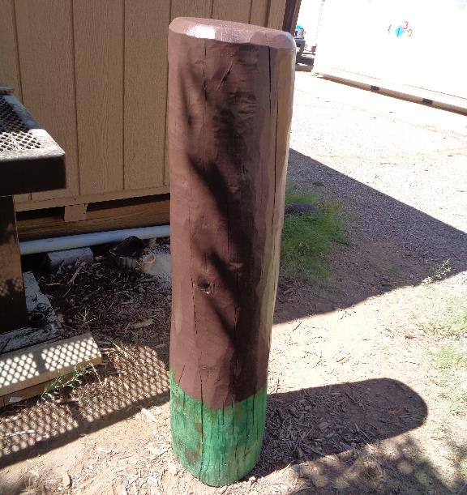

Replacement tall post for the restoration of the Balsam Glade PA shelter. The original post

rotted below the concrete floor surface and had to be removed. This new post will be placed in the hole in the floor

so that only the brown is showing above the floor surface.