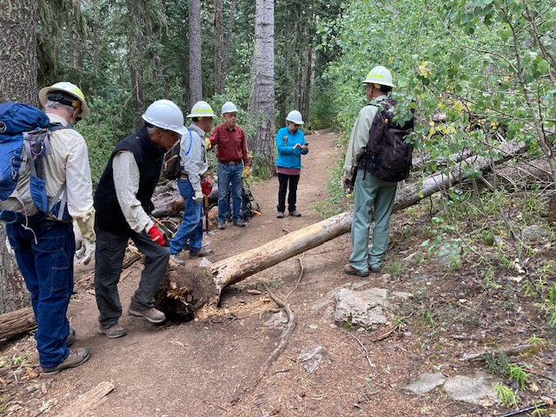
The crew is checking out this dead 6-inch diameter fir that had fallen over Crest Trail 130-South about halfway between the Crest and the Kiwanis Cabin road.

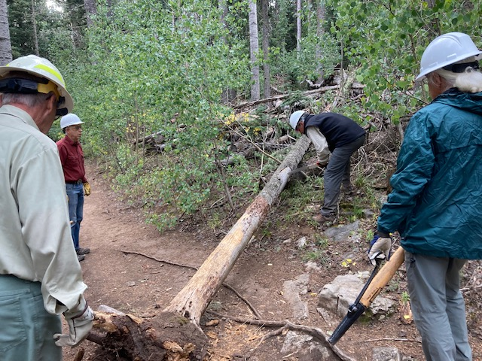
Ken is cutting the fallen tree so that it can be moved off the trail. Bill stands by with the cant hook to assist as needed.
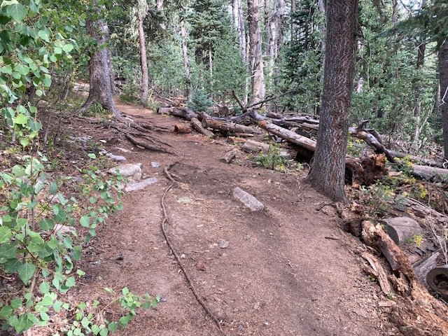
The fallen tree has been removed and the root ball hole repaired. The trail is now clear.
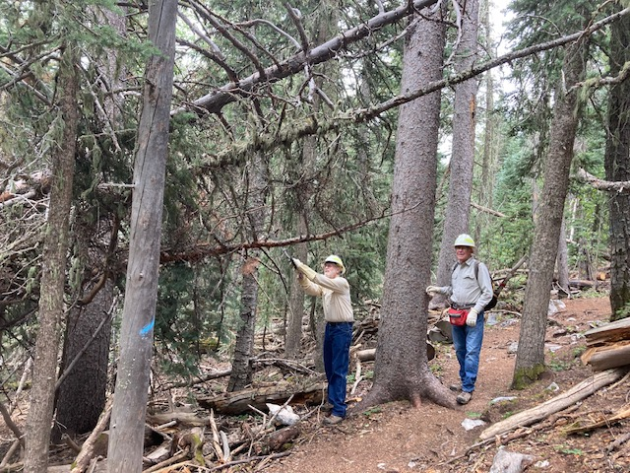
Cleve cuts away the lowest of three hung-up trees suspended over Upper Switchback trail downhill from the Crest. It was near head space for hikers and would not clear someone on horseback. The remaining two trees are high and well supported. Their removal will come later when they settle lower.

