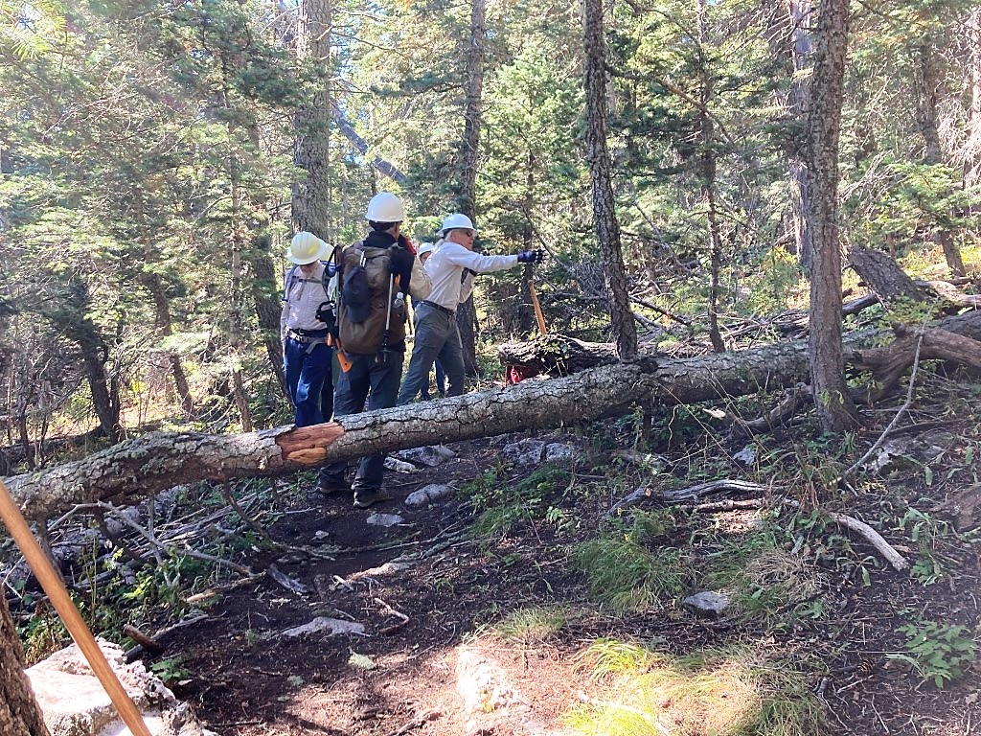
The crew has just arrived at the fallen and are getting ready to go to work.

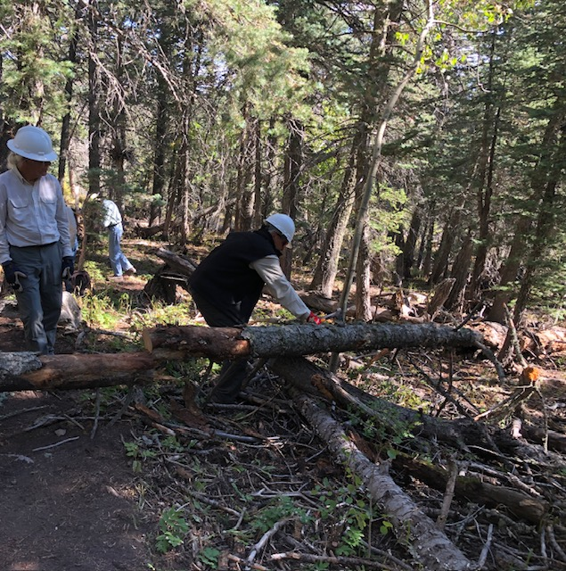
The first cut has been completed and the top portion of the fallen tree is being moved away from the trail.

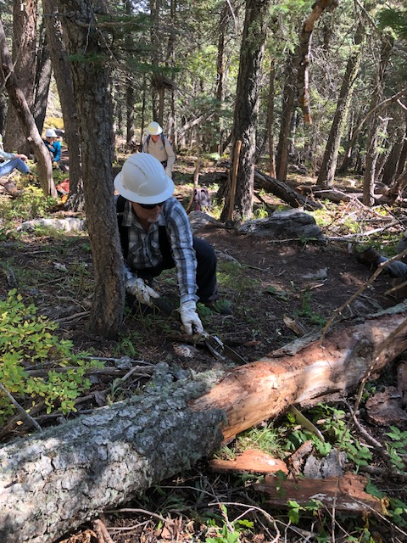
Jamey works on the second cut. Once this was completed
and the cut portion moved away, the trail was clear.
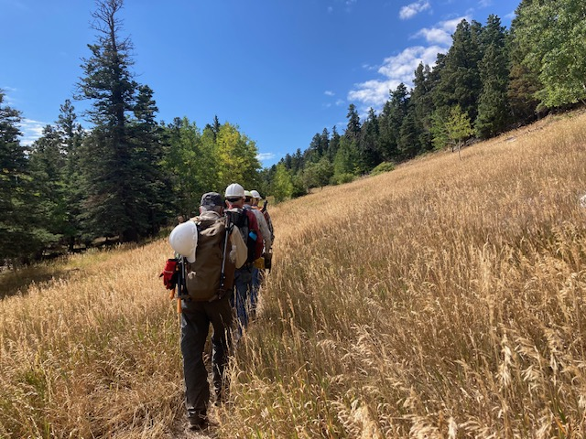The work is done and the crew is returning to the trailhead through a sea of tall grass along Ellis Trail.

