Trail Report: Monday, October 2, 2023

Byron Garner

The original plan for the Monday Trail Crew which was to address two reported trees, one on 10K-S and 10K-N each, required a bit of revising due to the Crest Road closure at Capulin. After parking at Capulin, we hiked up Challenge to the 10K-S junction and continued down 10K a short distance (a segment adopted by Ken and Rav Nickolson) to complete some work removing an aspen which was started by Galbraith and reported by Ken Smith. Due to the additional millage required, we had to cancel the 10K-N segment of the project. Though it was disappointing not to complete the project as planned or find more work, we did have an invigorating hike on a great fall day with a very luminous fall yellow extravagantly displayed everywhere you looked. The crew included Ken and Rav Nicholson, Ken Wilson, Jerry Pekerek, Jamey Browning, John Cooper, Rene Archer and Dave McCreery.

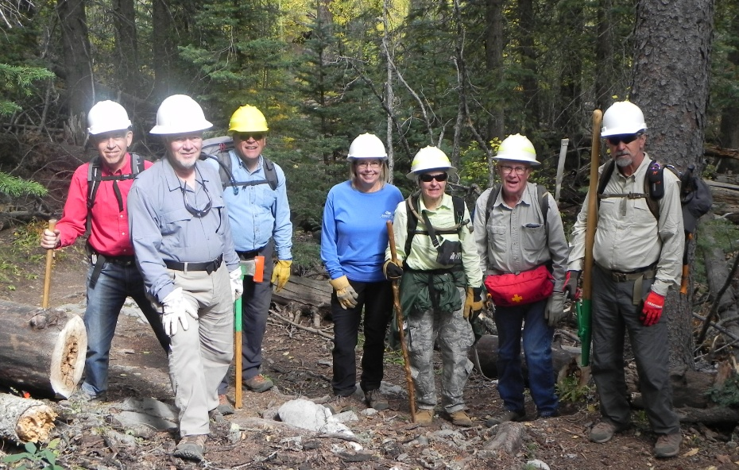

John, Jamey, Dave, Rene, Rav, Jerry, Ken

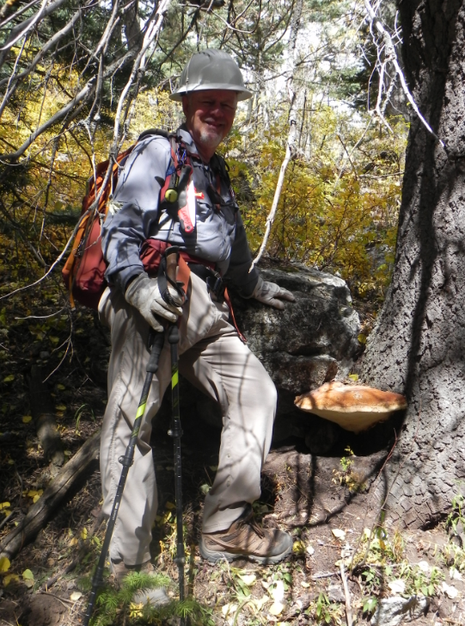

trophy fungi

