**Report of FOSM Removing Graffiti in La Cueva and Juan Tabo Picnic Areas**

**on Tuesday, October 3, 2023**

Sam Beard

On Tuesday, Oct. 3, Sam Beard, removed nine graffiti tags in La Cueva and Juan Tabo picnic areas. Chris Baca, SRD Recreation Field Operations Manager, had requested two graffiti tags in La Cueva PA be removed. Sam drove through all the parking lot in these picnic areas and found a total of nine relatively small tags. He used World’s Best Graffiti Removal System chemicals to remove all these tags.

Photos of boulders, pavement, and trash containers with tags and after the tags were removed are presented below.

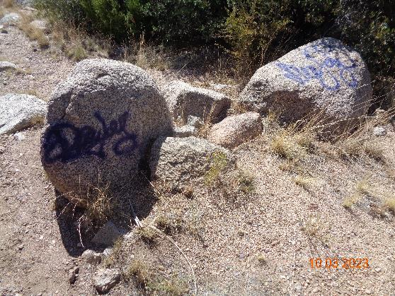

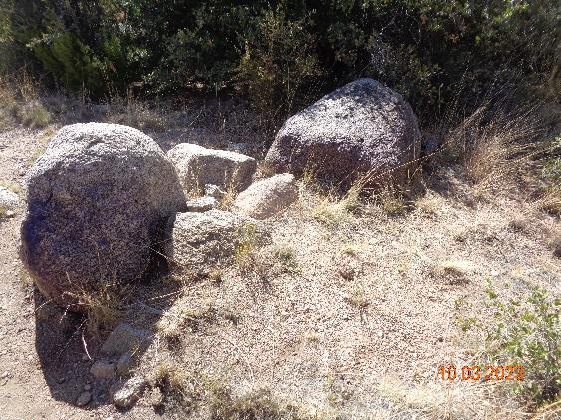

Graffiti on two boulders in La Cueva Picnic Area. All photos by Sam Beard

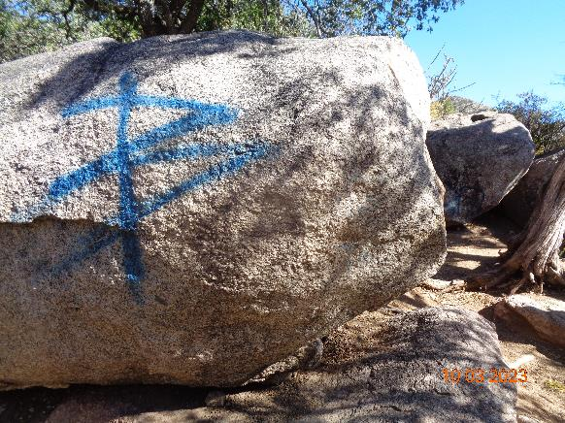

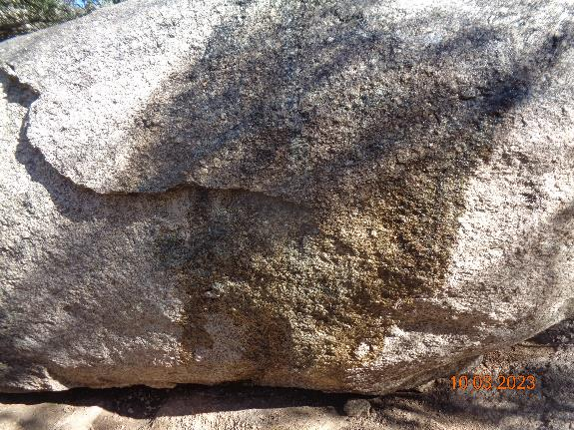

Graffiti on large boulder in La Cueva picnic area

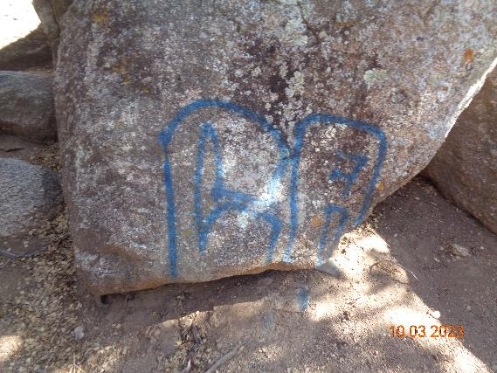

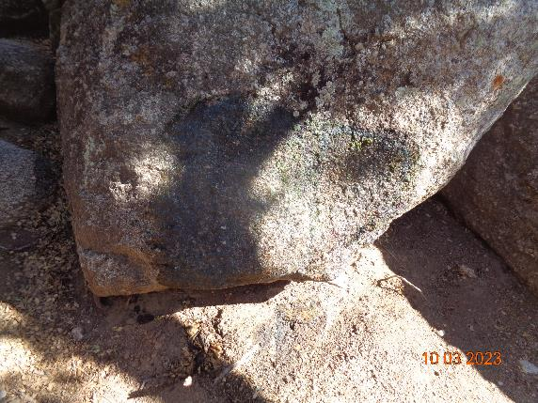

Graffiti on lichen-covered boulder in La Cueva picnic area.

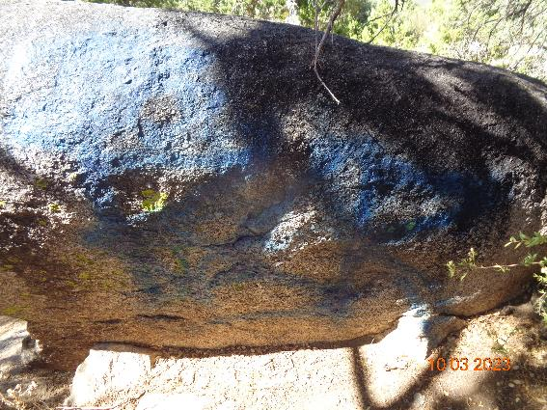

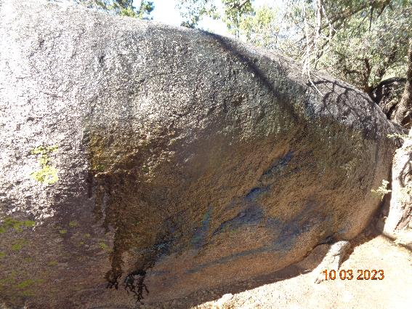

Blue graffiti on boulder in La Cueva picnic area.

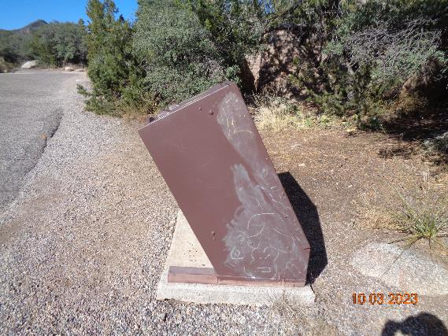

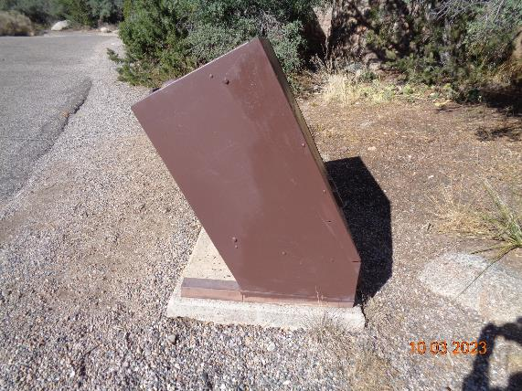

Graffiti on trash container in Juan Tabo PA near stone pillars. Graffiti on painted

surfaces may be painted over with the same color paint.

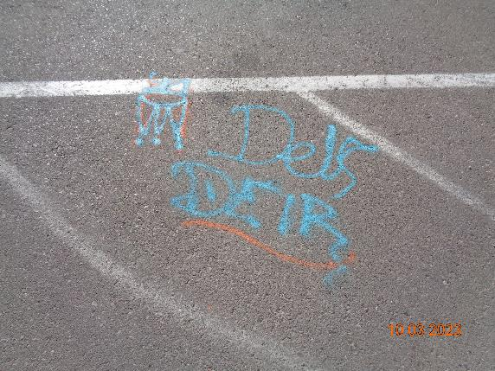

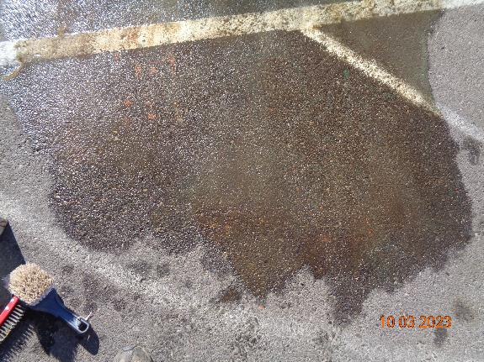

Graffiti on La Luz Trailhead parking lot.

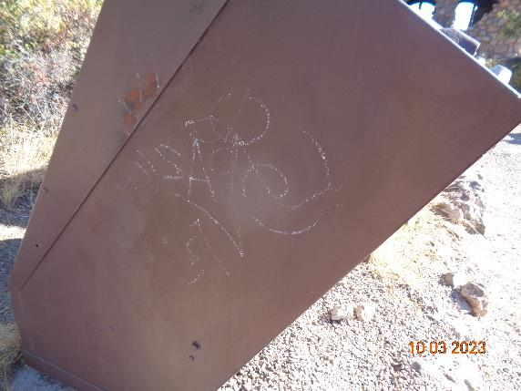

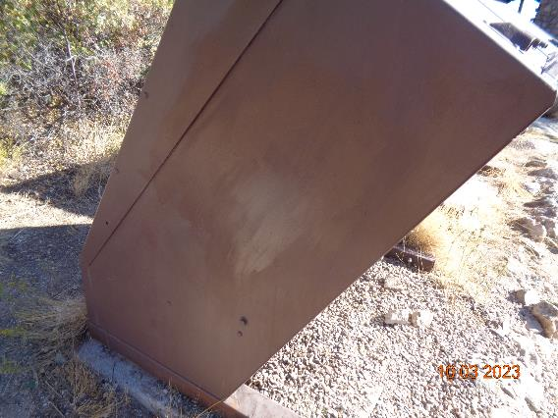

Graffiti on trash container at Juan Tabo stone shelter parking lot.

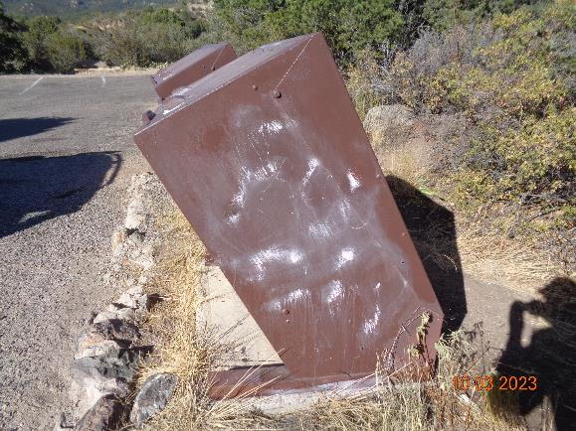

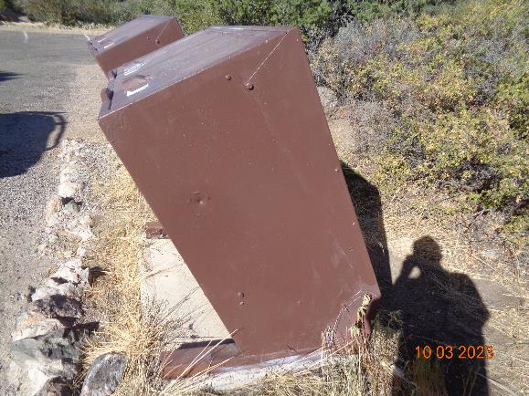

Graffiti on another trash container at Juan Tabo stone shelter parking lot.