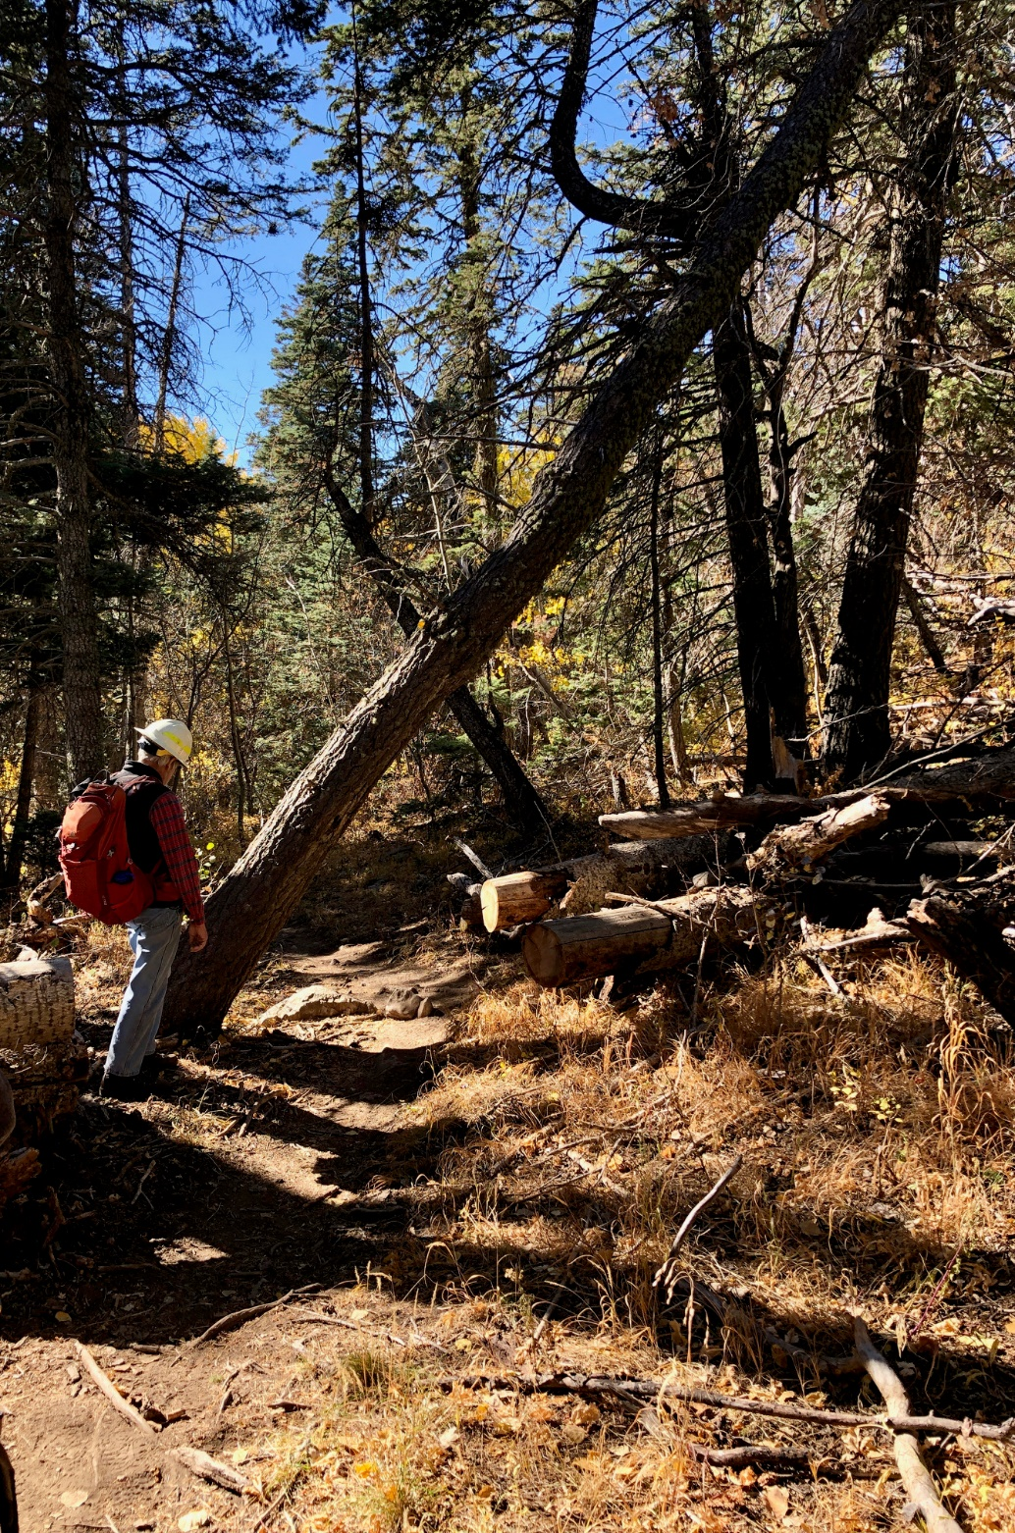
This poorly supported 15-inch diameter fir was
leaning over 10K North trail about 150 feet
above the Survey junction. While it was a duck-
under for hikers, a person on horseback could
not pass under it. Byron is sizing up the situation.

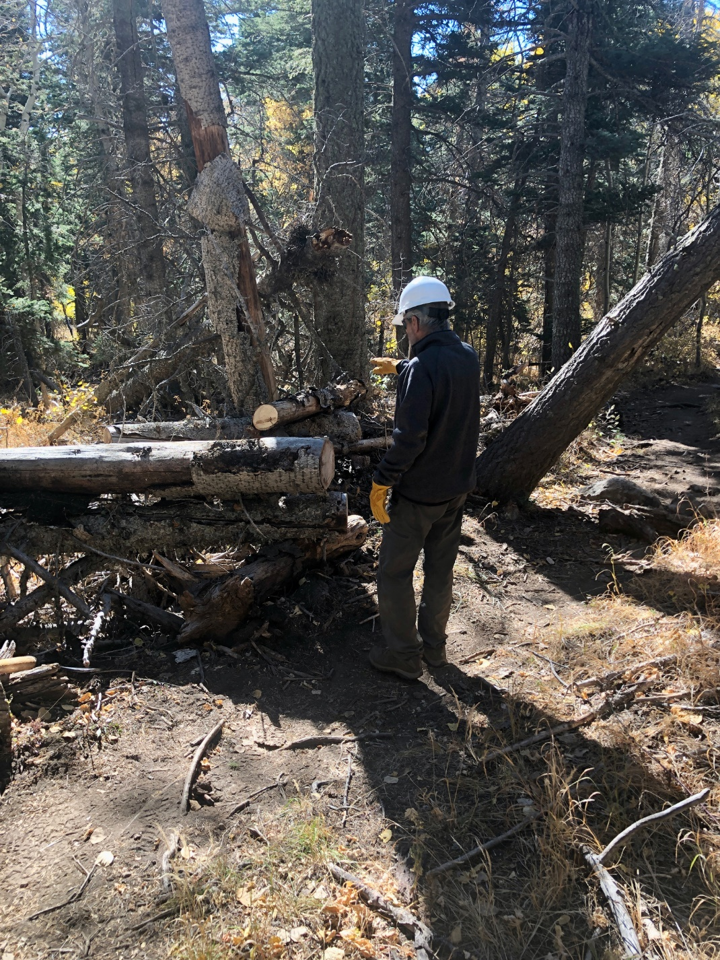
Ken is checking out the materials that must be
removed to complete the needed re-route.

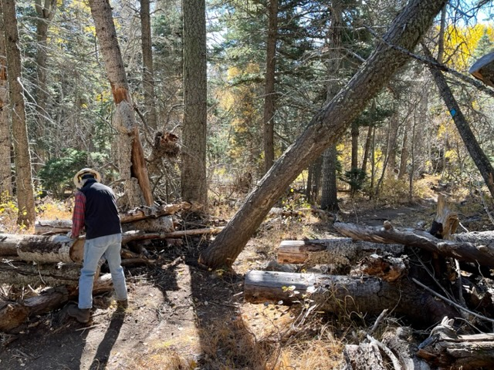
This photo shows the general problem area. Although the perspective is a bit off, the current trail passes under the leaning tree and to the left of the two logs in the right center of the photo. While the leaning tree was quite poorly supported near its top, it was still firmly attached to the roots at its base.
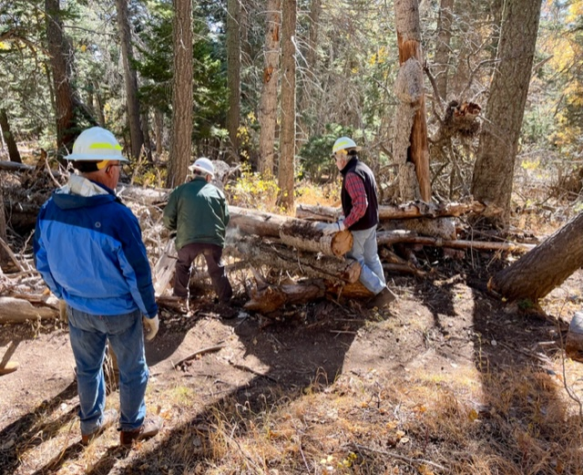
Jamey begins the cut on the first log that needed to be removed to complete the necessary re-route of the trail.

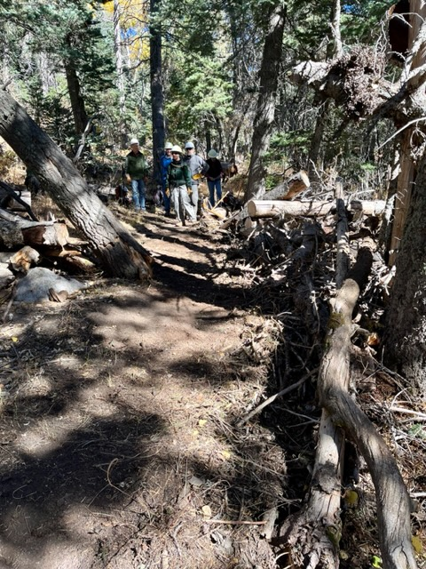
The re-route has been completed. Some of the logs and
other forest debris used to close off the old trail
that went under the leaning tree is shown in the left
side of the photo. This photo is looking uphill. All
previous photos are looking downhill. This section
of trail is now straighter than it was when it was
left of the tree.
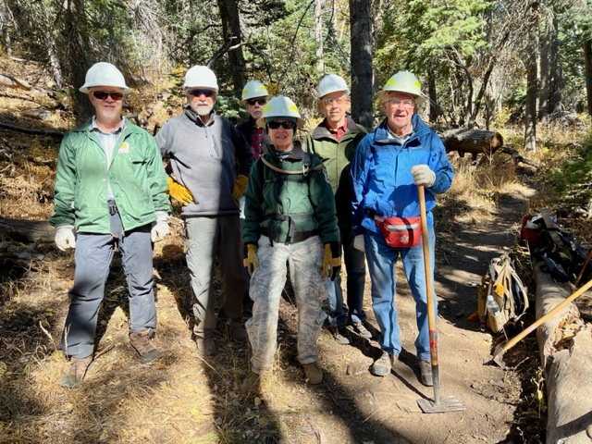
Monday’s crew (left to right) – Jamey Browning, Ken Wilson, Byron Garner, Rav Nicholson, John Cooper, and Jerry Pekarek.
(Not shown – Bob Lowder)

