**Report of** **FOSM Project to Process Logs on the Ground in Cienega Picnic Area and Haul Them**

**to the Mountain Christian Church Woodlot, Wed., Oct**. **11, 2023**

Sam Beard

On Wed., Oct. 11, ten FOSM volunteers processed several logs on the ground in Cienega Canyon Picnic Area and hauled the split wood to the Mountain Christian Church woodlot. Church Wood Ministry volunteers will donate this wood to families in the East Mountain Area who need it to heat their homes.

A few months ago, FOSM volunteers buck several logs in this PA to 6-foot lengths and moved them down to Acequia Trail near where the access road from the Crest Highway enters the PA. On Tuesday, the sawyers bucked these logs to a length of 1 foot, and volunteers used Lou Romero’s power splitter to split the rounds. The split wood was hauled to Joe Meade’s truck and trailer on wheelbarrows. One dump trailer load was hauled to the church wood lot on Sandia Haven Road west of NM-14.

The volunteers were Lou Romero, Joe Meade, Dan Benton, Eric Russell, Jerry Carroll, Cliff Giles, Sim Cook, Sam Beard, Steve Roholt, and Don Carnicom.

Project photos are presented below.

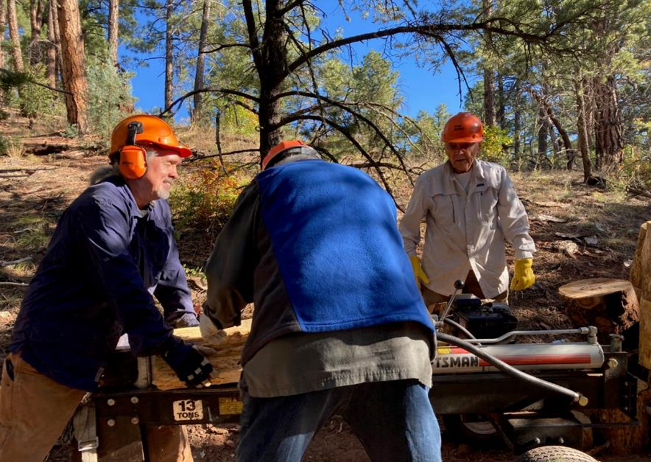

L to R: Joe Meade and Lou Romero loading a piece of wood on the power splitter while Don Carnicom observes.

Note the large stacked rounds on the right side of the photo. All photos by Cliff Giles unless noted otherwise.

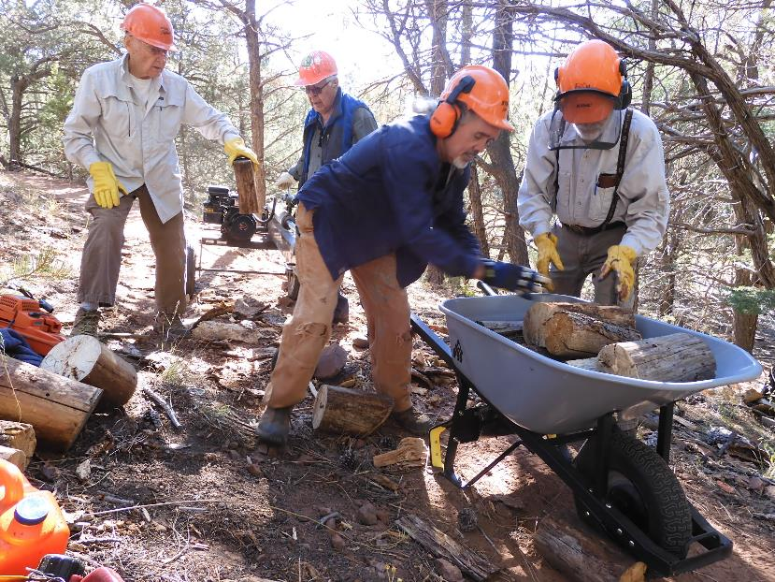

Don is handing a round to Lou Romero to be split and Joe and Sam Beard are loading the wheelbarrow.

Photo by Dan Benton

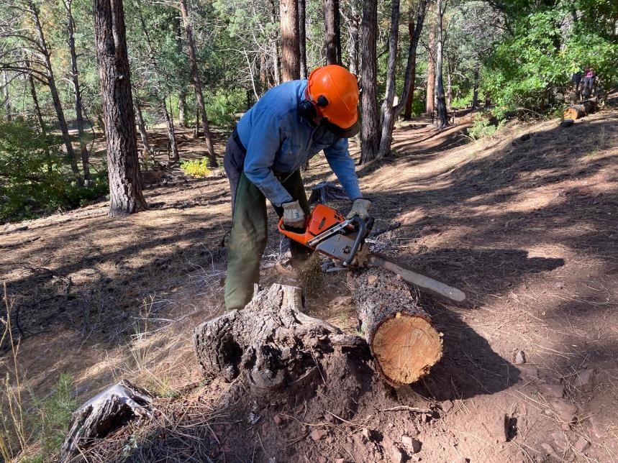

Eric Russell bucking a log that he found on the ground in this area.

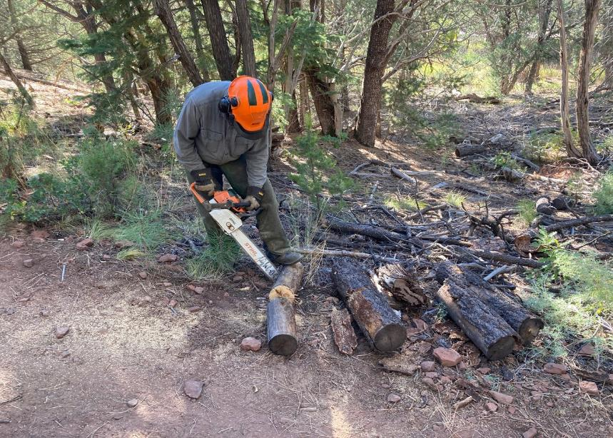

Jerry Carroll bucking a small log after all the large logs near the splitter had been split.

Photo by Dan Benton

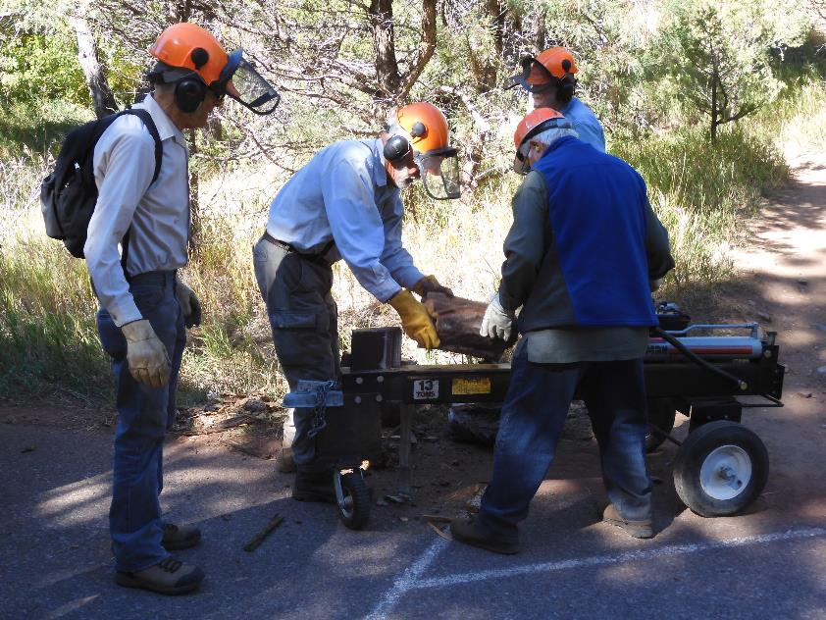

A few large pieces of Rocky Mountain Juniper were hauled to the trailer and split there.

Photo by Dan Benton

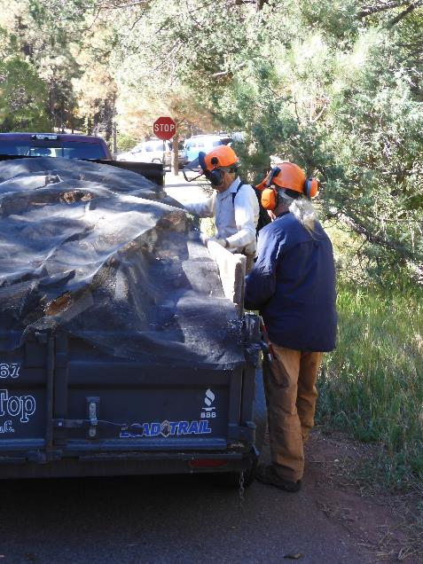

Sim Cook and Joe Meade attaching a cover over the wood on the trailer.

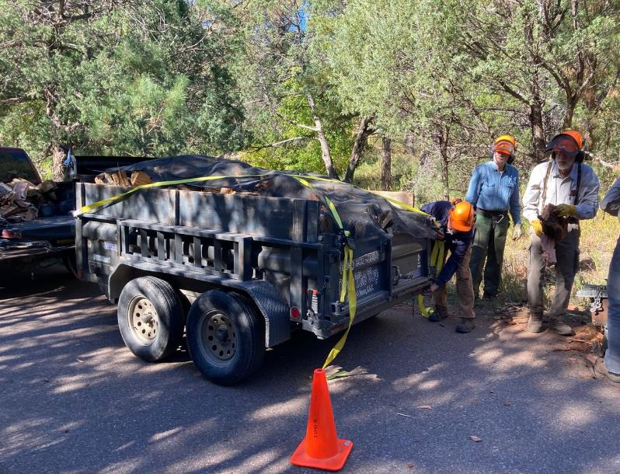

After the wood had been covered with the net, Joe Meade placed yellow straps over the load to be certain that no wood fell out.