Trail Report: Monday, October 23, 2023

Byron Garner

On October 23 the Monday trail crew hiked Rocky Point from Ellis to remove an 11" fir across the trail reported by Gustafson and Tannenbaum. With a one cut team effort, the trail was clear. A small and poorly supported leaner was also pulled down. Efforts along the way included clearing overgrowth, trail side downfall debris and various encroachments with the full length of Rocky Point now clear. The return hike, by way of Gravel Pit, was led by Jamey Browning. The crew included Rav Nickolson, John Cooper, Bill Perkins, Jerry Pekerak, Sim Cook, Jamey Browning, Cleve Sharp and Dave McCreery.

Jamey Browning

On the return hike, general maintenance was performed on Gravel Pit trail. Just past the giant root ball hole, which was filled in earlier this year, the crew removed a six-inch tree encroaching on the upper trail edge and removed a pile of debris left over from last year's big blow-down. In addition, a small root ball, some small leaners plus several logs blocking drainage on the lower side of the trail were removed.

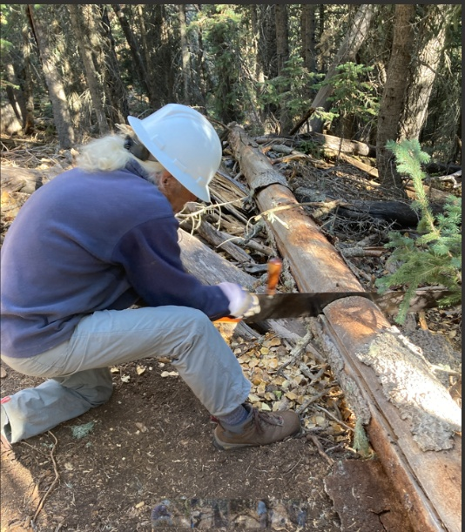 Browning

Bill gets serious

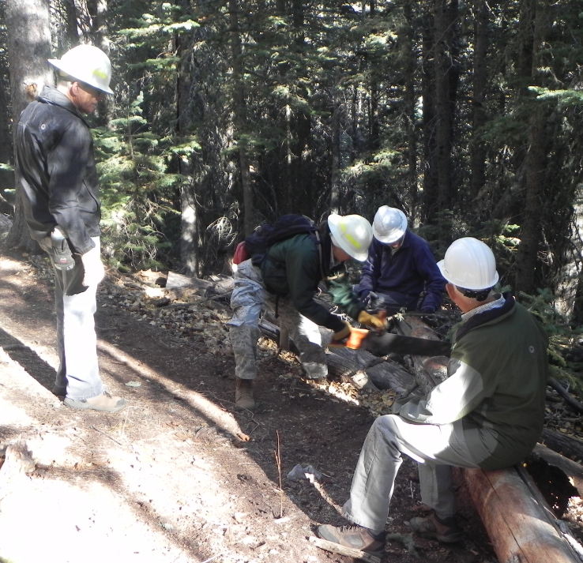

Rav revs it up

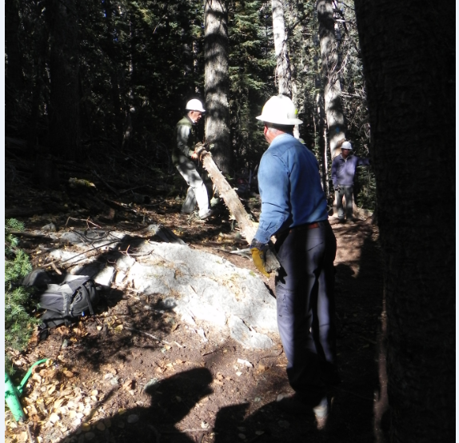

John and Dave clear the way

