**Report of** **FOSM Project to Buck and Split Logs along Kiwanis Meadow Road**

**near the Gate on Wednesday, October 25, 2023**

Sam Beard

On Wednesday, October 25, eleven FOSM volunteers bucked several logs along Kiwanis Meadow Road and hauled loads of donation wood on Joe Meade’s pickup and dump trailer. Most of the processed wood came from one 20-inch diameter spruce on the hillside above the road. Several other smaller logs were also processed slightly farther down the road. The split wood was loaded by noon, and the crew ate lunch at Doc Long Picnic Area.

The volunteers were Dan Benton, Lou Romero, Jamey Browning, Jerry Carroll, Don Carnicom, Sam Beard, Dennis Crowther, Steve Roholt, Cliff Giles, Joe Meade, and Francis Algermissen, Jerry’s neighbor.

Project photos are presented below.

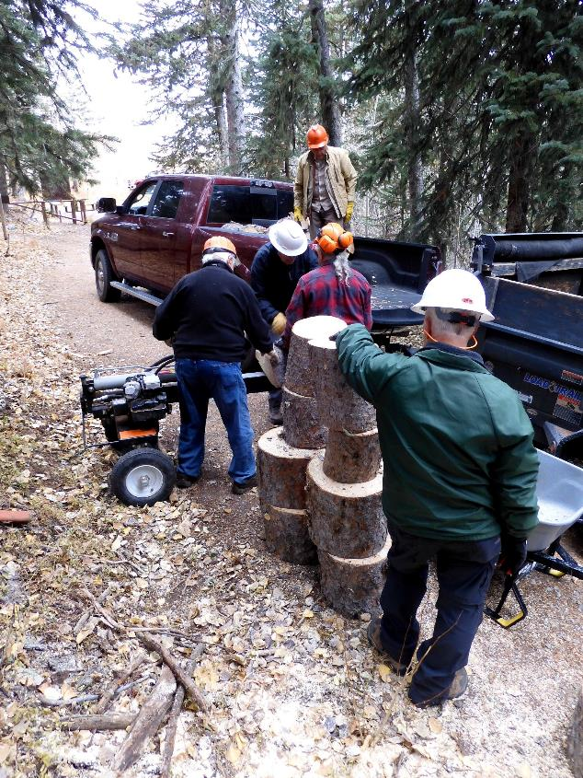

Splitting rounds on Kiwanis Meadow Road near the gate. L to R: Lou Romero, Cliff Giles, Joe Meade,

Don Carnicom, and Jamey Browning. All photos by Dan Benton unless noted otherwise

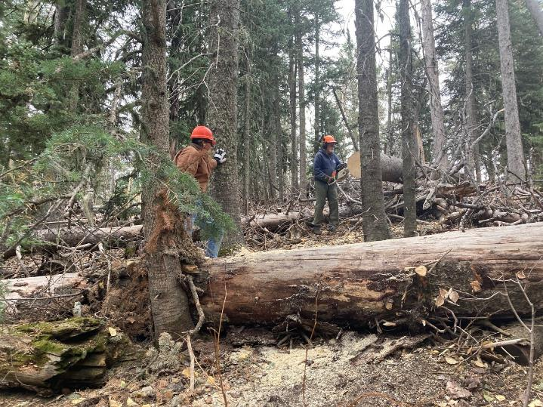

Francis Algermissen moves the rounds to the splitting team from the hill where Jerry bucks them. Photo by Cliff Giles

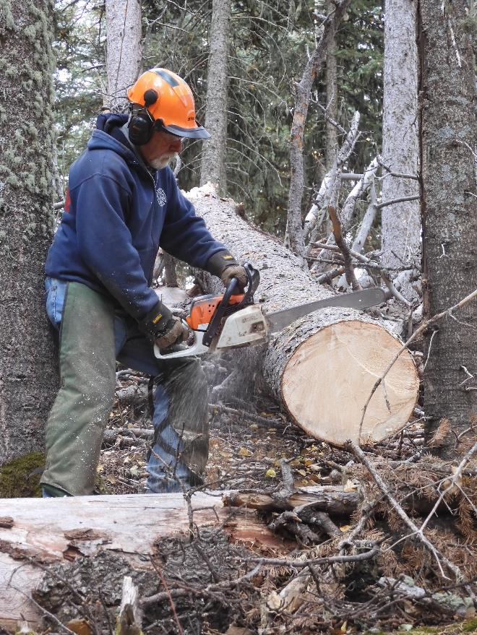

Jerry Carroll bucking a large spruce. Most of the wood in the trailer came from this log.

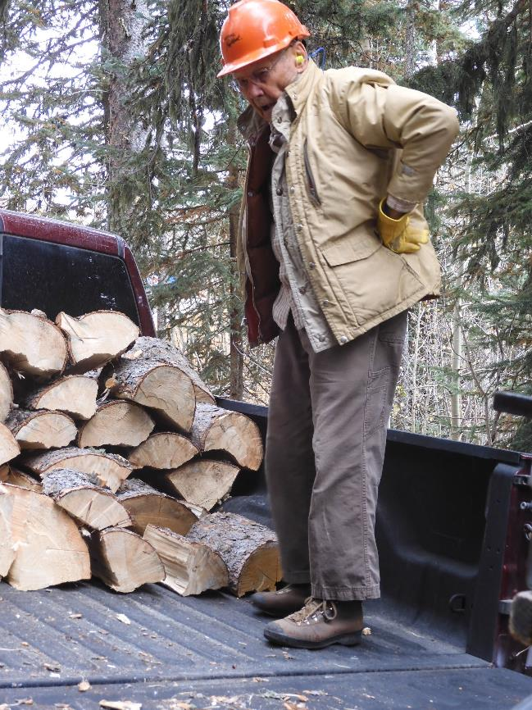

Don Carnicom in the bed of Joe Meade’s pickup where he was stacking wood.

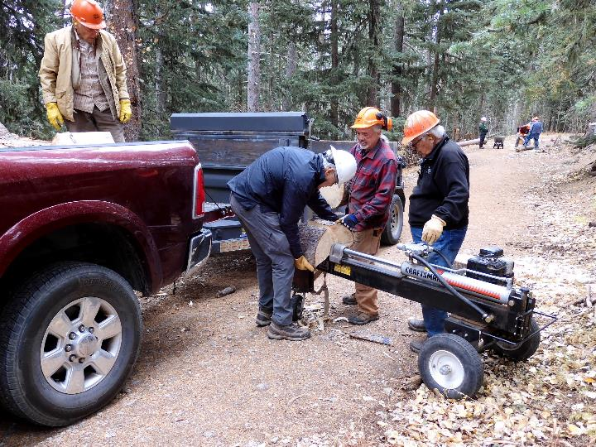

Splitting wood on Lou’s power splitter. L to R: Don Carnicom, Cliff Giles, Joe Meade, and Lou Romero.

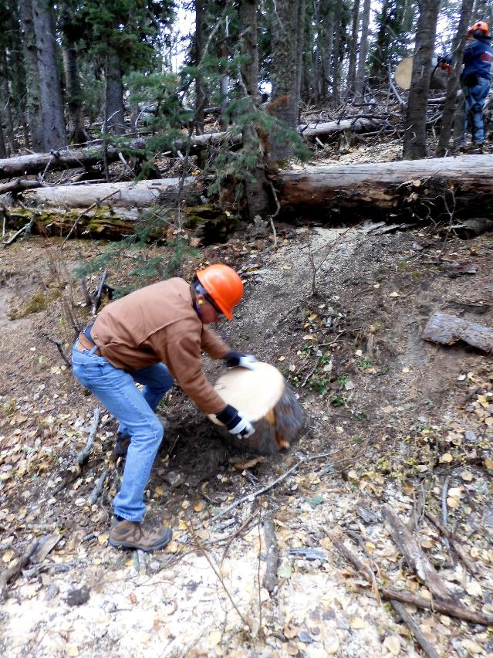

Francis is moving the round down the hill to the splitter.

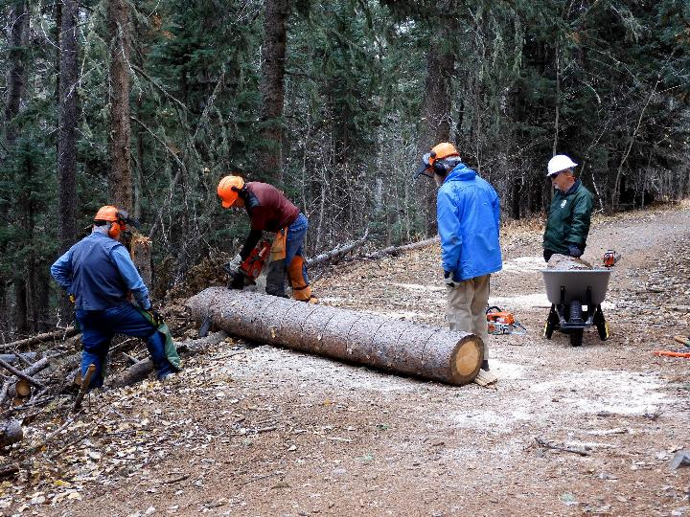

Steve Roholt bucking a spruce log on Kiwanis Meadow Road. L to R: Dennis Crowther, Steve Roholt, Sam Beard,

and Jamey Browning.

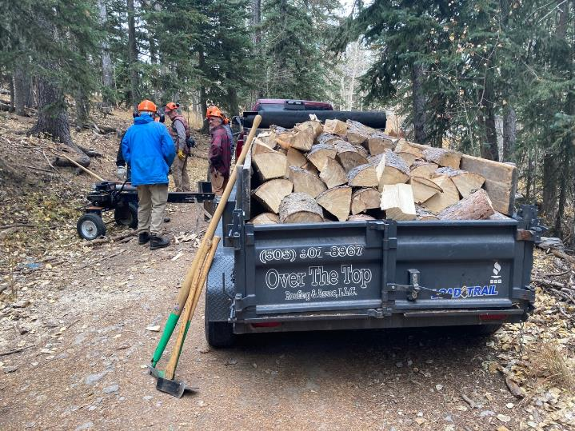

The trailer is loaded with wood. Photo by Cliff Giles