Trail Report: Monday, October 30,2023

Byron Garner

On October 30 the Monday trail crew hiked Cienega Trail to access a tree reported by Kearns and located on the upper most switchback of Pino Trail below the crest. After a brisk hike to the crest and down Pino, we arrived at our objective only to discover that through some unknown force of nature or some otherwise unreported effort, that our work was no longer needed. Not being deterred by this and enjoying a beautiful day, we began our return hike while clearing the trail of the more egregious intrusions and face slapping overgrowth with a pause for lunch at a sunny and much appreciated warm opening in the trail. It was an exceptionally beautiful day on the trail with heavy frost on the upper forest and lingering fall foliage. With welcoming Rich Feddersen as our newest member, the crew also included Ken Wilson and Dave McCreery

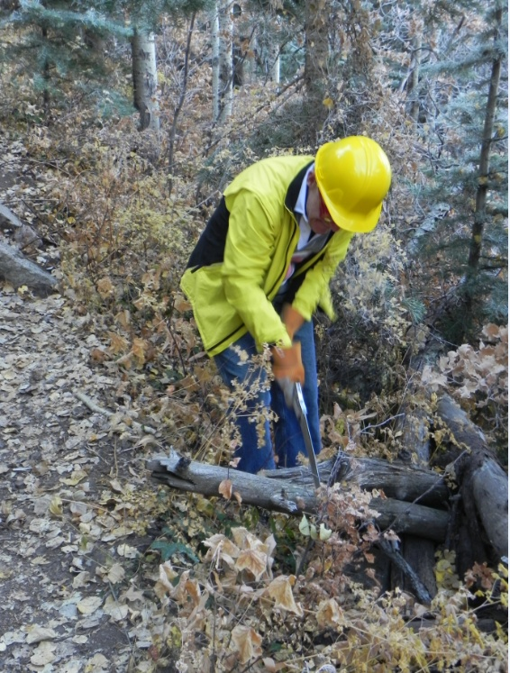

Rich finishes off an intrusion

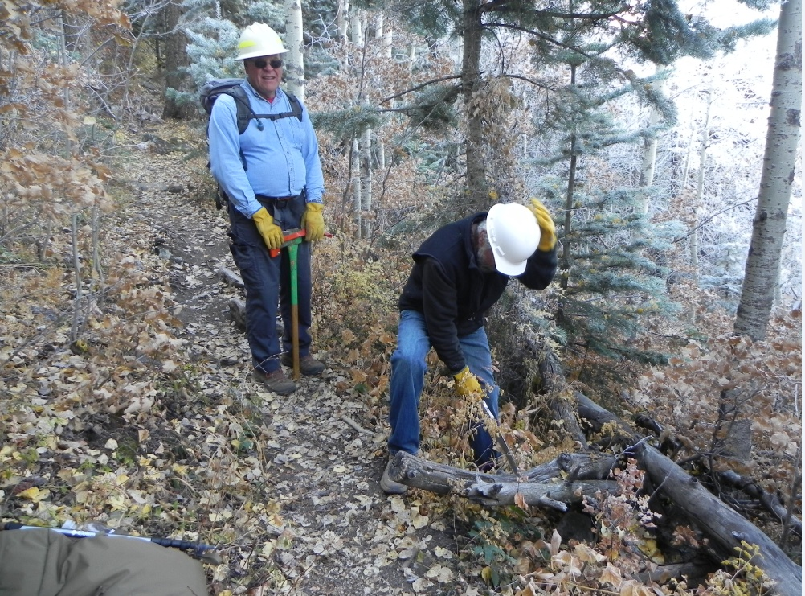

Ken takes charge of another intrusion

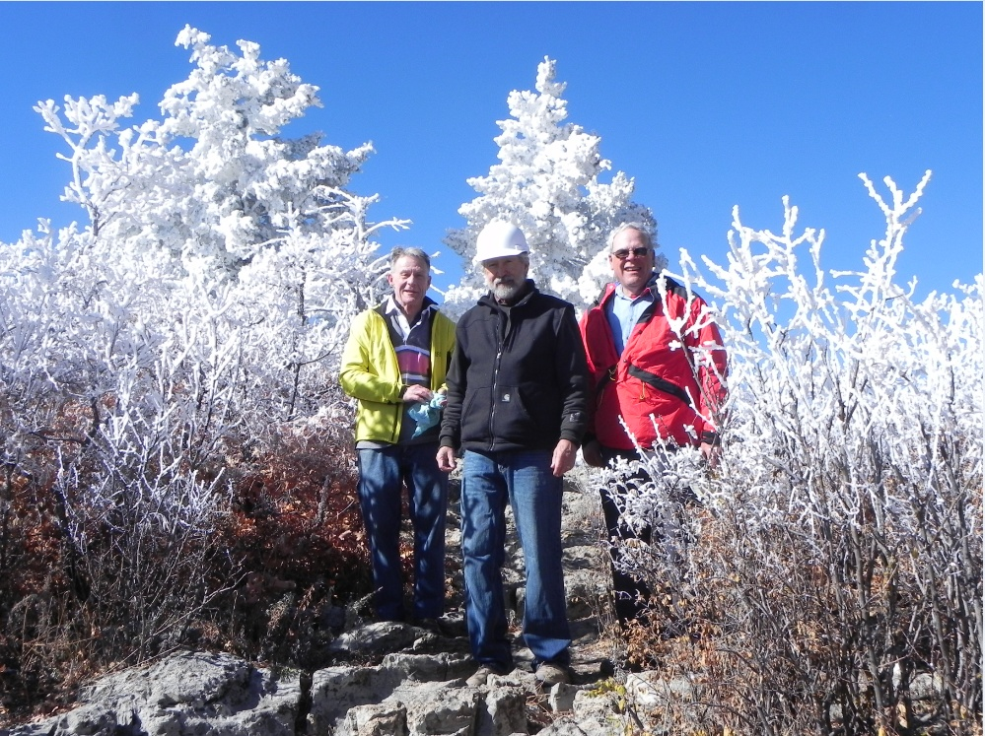

Rich, Ken and Dave at the crest with an unusual frosted backdrop

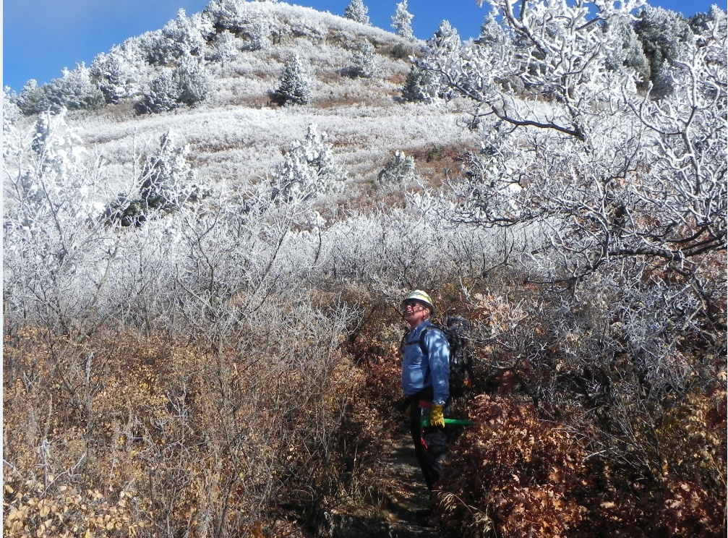Dave on the crest at the frost line

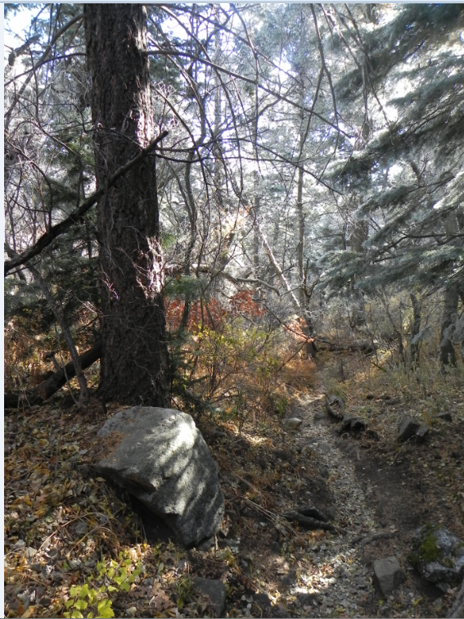

Early light on Cienega