**Report of Graffiti Removal and Painting a Kiosk in the Crest Area by FOSM Volunteers**

**on Tuesday, November 7, 2023**

Sam Beard

On Tuesday, November 7, five FOSM volunteers removed or painted over approximately a dozen graffiti tags in the Crest Area and along the Crest Nature Trail.

Near the upper Crest restrooms four tags on painted surfaces were painted over, and two tags on boulders were removed with chemicals. Along the Nature Trail, three larger tags were removed from boulders, and about 4 smaller tags were removed from aluminum posts supporting information signs. At the gate on Kiwanis Cabin Road, a large tag on the back of the sign was painted over. The south side of the North Crest Trailhead kiosk was painted with gray paint.

The volunteers were Pauline Ho, Rick Buss, Katie Ziegweid, Gordon Eatman, and Sam Beard.

Project photos are presented below.

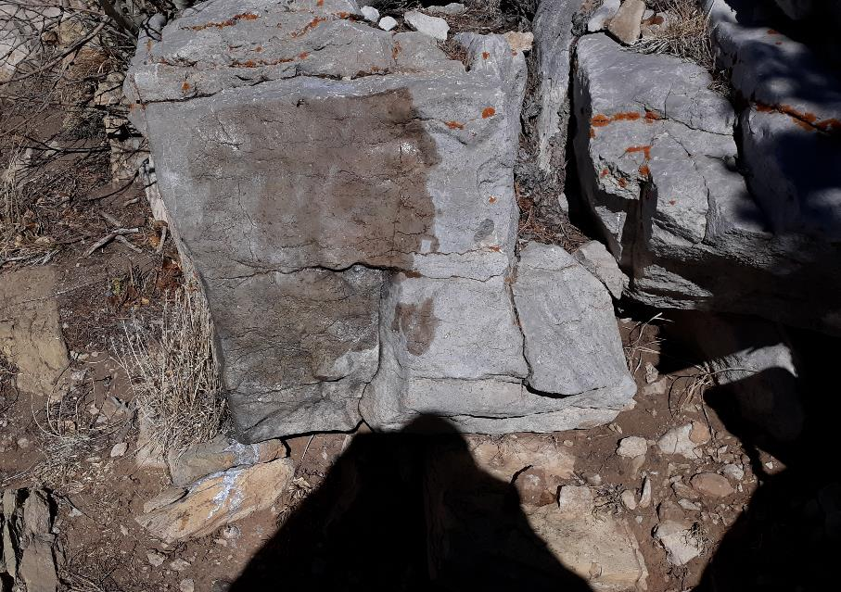

A boulder on the Crest Nature Trail after the black graffiti was removed. Photo by Sam Beard

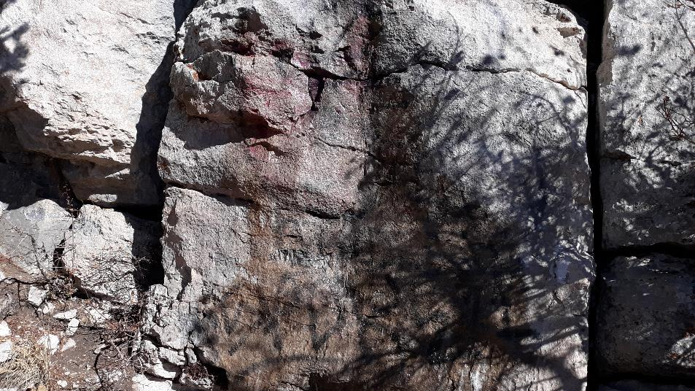

FOSM volunteers have attempted to remove the large purple graffiti from this boulder on the Crest Nature Trail three times, but some of the purple

color remains. We were able to remove only about 50% of the black graffiti lower on the boulder. Photo by Sam Beard

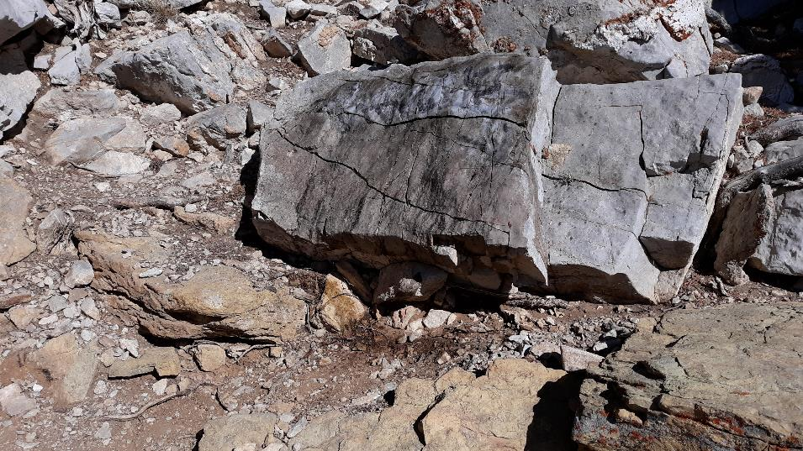

We were able to remove only about 50% of the black tag on the upper part of this boulder. A similar large black tag about 4 feet by 1 foot

was located high on a boulder where the Nature Trail turns to the left and ascends the narrow steps. Due to the strong cold wind and the height of that black tag, we did not attempt to apply any chemical. We will bring a ladder when we apply the removal chemical to this large graffiti later.

Photo by Sam Beard

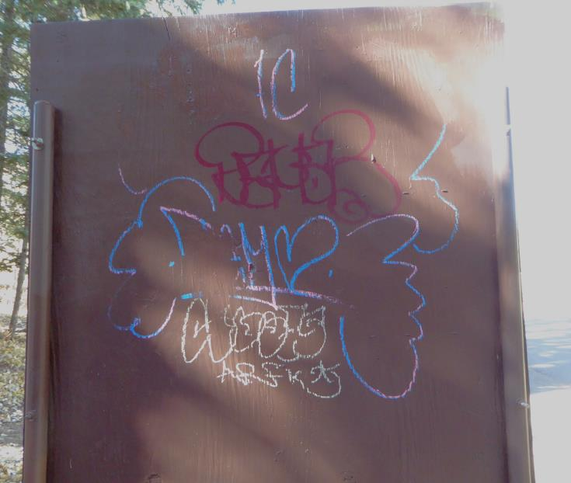

Graffiti on the back of the large map display by Don Carnicom at the gate on the road to Kiwanis Cabin.

Photo by Pauline Ho

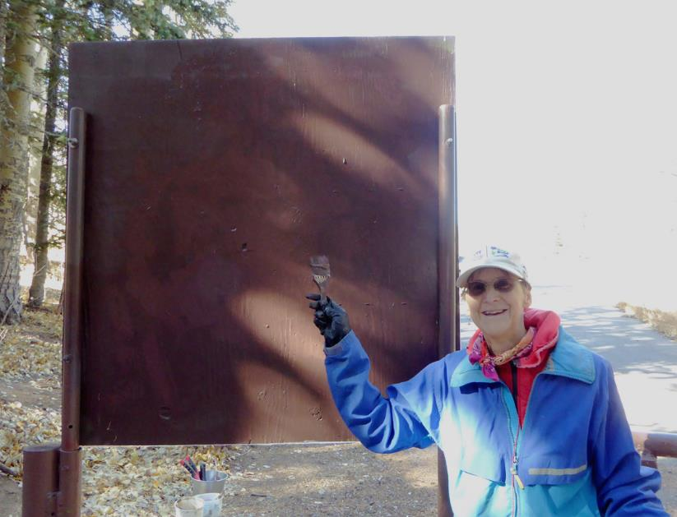

Katie Ziegweid painted over the graffiti in the above photograph with brown paint. Photo by Pauline Ho