**Report of FOSM Project to Cut Brush around the Old Barro Wildlife Drinker**

**on Wednesday, November 8, 2023**

Sam Beard

On Wednesday, November 8, seven FOSM volunteers cut brush around the old Barro Wildlife Drinker back to a radius of 50 feet so that prey animals can see mountain lions in time to escape. At both the old and new drinkers, there was no water in the rain collectors or in the drinkers.

As part of the Adopt-A-Drop program, Jean Payne and Joelle Hertel check the conditions at these drinkers throughout the year.

The volunteers working on this project were Dan Benton, Sim Cook, Jerry Carroll, Dennis Crowther, Cliff Giles, Don Carnicom, and Sam Beard.

Project photographs are presented below.

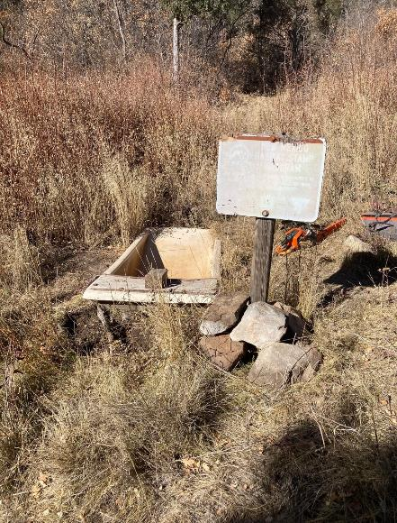

Old Barro Drinker and Habitat Stamp sign about funds for this facility

that was reinstalled by Dan Benton on Wednesday. All photos by Cliff Giles

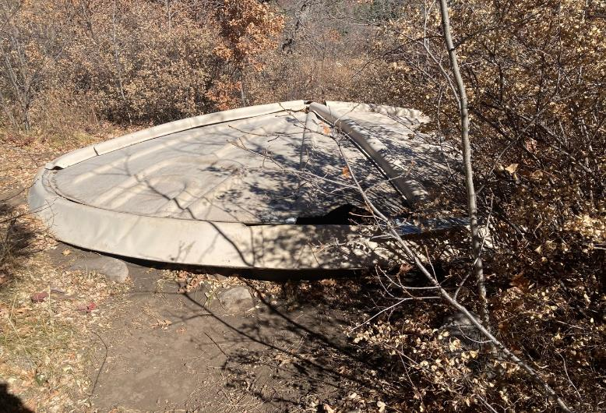

The old clam shell rain collector. Rain flows down the sides of the top

and goes into the tank below at the lower edge of the top clam shell.

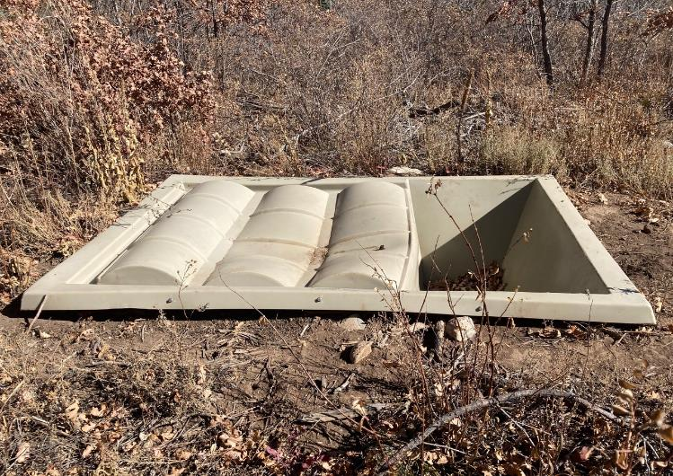

The new rain collector. Rain falls on the left part of the collector and flows into the basin on the right and into

the tank below the left cover. Water flows through a pipe from the tank to the drinker located about 100 feet to the right.

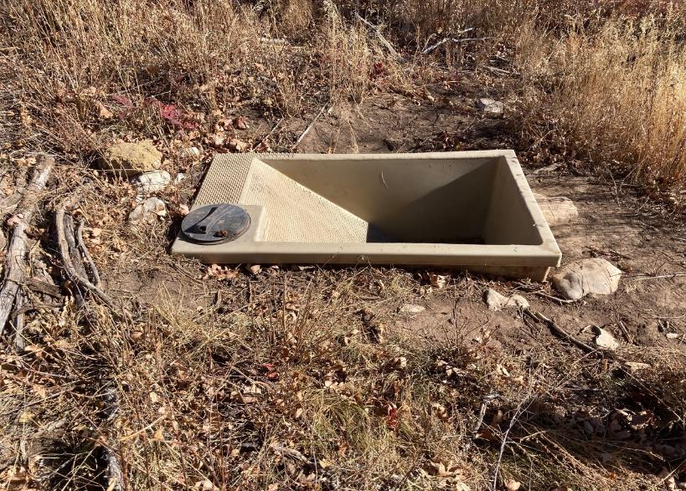

The new wildlife drinker. A float valve is located in the compartment below the black top. Water flows into the drinker

through a pipe from the rain collector located about 100 feet to the left.

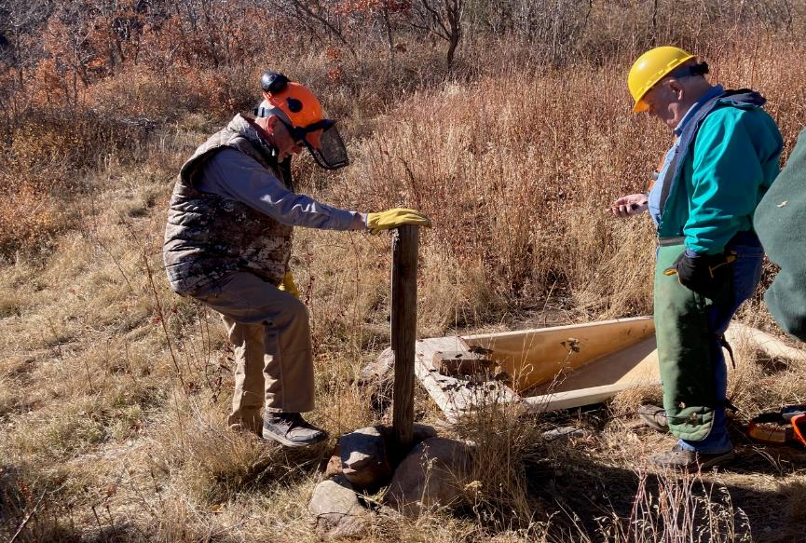

Dan Benton is reinstalling the Habitat Sign, and Dennis Crowther is using his GPS receiver to located pink flags at a distance of 50 feet

from the drinker.

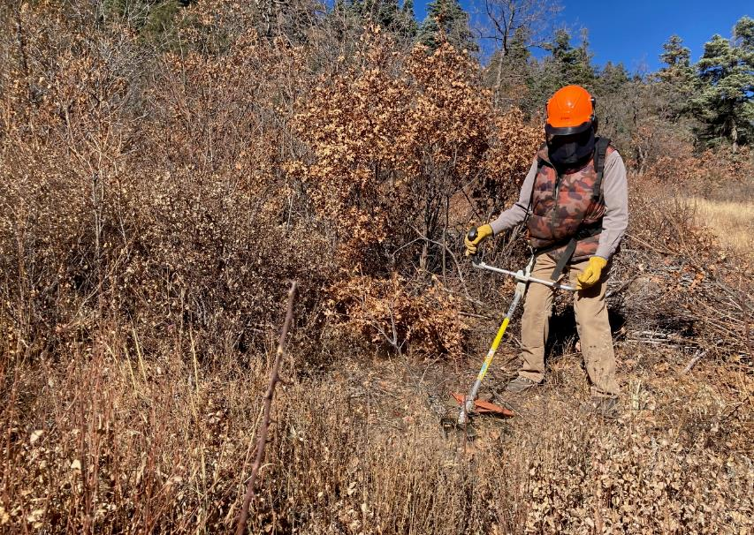

Dan Benton is using one of the FOSM brush cutters to cut brush between the two drinkers.

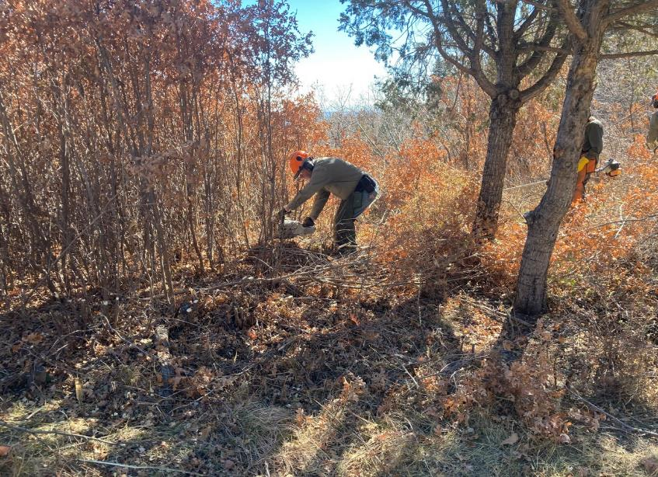

Jerry Carroll is using his chain saw to cut oak brush.

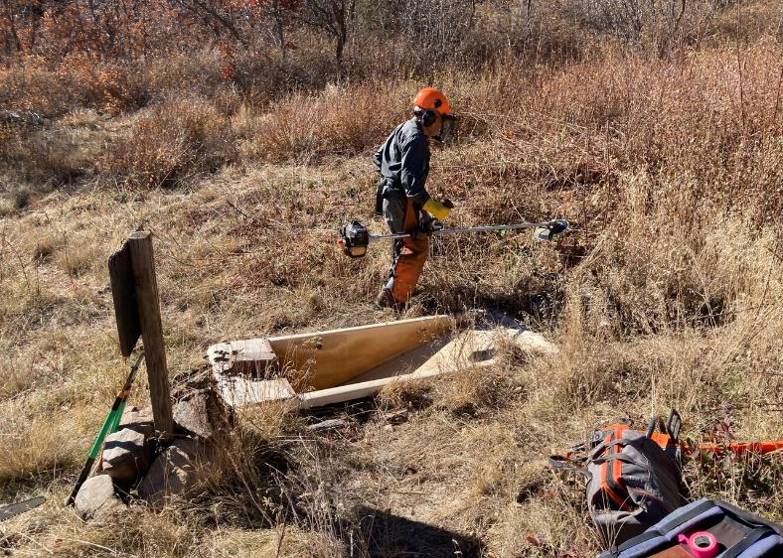

Don Carnicom is using his personal power cutter to cut brush near the old drinker.

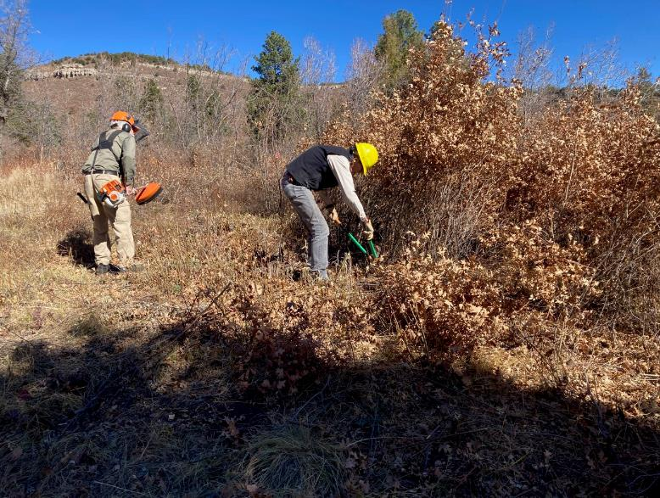

Sam Beard is using a FOSM brush cutter to cut short brush, and Sim Cook is using loppers to cut taller oak brush.

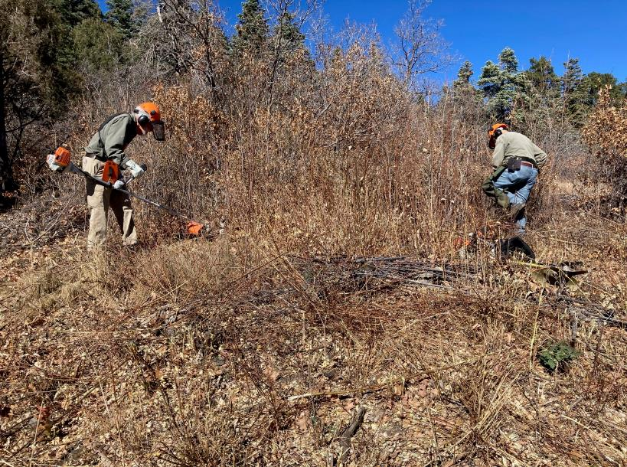

Sam is using a Stihl brush cutter to cut brush, and Jerry is cutting brush with this chain saw between the old drinker

and the clam shell rain collector.