Trail Maintenance Report: Monday, November 13, 2023
Byron Garner
On November 13, the Monday trail crew hiked Rocky Point picking up the Crest trail at the tram and following that to the crest house while splitting the crew along the way to pick up Nature Trail. From there our return course back to Ellis was by way of Switchback and Buried Cable. Our efforts resulted in removing three unreported trees which included a 10" and 5' aspen on Rocky Point and The Crest trail respectively with an 8" fir further up the Crest Trail. While on the return we met up with Steve Roholt and helped him finish another 5' fir. Though the day began a bit on the cold side with two to three inches of snow, conditions warmed rapidly with intermittent patches of ice and progressively more frequent segments of clear trail. Overall, a great day to be on the mountain ending with lunch and good conversation at Ellis - and no wind! The crew included Bill Perkins, John Cooper, Jamey Browning and Dave McCreery. Photos: Jamey Browning; Byron Garner

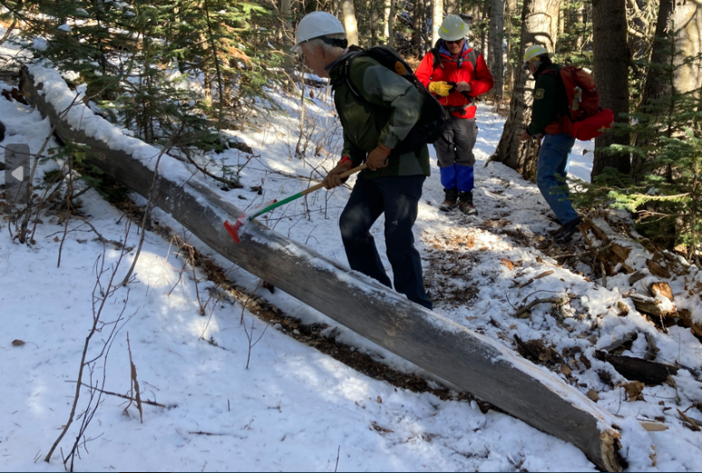Browning
John makes assessment of the Rocky Point aspen

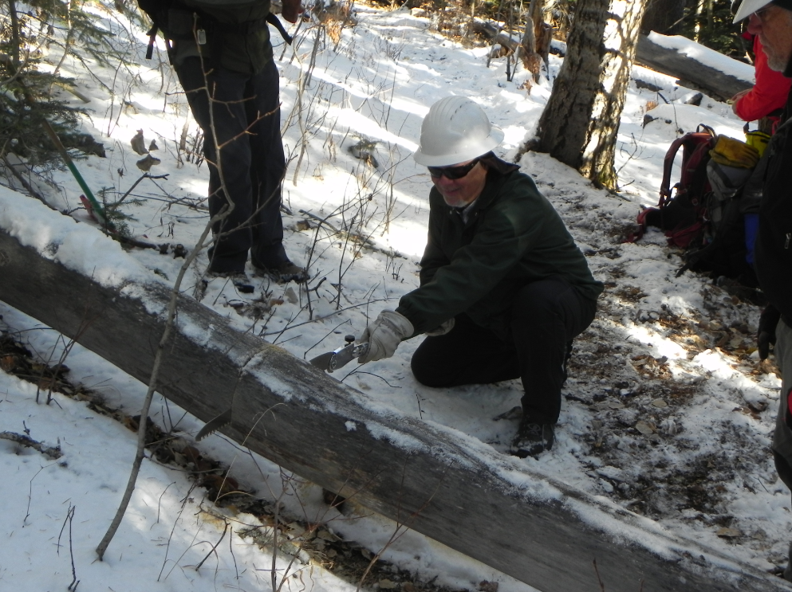
Jamey finds the going easy on the very dry aspen

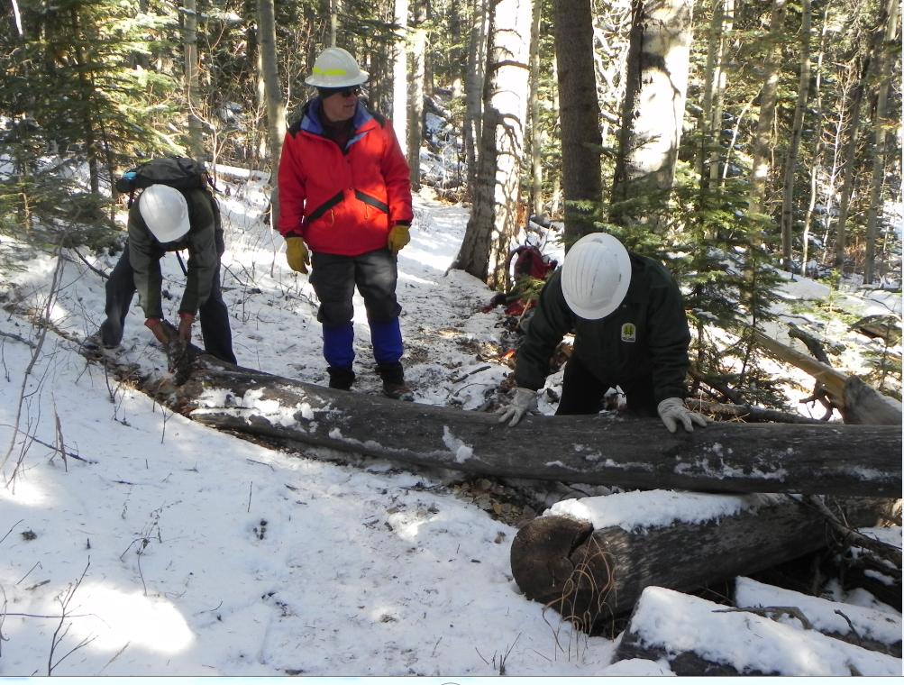
John, David and Jamey in the final effort clearing the trail

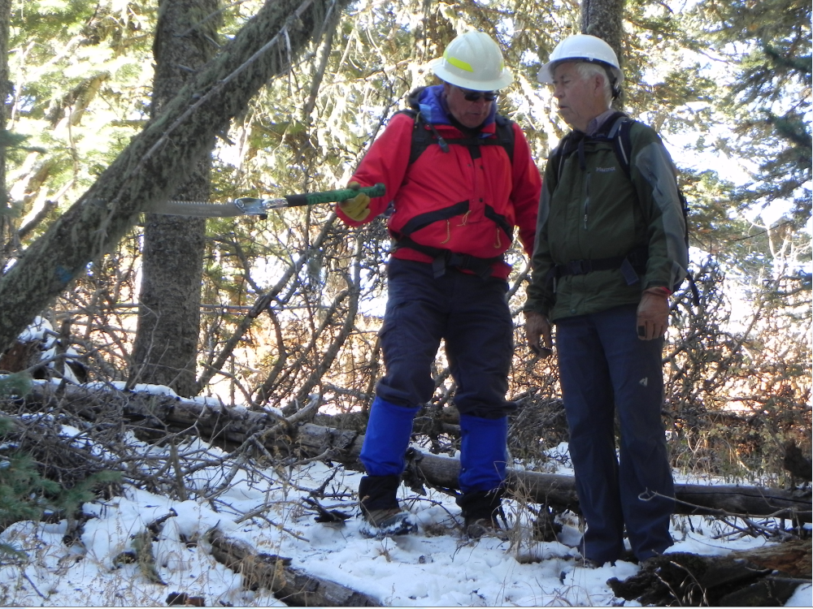
David and John take measure of a leaning fir

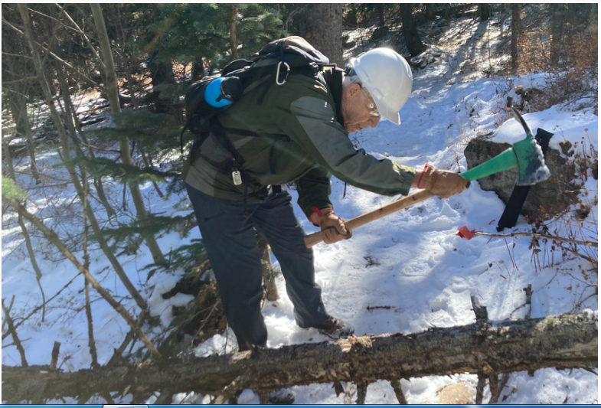Browning
John limbs for the final clearing

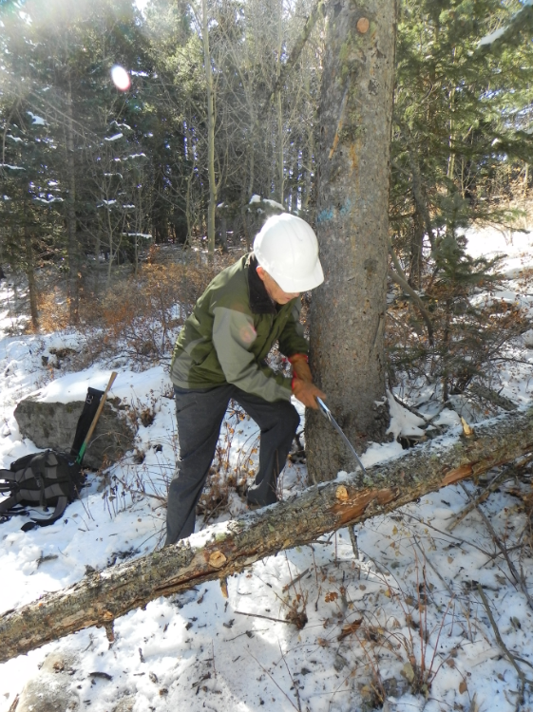
Steve "caught in the act"
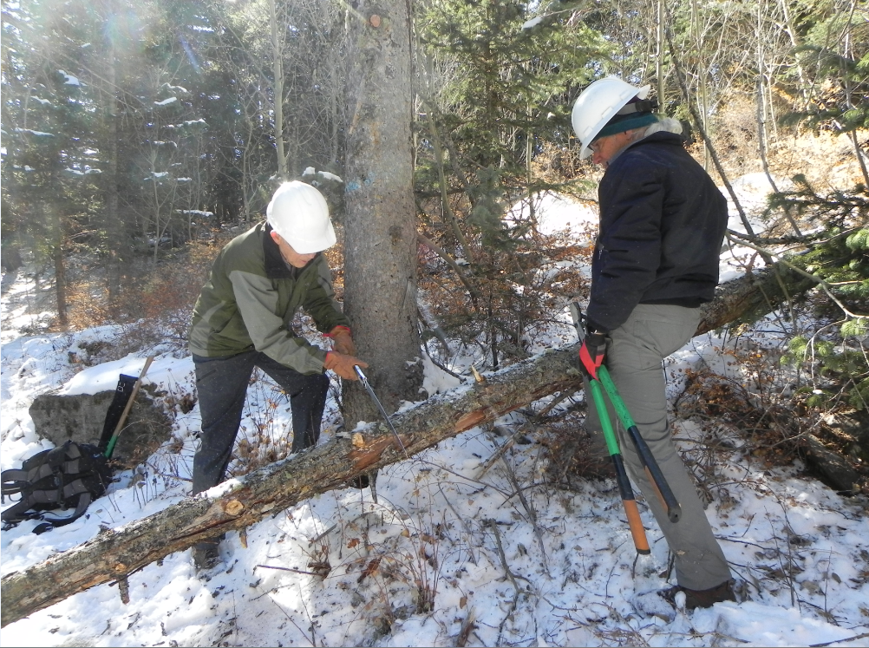
Steve and Bill team up for the final fir

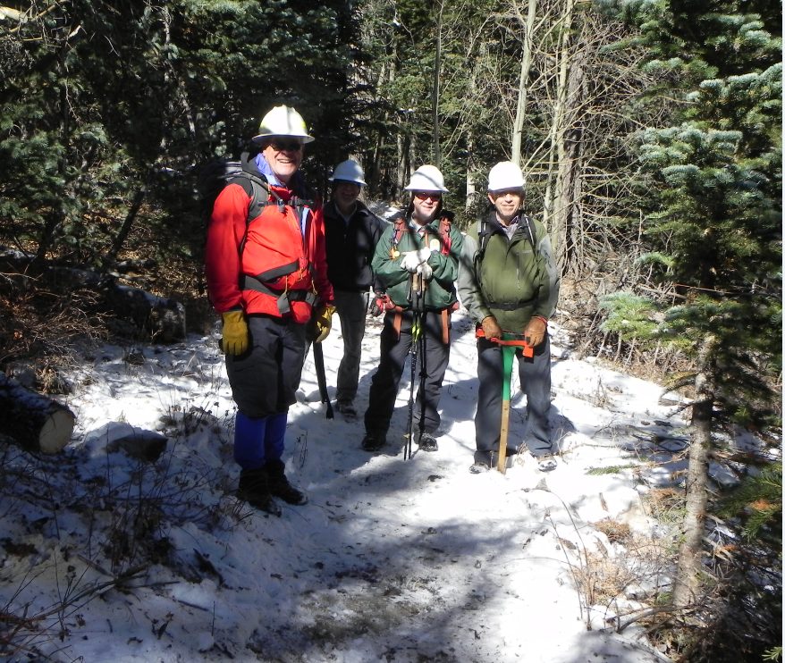
Dave, Bill, Jamey and John enjoy a productive day

