**Report of FOSM Projects to Cut Brush at Cienega Road/Crest Highway Intersection**

**and Process and Haul Sulphur Picnic Area Log, Wednesday, November 15, 2023**

Sam Beard

On Wednesday, November 15, ten FOSM volunteers completed projects to cut brush for better sight distances at the Cienega Road/Crest Highway intersection and process a log in Sulphur Canyon Picnic Area so that it could be hauled as donation wood to a church woodlot.

1. **Cutting Brush at Intersection** – This annual fall project began several years ago when a USFS low enforcement officer (LEO) asked FOSM to cut the brush back farther from the highway so that drivers would have better sight distances when turning onto the highway. The N. M. Department of Transportation only mowed the shoulder of the highway. The first year we cut brush here there were numerous small trees that required the use of chain saws. By cutting brush here each fall, the mostly willow plants are small and can be cut with power brush cutters and loppers. We also cut with chain saws. This year we had very little brush to cut at the entrance to Sulphur Canyon, and we had ten volunteers to do the work. Instead of working to noon, we completed this project at 1030, and we were able to complete another project in Sulphur Canyon PA before lunch.
2. **Planned to Haul Bucked Wood on Old Paved Road** – The planned secondproject was hauling bucked wood located on the old paved road at Doc Long Picnic Area, but when we checked the area, all the wood had been taken (stolen). We then decided to go to Sulphur Canyon Picnic Area and process the white fir on the ground there. Several years ago, we had bucked and maybe split a cord of wood in the lower part of Capulin PA and left it behind the locked gate there. When we returned to haul it away, someone had taken all the wood. We assumed that they had used wheel barrows to move it past the locked gate.
3. **Processing Log in Sulphur Canyon Picnic Area** – In Sulphur Canyon PA, we processed a 15-inch diameter white fir that had been felled as a hazard tree earlier this year. The log was limbed and bucked, and the pieces were moved down to Jerry Carroll’s pickup by using a chain of volunteers. The wood was hauled to the Hopkins’ corral where it will be stored until it is given to families who need it to heat their homes by the Mountain Christian Church Wood Ministry volunteers.

The volunteers who worked on these projects were Steve Roholt, Eric Russell, Rene Archer, Laura Leon (new Wed. vol.), Sim Cook, Cliff Giles, Dan Benton, Jerry Carroll, Don Carnicom, and Sam Beard.

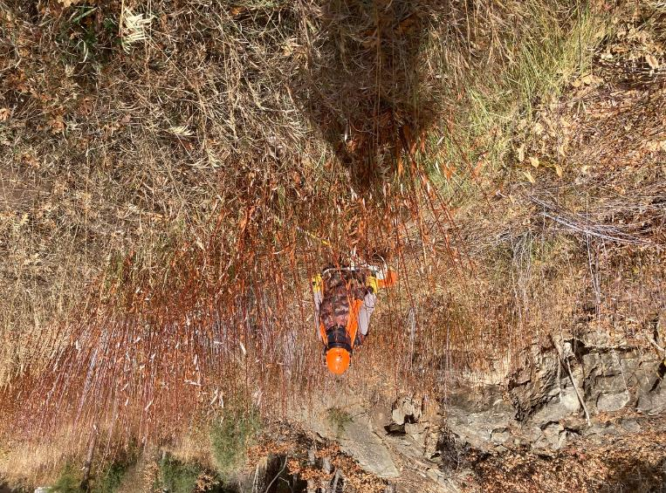

Dan Benton cutting willow brush along the creek at the intersection of Cienega Road and the Crest Highway.

All photos by Cliff Giles unless noted otherwise

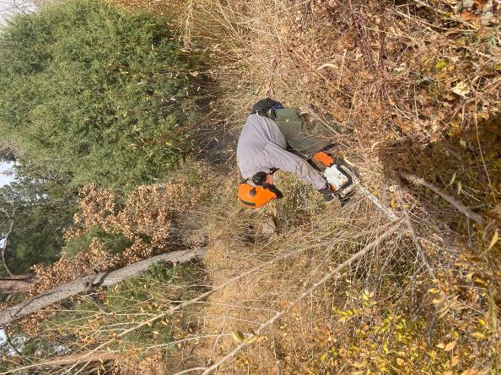

Jerry Carroll cutting brush with his chain saw.

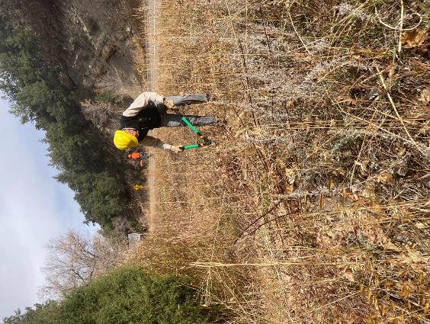

Sim Cook cutting brush with loppers.

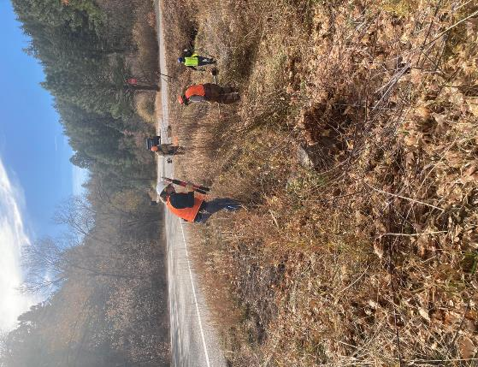

L to R: Rene Archer, Don Carnicom, Dan Benton, and Laura Leon cutting brush along the creek.

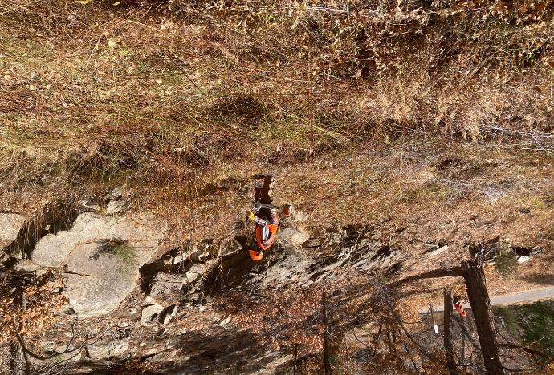

Dan cutting brush with the FOSM clearing saw with a blade designed to cut small trees.

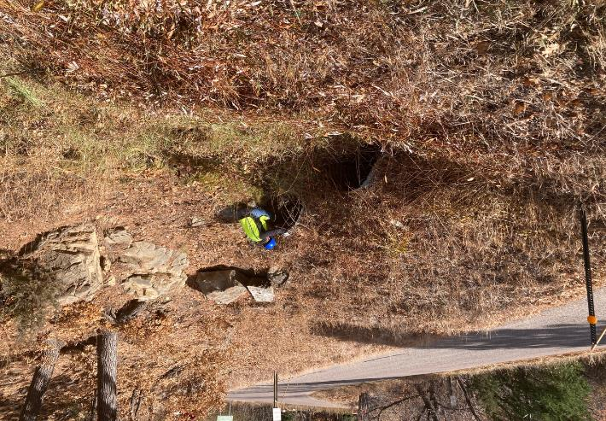

Laura cutting brush at the culvert under Cienega Road.

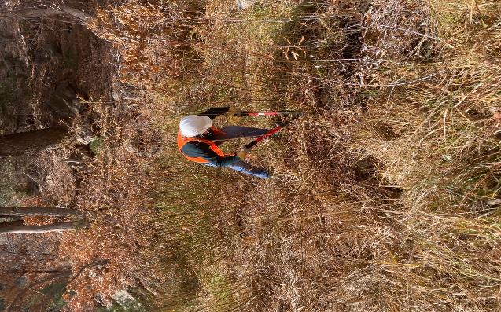

Rene cutting brush on the south side of the creek with loppers.

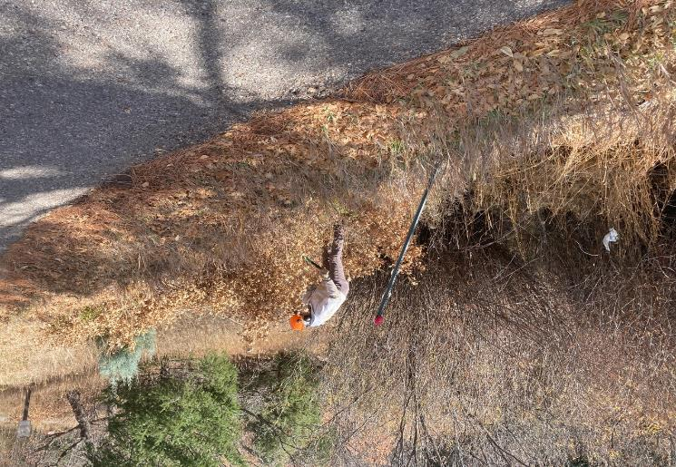

Eric Russell cutting oak brush with loppers on the east side of Cienega Road.

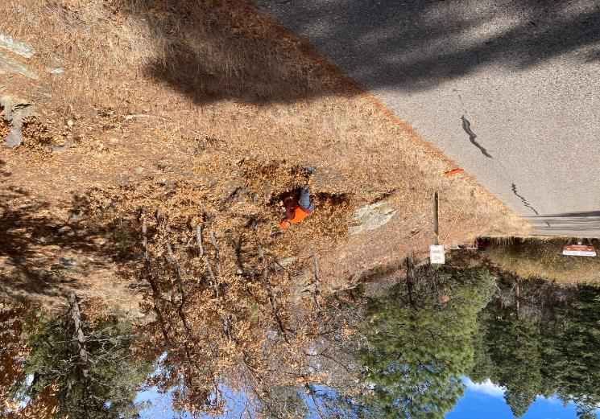

Steve Roholt cutting oak brush with the FOSM battery-powered chain saw.

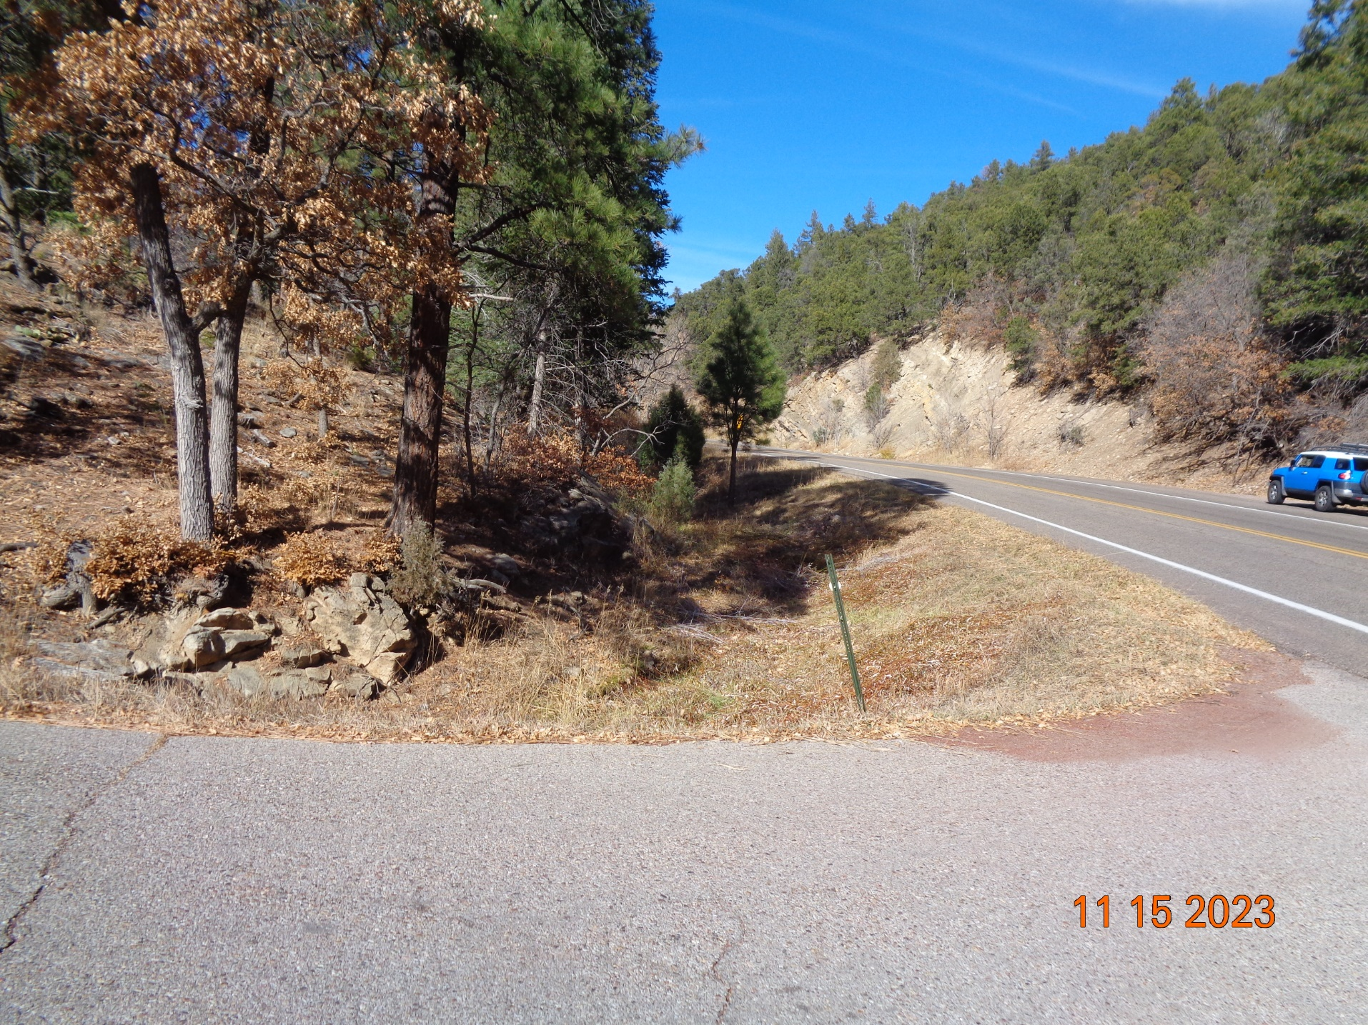

The brush along the creek has been cut, and the sight distance up the Crest Highway is very good. Photo by Sam Beard

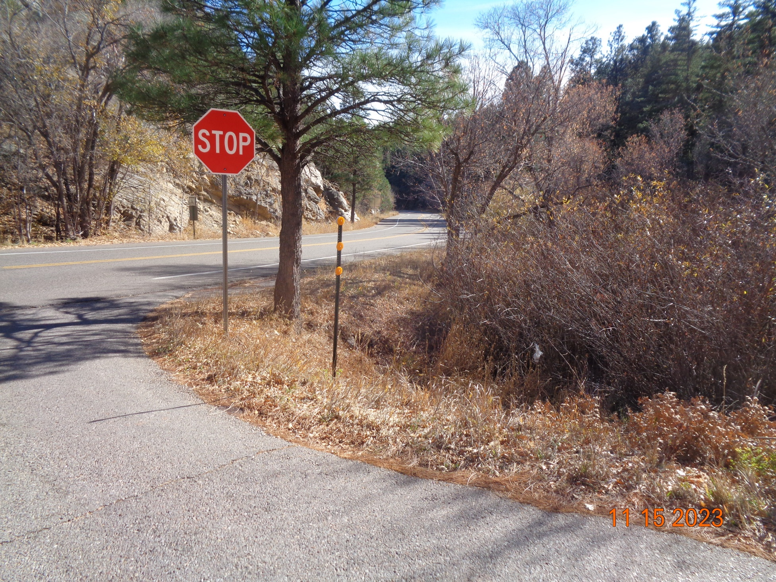

The sight distance down the Crest Highway is also very good. Photo by Sam Beard

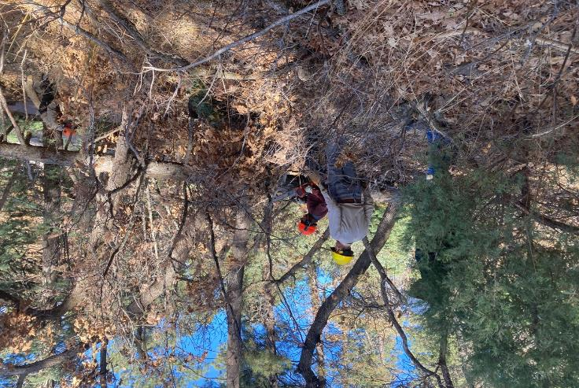

Steve Roholt using the battery-powered chain saw to cut limbs on the white fir log. Sim Cook is ready to move the cut branch away from the log.

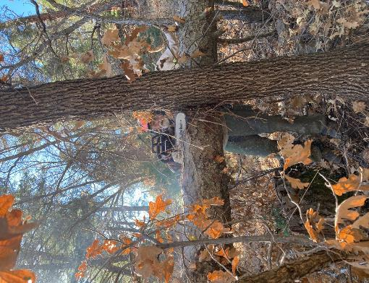

Jerry beginning to buck the log with his new chain saw.

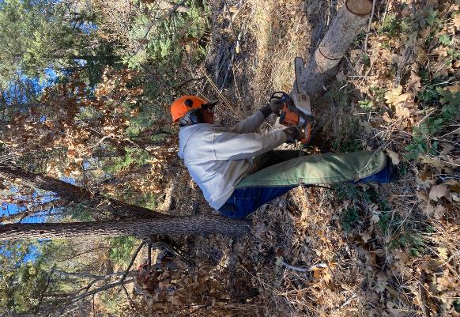

Jerry bucked the log so that the small top section can be processed separately from the large part of the trunk.

Here he is beginning to buck this section into 12-inch pieces.

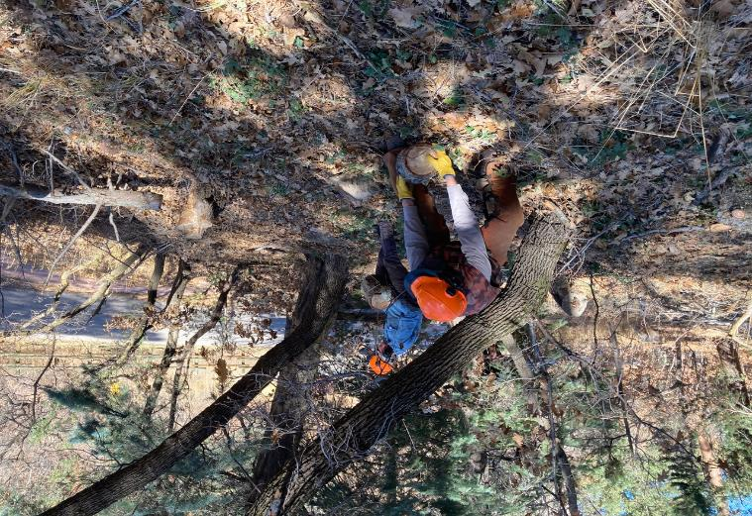

Dan and Eric are beginning to roll the pieces down to the Jerry’s pickup.

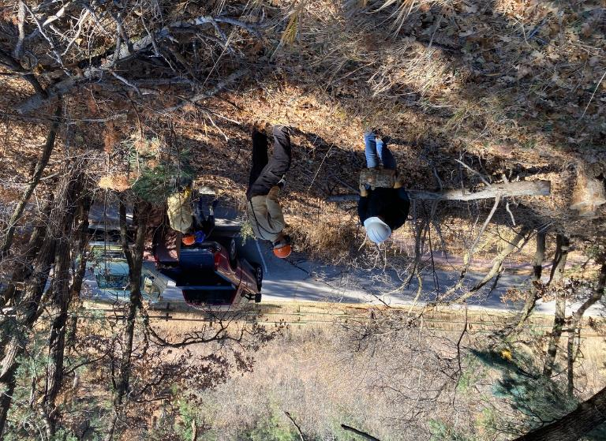

The volunteer chain is rolling rounds down to the pickup.

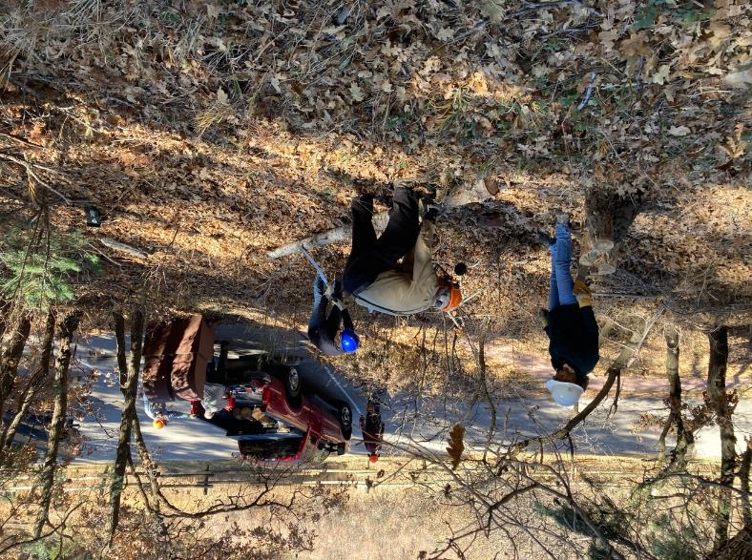

L to R: Rene, Sam, and Laura are limbing the small end of the trunk. They later

used the Katanaboy manual saw to cut the small end into 36-inch-long pieces

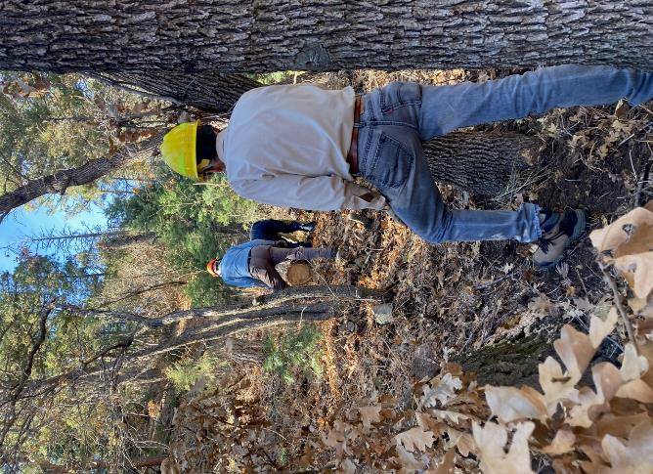

Sim is waiting for Eric to roll a round down to him.

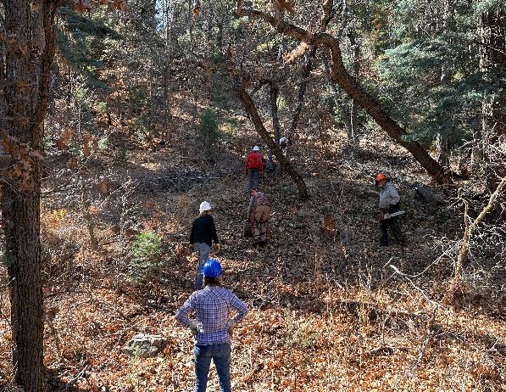

L to R: Laura, Rene, Dan, and Cliff Giles are rolling rounds down to the pickup. Jerry in the orange hard hat has finished

bucking the log and is carrying his chain saw to his pickup. Photo by Steve Roholt

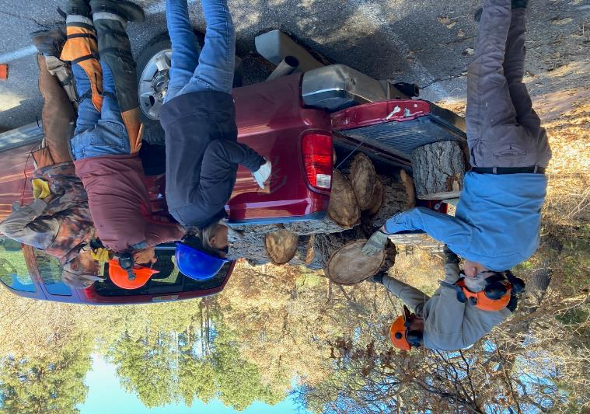

L to R: Eric, Jerry, Laura, Steve, and Dan. Eric and Jerry are completing the loading

of the pickup by placing the rounds so that they will not fall off.

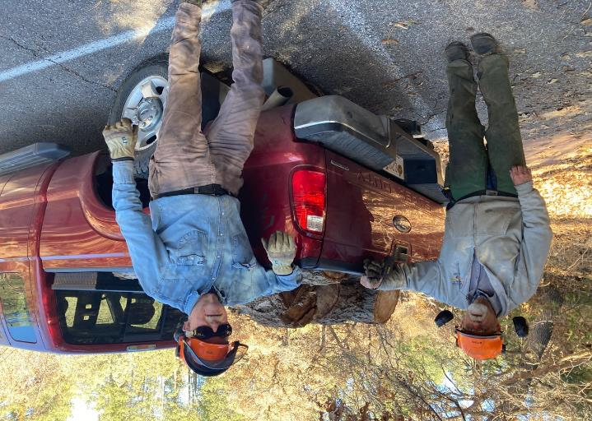

The rounds are securely loaded, and Jerry will deliver them to the church woodlot in the Hopkins’ corral. The Mountain Christian

Church Wood Ministry members will distribute the wood to families that need it to heat their homes this winter.

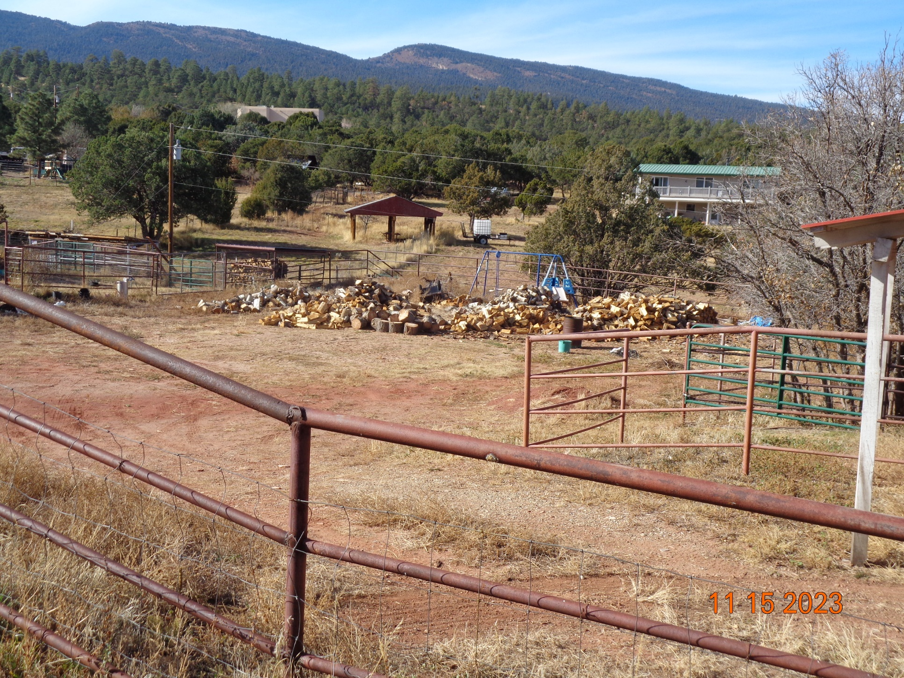

Piles of donation wood in the Hopkins’ corral located on Sandia Haven Road west of NM-14 and about one mile south of the Triangle.

The wood processed on Wednesday is the pile of rounds in the center of the photograph. Photo by Sam Beard