Trail Maintenance: Monday, November 20, 2023

Byron Garner

On November 20, the Monday trail crew hiked the Faulty/ Upper Faulty Loop trail from Canyon Estate to remove an assortment of unreported tress which included three dead and overhanging oaks at 1.5 miles. Another mile up, a 6" bifurcated pinon was cleared and at mile 2.8 we met up with the trophy tree of the day- a 16" ponderosa. With due celebration and a little saw time for almost everyone, the trail was clear. We encountered .5" of patchy and melting snow at 7000+' but what had begun as a very iffy looking cloudy day, continued to clear and warm up to give us a relaxing and sunny lunch under the ridge top ponderosas. The efforts of the day were also clearing a few intrusions and frequent oak overgrowth while enduring at times a somewhat muddy trail. The crew included Silke Bletzer, Cleve Sharp, Rav Nickolson, Dave McCreery and Jen Medina-Gray-USFS Trails Foreman. Photo and trail notes credit: Silke Bletzer

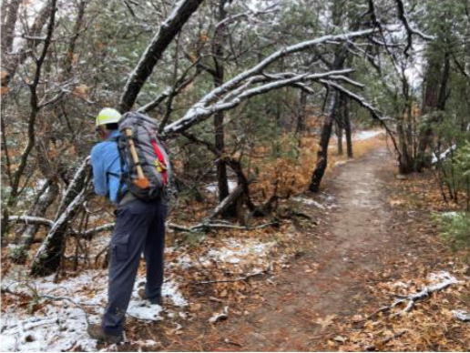

Dave clears the head knocker

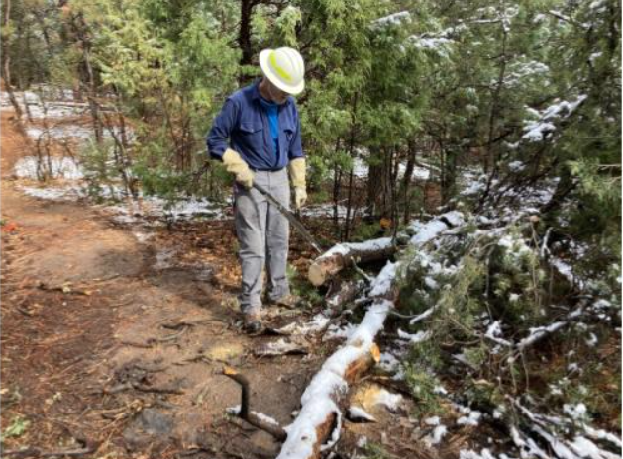

Cleve pauses for the final clearing

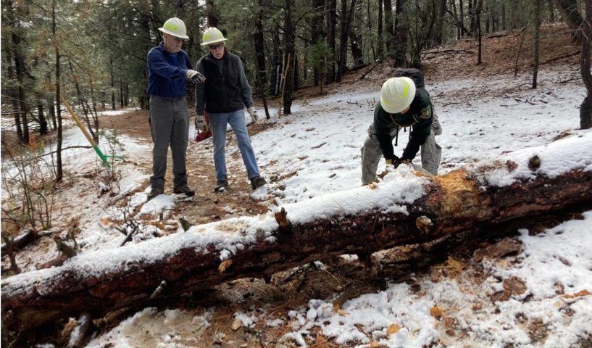

Rav begins the "honors"

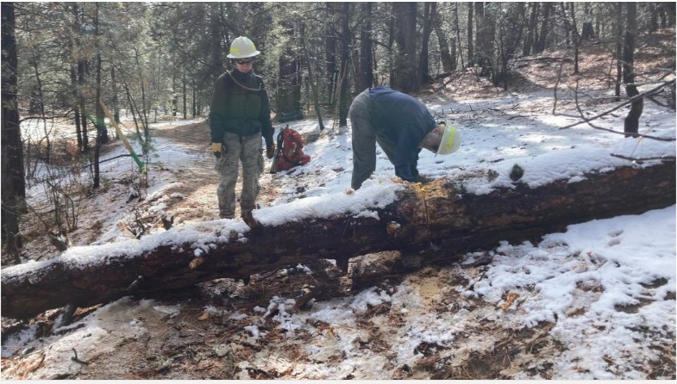

And Cleve "brings it home"