Sandia Nordic Klaus Trail Hazard Tree Removal Monday, December 4, 2023

Scott Dietrich, President of Sandia Nordic Ski Club, requested the removal of a hazard tree that was hung up over the Klaus Trail approximately ¼ mile south of the Ellis Parking Area. The top of the tree was well secured, and consequently the hazard was not so much the risk of the tree falling and injuring someone (although that was a concern), but rather that the tree would limit skiers and groomers from being able to pass under it as snow continues to accumulate throughout the winter. FOSM chain sawyer Jerry Carroll, and FOSM members Francis Algermissen and Scott Dietrich met at the Ellis Lot at 10:45 AM. Earlier that morning, Scott groomed the Service Road with Sandia Nordic’s 700 cc Yamaha Grizzly ATV and the club’s Ginzu Groomer grooming attachment. Scott dropped the Ginzu Groomer at the Ellis Lot and used the ATV to shuttle Jerry’s chainsaw and axe to the worksite. Jerry was able to fell the tree and buck it into 3 sections in less than 30 minutes. Skiers and groomers will now be able to easily pass this section of trail when snow from future storms accumulates. All photos by Scott Dietrich.

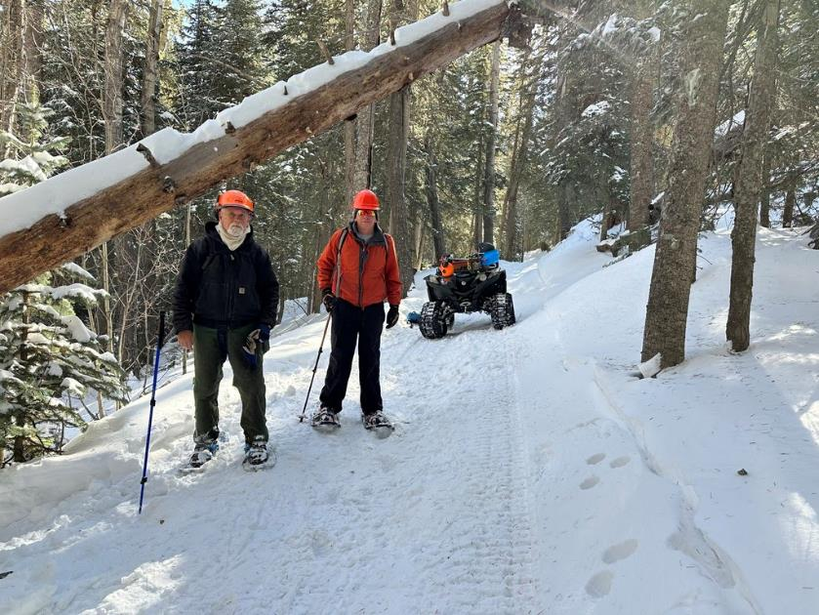

Jerry and Francis standing near the hazard tree. The Sandia Nordic 700 cc Yamaha Grizzly ATV in the background was used to shuttle the chain saw and axe to the worksite. If the tree had not been removed, it would have restricted skiers and groomers when accumulating snow raised the level of the trail.

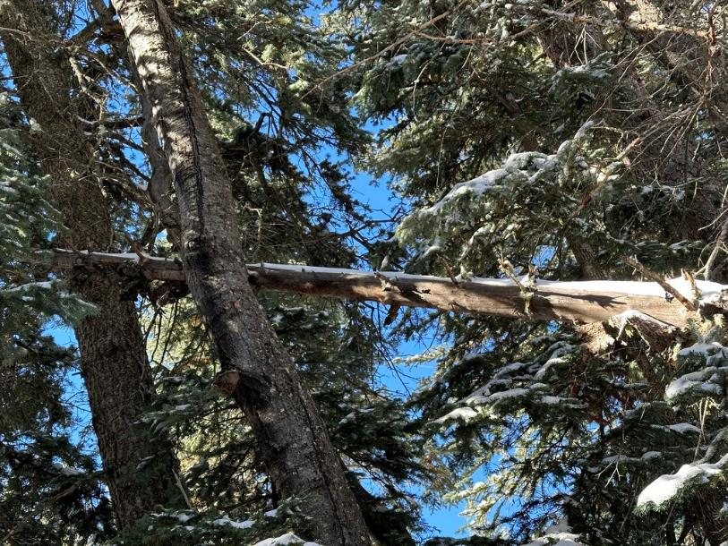

The top of the tree was well secured.

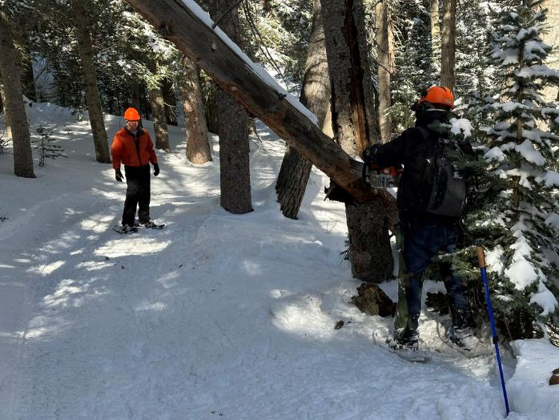

Jerry starts the first cut as Francis watches in the background

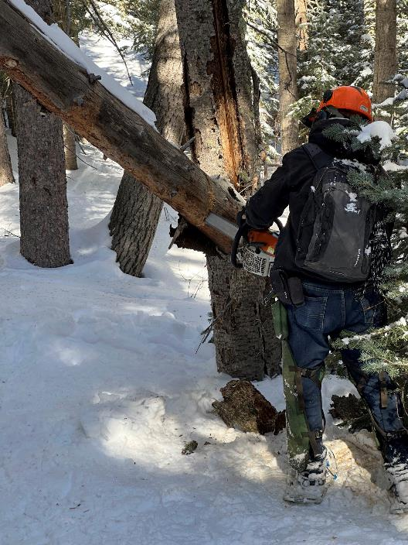

Jerry continues the first cut using the tip of the chainsaw to minimize the risk of binding.

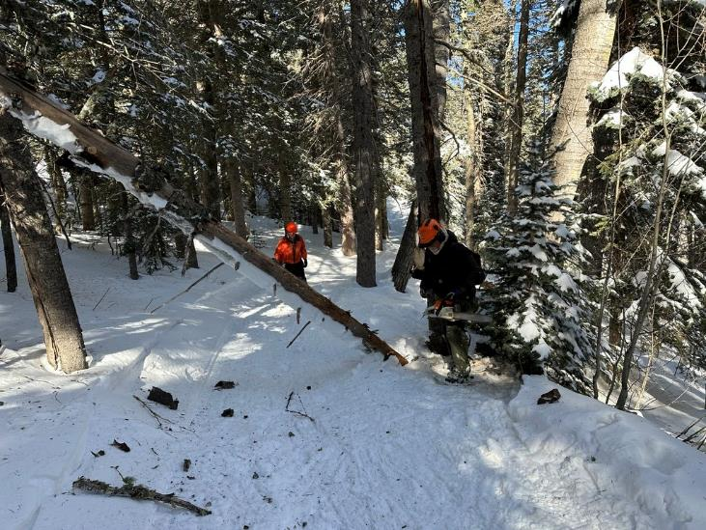

The first cut went exactly as planned, bringing the tree down to trail level. Wedges were not needed due to Jerry’s technique.

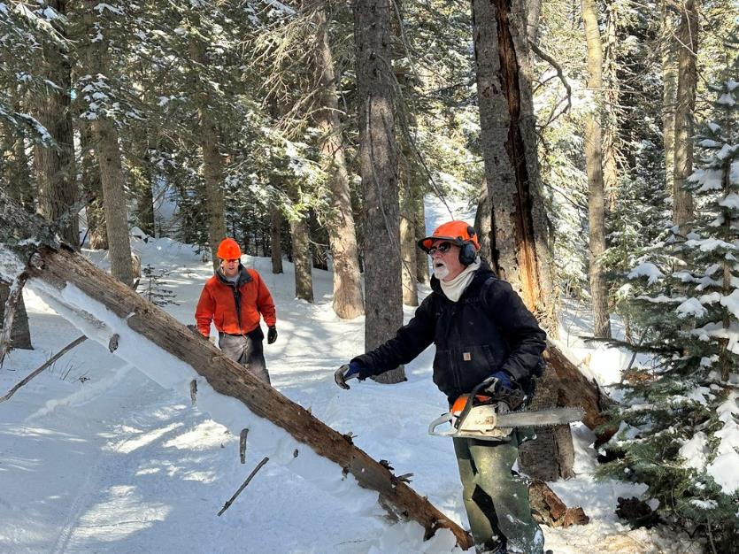

Jerry plans his next cut.

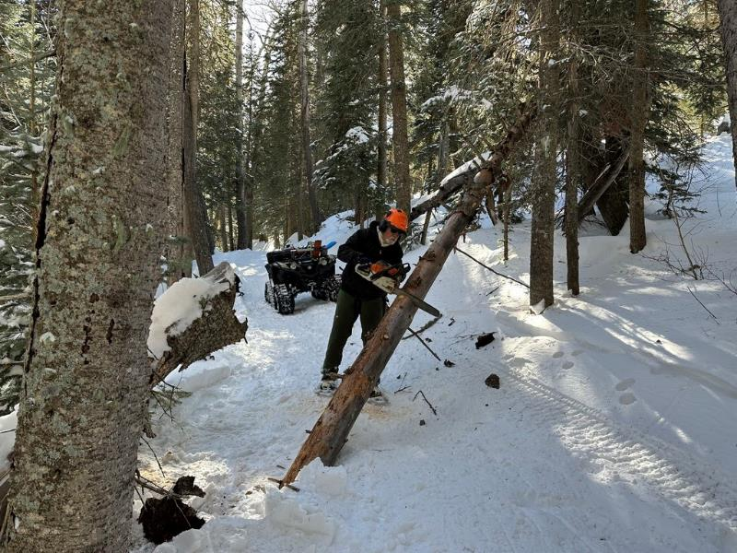

Jerry begins the second cut.

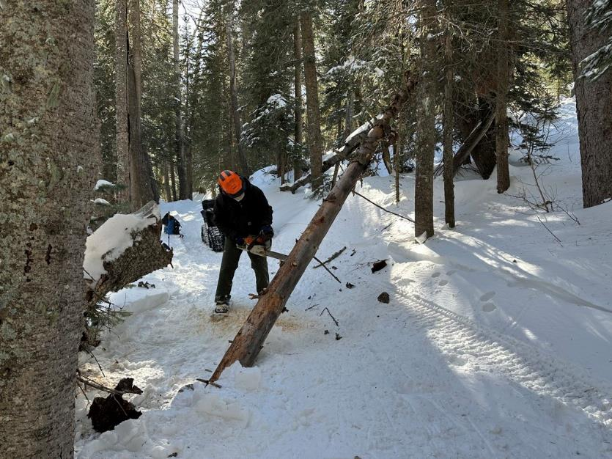

The second cut continues using the tip of the saw.

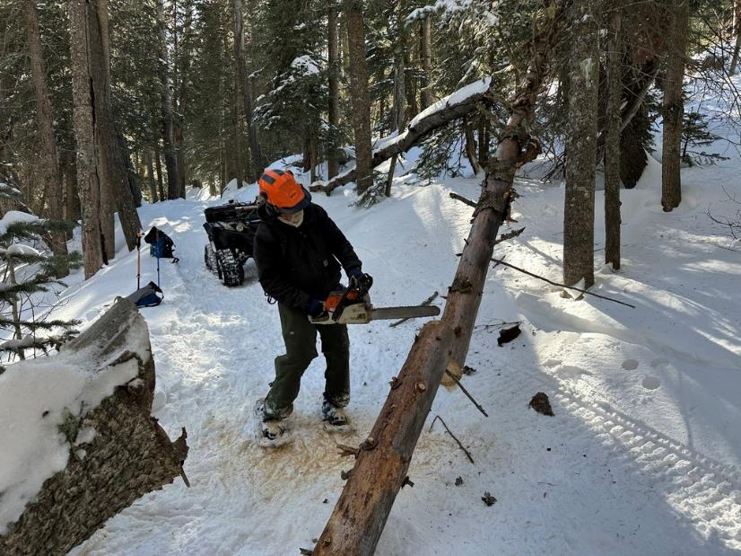

The second cut was completed, again, without the need for wedges.

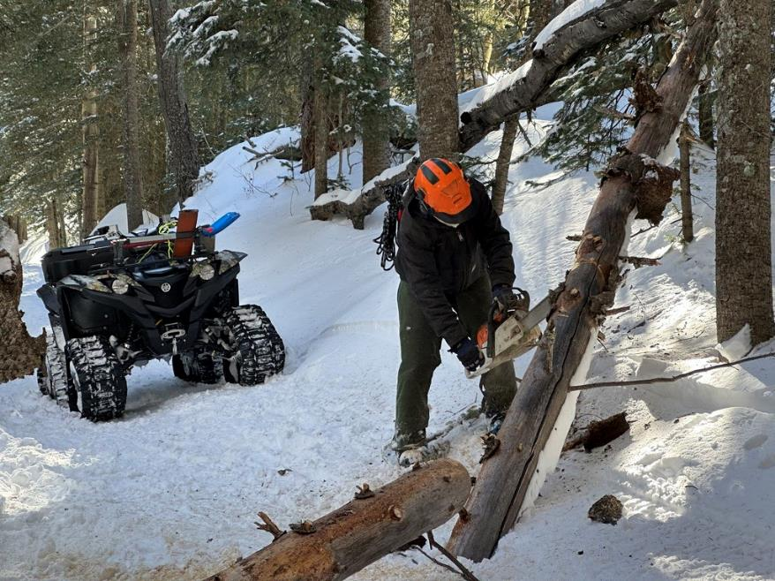

Jerry finesses the final cut able to avoid the use of wedges once again. After this cut, all sections of the tree were removed from the trail, and the stump left behind after the first cut was trimmed.

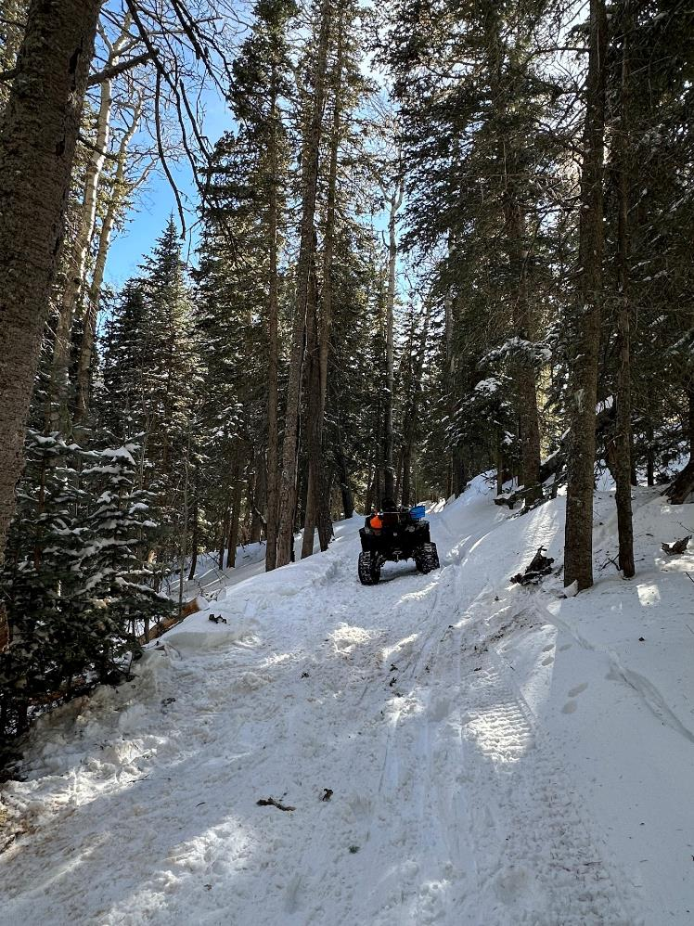

After clearing the tree, Jerry and Francis hiked back to the Ellis Lot and Scott shuttled the tools to them using the ATV.