**Two Bucks Made with 4-inch** **Diameter Poles Were Fabricated at the FOSM Guard Station**

**as Part of the Initial Planning to Construct a Buck and Pole Fence around the Part**

**of Kiwanis Meadow where the Road Enters the Meadow Next Spring**, **Monday, December 4, 2023**

Joelle Hertel and Sam Beard

On Monday, December 4, Joelle Hertel and Sam Beard fabricated two prototype bucks similar to those that will be used in the construction of a buck and pole fence around the part of Kiwanis Meadow where the road enters the meadow. They had studied the many designs of this type of fence available on the Web, and fabricated the two bucks in the photos below in an initial attempt to select a design using 8-foot-long 4-inch diameter poles available locally. Joelle contacted Western Wood Products in Raton, NM, and learned that we can obtain 10-foot-long 4-inch diameter pressure treated poles from them for use between the bucks. These 10-foot-long poles are also needed to replace broken poles in the fences in Doc Long, Sulphur, and Cienega Picnic Areas. We will eventually order poles for the Kiwanis Meadow project and also enough for replacements for several years. Ten-foot long 4-inch diameter poles are not available locally.

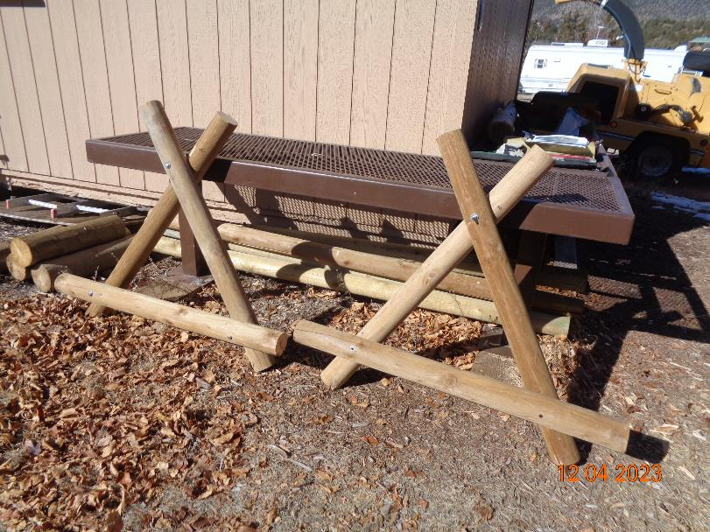

Bucks similar to these will be used to construct a buck and pole fence along the side of Kiwanis Meadow where the road enters the meadow.

Photo by Sam Beard