On Thursday December 28, five FOSM volunteers and SRD Trails Foreman Jen Medina-Gray hiked about 2 miles along Lower Pine to the southern reroute area near Gear Grinder Trail. We worked back northward clearing prickly pear and scrub oak, digging out stumps and trimming branches. It was a cold start but warmed nicely and we may try starting a bit later on our next workday so that the soil and air temp has time to warm before we work. Jen thinks we may be able to do some rough tread work if the weather continues as it has with steady temps and not much new snow. It was a muddy hike back out at the end of the day.

Volunteers today were: Byron Garner, Jim Houle, Andrew Leon, Laura Leon and Roland Stumpf. Photos by Laura Leon

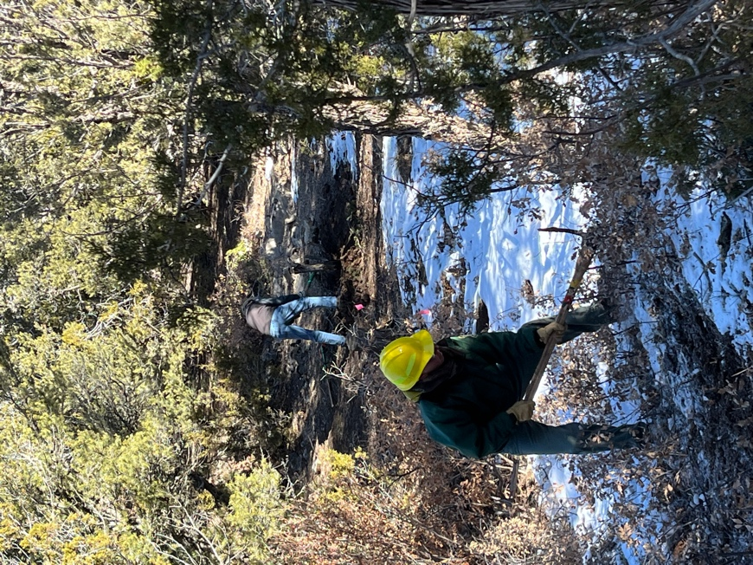 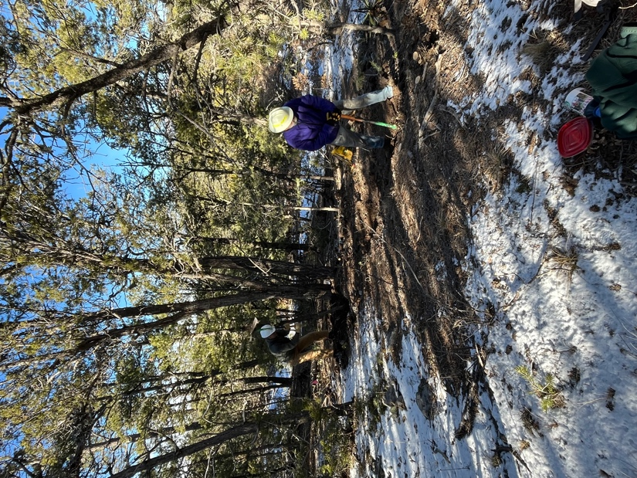

Jen and Byron digging deep. Roland and Jim working tread.

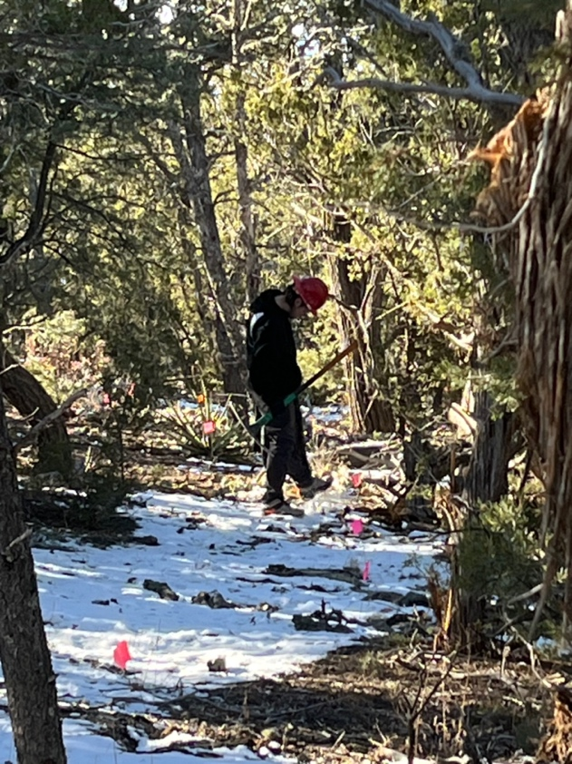 Andrew thinks deep thoughts.