On Thursday, January 18, seven FOSM volunteers worked with Canyon and Dorothy (both just started this week) from the SRD on the Lower Pine Trail. We had planned to hike to the southern end of the reroute and work our way back cutting brush, digging stumps and working the tread if possible. Due to the muddy conditions we worked a section of the reroute in the middle distance of the trail, about a mile from the parking area. We worked until noon and then decided to hike out before the trail and parking area got too muddy to handle. It was a really nice, warm day but there is still quite a bit of snow especially on the southern end near gear grinder.

The volunteers were Dan Benton, Claudia Bergsohn, John Braly, Byron Garner, Susan Gregory, Bruce Hansche and Laura Leon.

Photos by Laura Leon and Dan Benton

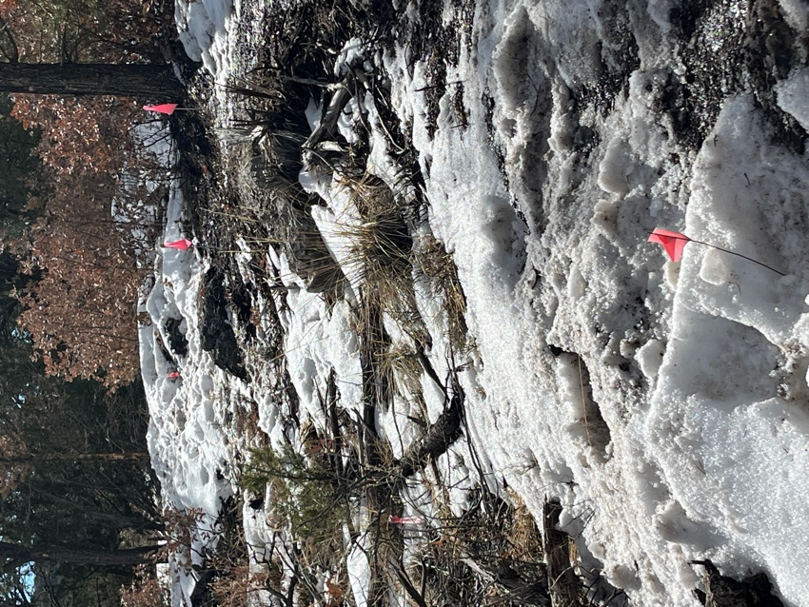 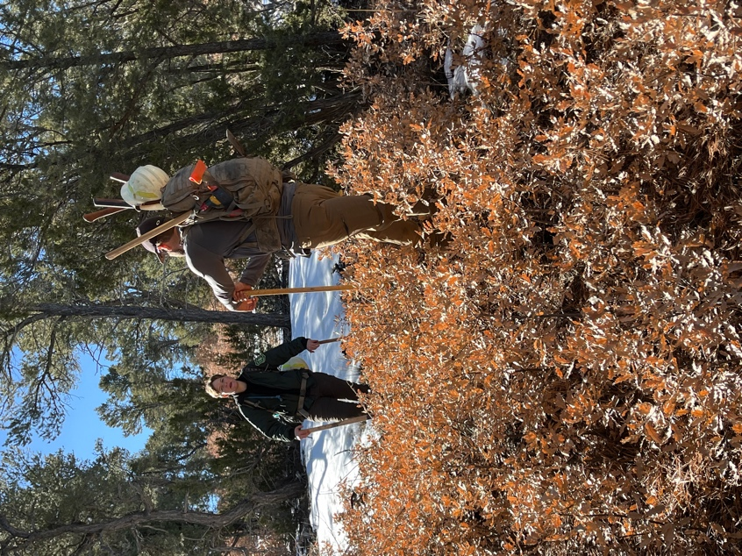

Snowy and muddy conditions. Dorothy and Canyon discuss strategy.

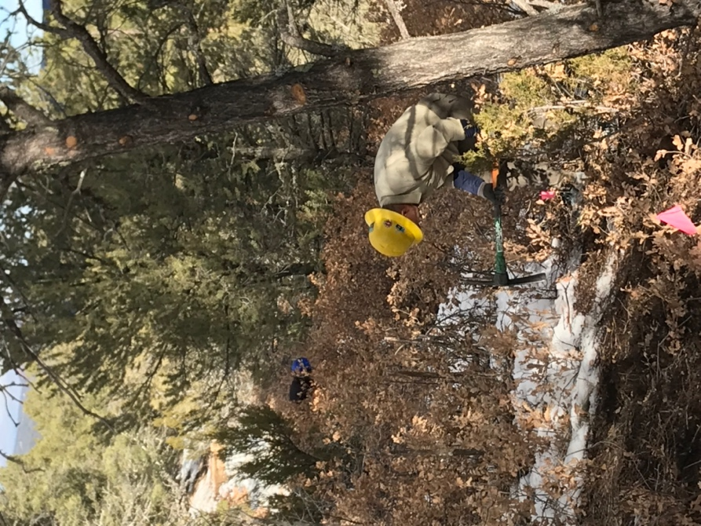 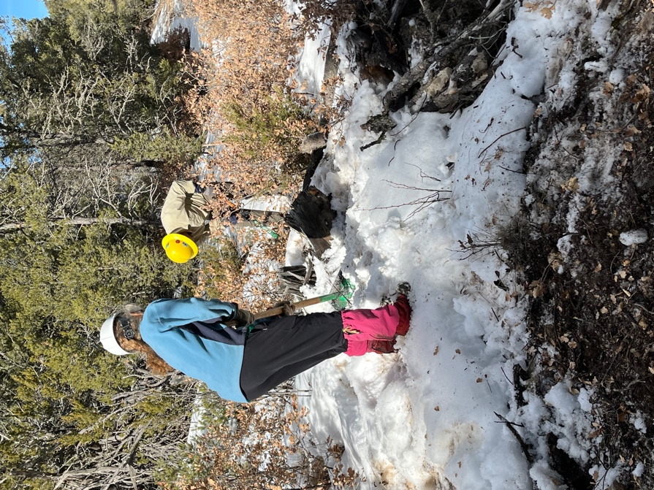

Laura and John clearing brush. Claudia and John hard at work.

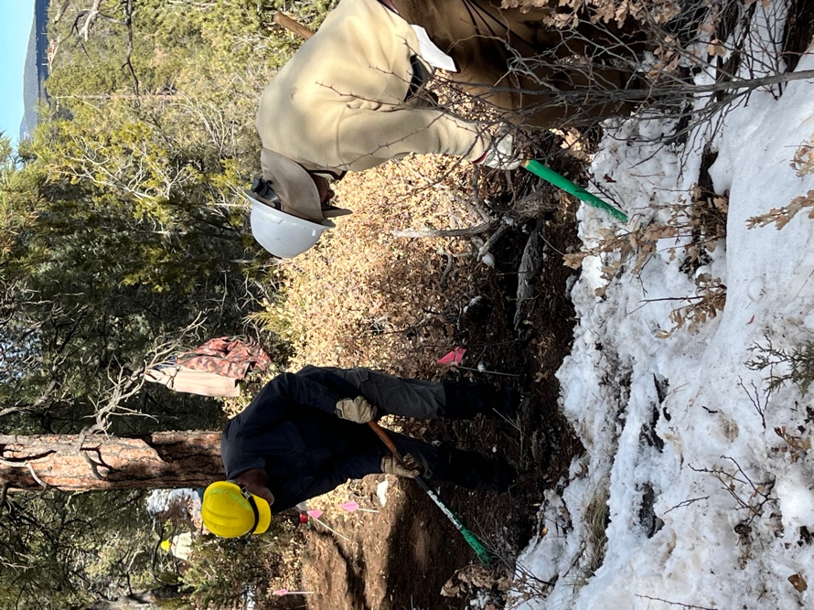 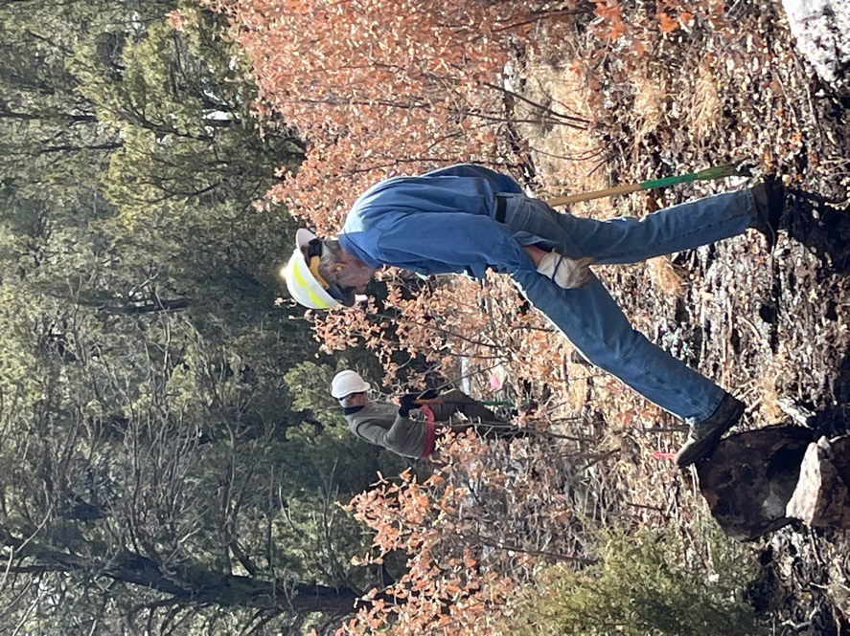

Bruce and Dan clear snow and work tread. Susan and Byron clearing stumps.