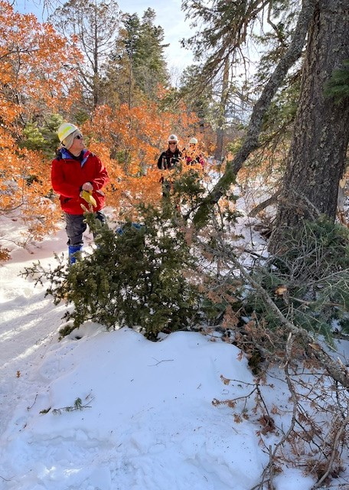
David checks out a fallen branch that was intruding into Capulin Peak trail.
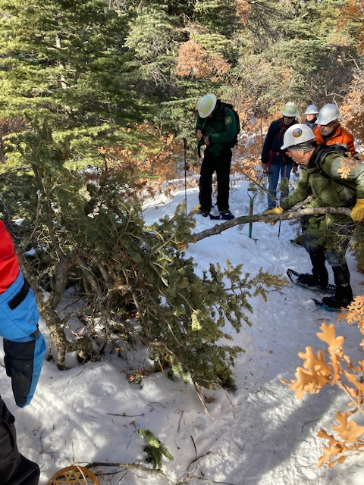
John is removing part of the fallen branch shown in the previous photo.

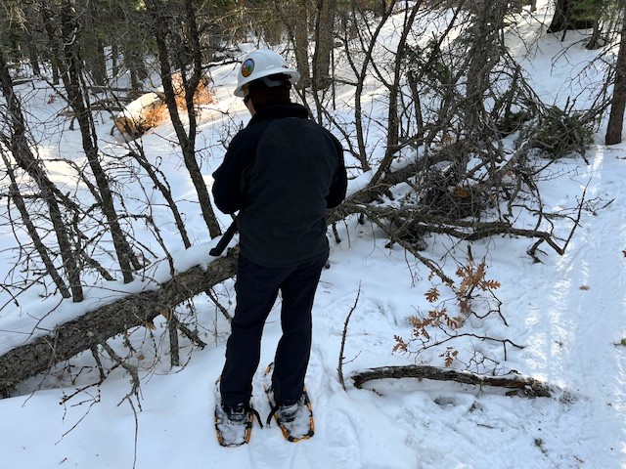
Jamey surveys the first fallen tree, a dead fir. It is about 12 inches in diameter.
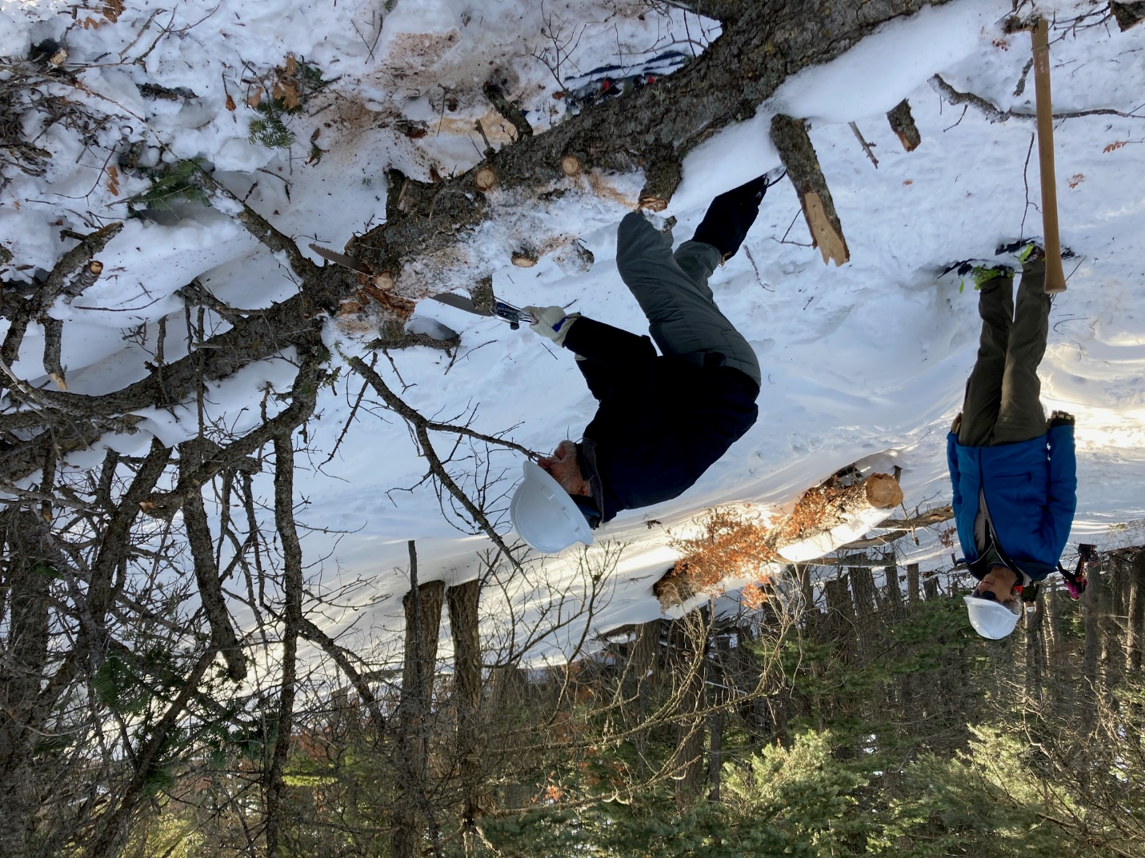
Bill works on the first of two cuts needed to remove the fallen tree. (Photo looking north)
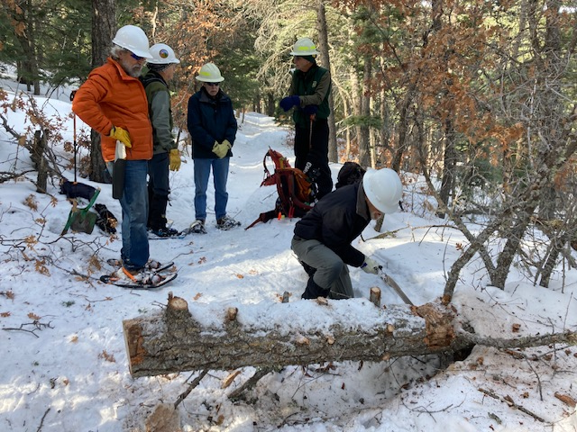
Bill working on the second of two cuts. No, Bill did not do all the sawing! Everyone had their turn. These two photos were just good illustrations. (Photo looking north.)

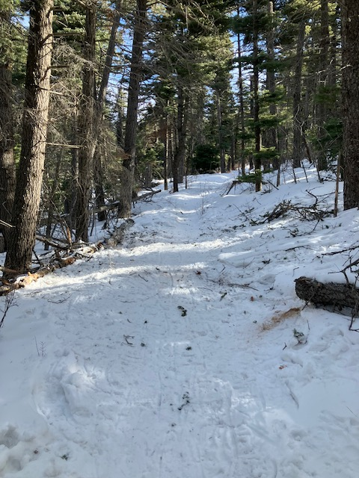
This is the “after photo” of the second fallen tree which was removed by
the crew. It was about 10 inches in diameter and was located about 100
feet north of the first tree.

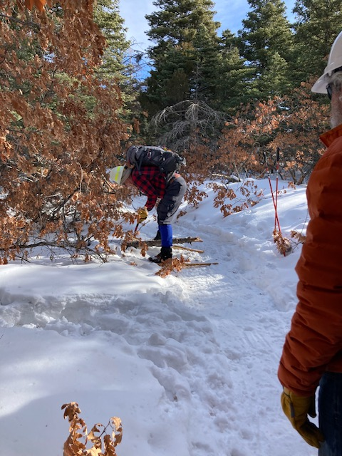
Some fallen trees (or parts thereof) don’t present as much of a challenge
to remove as do other fallen trees.
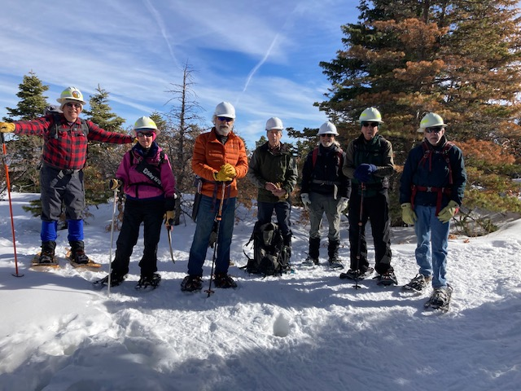
Monday’s crew (From left to right) – David McCreery, Rav Nicholson, Ken Wilson, John Cooper,
Bill Perkins, Bob Lowder and Byron Garner. (Not pictured – Susan Gregory, Jamey Browning)

