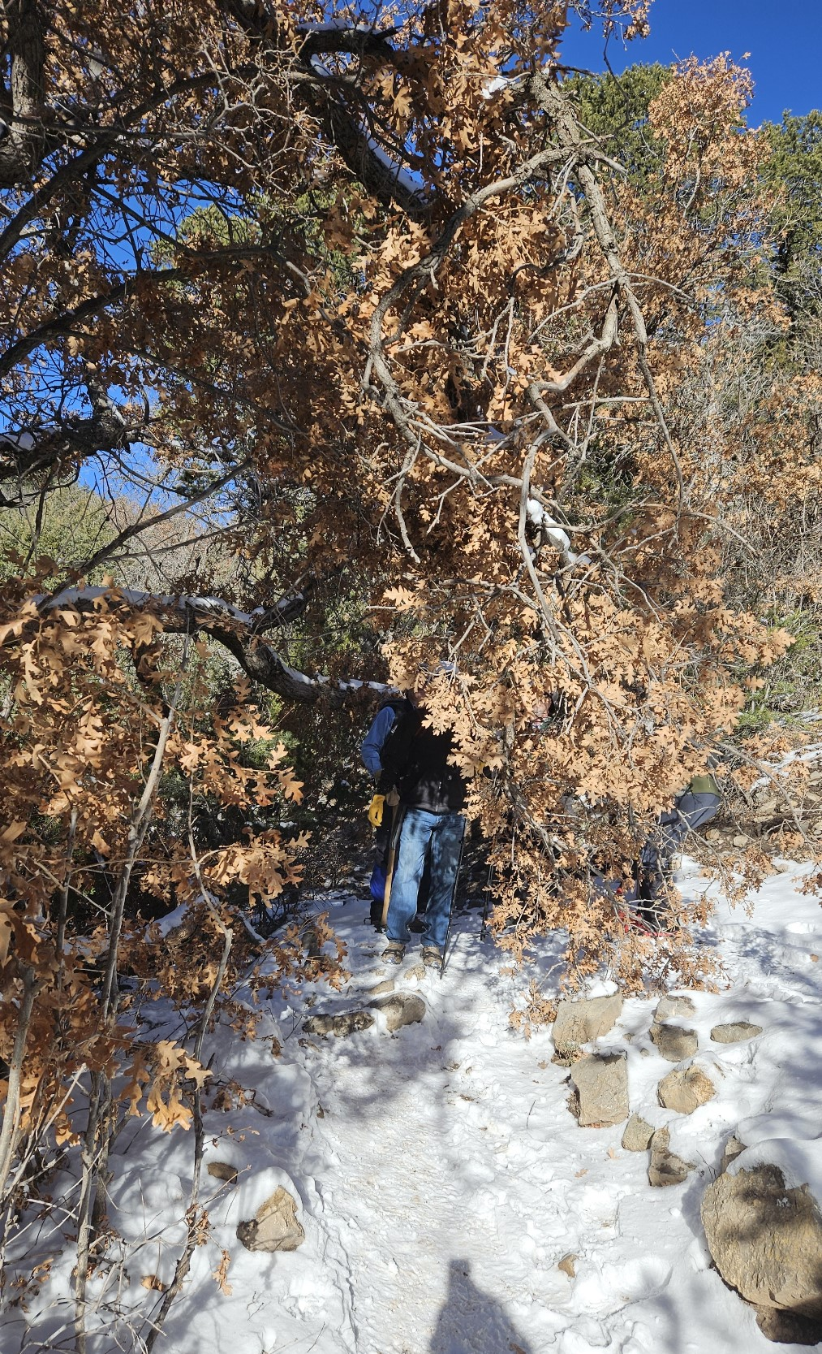
This 3-inch diameter broken Oak branch was
hanging down into headspace on Crest Trail
130 South near the junction to Travertine Falls.
It was removed.

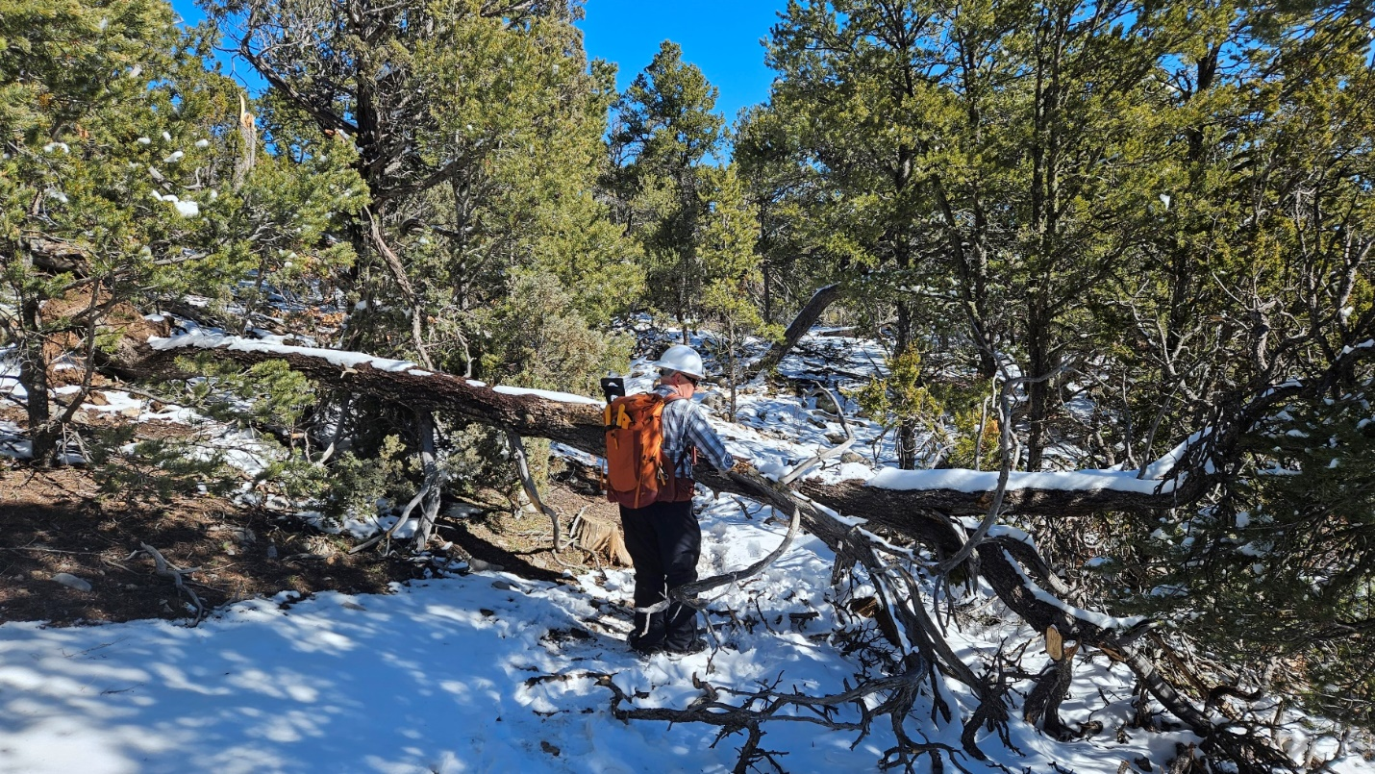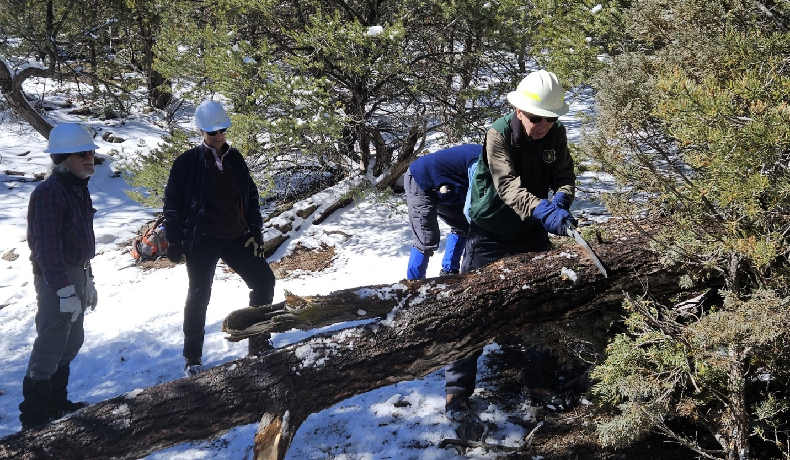
Top photo shows the first of two trees fallen over Crest Trail 130 South about ¾ mile above the Lower Faulty Junction. Lower photo shows start of the final cut on that tree after top branches had been removed. The tree was about 11-inches in diameter.
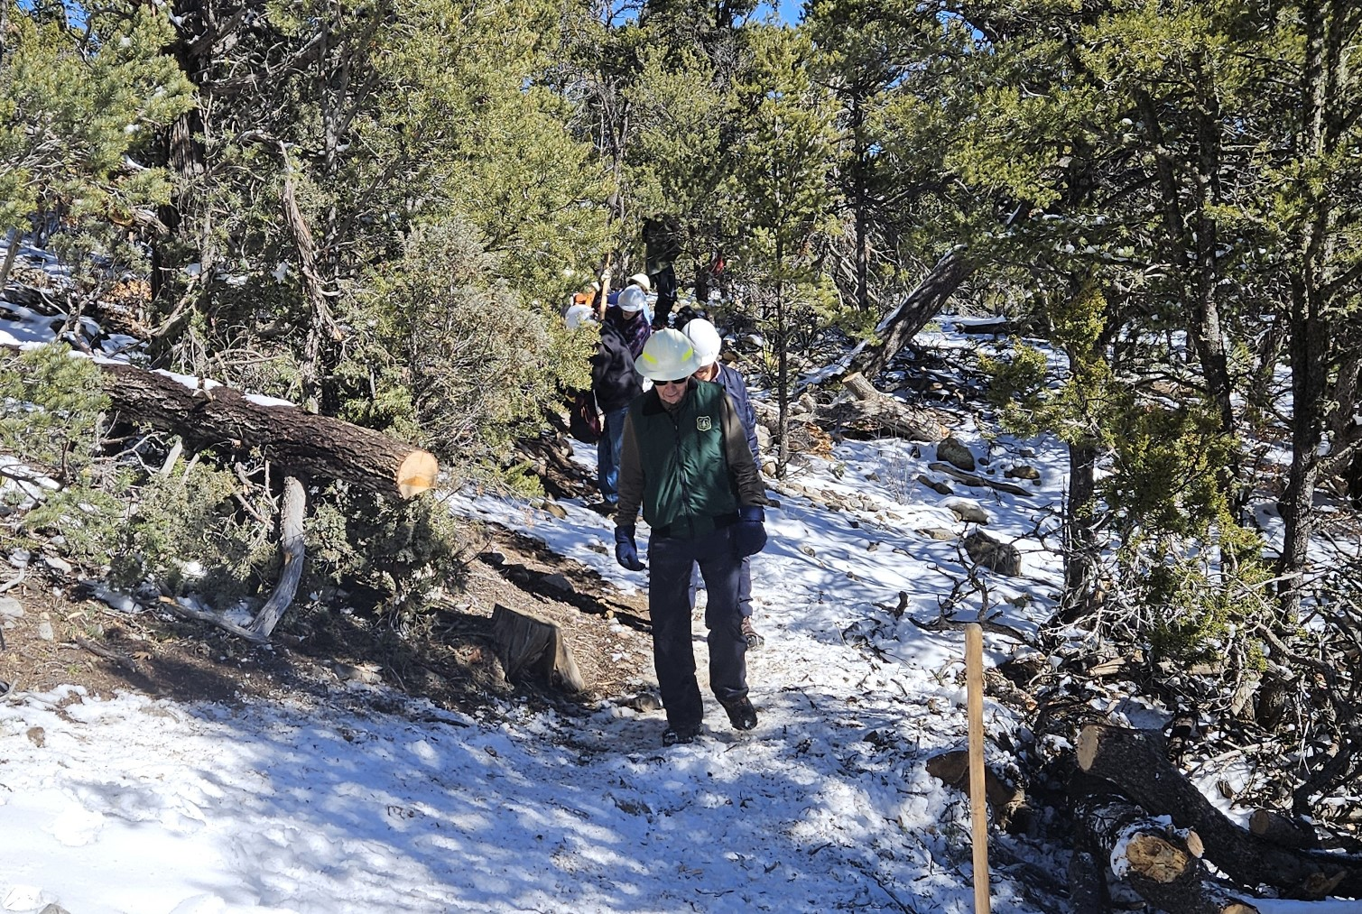
The first tree has been removed and the trail is now clear at that point.

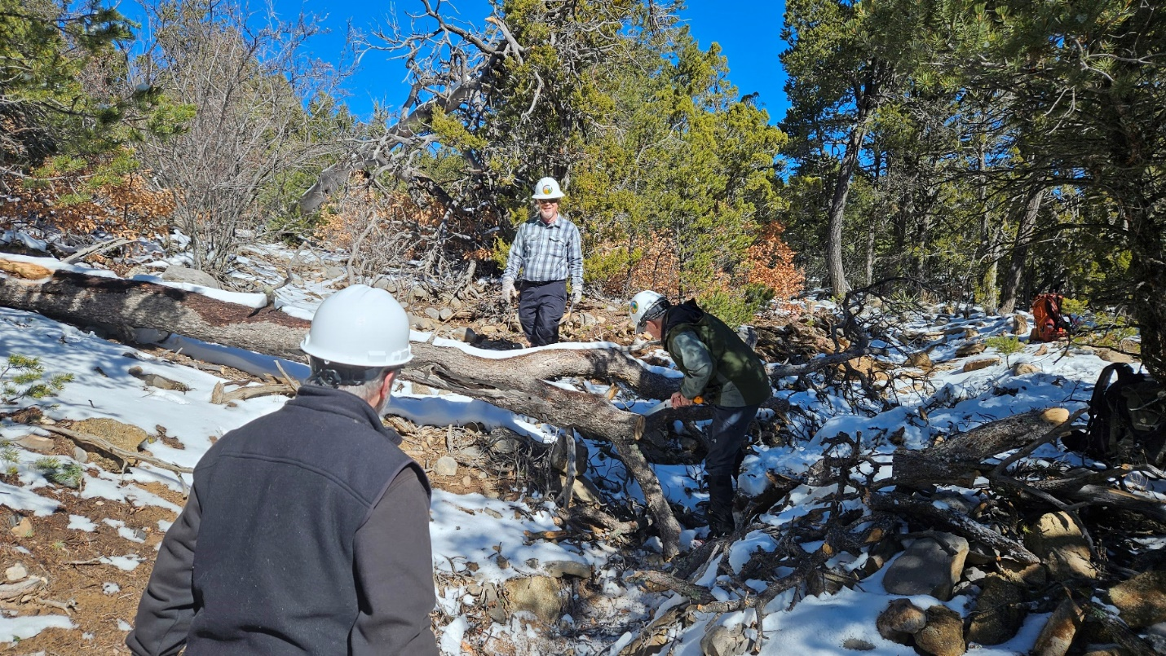
The crew working to remove the top branches from the second fallen tree that had been blocking Crest Trail 130 South.

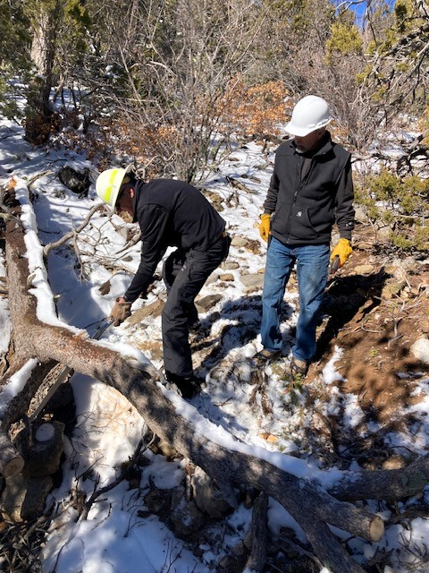
More work on the second tree.

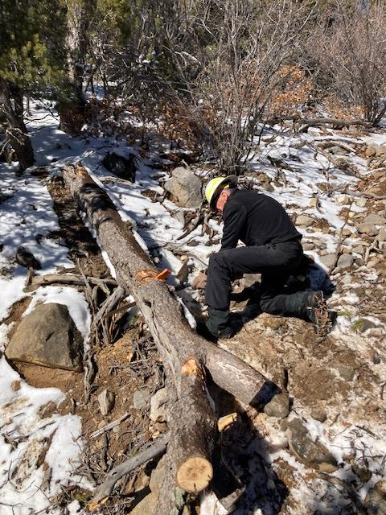
Getting close. Cutting just about done on the second
tree.

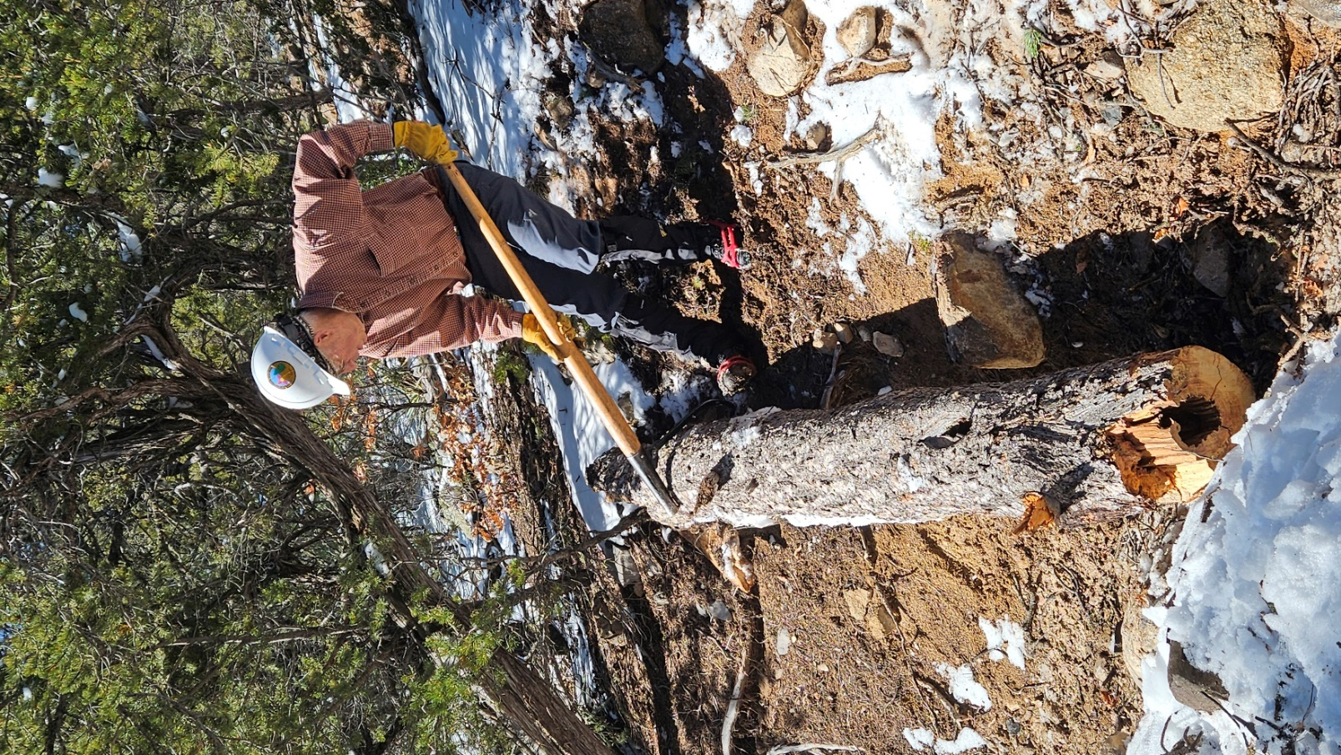
The lower end of the second tree is being
moved off of the uphill side of the trail
to the downhill side so that it cannot roll
back down into the trail tread.

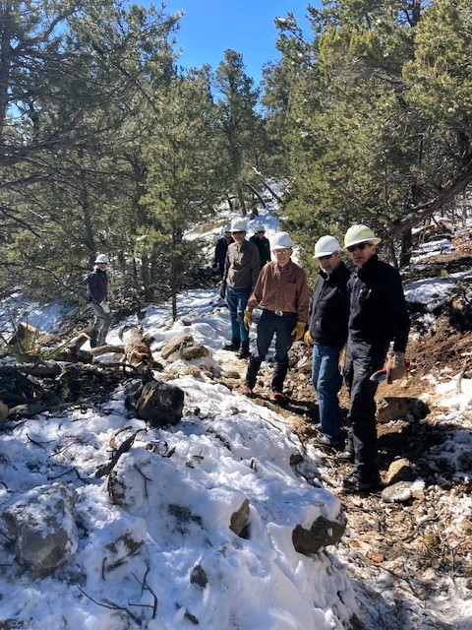
The second fallen tree has been removed and the trail
is clear.

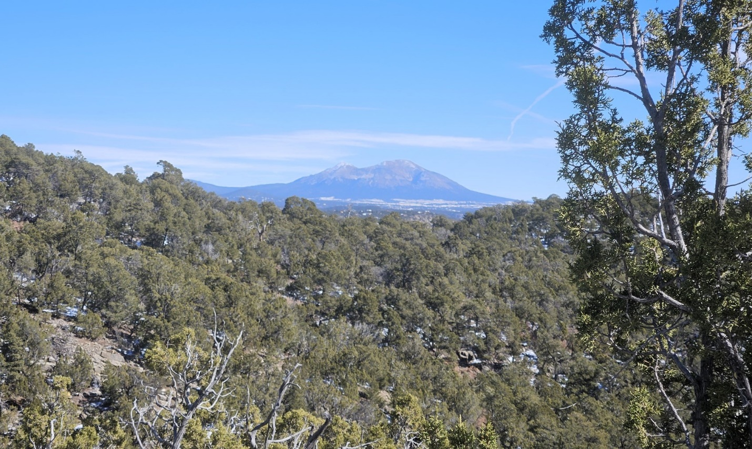
A view of South Mountain taken from Crest Trail 130 after our work was done.

