**Report of Bucking Logs on Wednesday, Feb. 21, in Cienega Picnic Area That Were Felled**

**during the Chain Saw Recertifications on Thursday, Feb. 8**

Sam Beard

On Wednesday, February 21, 2024, seven FOSM volunteers bucked three trees felled during the chain saw recertifications on February 8 in Cienega Picnic Area. The following logs were bucked in two areas: 1. Near the loop sidewalk at the upper parking lot – 8-inch Rocky Mountain juniper and 16-inch green white fir; 2. In group area – 23-inch-diameter tall cigar butt green ponderosa pine. This tree was bucked into 26 rounds with each round having a length of 1 foot. The volume of wood in this one large tree was approximately one-half cord.

All of the rounds were left at the two sites. The plan is to continue bucking other felled trees next Wednesday and split and haul this donation wood before the picnic area gates are opened this spring.

The volunteers working today were Don Carnicom, Cliff Giles, Byron Garner, Eric Russell, Sim Cook, Lou Romero, and Sam Beard.

Project photographs are presented below.

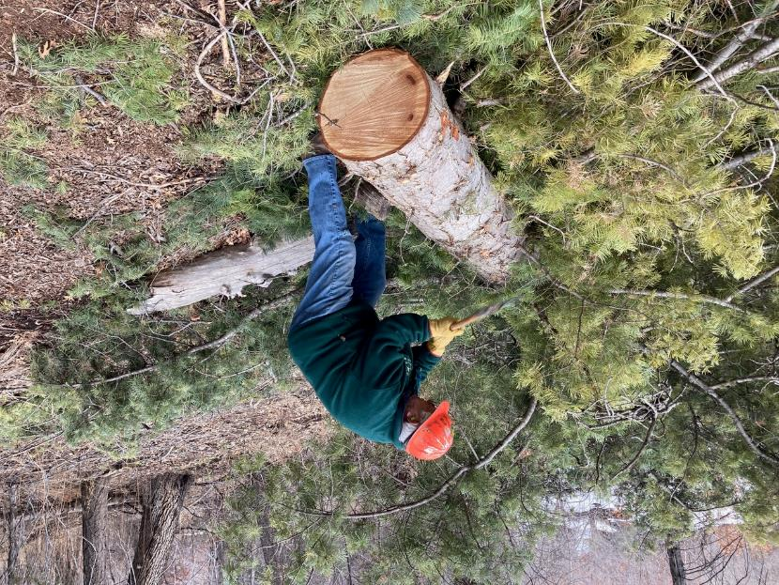

Lou Romero limbing a large white fir with his axe at the upper end of the Cienega Picnic Area loop sidewalk.

All photos by Cliff Giles unless stated otherwise

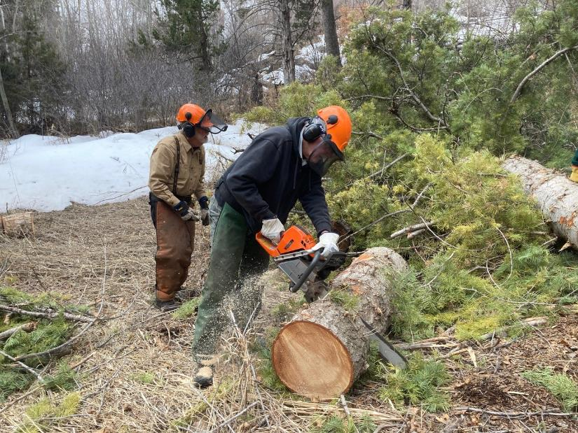

Eric Russell bucking the trunk of the white fir.

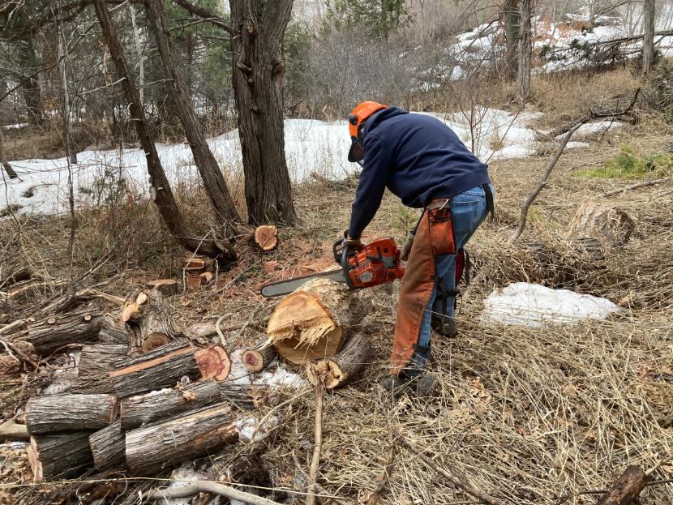

Byron Garner bucking a piece of the white fir that rolled down the hill to where he was bucking a small Rocky Mountain juniper.

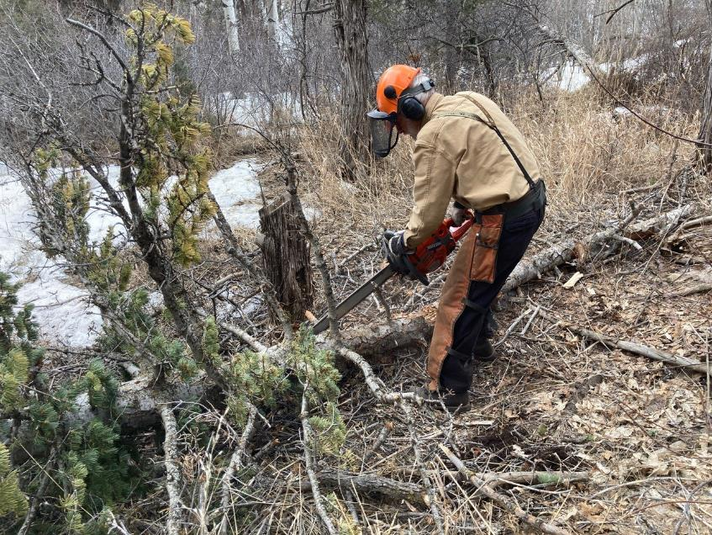

Sam Beard limbing the top of the white fir.

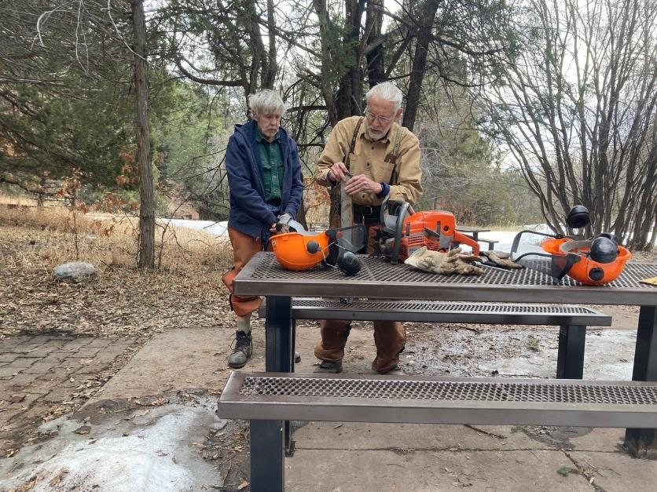

Byron and Sam putting a sharp chain on one of the Husqvarna chain saws.

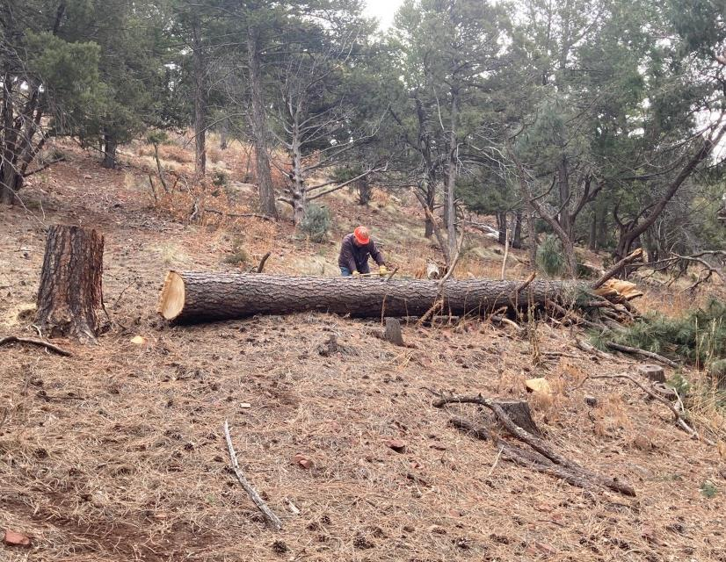

Lou Romero using his axe the mark where the log will be bucked to one-foot lengths at the Cienega PA group area.

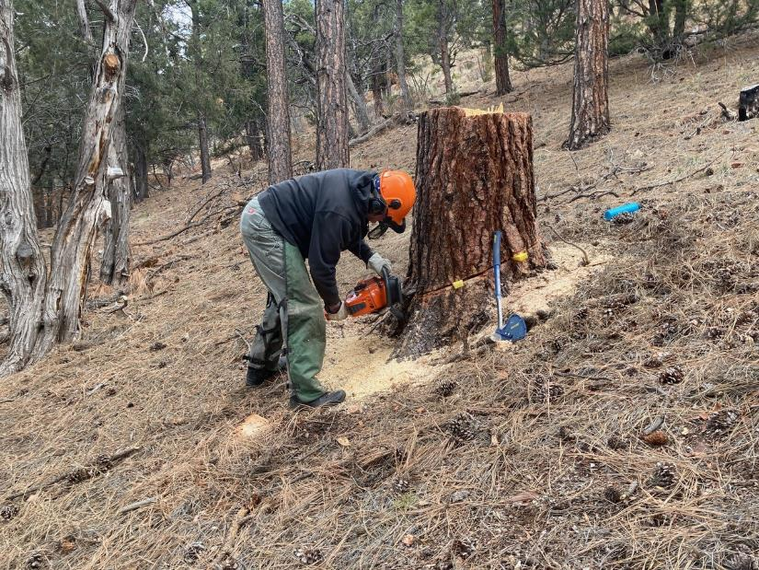

Eric Russell cutting the stump of the 23-inch pine lower. Three rounds of wood will be cut from this stump, and the appearance

of the forest is better with the stump cut lower.

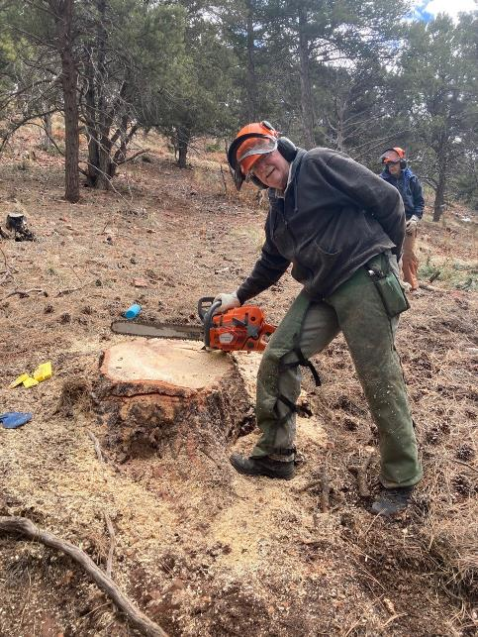

Eric at the low-cut stump.

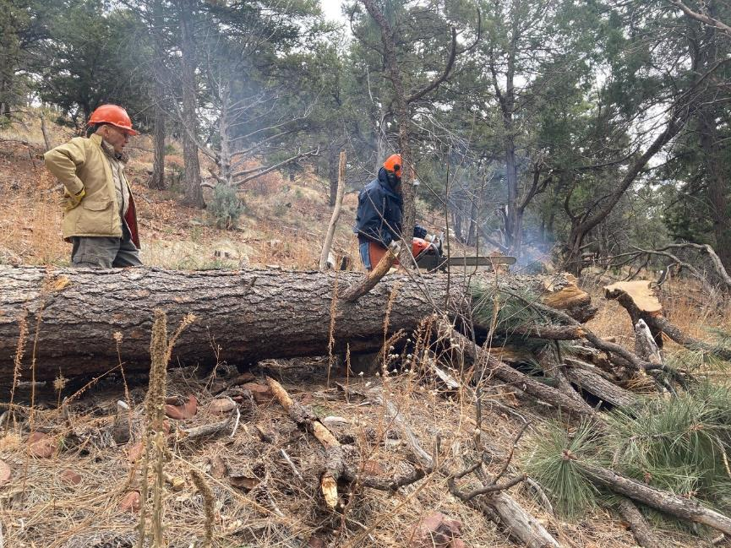

Don Carnicom observing Byron Garner cutting limbs on the large pine trunk.

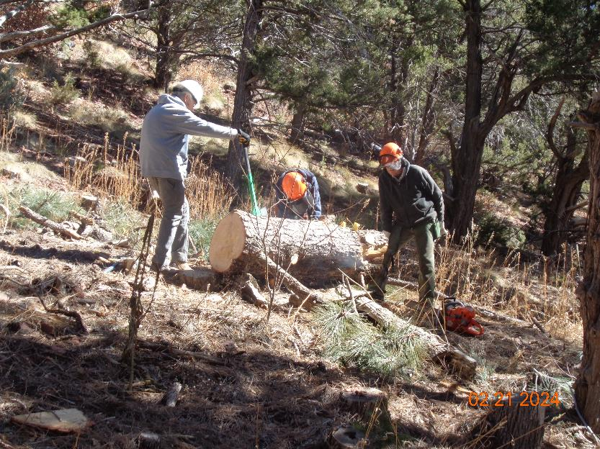

Bucking the upper end of the large pine trunk. L to R: Cliff Giles, Byron Garner, and Eric Russell. Photo by Sam Beard

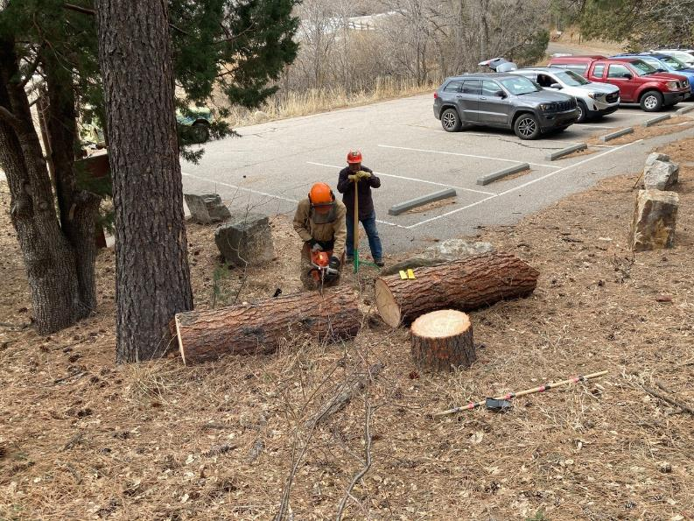

The lower part of the pine trunk was rolled down to the parking lot, and Sam is bucking it into one-foot lengths.

Lou is holding a cant hook that is used to roll large logs.

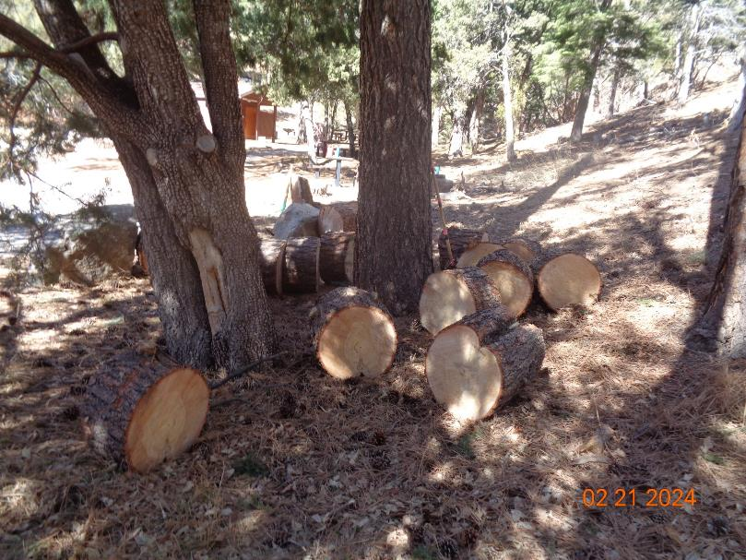

The trunk of the large pine was bucked into 26 rounds that will be split later and hauled to a woodlot where Mountain Christian Church

Wood Ministry volunteers will distribute it to East Mountain families who heat their homes with fire wood. Photo by Sam Beard