**Report of** **FOSM Project to Buck Trees in Lower Cienega Picnic Area Felled during the Recent Chain Saw Recertification Outing**

**with Kerry Wood, Wednesday, February 28**

Sam Beard

On Wednesday, February 28, seven FOSM volunteers bucked several trees in lower Cienega Picnic Area that had been felled during the recent chain saw recertification outing with Kerry Wood. The felled trees were located near the picnic tables across the road from the lowest restroom. The largest log was approximately 20 inches in diameter, and 30 rounds were obtained from it. A total of approximately 60 rounds were produced by this project. They will be split with Lou Romero’s power splitter and hauled to a woodlot. The Mountain Christian Church Wood Ministry volunteers will distribute the wood to families in the East Mountains who need it to warm their home in the winter.

The volunteers were Dan Benton, Cliff Giles, Jamey Browning, Eric Russell, Byron Garner, Don Carnicom, and Sam Beard.

Project photographs are presented below.

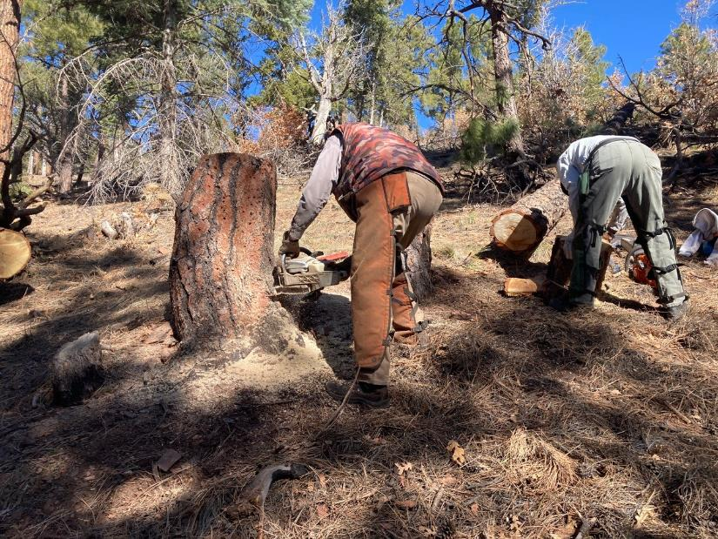

Dan Benton low stumping so that the area will be more attractive, and Eric Russell moving a round so that it will not roll down the hill.

All photos by Cliff Giles

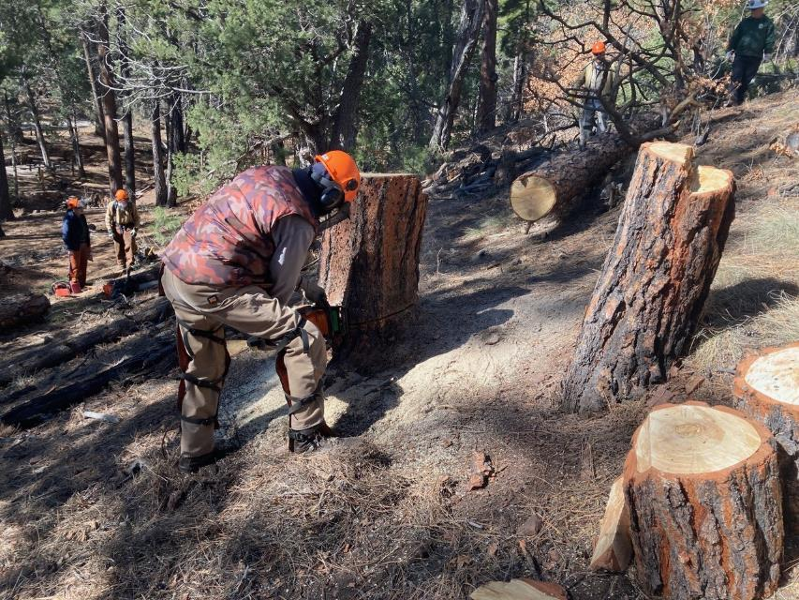

Dan low cutting another stump where a tree was felled recently.

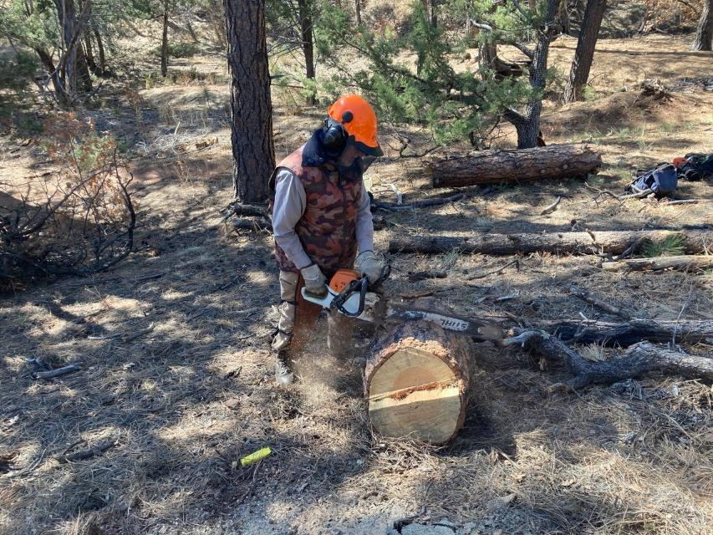

Dan bucking the lower part of a felled tree.

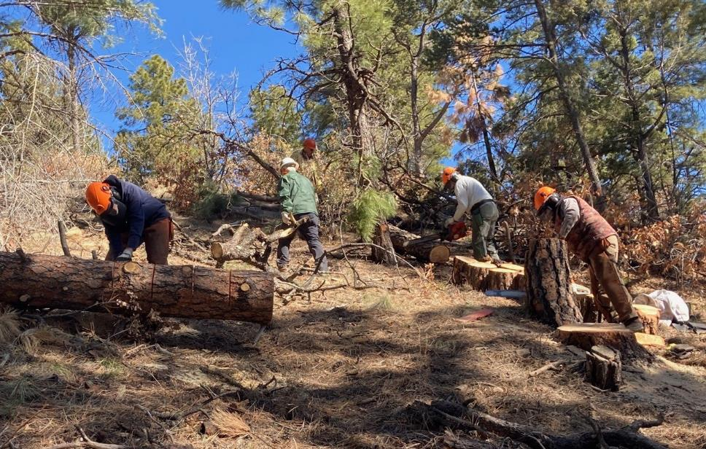

L to R: Byron Garner, Jamey Browning, Eric Russell, and Dan Benton working on the Wednesday project.

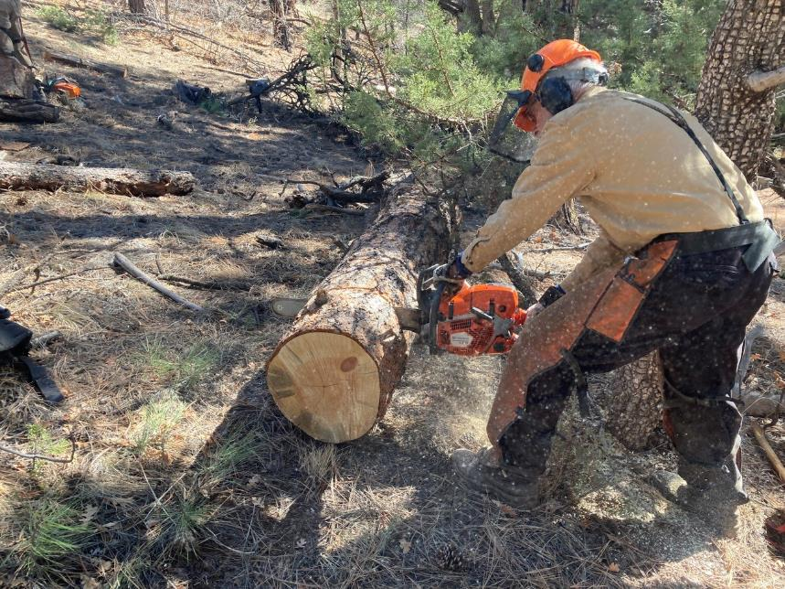

Sam Beard bucking one of the larger logs.

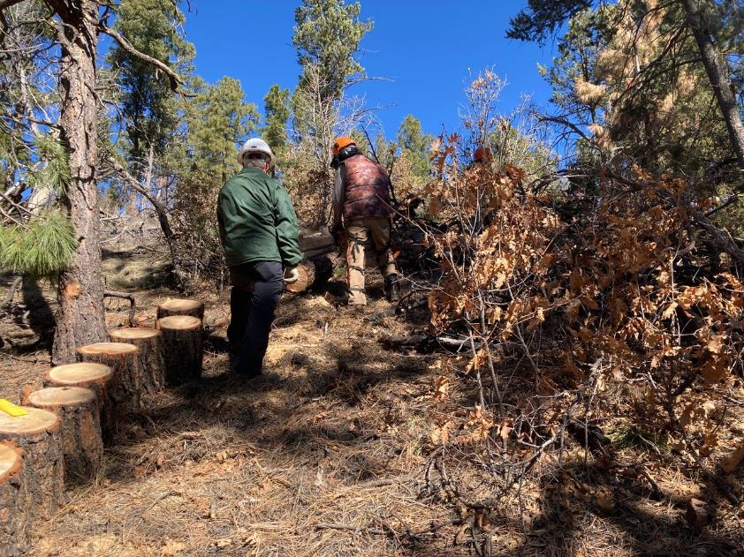

Jamey Browning observing Dan bucking one of the logs. Jamey will set the round on end so that it will not roll down the hill.

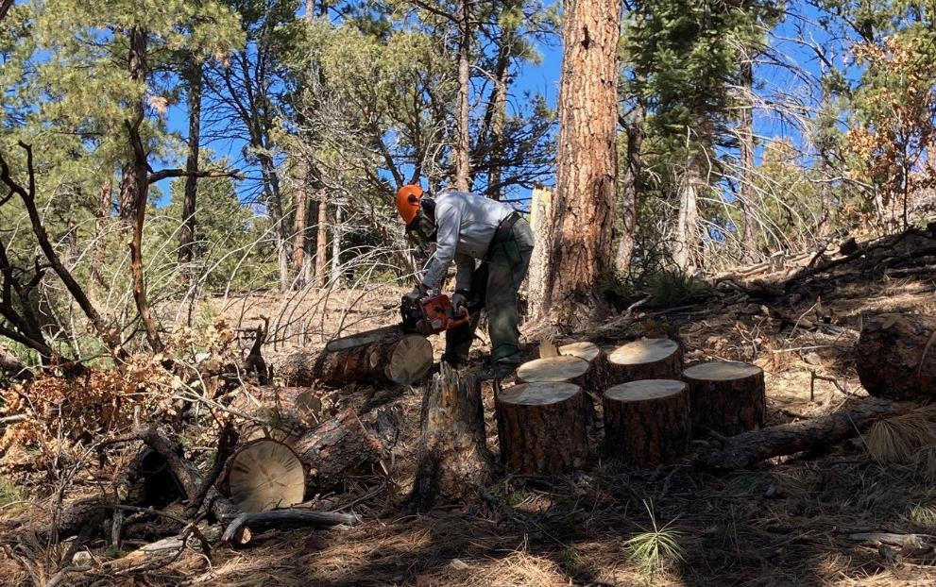

Eric Russell has cut several rounds from this log.

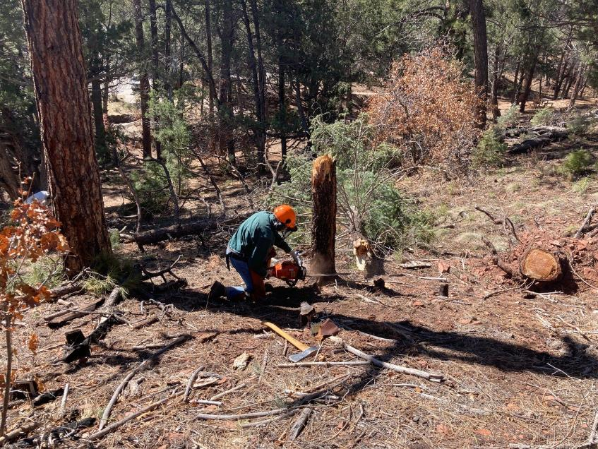

Byron Garner felling a short cigar butt tree formed when the upper part of the tree broke.

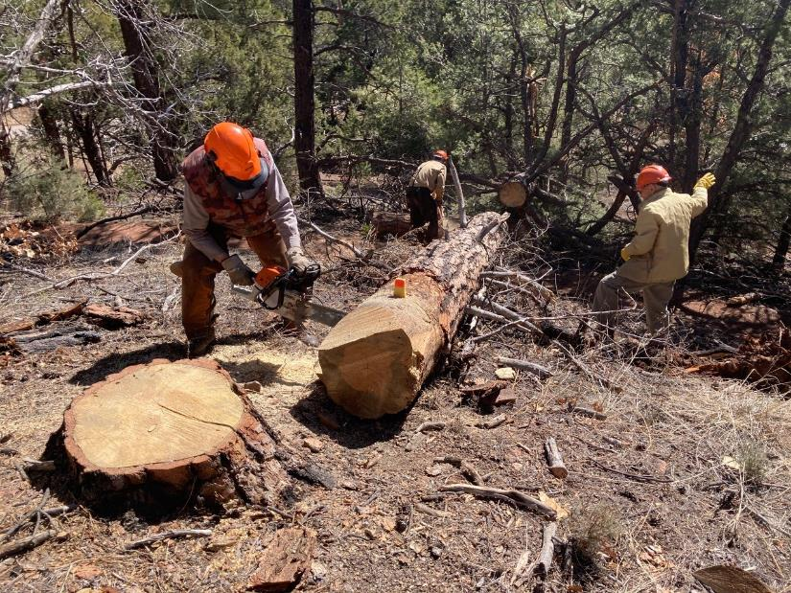

Dan bucking the largest tree that was felled in this area. Sam Beard and Don Carnicom are working in the background.

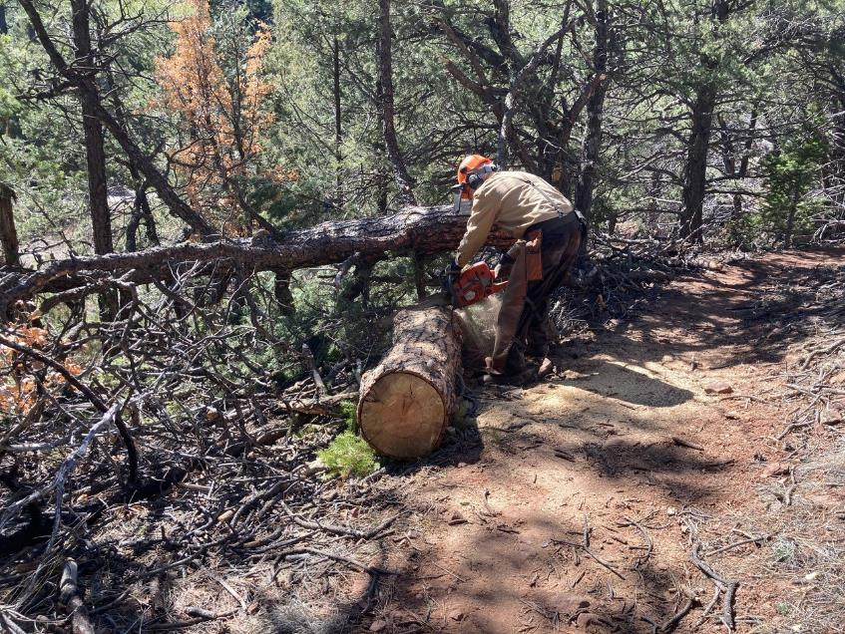

Sam bucking part of the large tree that had been across Wagon Trail.

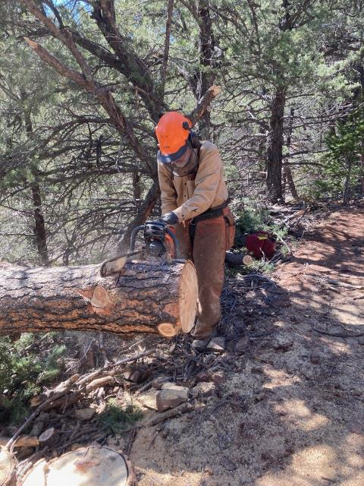

Sam bucking part of this tree that was supported off the ground by the upper branches.