The crew gets a first look at the fallen trees on Bill Spring Trail. Photo is looking north.

Same trees, but this time looking south. The lower

trunk is more visible. Work is starting to clear the

area so that the obstacle came be removed.

Jamey is starting a cut on the lower trunk.

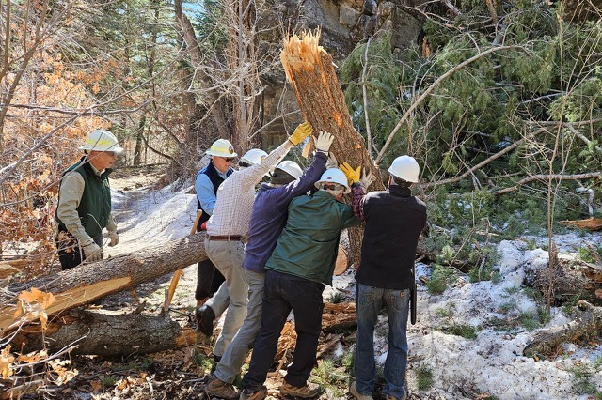

After the cut was completed, the trunk section is being flipped

over to the side of the trail. In this way, it lies perpendicular to the trail to prevent it from eventually rolling down into the tread as gravity slowly would do its work. The trail margins go uphill on both sides at this location so there was no downhill side to move the trunk to. (Perhaps a resemblance to an historic event on Iwo Jima, February 23, 1945.)

Obstacles removed and Bill Spring trail is now clear end to end.

This fallen hang-up greeted the crew shortly after starting up Faulty Trail from Bill Spring.

After making a cut to get the top of the fallen tree on the ground, the crew starts to remove it.

Faulty is now clear at this point.

This double-top tree had fallen into Faulty. Its top was stuck into the tread soil several inches. The ground was frozen and covered with about 4 inches of ice which had to be removed. The portion of the tree uphill to the top right of the photo extended about 10 feet and had several large branches.

The double top tree has been removed. Byron takes a last look at the repairs as the crew moves on.

This large fallen dead fir was blocking Faulty Trail a short distance uphill from the double trunk tree in the previous photos.

The trail has been cleared.

As the crew hiked south on Faulty from the previously shown

trees, this nasty apparition suddenly presented itself.

Final score – FOSM Trails Maintenance Crew – 1.

Nasty Apparition – 0.

Lunch break along a sunny section of Faulty Trail.

This rather lengthy section of a fallen Rocky Mountain Juniper was blocking Sulphur Canyon Trail. It was removed.

This large (20-22 inches diameter) fallen fir was blocking Sulphur Canyon trail. Given its size and the time

required to remove it with hand tools, Jen and Dorothy

suggested that they would hike ahead to where the Forest

Service truck was parked and bring back their chainsaw

to remove it. There were no objections to this suggestion

from the weary crew. We met them coming back in as we were hiking out. THANKS! This photo was provided by Volunteer Tim Murphy.