**Report of FOSM Project to Buck Trees in Cienega Picnic Area**

**Felled During Chain Saw Recertification, Wednesday, March 6**

Sam Beard

On Wednesday, March 6, nine FOSM volunteers bucked approximately five trees lying on the ground in Cienega Picnic Area that had been felled during the recent chain saw recertification outing. Rounds from one large tree were split manually, and more rounds will be split later with Lou Romero’s power splitter before this wood is hauled to the Mountain Christian Church woodlot to be given to East Mountain families who heat their homes with wood.

The volunteers working on this project were Dan Benton, Eric Russell, Lou Romero, Byron Garner, Cliff Giles, Jamey Browning, Don Carnicom, Jerry Carroll, and Sam Beard.

Project photographs are presented below.

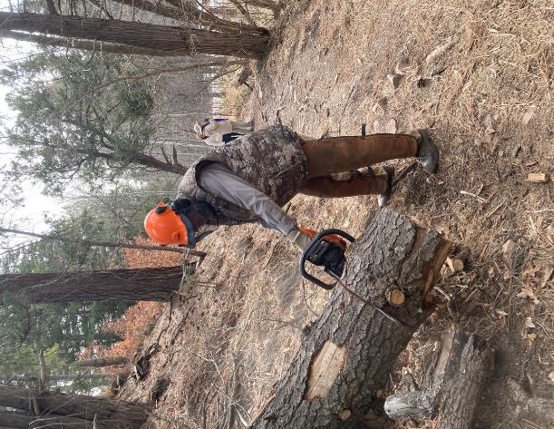

Dan Benton bucking a large fir trunk in the lower part of Cienega Picnic Area.

Photo by Cliff Giles

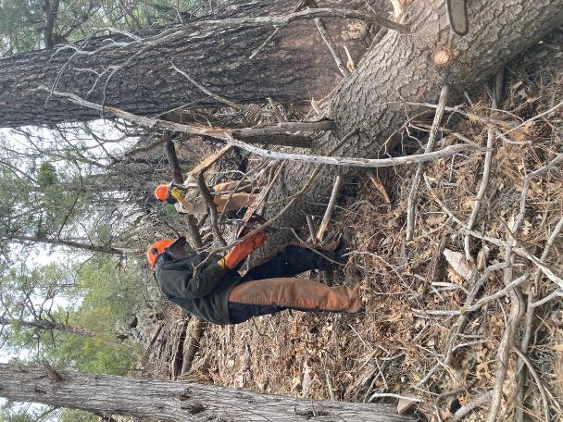

Sam Beard and Don Carnicom removing branches from the large fir trunk.

Photo by Cliff Giles

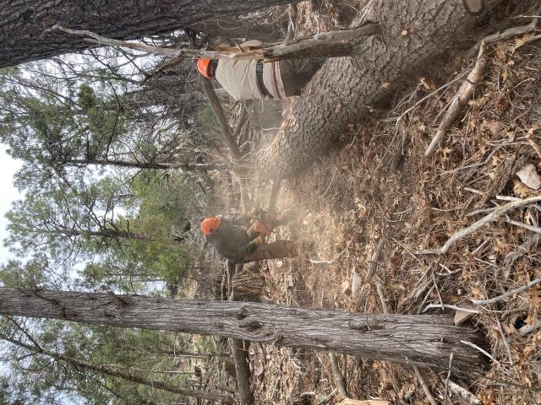

Sam bucking this large heavy trunk while Don observes. Photo by Cliff Giles

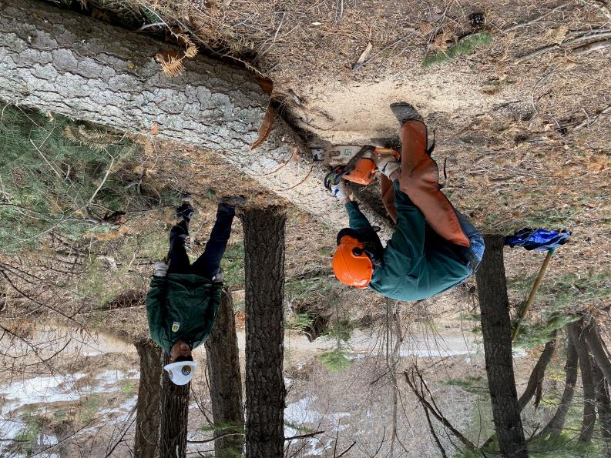

Byron Garner bucking a log on Acequia Trail in Cienega Picnic Area while Jamey Browning waits to move the rounds

after the bucking is complete. Photo by Cliff Giles

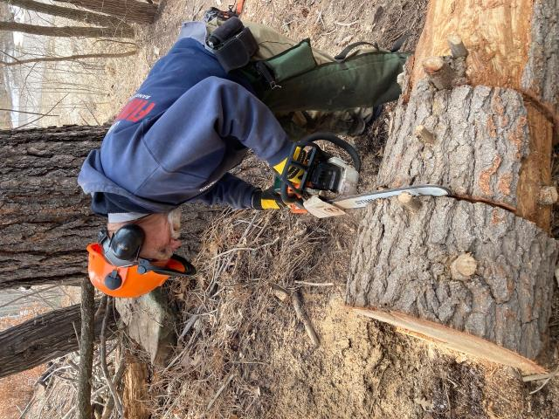

Jerry Carroll bucking a fir trunk on Acequia Trail. Photo by Cliff Giles

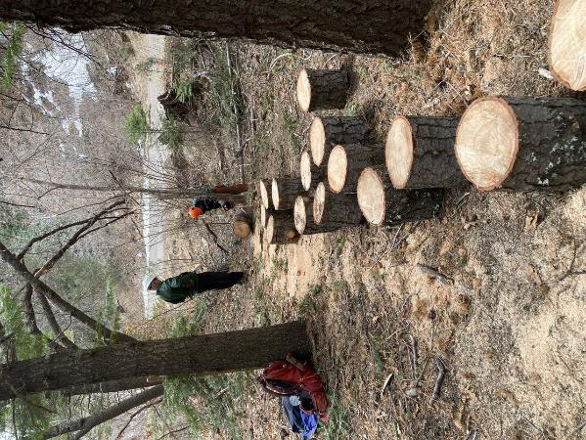

Jamey has placed the rounds on their ends to dry while Byron continues to buck.

Byron said that about 70 rounds were bucked by his crew. Photo by Cliff Giles

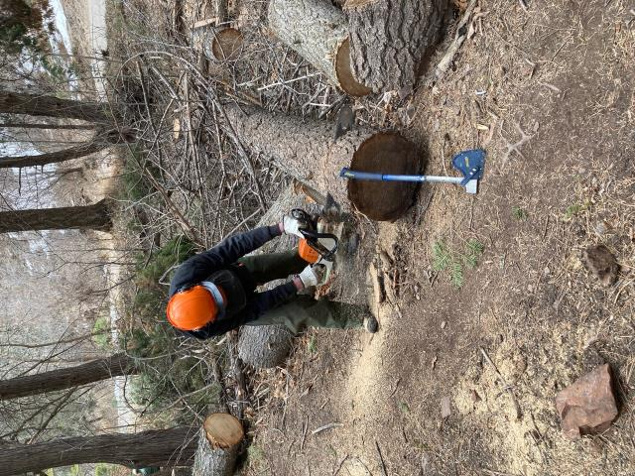

Eric Russell bucking a log with his axe handy to use to drive wedges. Photo by Cliff Giles

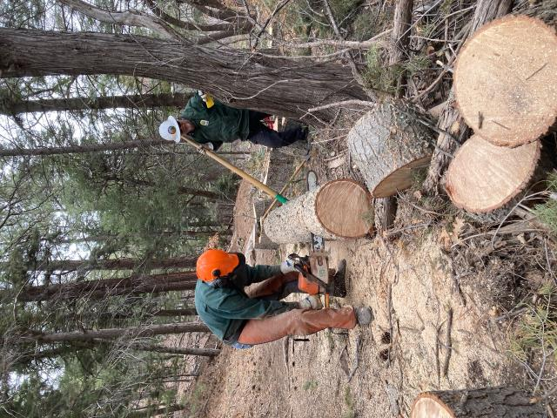

Byron bucking a larger log that Jamey is supporting with a peavy. Photo by Cliff Giles

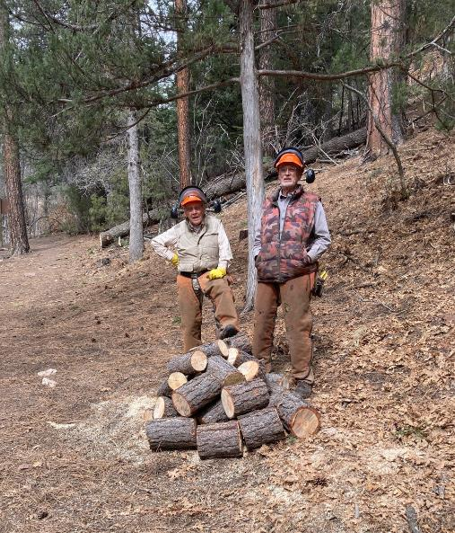

Don Carnicom and Dan Benton behind a pile of wood that Dan Bucked.

Photo by Cliff Giles

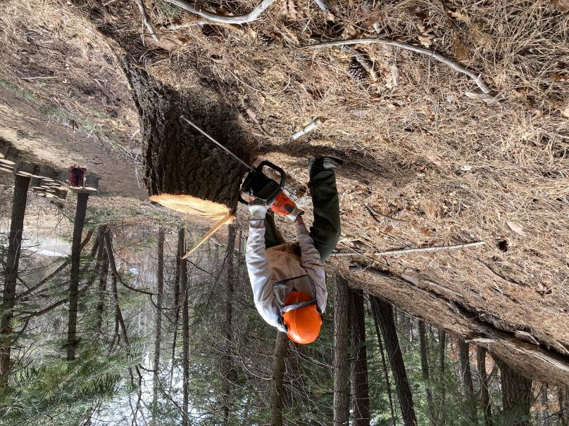

Eric Russell cutting a stump lower for better forest appearance and for another round of firewood.

Photo by Cliff Giles

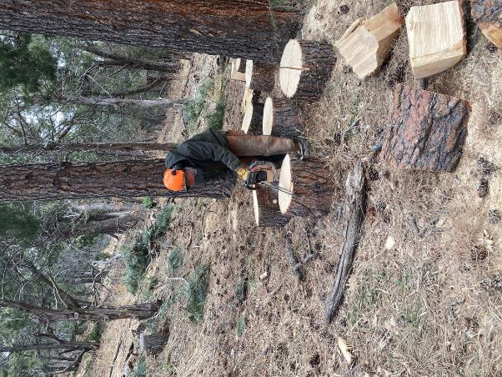

Sam is making two 4-inch-deep cuts in each round to make it easier

to manually split these rounds into quarters in the Cienega Group Area. Photo by Cliff Giles

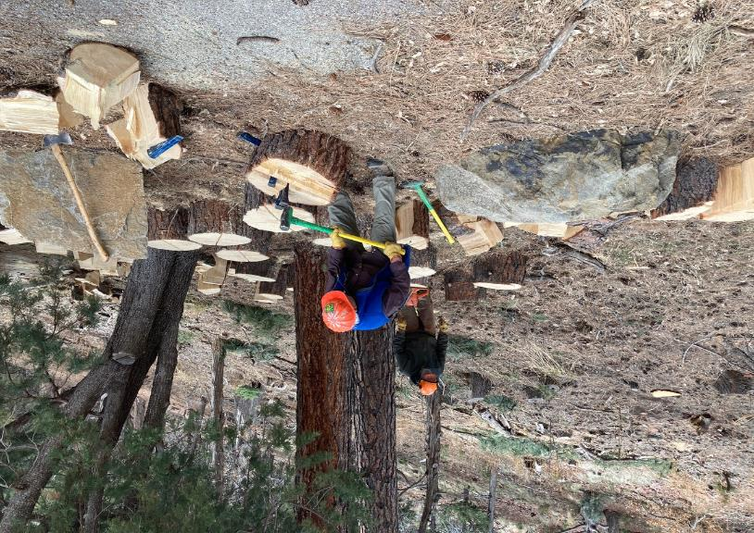

Lou Romero splitting one of the large rounds from a cigar-butt pine felled during the chain saw recertification outing.

The green wood was “stringy” and more difficult to split than if it had been dry. Some of these large rounds were

split with five steel wedges to make driving each wedge easier. Photo by Cliff Giles

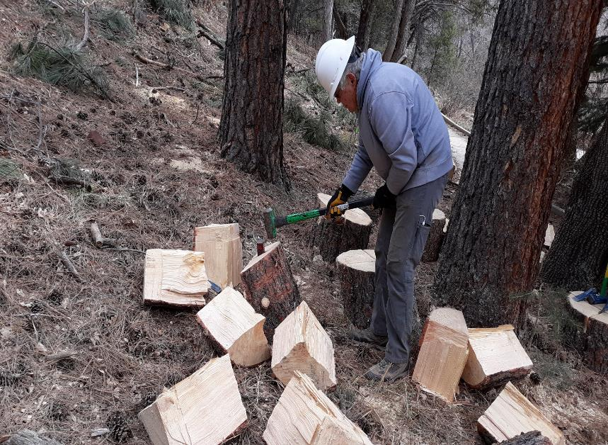

Photographer Cliff Giles help Lou and Sam finish splitting the rounds after lunch. Photo by Sam Beard

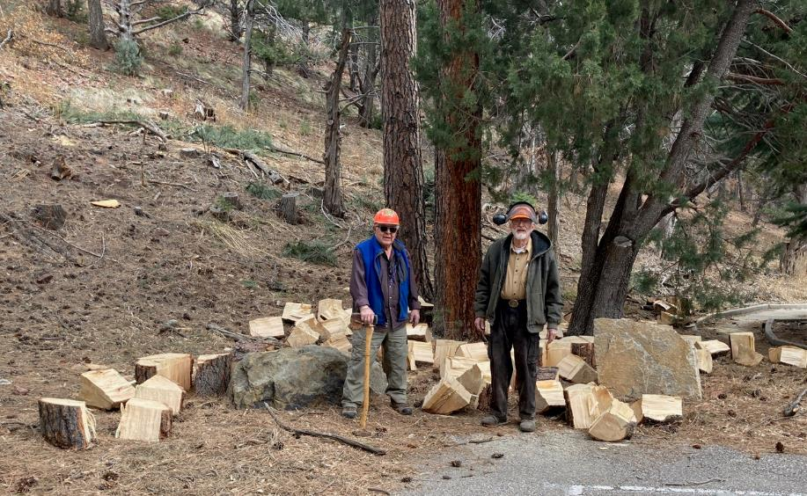

Lou and Sam are standing in the area where all the rounds from the large pine have been split.

The 26 rounds were manually split into 104 quarters so that they would be easier to handle. Photo by Cliff Giles