**Report of Bucking and Splitting Donation Wood in Cienega Canyon Picnic Area**

**on Wednesday, March 27, 2024**

Sam Beard

On Wednesday, March 27, eight FOSM members bucked and split donation wood in Cienega Picnic Area. These hazard trees had been felled during the recertification of several USFS employees and FOSM volunteers. The bucked and split wood will be hauled to a Mountain Christian Church woodlot and members of their Wood Ministry will distribute it to East Mountain families who heat their homes with wood.

The volunteers were Cliff Giles, Dan Benton, Byron Garner, Eric Russell, Jerry Carroll, Joelle Hertel, Dan Carnicom, and Sam Beard.

Project photos are presented below.

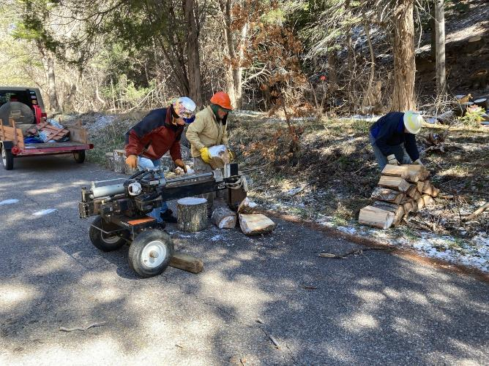

L to R: Joelle Hertel, Don Carnicom, and Byron Garner splitting and stacking wood between the two lower restrooms.

All photos by Sam Beard unless noted otherwise. Photo by Cliff Giles

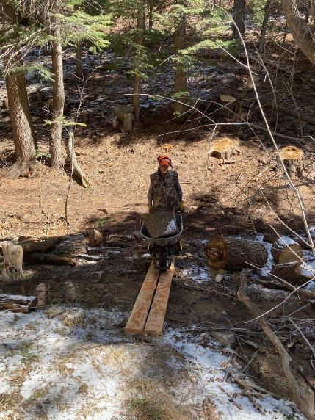

Dan Benton rolling a wheel barrow carrying a large round of wood over Cienega Creek to the splitter on the picnic area road.

Photo by Cliff Giles

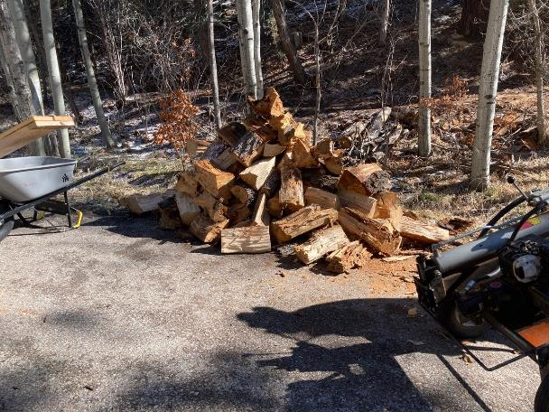

A pile of wood split on Wednesday. Photo by Cliff Giles

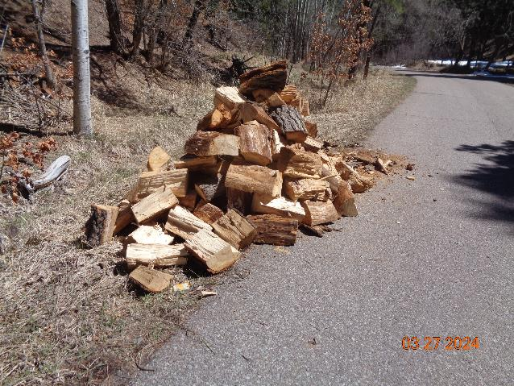

A second pile of wood split Wednesday.

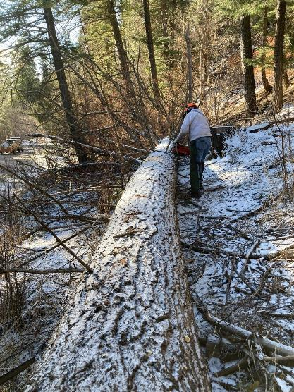

Eric Russell beginning to cut limbs on the 32-inch dead white fir felled recently by Canyon Young, SRD Trails and Wilderness Program Manager. Photo by Cliff Giles

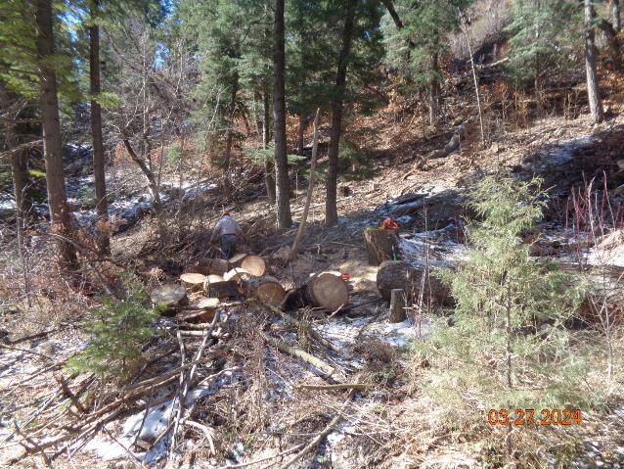

Several pieces of bucked wood from the middle part of the large white fir hazard tree.

Photo by Cliff Giles

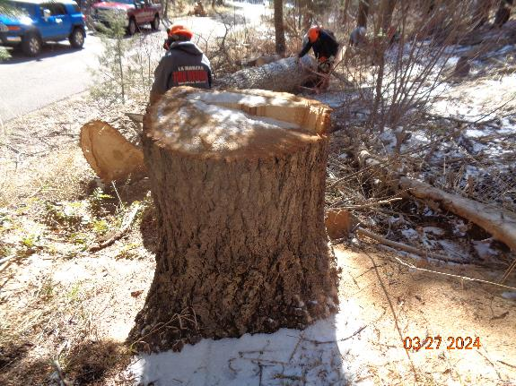

L to R: Jerry Carroll and Byron Garner bucking the lower larger part of the white fir.

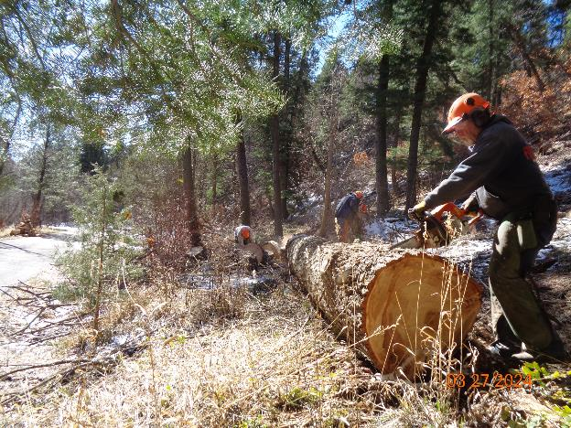

Jerry continuing to buck the large fir.

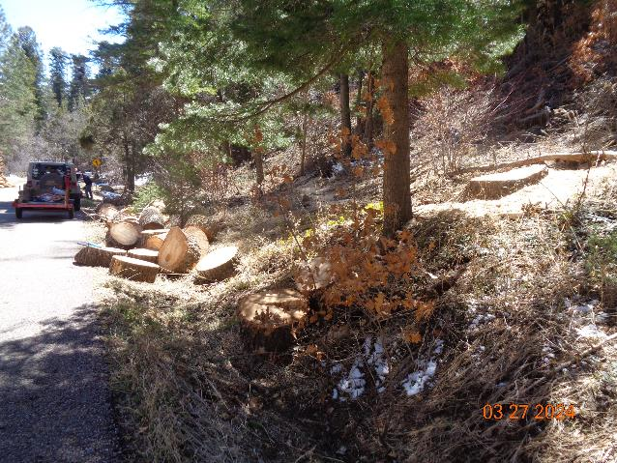

All of the white fir has been bucked into 12-inch-long pieces. Very large diameter solid rounds are very heavy; therefore;

this trunk was bucked into 12-inch pieces so that volunteers could lift the rounds to put them on the power splitter.

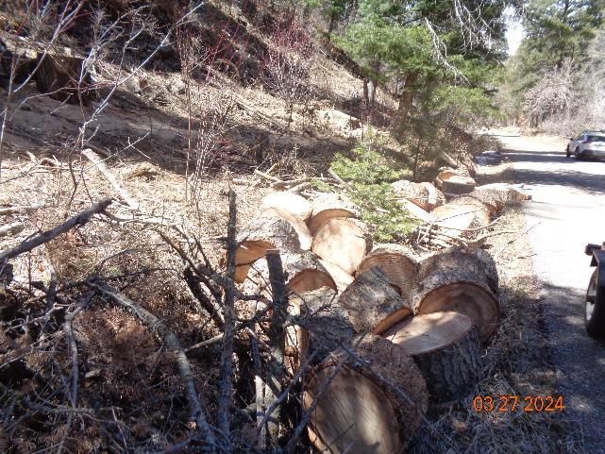

Large rounds in the ditch along the picnic area road.

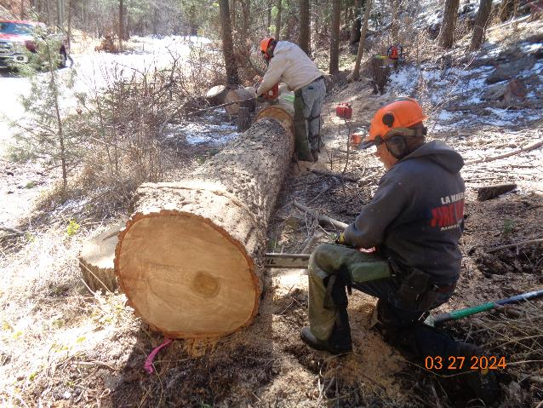

Jerry and Eric continue to buck the large lower part of the trunk. Jerry is using the large FOSM Stihl MS460 saw with a 28-inch bar.

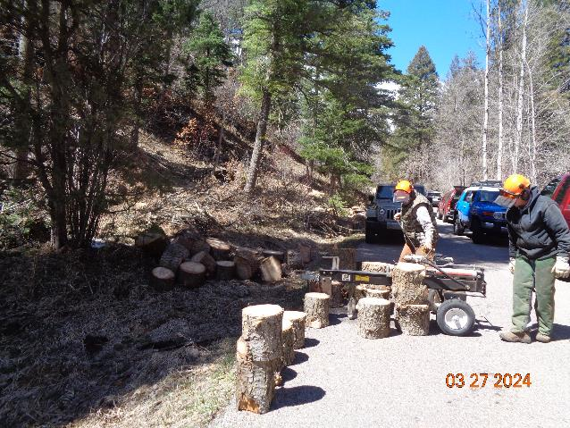

Dan Benton is starting Lou Romero’s power splitter on the road where the large white fir was felled.

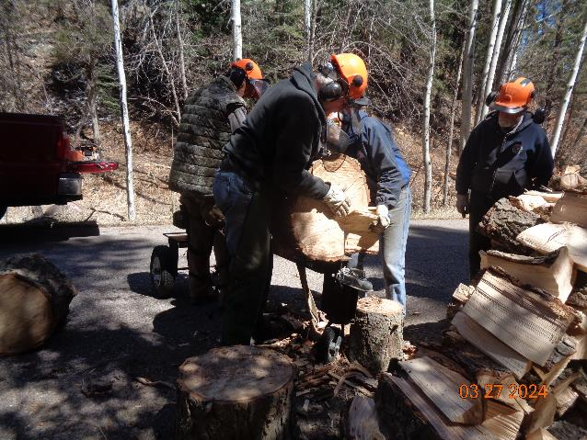

Eric and Byron are placing a large round on the splitter. Dan is operating the splitter control so that the hydraulic ram pushes the wood

into the sharp wedge-shaped part that actually splits the wood into two pieces. Jerry Carroll on the right is stacking the split wood.

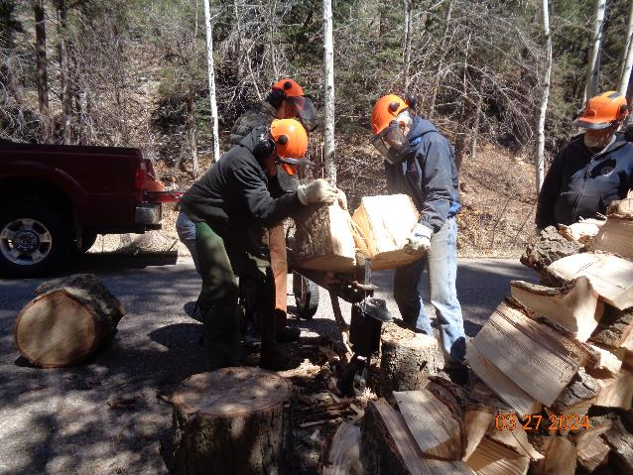

When a large round is not split completely by the splitter, the volunteers attempt to pull it apart. If they cannot pull the pieces apart,

the wood is rotated so the splitter will complete splitting the round.

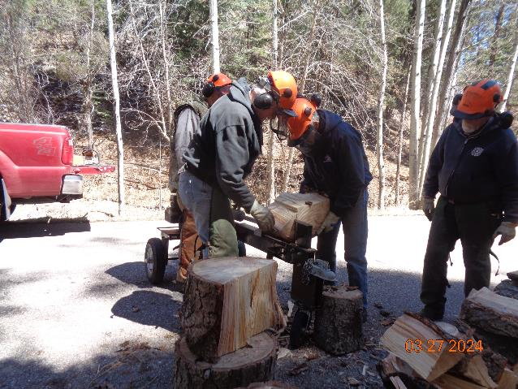

A large round is split into about eight pieces so that is easier to handle and to put in a stove.

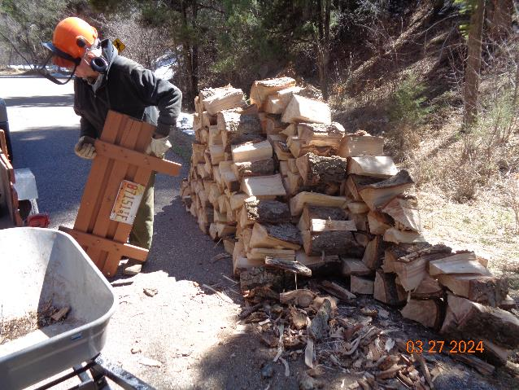

Eric is putting the end piece on Lou’s trailer beside the large pile of split wood.