**Report of FOSM Volunteers Manually Splitting Large Donation Wood Rounds, Moving Rounds**

**from the Creek to the Road, Hauling Wood to a Woodlot, and Felling a Hazard Tree**

**in Cienega Picnic Area on Wednesday, April 3, 2024**

Sam Beard

On Wednesday, April 3, eight FOSM volunteers completed four tasks in Cienega Picnic Area related to the donation of fuelwood to the Mountain Christian Church Wood Ministry.

1. Manual splitting of very large rounds from the 32-inch dead white fir that Canyon Young (USFS) felled so that the pieces could be put on the power splitter later.
2. Moving about 2 dozen rounds from the creek to the picnic area road for splitting later.
3. Hauling donation wood to Mike Oliver’s woodlot.
4. Felling, limbing, and bucking a Rocky Mountain juniper that Canyon had selected as a hazard tree.

The volunteers working on this project were Sim Cook, Cliff Giles, Scott Dietrich, Mike Madden, Mike Oliver, Jerry Carroll, Eric Russell, and Sam Beard.

Project pictures are presented below. All photos by Cliff Giles unless noted otherwise.

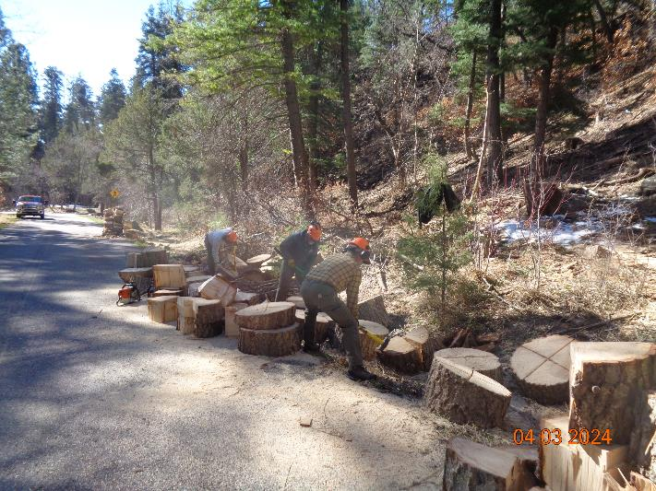

Manually splitting large rounds from the dead white fir felled by Canyon Young so that volunteers

could put them on the power splitter later. The rounds weighted as much as 100 to 200 pounds each.

Photo by Sam Beard

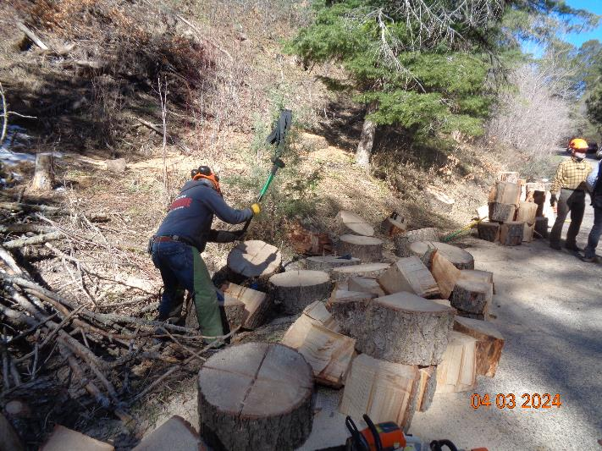

Jerry Carroll splitting a large round with a sledge hammer and steel wedges. Each round was scored

about 3 inches deep with chain saws to make splitting easier. Photo by Sam Beard

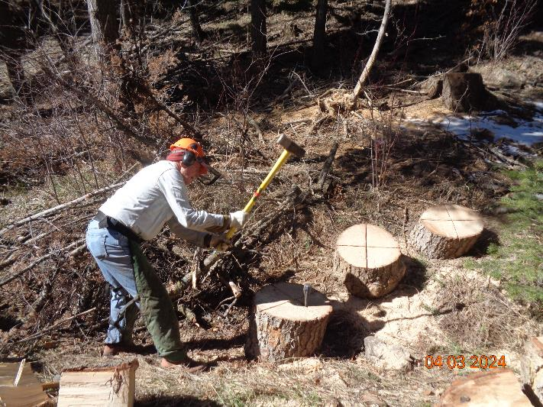

Eric Russell splitting a round with a 12-pound sledge hammer. Photo by Sam Beard

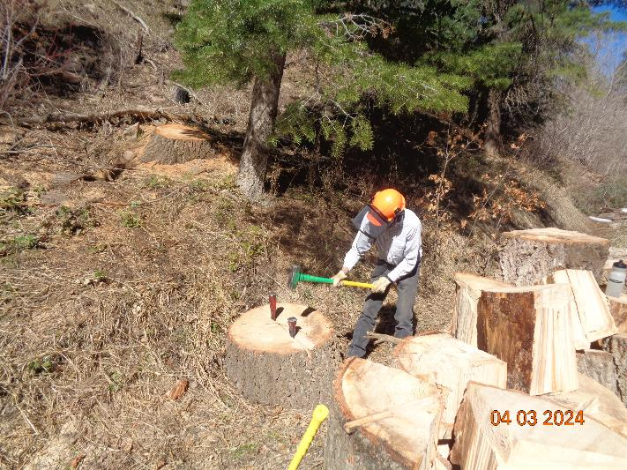

Sim Cook splitting a large round with an 8-pound sledge and two steel wedges. Photo by Sam Beard

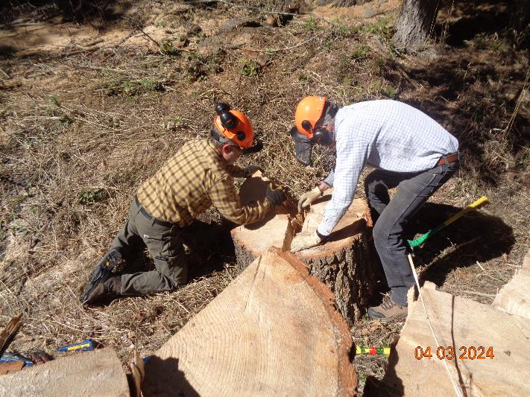

Scott Dietrich and Sim Cook pulling a round into four pieces after splitting with wedges did not completely

separate the quarter rounds. Photo by Sam Beard

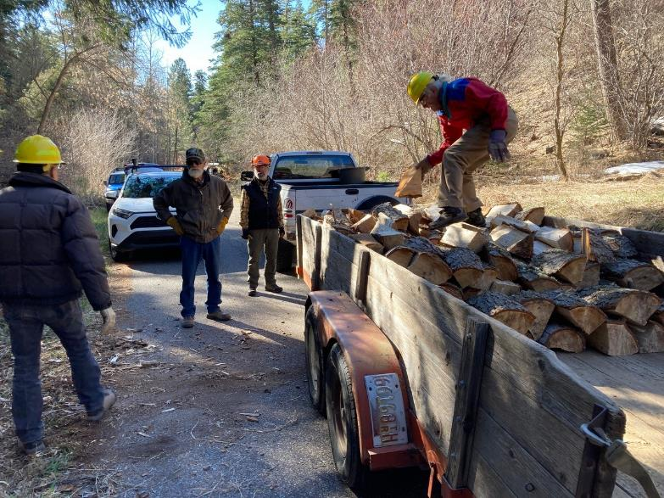

L to R: Sim Cook, Mike Oliver, Scott Dietrich, and Mike Madden loading split wood on Mike Oliver’s trailer.

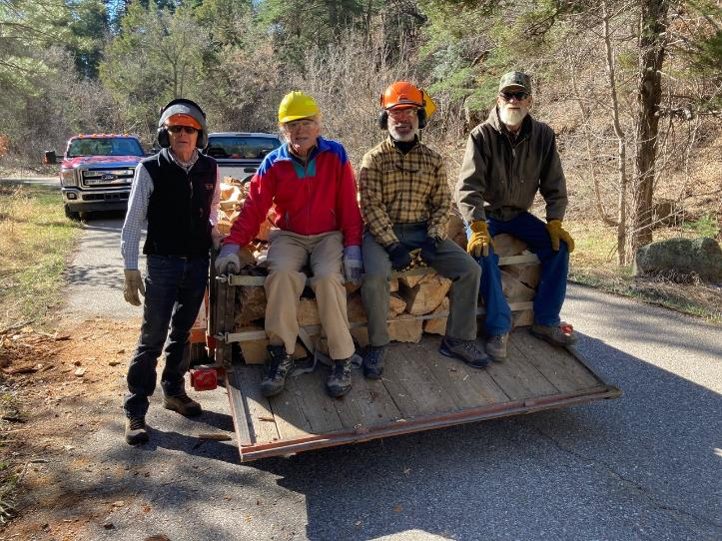

L to R: Sim, Mike Madden, Scott, and Mile Oliver sitting on the first load of wood.

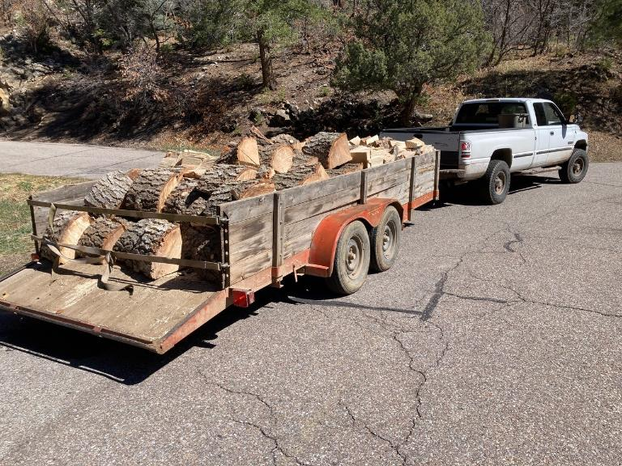

Second load of wood being hauled to the woodlot on Mike Oliver’s trailer. Note that about half of the load was

large quarter rounds that were split on Wednesday.

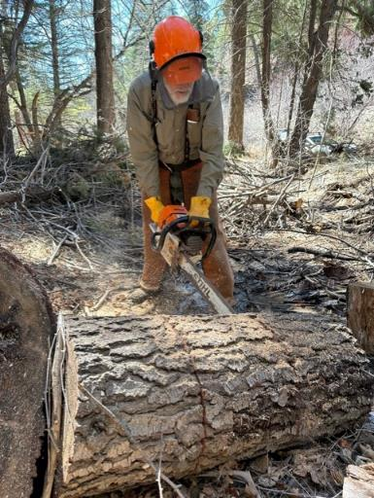

Sam Beard bucking a large round in Cienega Creek so that it could be rolled to the picnic area road.

Photo by Scott Dietrich

sd

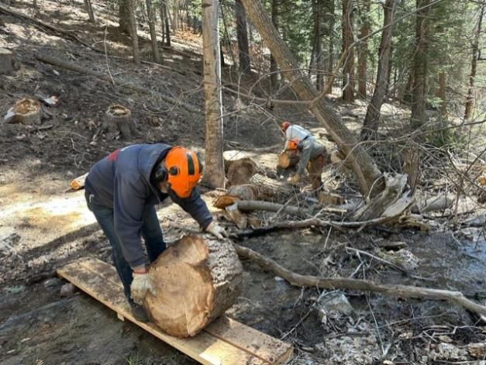

Jerry Carroll and Eric Russell rolling rounds from the creek to the road. The small bridge was made

by FOSM volunteers last Wednesday to haul rounds on wheel barrows. Photo by Scott Dietrich

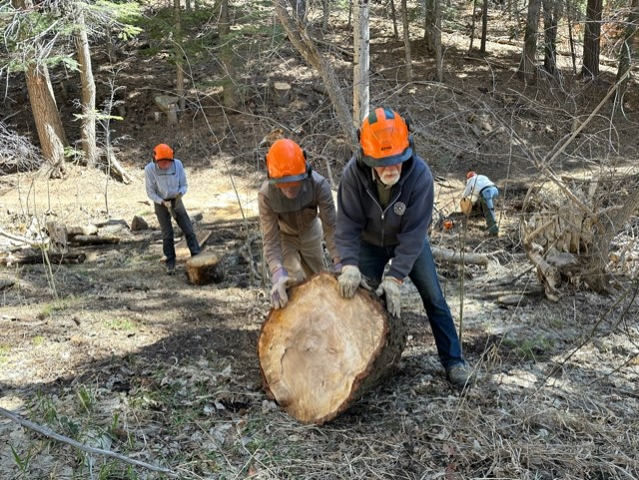

Mike Madden and Jerry Carroll rolling an especially large round from the creek to the road. Photo by Scott Dietrich

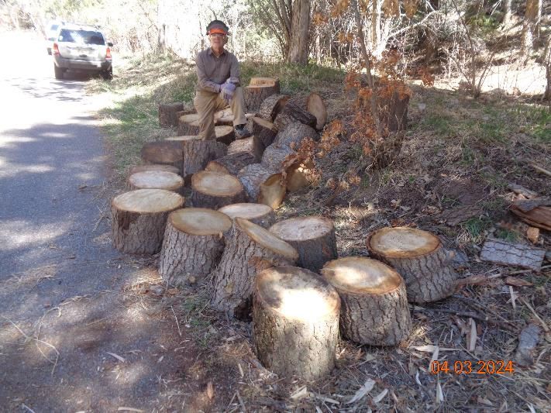

The approximately two dozen rounds rolled from the creek to the road. They will be split with the power

splitter later. Photo by Sam Beard

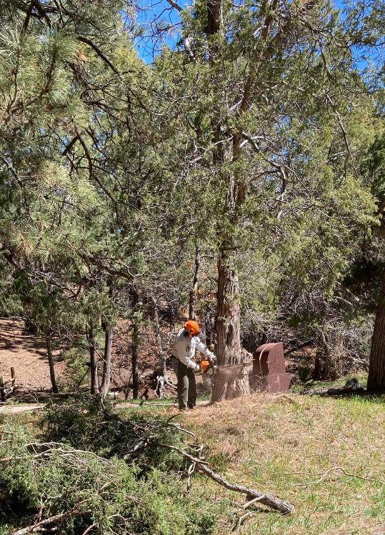

Eric Russell starting to fell the 18-inch Rocky Mountain juniper hazard tree near the lower restroom.

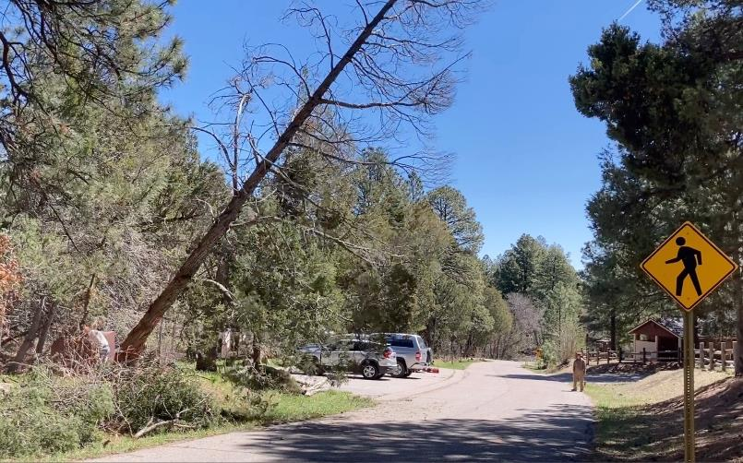

The mostly dead juniper tree is falling onto the road.

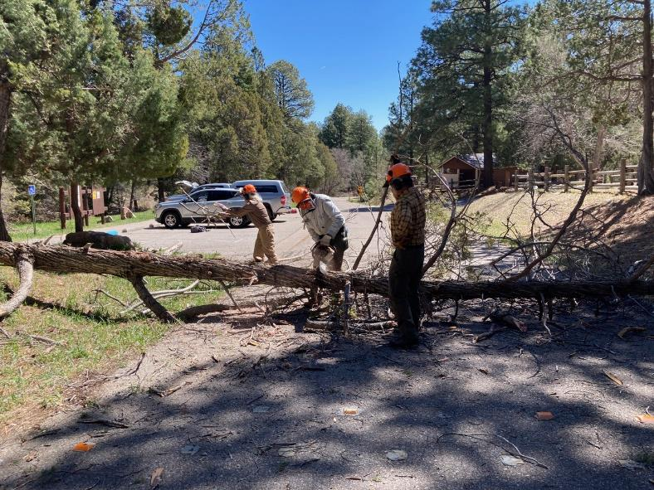

Eric is beginning to limb and buck the juniper.

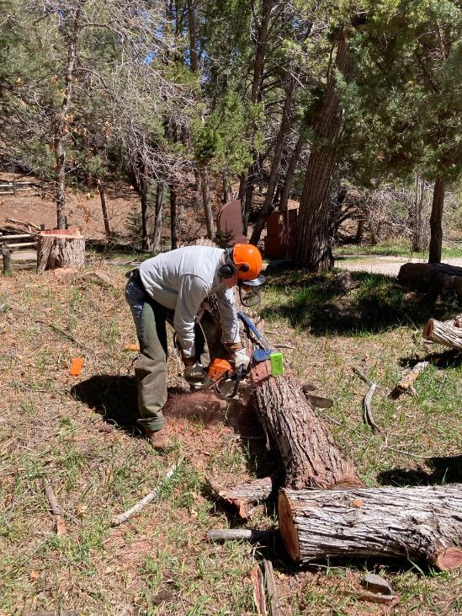

Eric is bucking the juniper trunk

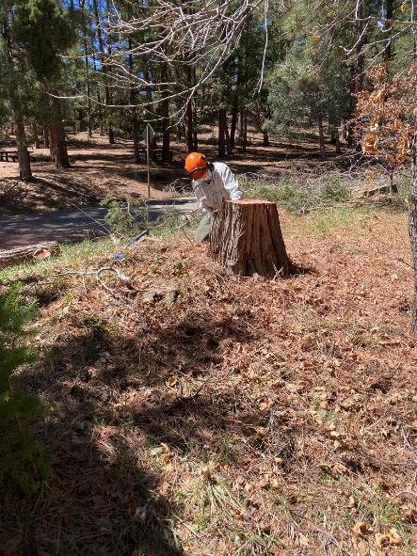

Eric is cutting the stump lower so that the area will be more attractive.

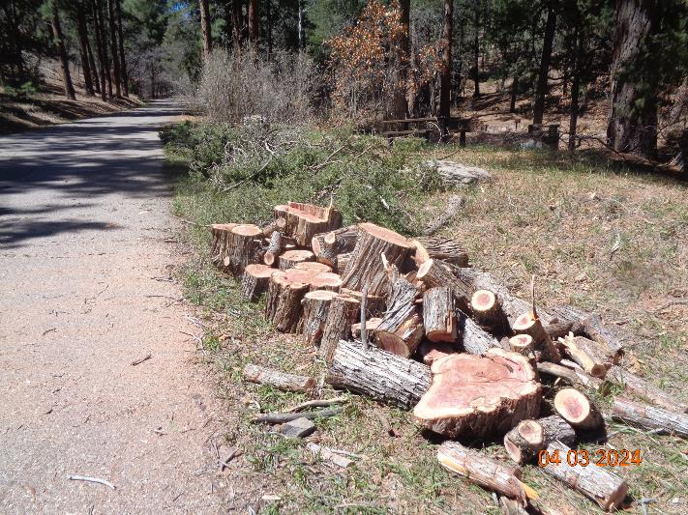

Firewood from the felled juniper hazard tree. The branches in the background will be chipped later.

Photo by Sam Beard

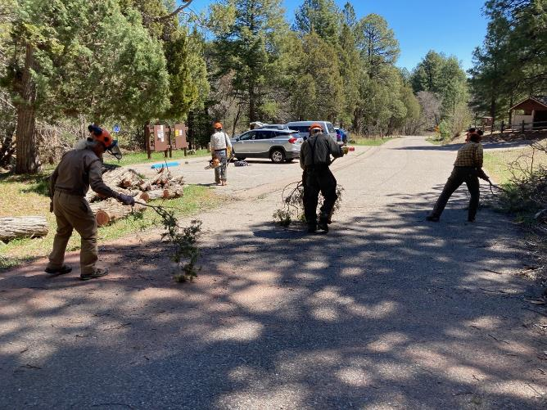

Sweeping the debris from the road with tree branches.

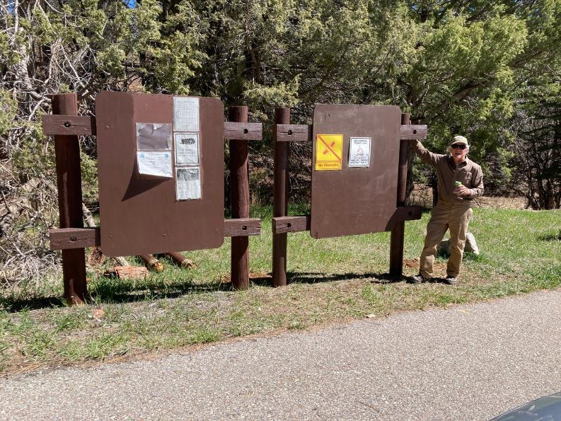

Mike Madden at the right kiosk where Don Carnicom had replaced both rotten posts a couple of weeks ago.