**Report of Removal of Graffiti Tags on Two Boulders near La Luz Trailhead Parking Lot**

**by FOSM volunteers and SRD Employees, Friday, March 29, 2024**

Sam Beard

On March 29, four FOSM volunteers and two Sandia Ranger District employees removed large graffiti tags on two boulders near La Luz Trailhead parking lot. After we completed removing these tags, we hiked up the canyon east of La Luz parking lot to check the area for tags since we removed tags here two years ago. We found a small tag high on some boulders that we could not safely climb to in the past. We also found a large tag on the stone dam that formed the pond for the CCC water system in Juan Tabo Picnic Area. We had removed a large tag here two years ago with the TTYL summer crew. I do not know when we will remove the new large tag on the dam that is 1/8 to ¼ mile from the parking lot.

The Graffiti Busters were Dallas Duckworth (SRD), Sam Beard, Rick Buss, Pauline Ho, Cliff Giles, and Heather Johnston (SRD).

Project photos are presented below.

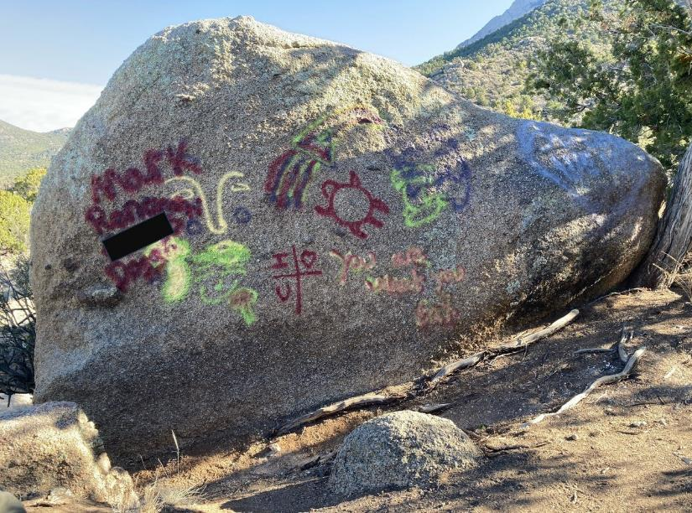

Numerous tags on this large boulder located a few hundred feet from La Luz Trailhead parking lot.

Cliff Giles “sanitized” the photo. All photos by Cliff Giles



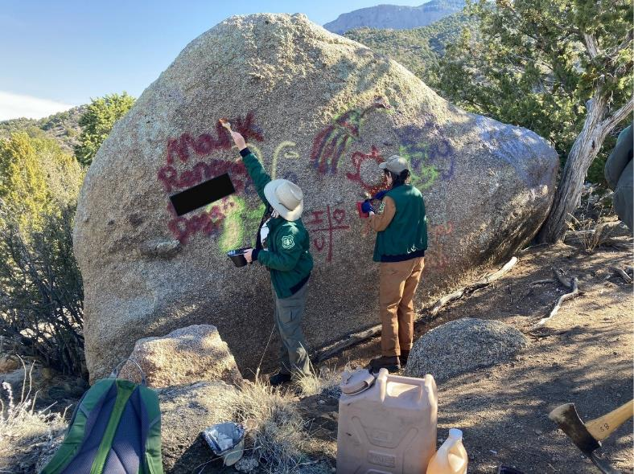

L to R: Heather Johnston and Dallas Duckworth (SRD) applying graffiti removal chemical on the tags on this large boulder.



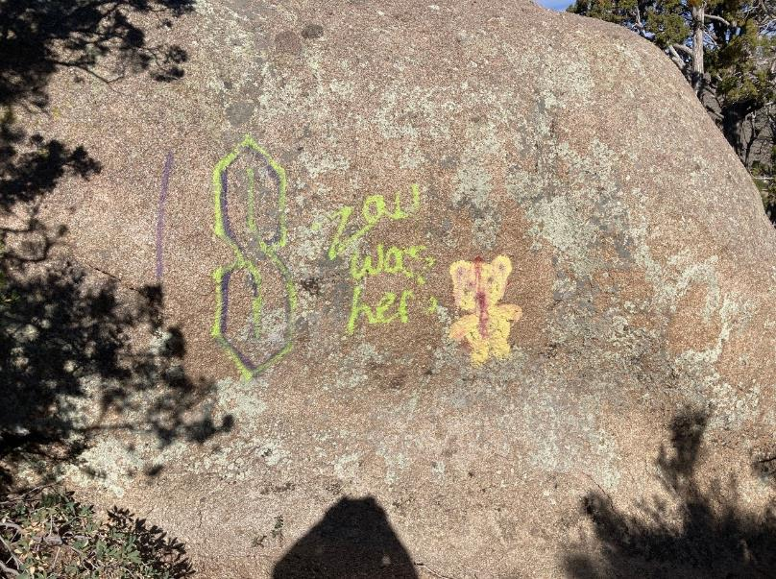

Tags on this large boulder.

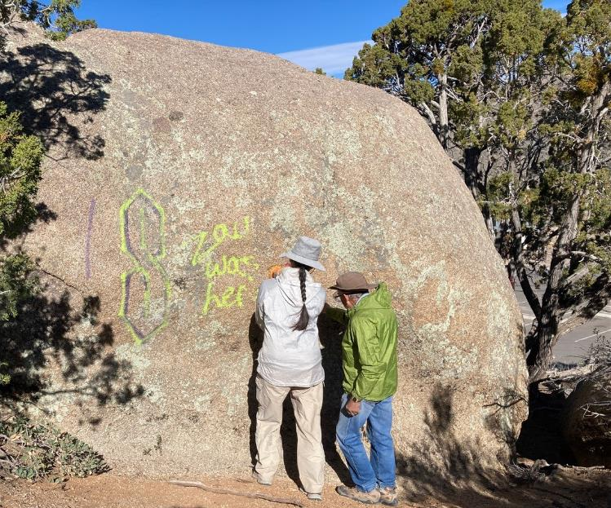

Pauline Ho and Rick Buss applying chemical to these tags.

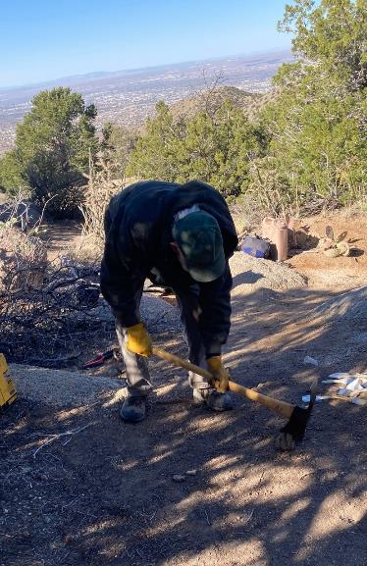

Sam Beard removing an old post tripping hazard.

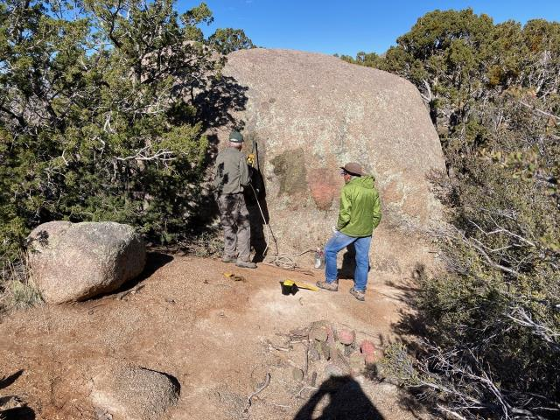

Sam showing Rick how to use the FOSM battery-powered low-pressure washer used to suction water from a gallon

jug to wash the chemical/paint residue from surfaces.

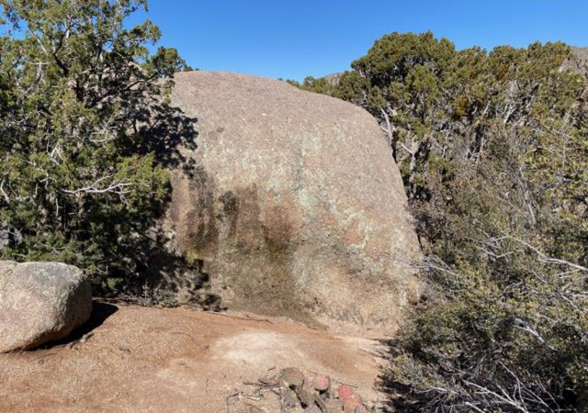

Graffiti has been removed from this boulder.

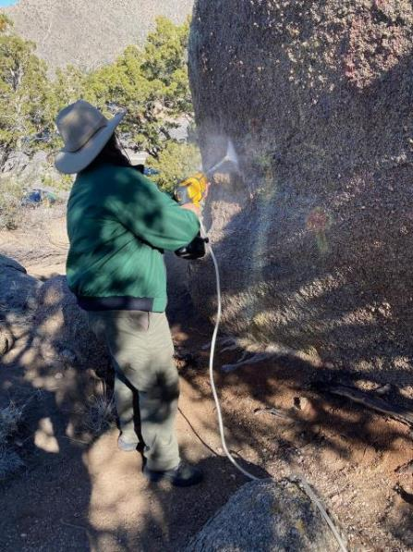

Heather is using the low-pressure washer to remove residue from this large boulder.

The low-pressure washer consumes one gallon of water per minute.

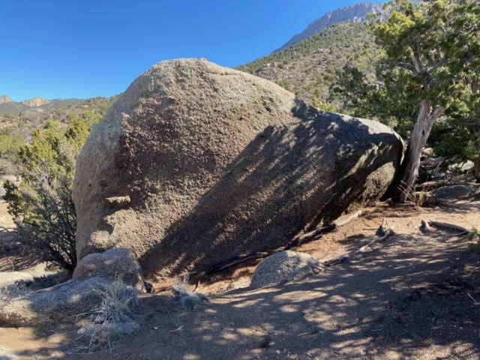

Graffiti tags have been removed from this boulder.

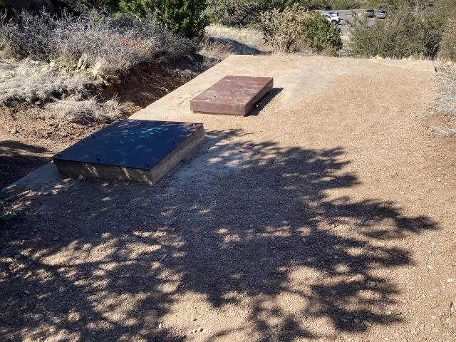

The Juan Tabo Picnic Area cistern built by the CCC to store water from a dam upstream. This unused cistern is located east

of the La Luz Trailhead parking lot seen in the background.

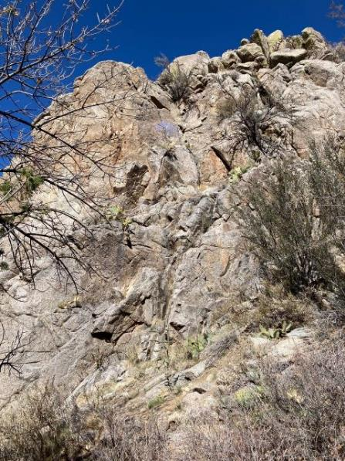

A small purple tag is shown on boulders above the photo center.

We could not find a safe route to this tag when we removed all the other tags in this canyon two years ago.

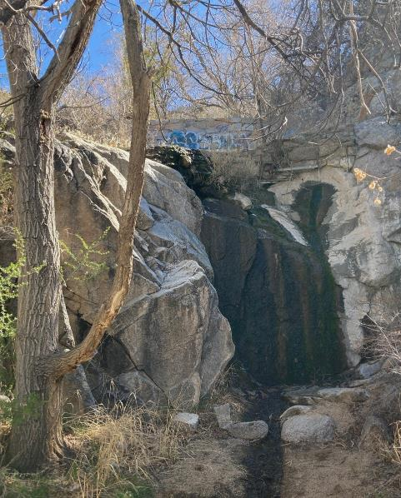

Large blue tags on the CCC water system dam above the Waterfall. The pond behind the dam

Is filled with dirt and gravel.

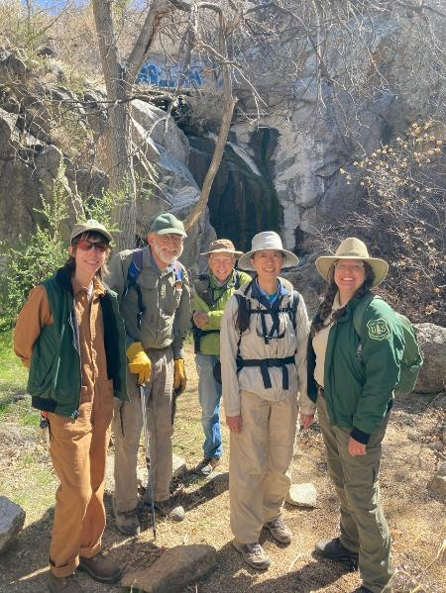

Dallas Duckworth (SRD), Sam Beard, Rick Buss, Pauline Ho, and Heather Johnston (SRD)

in front of the Waterfall.