Thursday, April 4, 2024 saw the trail construction crew back on the Lower Pine reroute work. Seven volunteers joined Jen as we continued to create new tread, close off old trail and start some more brush work. We hiked up to the southern end of the Lower Pine trail and started work where we left off last week. We had several bike riders come through and they gave the new route a thumbs up. Conditions were again fantastic and it was a really great day to be outside working.

Volunteers on this work day were Claudia Bergsohn, John, Braly, Jim Houle, Laura Leon, Bill Perkins, Steve Roholt, and Roland Stumpf.

Photos by Laura Leon.

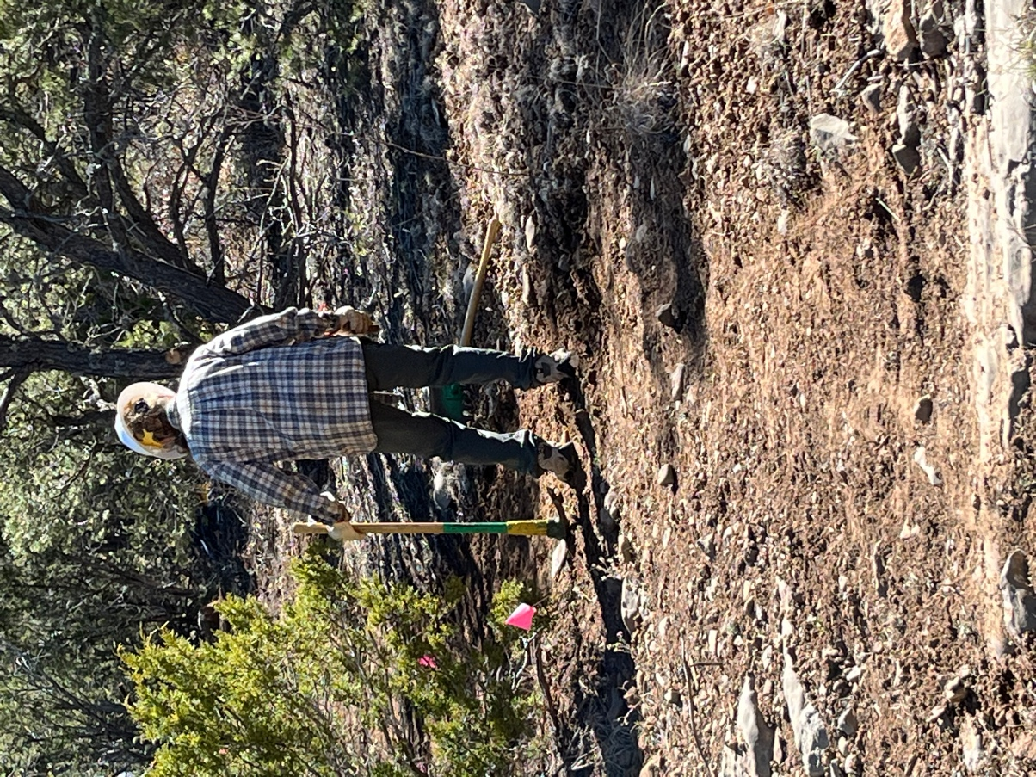

Claudia works on some rocky areas.

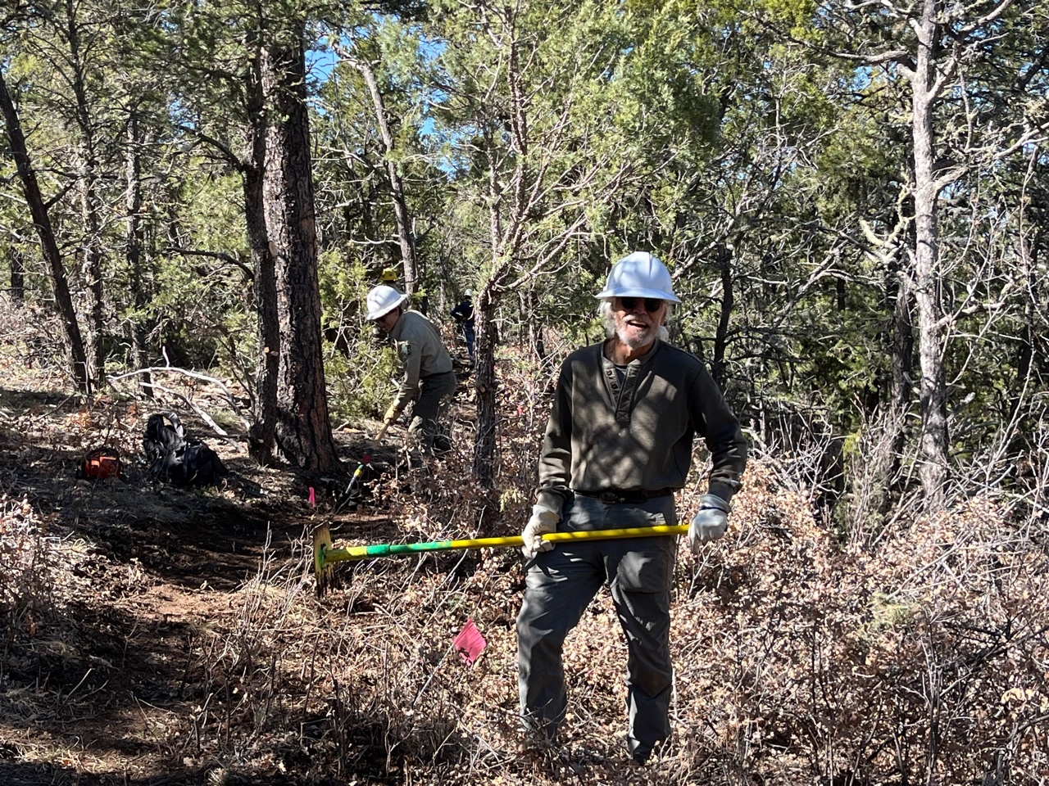

Jen and Bill clear scrub oak for tread.

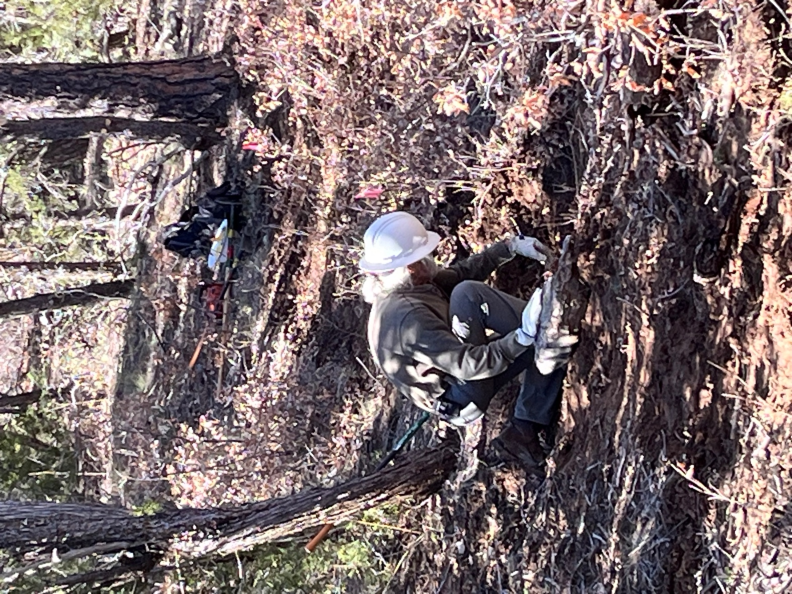

Bill works on drainage.

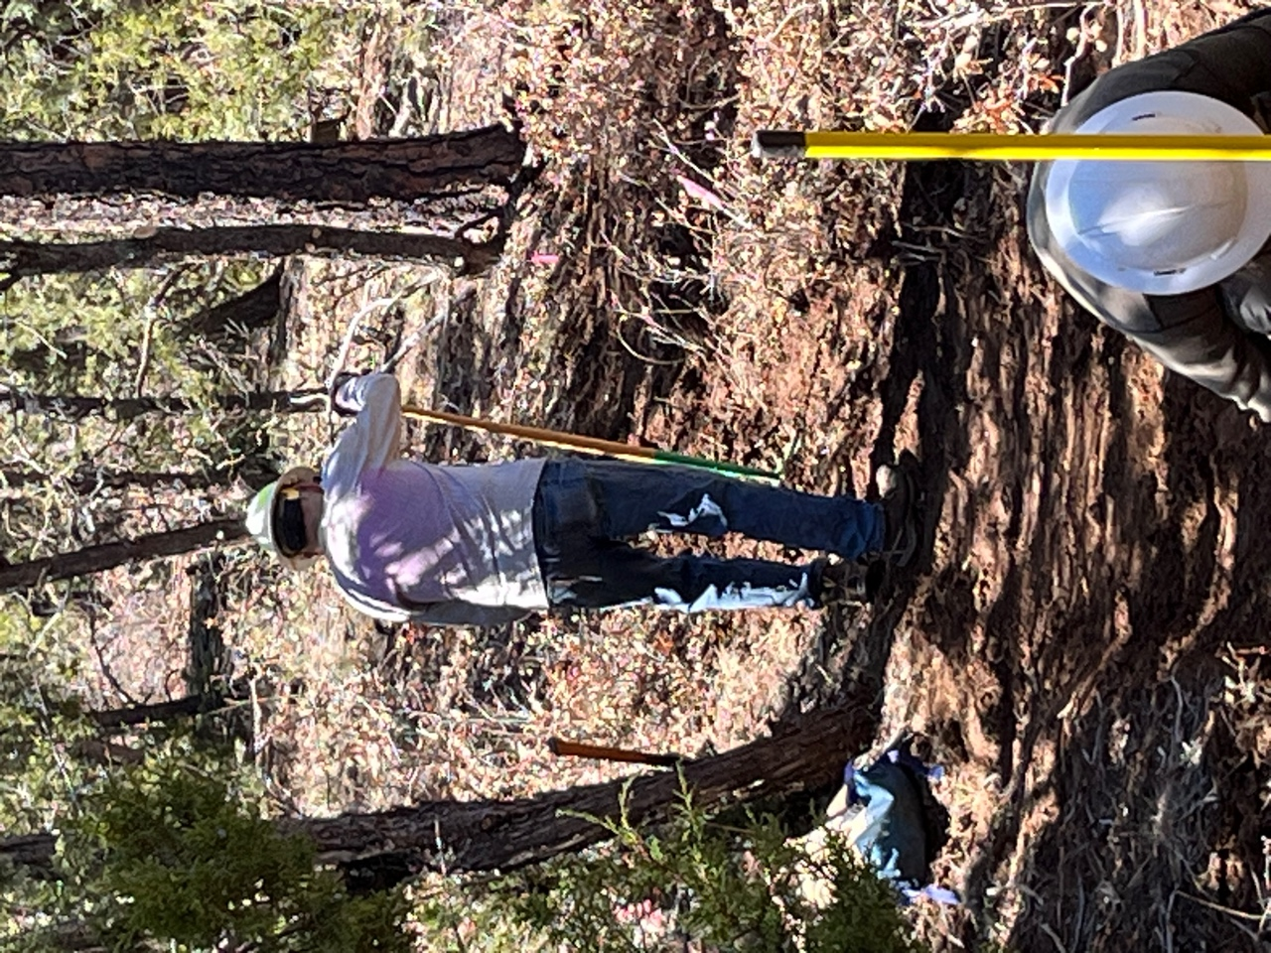

Jim smooths the tread.

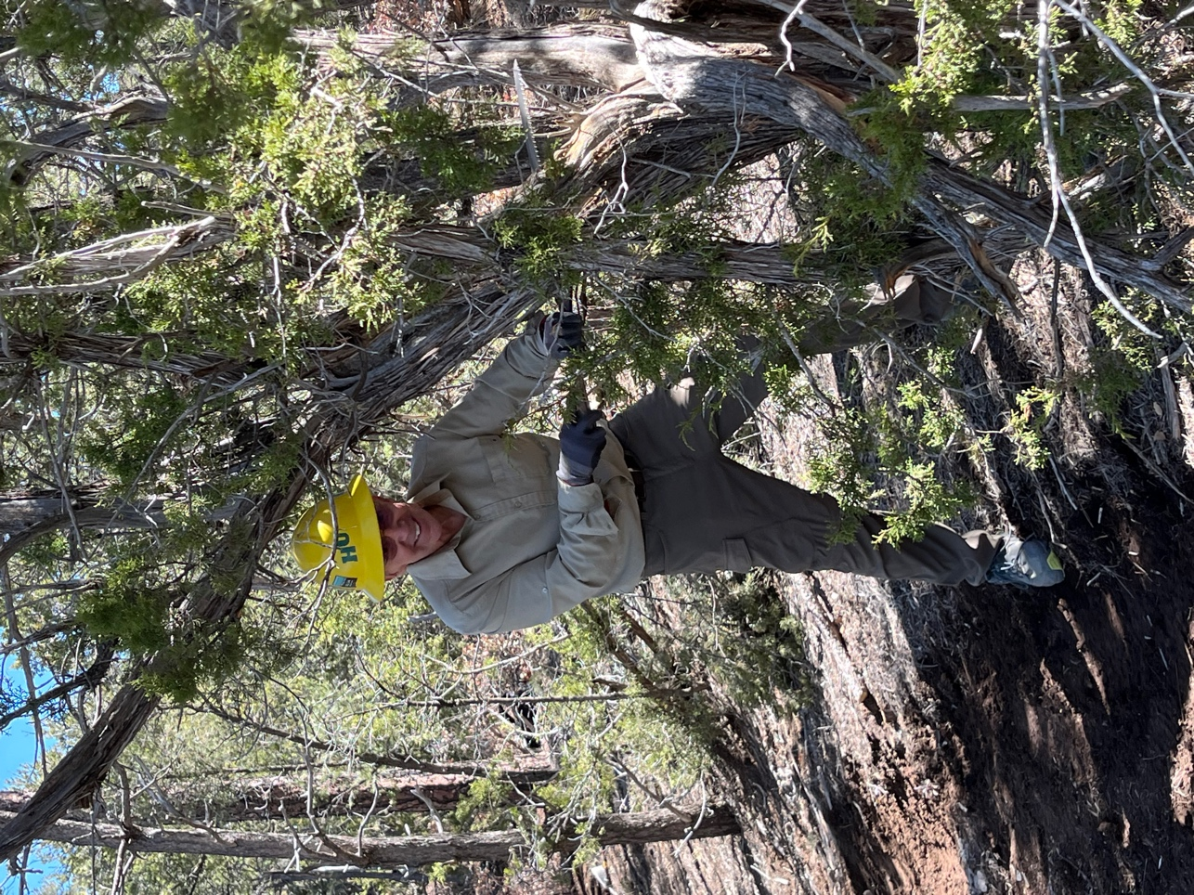

John gets busy with his saw.

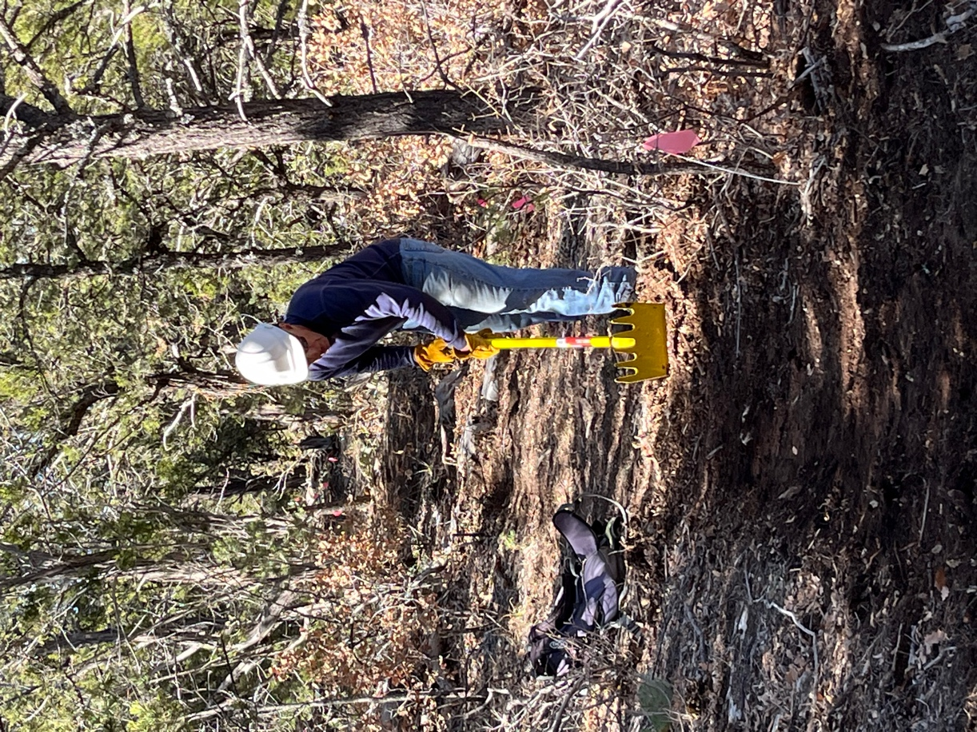

Steve works on the tread.

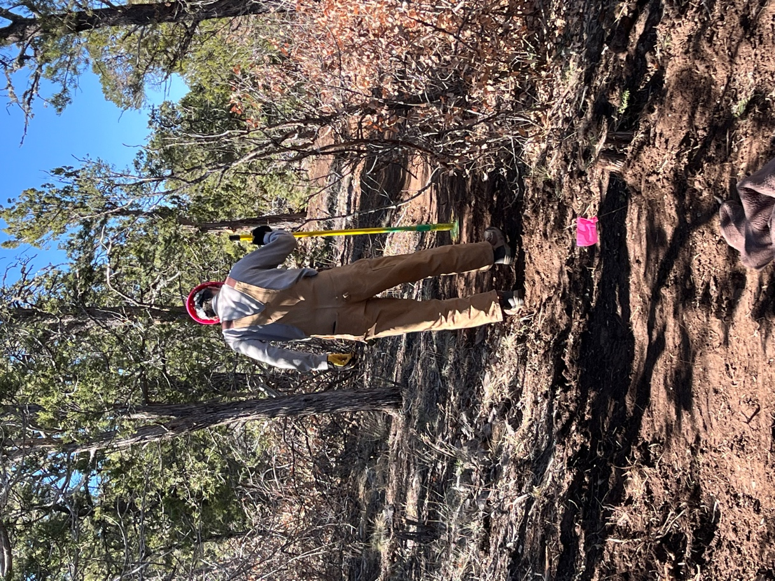

Roland busy at work, thinking about lunch.