**Report of FOSM Processing Donation Wood in Cienega Picnic Area and Felling a Forked Hazard Tree**

**at Balsam Glade Picnic Area on Wednesday, April 10, 2024**

Sam Beard

On Wednesday, April 10, seven FOSM volunteers processed donation wood in Cienega Picnic Area and felled a large forked hazard tree in Balsam Glade Picnic Area. The volunteers completed the following tasks:

1. **Moved Rounds to Picnic Area Road** – Eric Russell, Jerry Carroll, and Sam Beard used wheel barrows to move four loads of bucked Rocky Mountain juniper (RMJ) rounds from the upper part of the picnic area behind the middle restroom to the parking lot. They also moved two loads of RMJ rounds from the group area to the road at the middle restroom.
2. **Split Piles on Rounds on the Road** – Dan Benton’s crew consisting of Cliff Giles, Sim Cook, and Mike Madden split three piles of rounds on the road. The largest pile contained a few dozen quarter-rounds of wood from the 32-inch diameter dead white fir that Canyon Young felled. The rounds from this tree were too heavy to place on Lou Romero’s power split, and they had been split manually with steel wedges and sledge hammers last Wednesday. The next pile contained about two dozen rounds that had been in the creek and had been rolled to the road last Wednesday. Although they were very heavy, all of them were split on Wednesday. The pile of a couple dozen RMJ rounds at the middle restroom were also split.
3. **Felling Hazard Tree at Balsam Glade Picnic Area** – After moving two piles of rounds to the road at the middle restroom, Jerry Carroll, Eric Russell, and Sam Beard went to the Balsam Glade upper parking lot where they felled a 21-inch diameter white fir hazard tree selected earlier by Canyon Young, Sandia Ranger District Trails and Wilderness Program Manager. This large trunk was one of two trunks in this forked tree. The felled trunk contained more dead branches than the other trunk. We will consult Canyon to determine if we should fell the other trunk. It has been the USFS policy to fell both trunks of forked trees, because felling one trunk leaves a large wound on the second trunk where disease and insects can enter the tree.
4. **Reason for Felling Both Trunks of Forked Trees** – See the attached Word document for an explanation of why both trunks of forked trees may be felled as hazard trees. This explanation and photos were taken from the USFS document entitled **Tree Risk Assessment and Hazard Tree Mitigation in the Southwest Region** dated June 2020.

Project photographs are presented below.

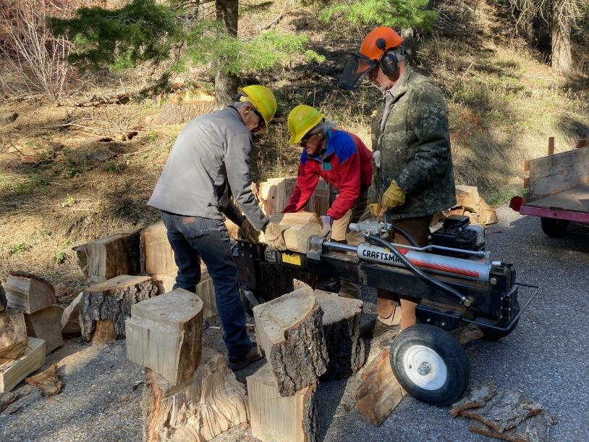

L to R: Sim Cook, Mike Madden, and Dan Benton splitting quarter-rounds of the tree that Canyon Young felled a few weeks ago

in Cienega Canyon Picnic Area. Photo by Cliff Giles

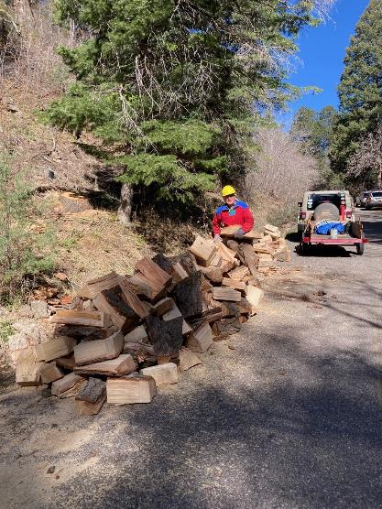

Mike at the large pile of rounds split in Cienega PA. Photo by Cliff Giles

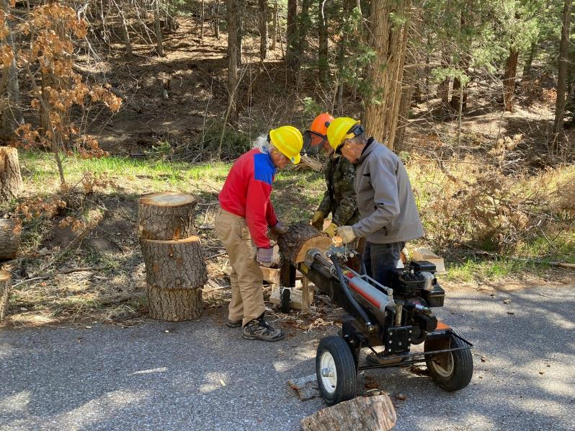

Mike, Dan, and Sim splitting rounds moved from the creek to the road. Photo by Cliff Giles

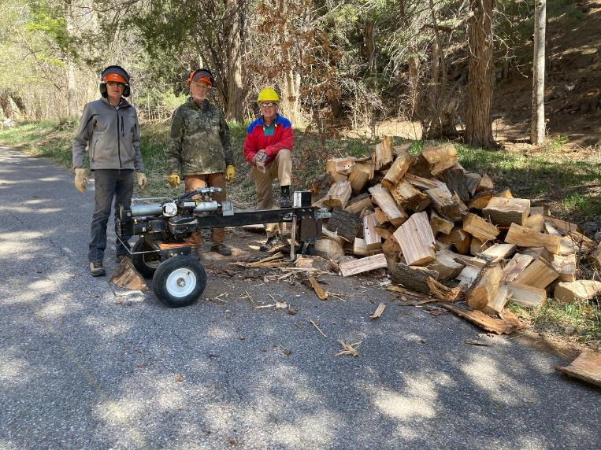

Sim, Dan, and Mike at the pile of wood that was made when the rounds from the creek were split. Photo by Cliff Giles

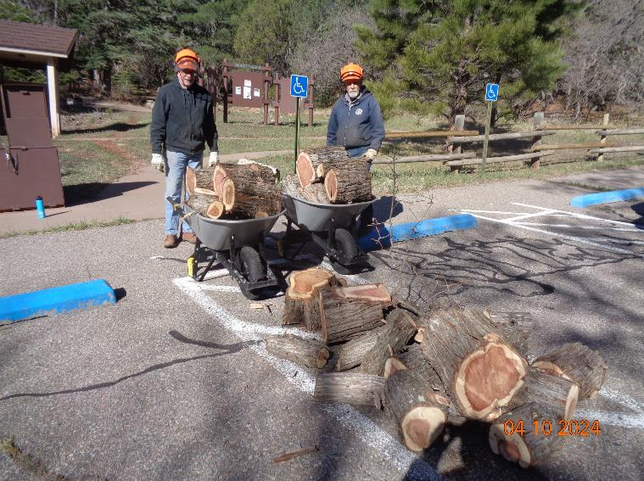

Eric Russell and Jerry Carroll moved these RMJ rounds from the picnic area behind the middle restroom. Photo by Sam Beard

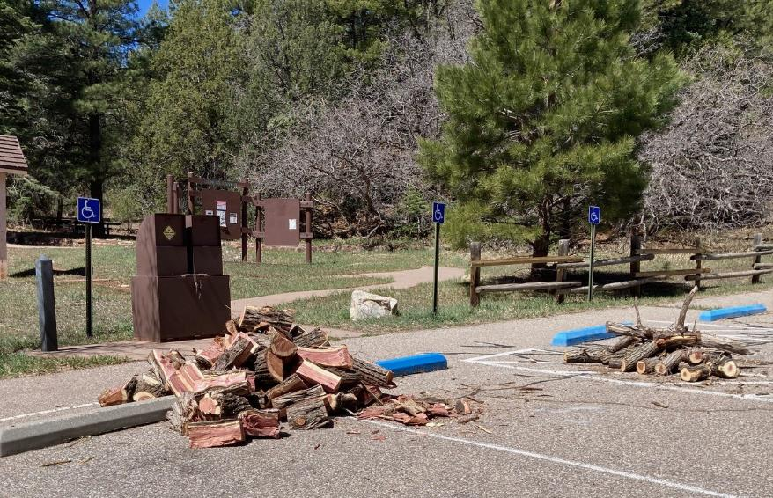

Dan’s crew split the wood shown in the above photo. Photo by Cliff Giles

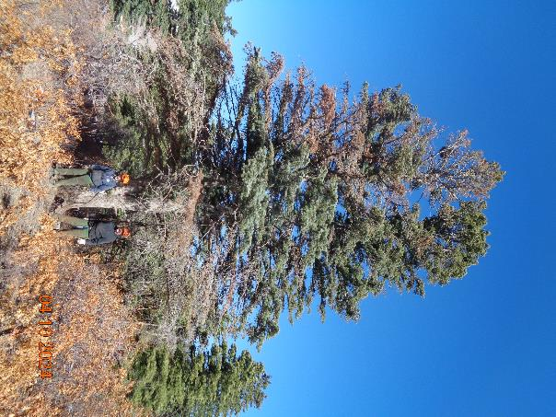

L to R: Jerry Carroll and Eric Russell at the large white fir hazard tree selected by Canyon Young

at Balsam Glade PA. The left fork was felled as a hazard tree. Photo by Sam Beard

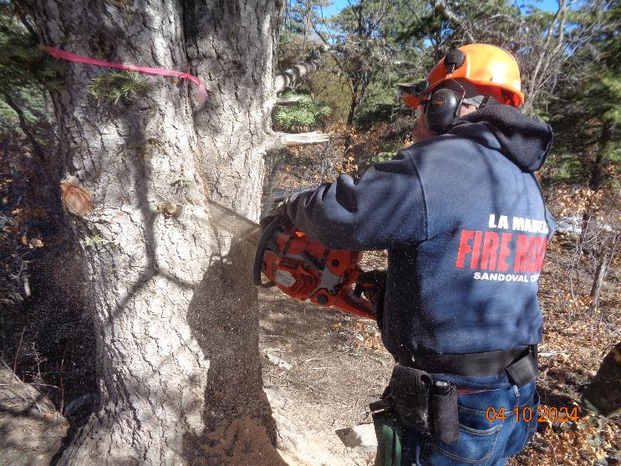

Jerry Carroll sawing down between the trunks so that the one on the left could be felled. Photo by Sam Beard

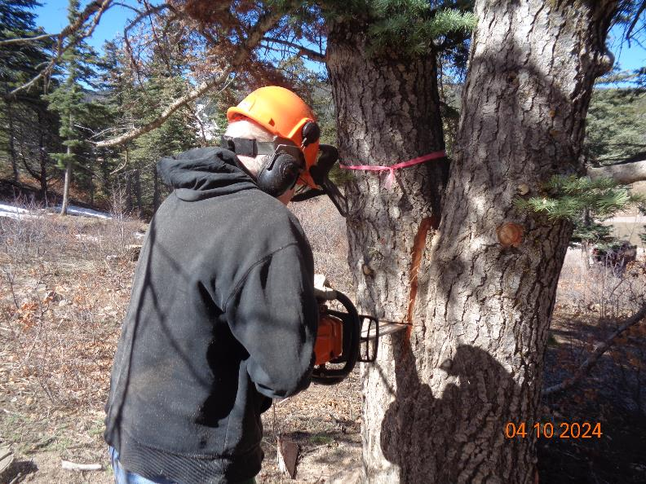

Eric Russell starting the back cut to fell this tree by boring into the trunk with the horizontal bar. Photo by Sam Beard

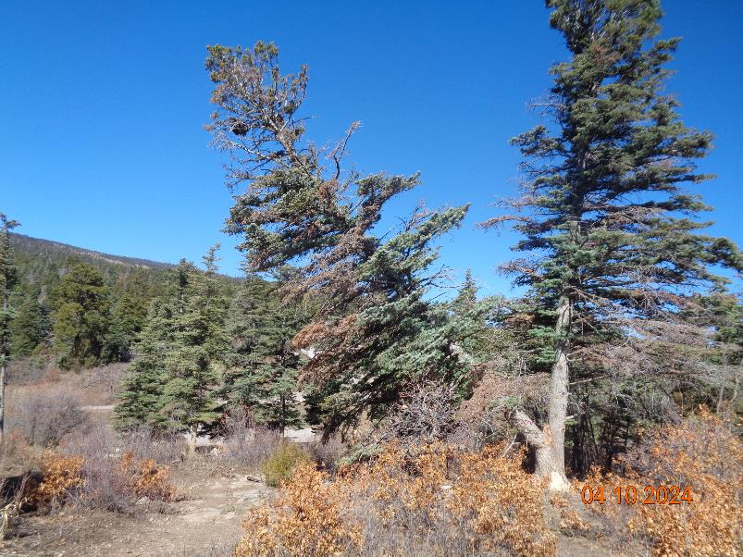

The left tree of the forked tree is falling. Photo by Sam Beard

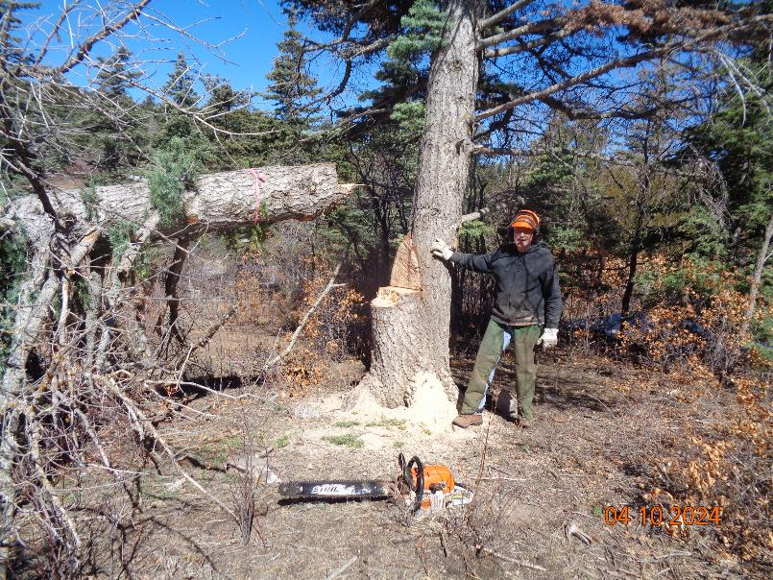

Eric standing at the stump of the tree he felled. Photo by Sam Beard

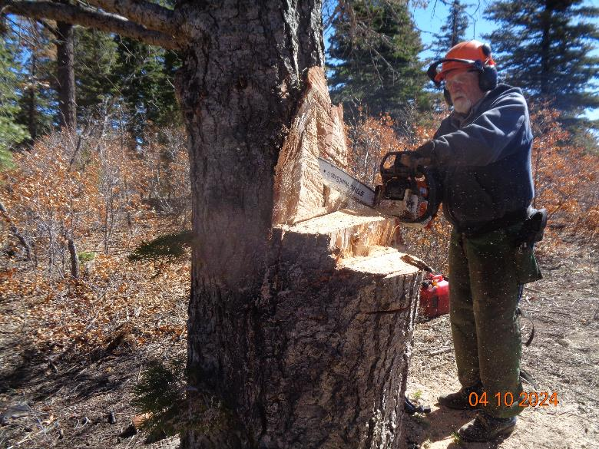

Jerry sawing off a slab so that we could see if the bark was still on the left trunk. Photo by Sam Beard

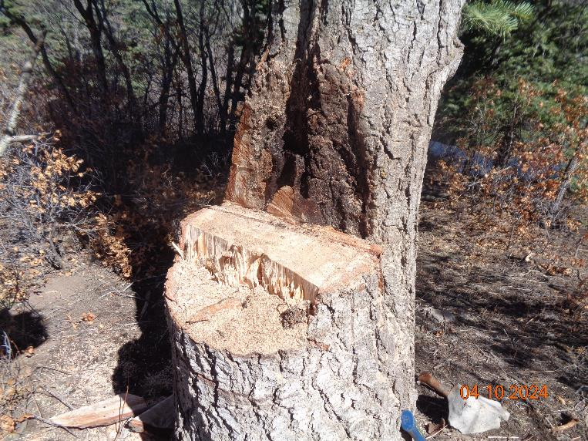

The black material is the bark of the trunk that was not felled. The presence of the bark proved that there was included bark between the

two trunks of the forked tree. See the attached document that explains the significance of the bark and why forked trees with included bark are

considered hazard trees. Photo by Sam Beard

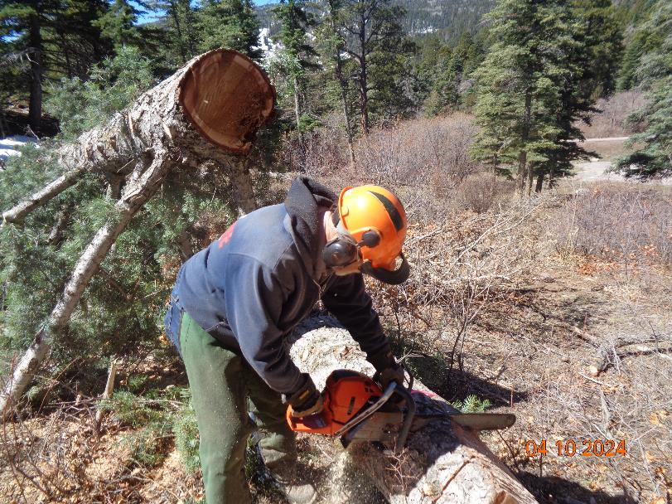

Eric bucking the large end of the trunk. Photo by Sam Beard

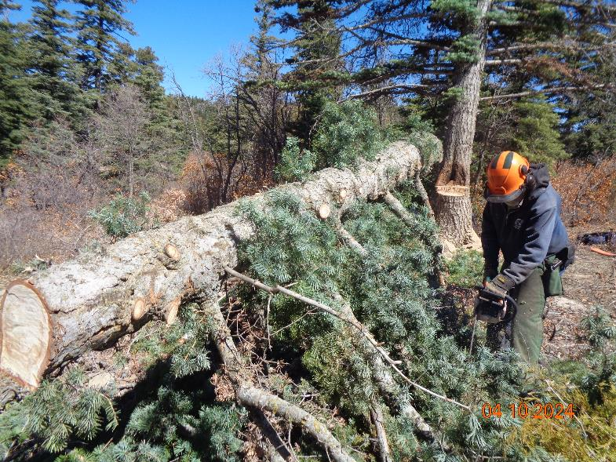

Eric limbing the felled hazard tree. Photo by Sam Beard

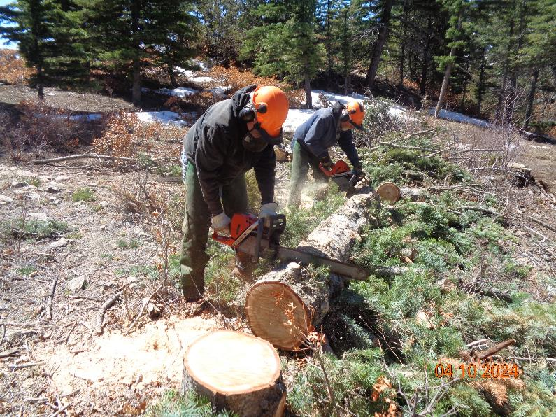

Eric and Jerry bucking the heavy trunk after it was safely on the ground. When the trunk was shorter and the sawyers were possibly too close,

Jerry stopped bucking, and Eric completed the bucking. Photo by Sam Beard

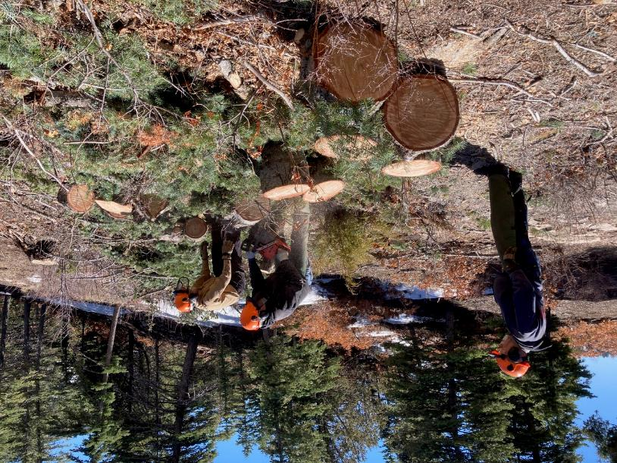

Jerry observing Eric bucking a round and Sam moving another round. Photo by Cliff Giles