**Report of Fence Repair and Felling Hazard Tree in Doc Long Picnic Area**

**And Felling Hazard Tree in Balsam Glade Picnic Area**

**on Wednesday, April 17, 2024**

Sam Beard

On Wednesday, April 17, ten FOSM volunteers completed the following tasks:

1. Replaced two broken fence rails and felled a hazard tree in Doc Long Picnic Area.
2. Felled the second trunk of the forked hazard tree in Balsam Glade Picnic Area.

The volunteers were Byron Garner, Dan Benton, Cliff Giles, Karen Greif, Jamey Browning, Jerry Carroll, Eric Russell, Sim Cook, Don Carnicom, and Sam Beard.

Project photographs are presented below.

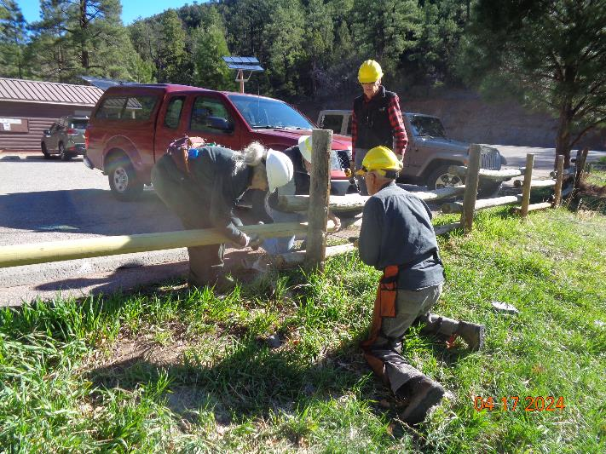

Dan Benton drilling through the post into the new lower pole being held by Karen Greif and Byron Garner.

Photo by Sam Beard

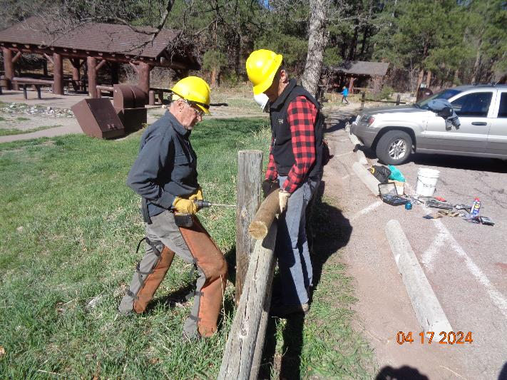

Dan drilling into the upper rail being held by Sim Cook. Photo by Sam Beard

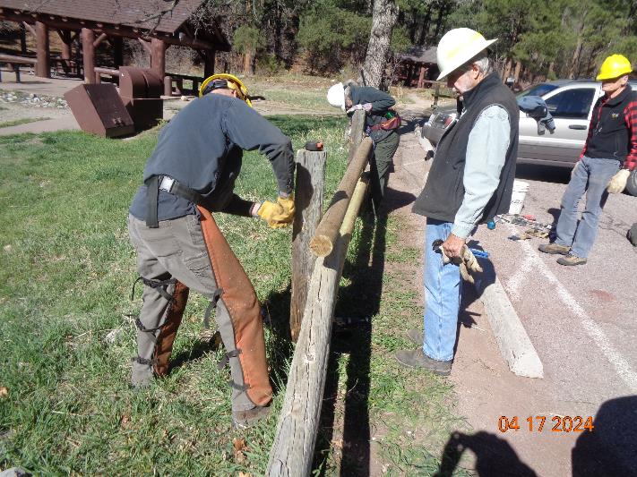

Byron observing Dan tightening the nut on the ½-inch diameter threaded rod securing the rail.

Photo by Sam Beard

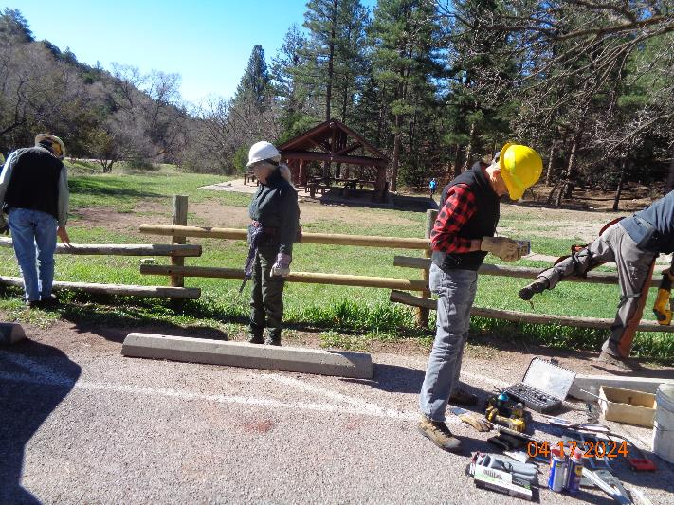

The crew after completing the installation of the two rails. Photo by Sam Beard

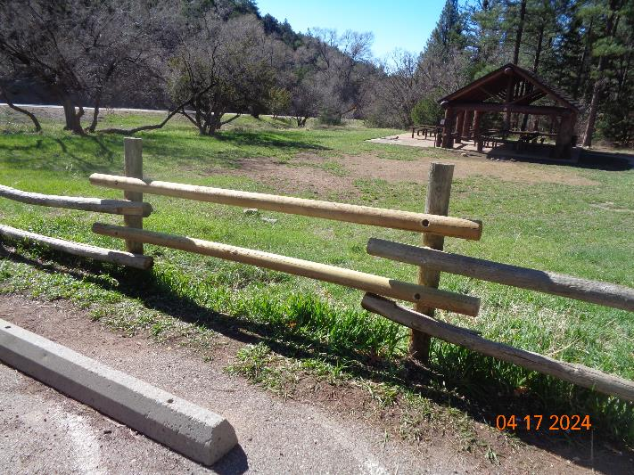

Both replacement rails have been installed. Photo by Sam Beard

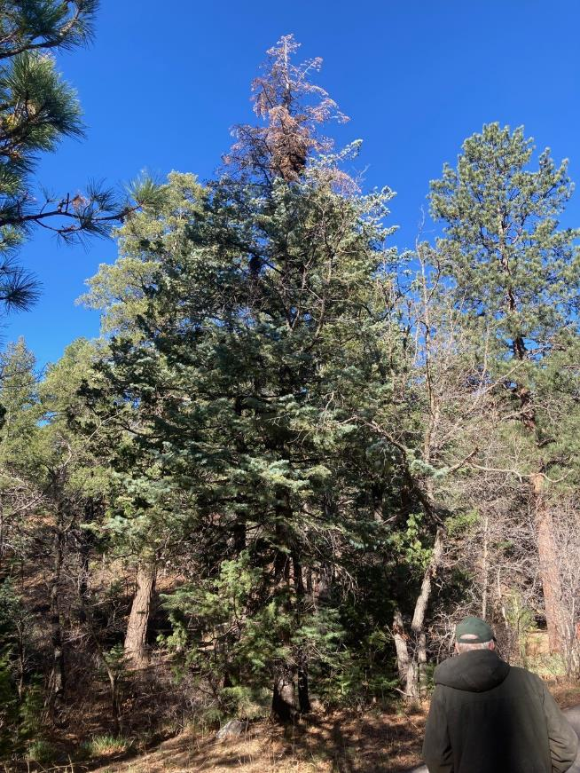

Hazard tree with dead top in the upper part of Doc Long Picnic Area. Photos by Cliff Giles

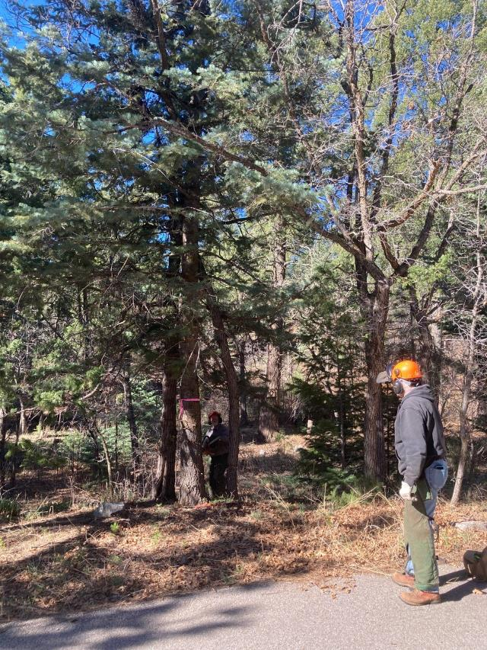

Eric Russell observing Jerry Carroll at base of white fir hazard tree. Note the two other tree near the hazard tree:

a Rocky Mountain juniper left of the flagged tree and a small oak right of the hazard tree.

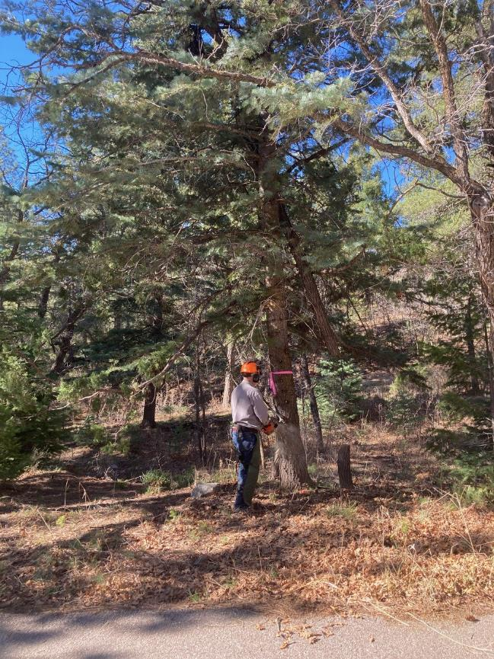

Jerry has cut a 5-foot piece out of the oak and is making a face cut on the hazard tree.

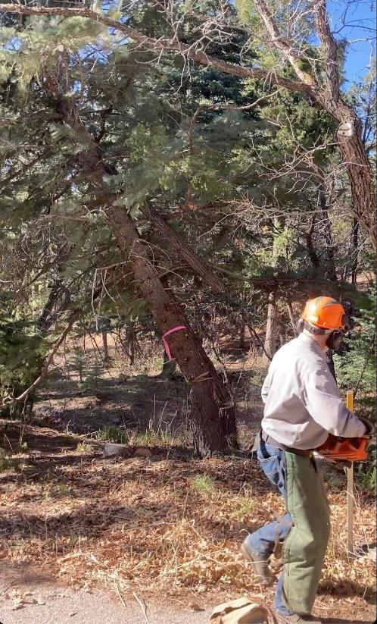

The white fir, oak, and Rocky Mountain juniper are falling as Jerry runs away from the trees.

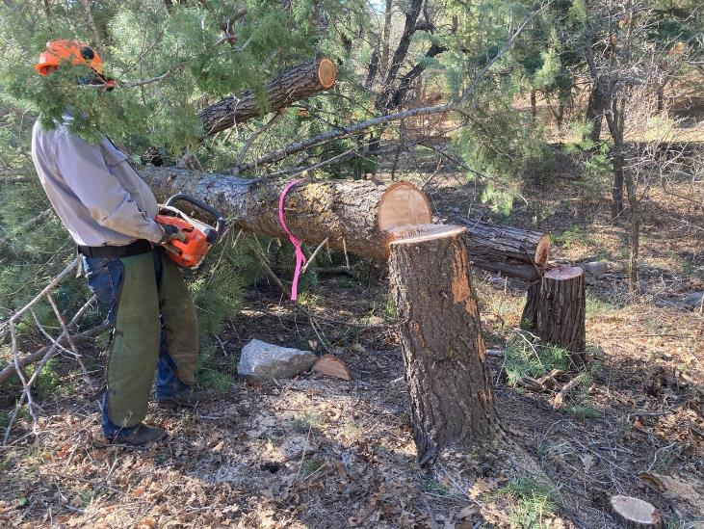

Jerry is limbing the three felled trees.

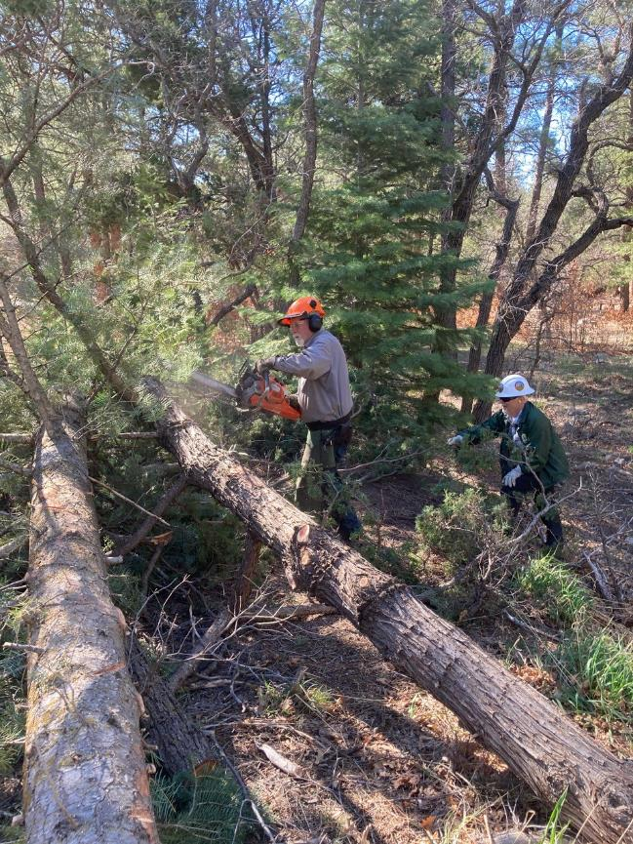

Jamey Browning is swamping for Jerry who continues to limb the three trunks.

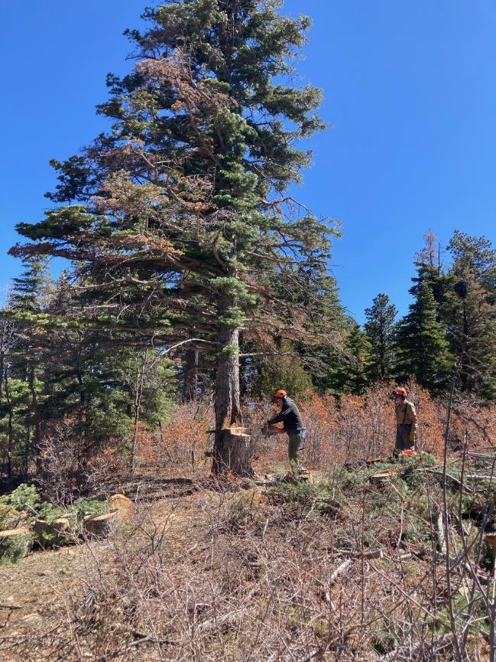

Eric Russell is removing the 4-inch-high step in the stump where the first white fir tree was felled earlier

before Byron Garner felled this hazard tree in Balsam Glade Picnic Area.

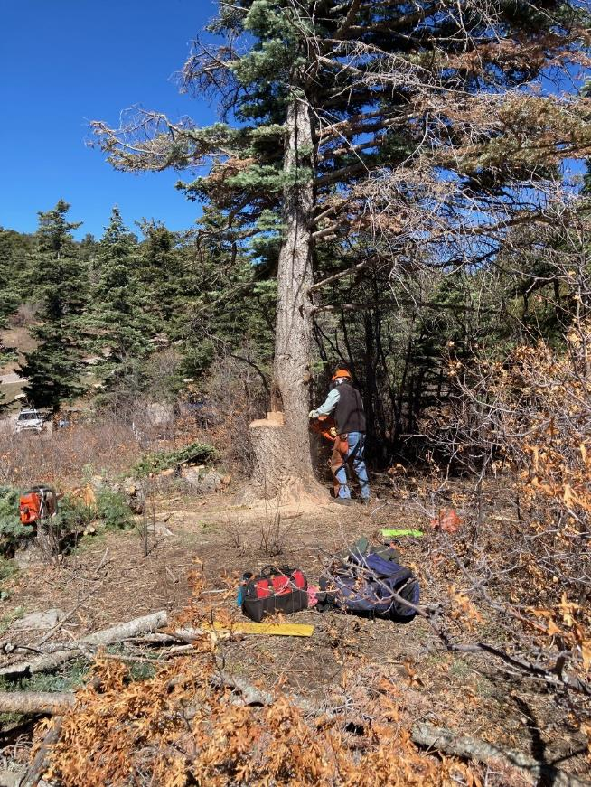

Byron is making the face cut in the white fir.

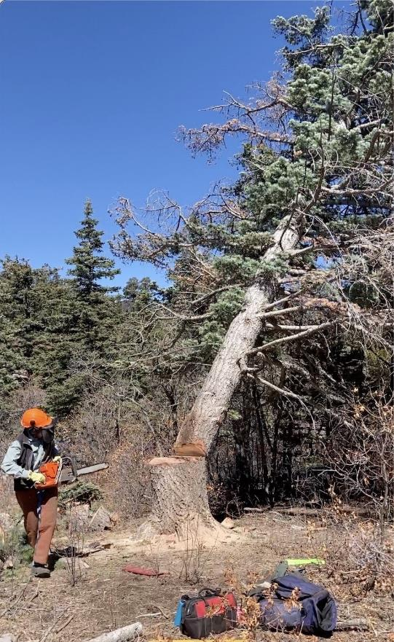

The white fir is falling as Byron runs away from the stump.

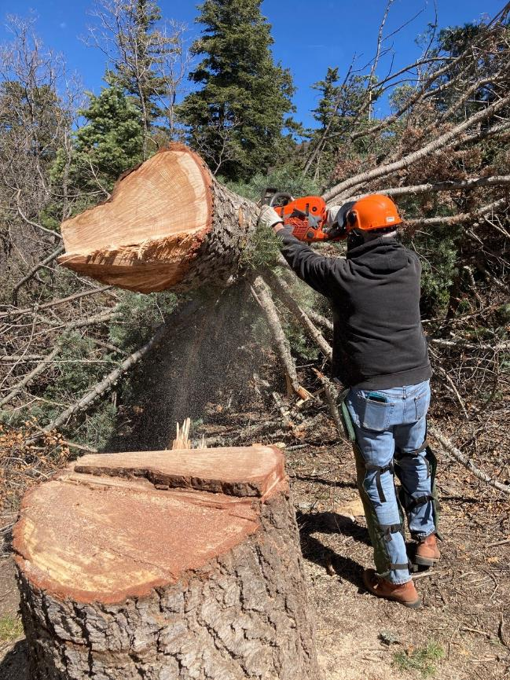

Eric is bucking the large lower end of the trunk to reduce the weight before it is limbed.

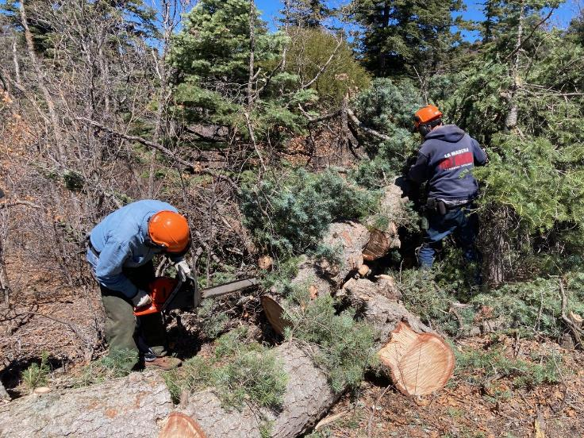

Eric and Jerry are completing the task of limbing after all of the trunk was on the ground.

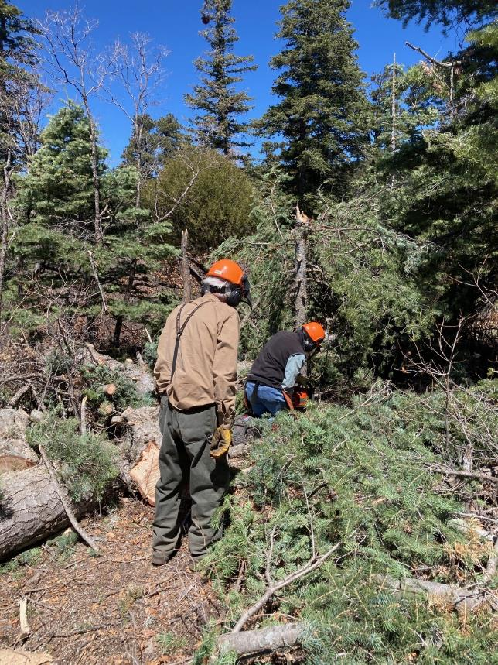

Sam is observing Byron felling the small white fir that was hit by the falling hazard tree.

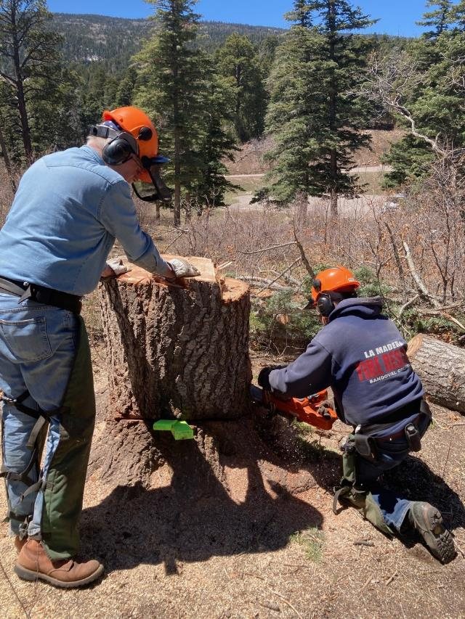

Eric is observing Jerry who is cutting the white fir stump lower.

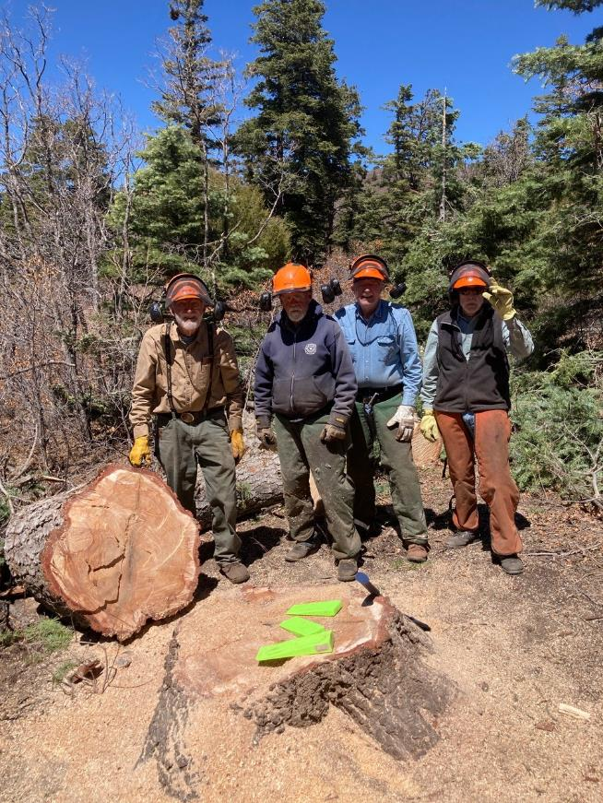

L to R: Sam Beard, Jerry Carroll, Eric Russell, and Byron Garner standing behind the low-cut stump.