**Report of FOSM Project to Buck, Split, and Haul Donation Wood**

**from Three Picnic Areas to Church Woodlot on Wednesday, April 24, 2024**

Sam Beard

On Wednesday, April 24, ten FOSM volunteers processed donation wood in Cienega, Doc Long, and Balsam Glade Picnic Areas and hauled five loads to the Mountain Christian Church woodlot at Mike Oliver’s home south of Frost Road in the East Mountains. Church Wood Ministry volunteers will donate the wood to East Mountain families who heat their home with wood.

The volunteers were Sam Beard, Scott Dietrich, Rene Archer, Sim Cook, Lou Romero, Joe Meade, Dan Benton, Jerry Carroll, Eric Russell, and Cliff Giles.

Project photographs are presented below.

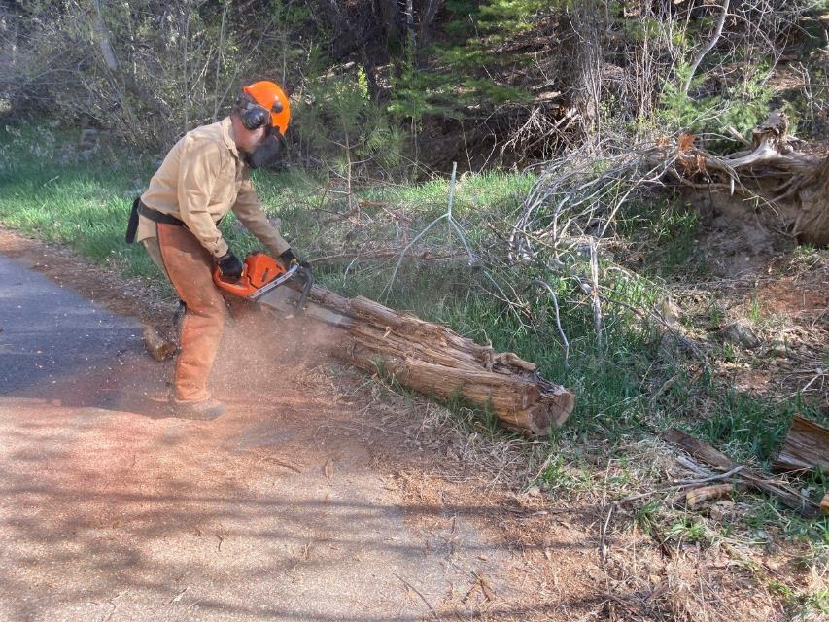

Scott Dietrich bucking a Rocky Mountain juniper trunk in Cienega PA. All photos by Cliff Giles unless noted otherwise

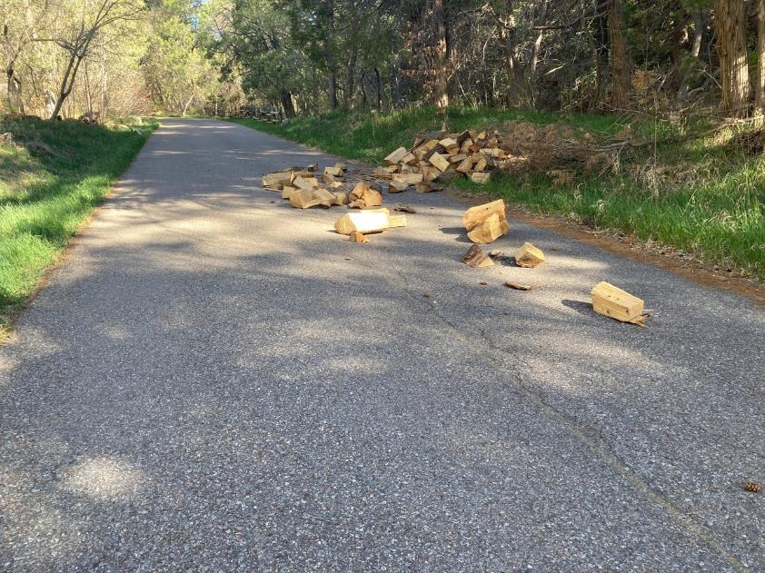

In the past week someone had scattered the stacks of wood that volunteers had made earlier, and one piece was even in the creek.

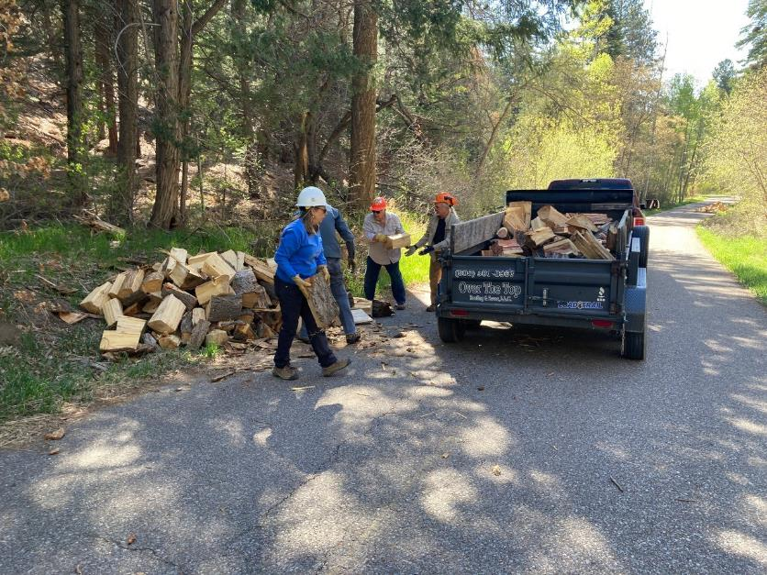

Volunteers loading split wood on Joe Meade’s trailer in Cienega PA. L to R: Rene Archer, Lou Romero, and Joe Meade.

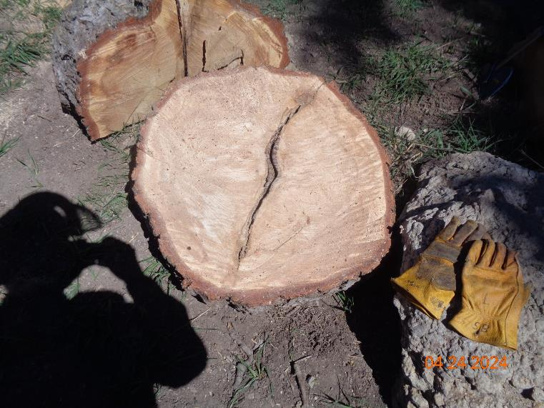

The base of the large forked tree in Balsam Glade PA. The two dark layers of bark in the center of the round show that the forked

tree was actually two trees that had grown together. As the two trees grew larger, the force of the trees against

each other caused an almost straight joint to form where the bark of the two trees met. The horizontal force of the

two trees forced the wood at the joint outward so that only one round shape was formed, instead of two cylinders.

Photo by Sam Beard

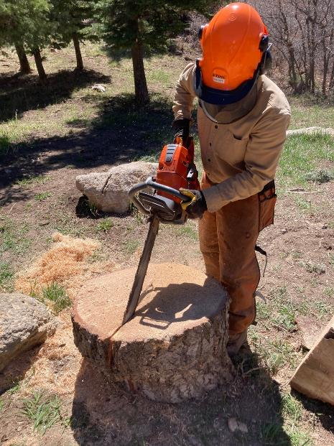

Scott is cutting this large round into two pieces so that it would be easier to put the wood on the splitter.

Photo by Sam Beard

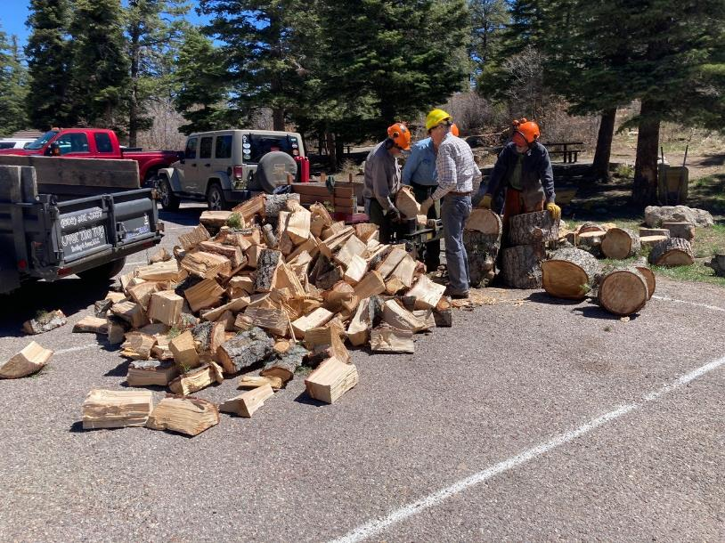

Splitting wood at Balsam Glade PA with Lou Romero’s power splitter. L to R: Jerry Carroll, Eric Russell, Sim Cook, and Dan Benton.

Photo by Cliff Giles

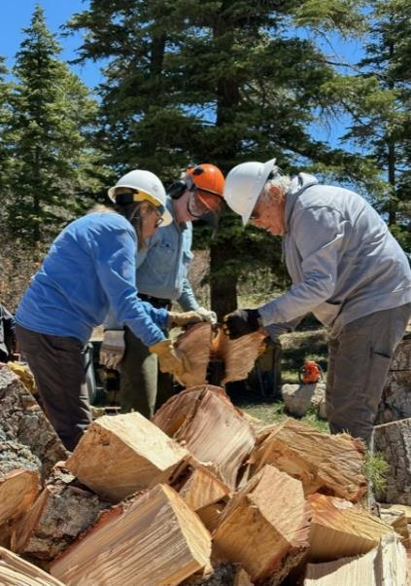

L to R: Rene Archer, Eric Russell, and Cliff Giles. Wednesday was the first day

that Rene had placed wood on the splitter. Photo by Scott Dietrich

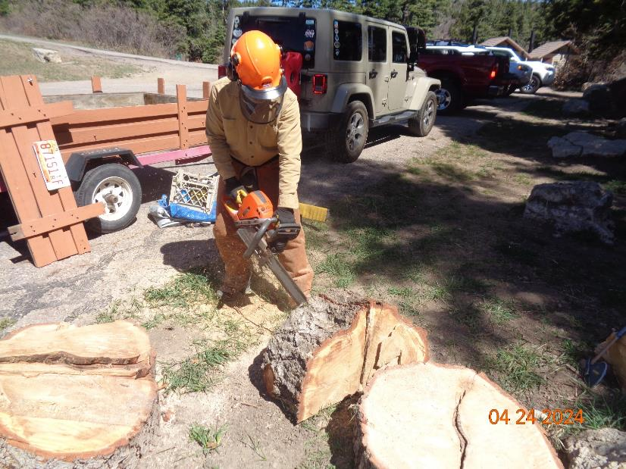

Scott cutting a large round into four pieces. Photo by Sam Beard

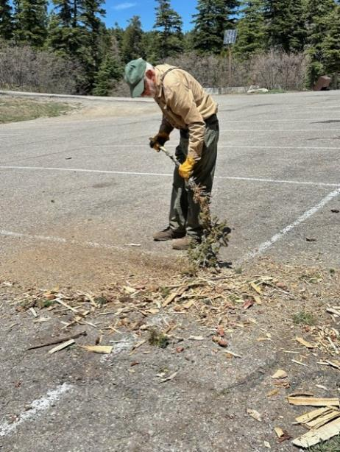

Sam Beard sweeping the wood chips off of the Balsam Glade PA parking lot

with a white fir branch. Photo by Scott Dietrich

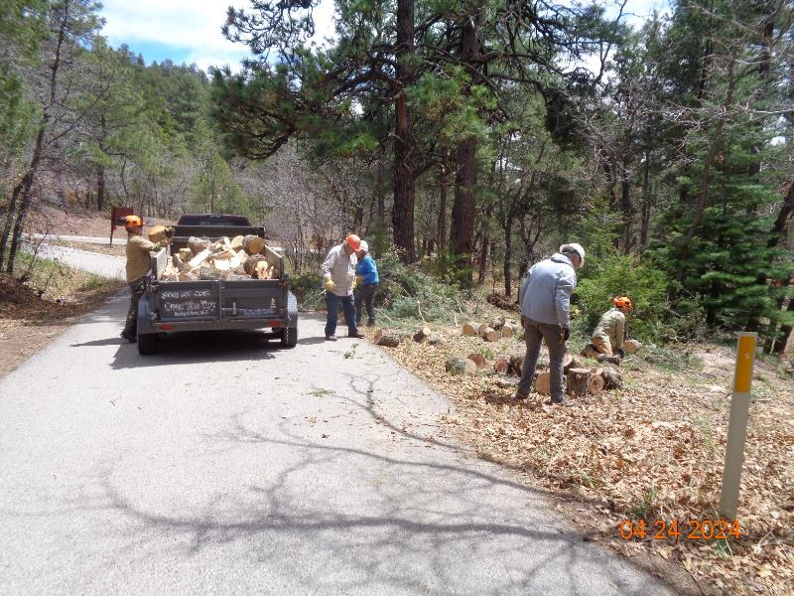

L to R: Scott Dietrich, Lou Romero, Rene Archer, Cliff Giles, and Joe Meade loading split wood onto

Joe’s trailer. Photo by Sam Beard

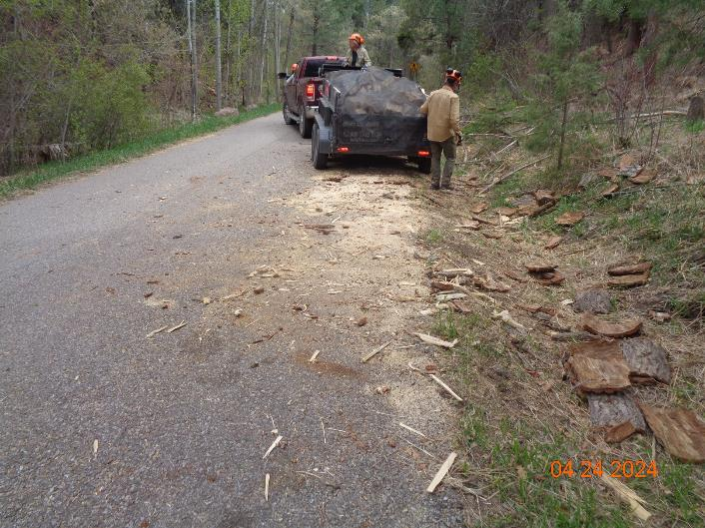

The last load of wood in Cienega PA is ready to take to the wood lot.

Photo by Sam Beard

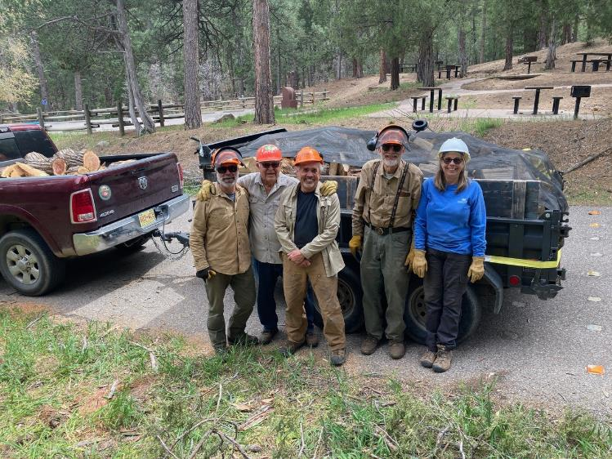

L to R: Scott Dietrich, Lou Romero, Joe Meade, Sam Beard, and Rene Archer at this load of wood in both Joe’s pickup

and trailer, approximately 1.5 cords of donation wood. Photo by Cliff Giles