Thursday, April 25, 2024 had 8 volunteers working with Jen and Dorothy from SRD on the Lower Pine Trail. We split into 2 groups and one group went up to the Tablezon junction to put in new signage and add a few finishing touches. The other group worked reroute sections on the Lower Pine Trail. A few check dams were added where some of the old trail was deeply eroded.

Volunteers were: Roland Stumpf, Eric Russell, Bruce Hansche, Laura Leon, Bill Perkins, Luis Cuadros, John Braly and Claudia Bergsohn.

Pictures taken by Roland Stumpf and Laura Leon.

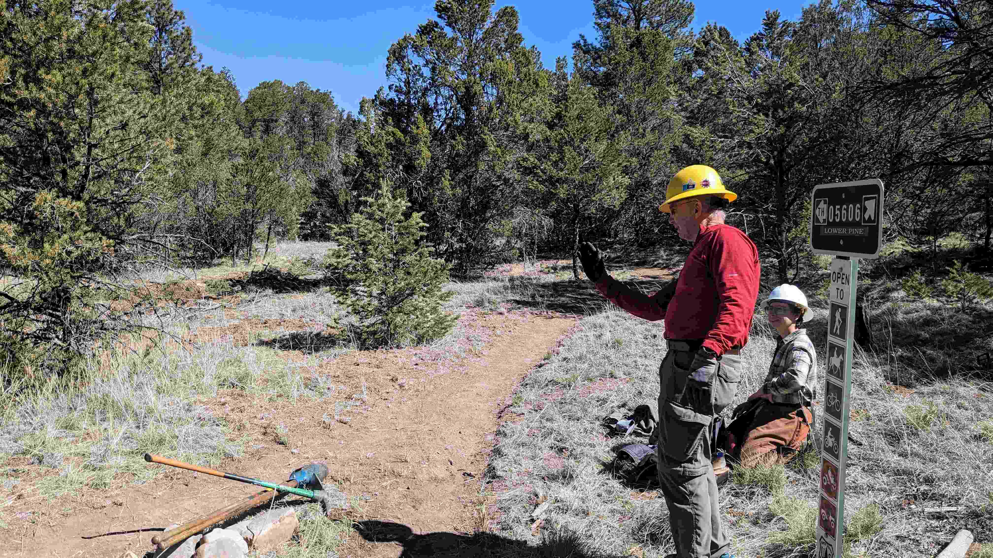

John and Jen get the junction just right.

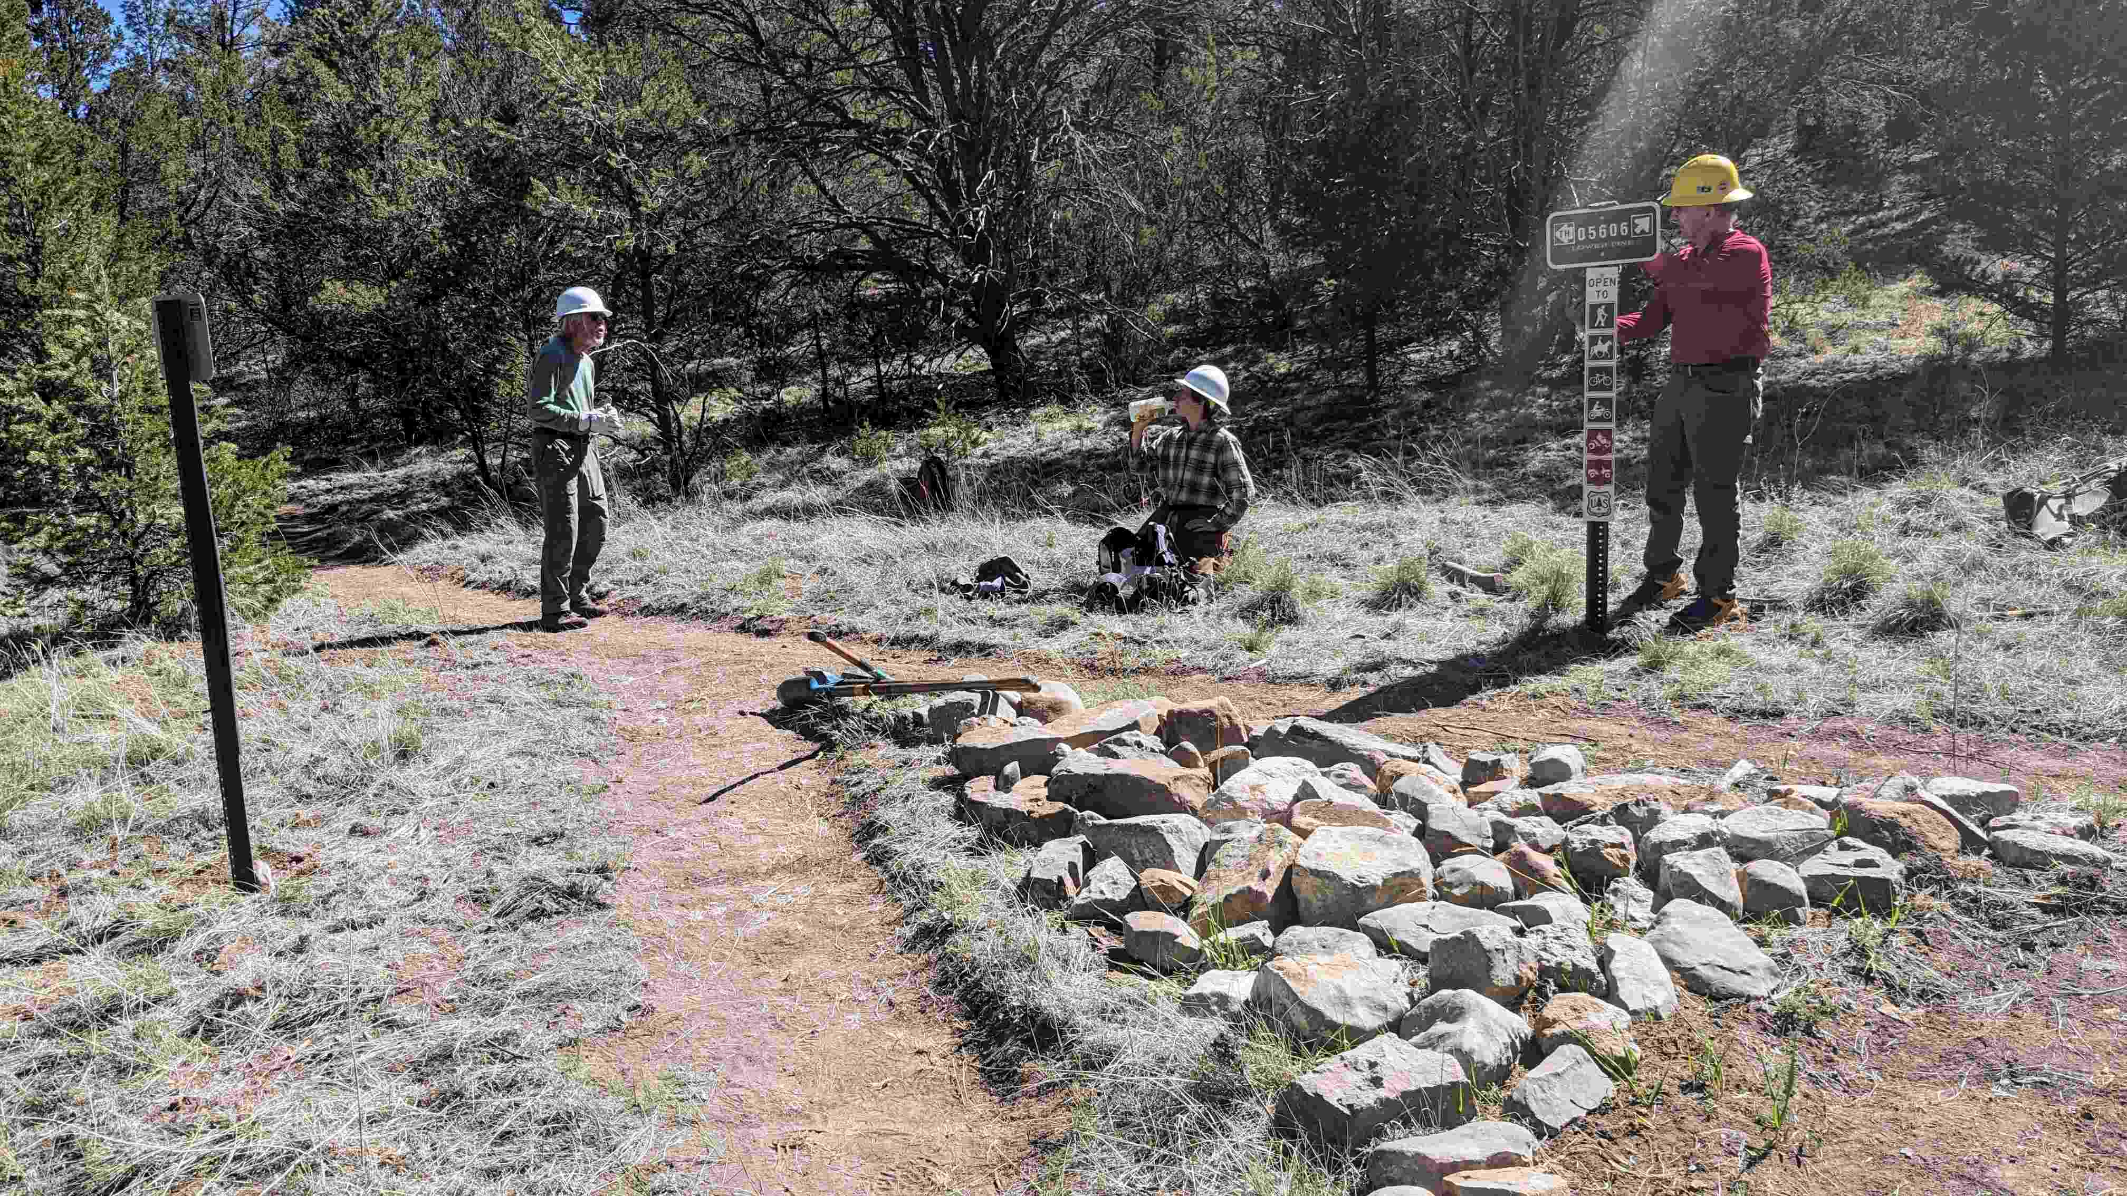

Bill, John and Jen at work creating a beautiful intersection.

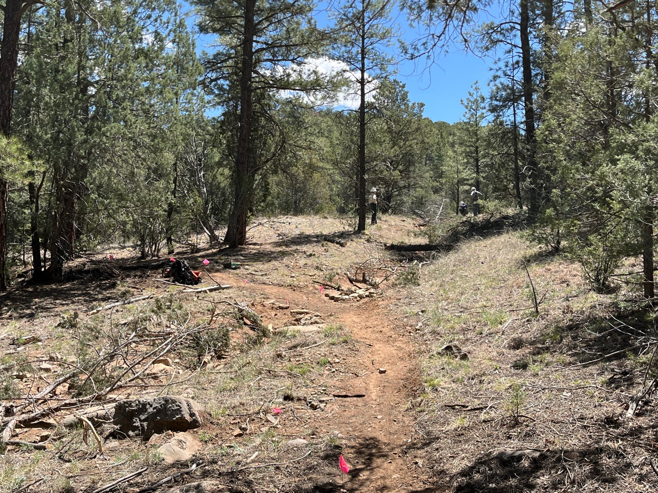

New trail and old obliterated trail with check dam work.

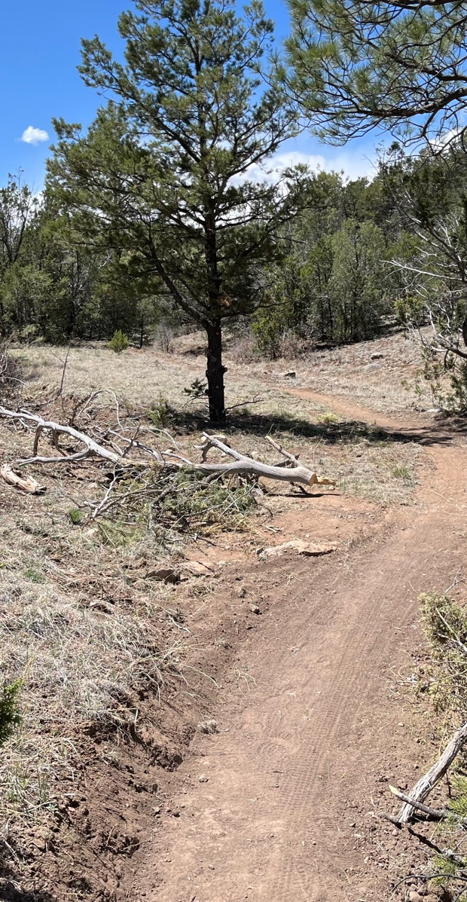 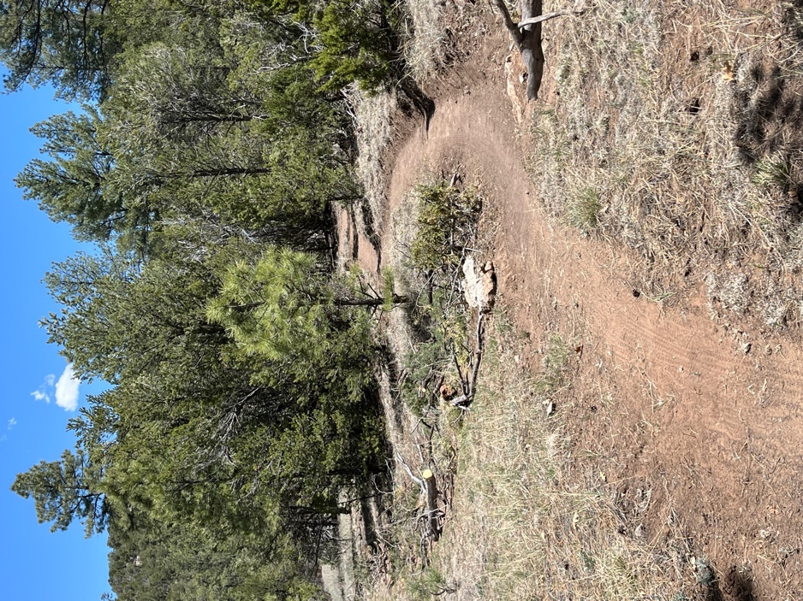

New trail cuts across old, obliterated trail. Lots of bike tire tracks on the new trail!

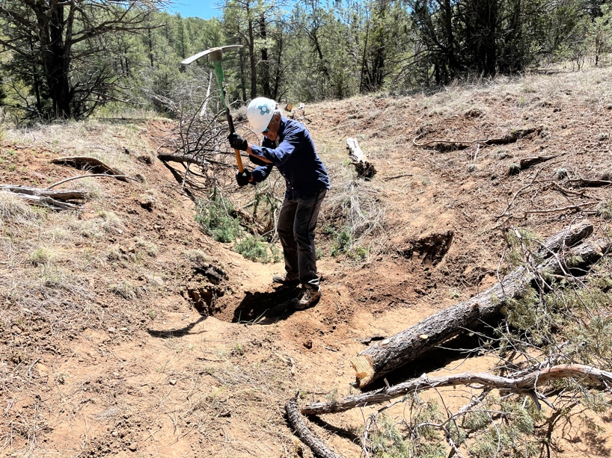

Luis digs notches for one of the check dams.

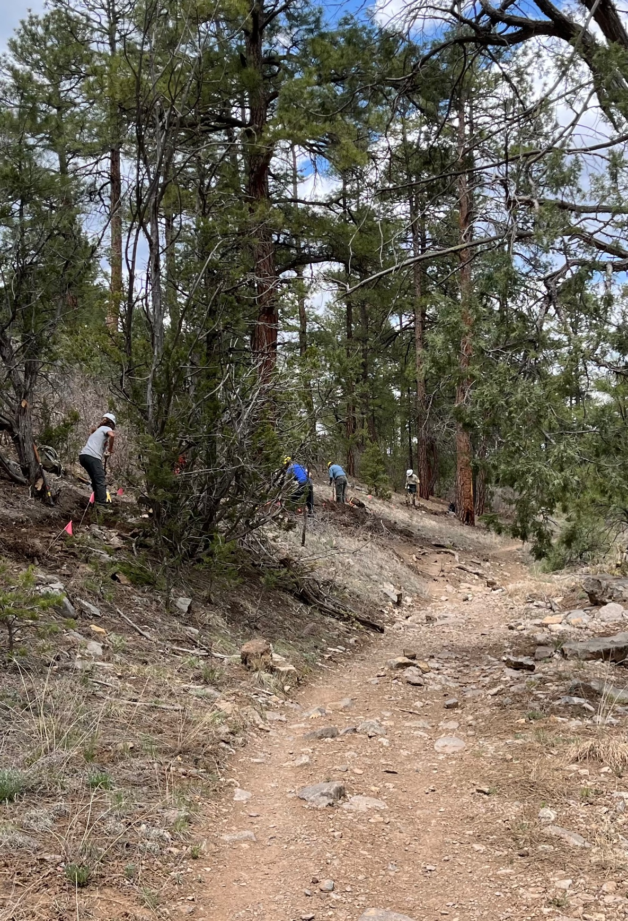

The crew working on new tread above the old trail.