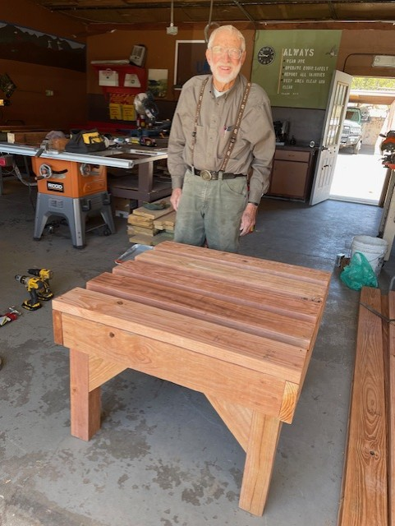

Rain barrel stand built by Don Carnicom and Sam Beard on Wed., May 1, 2024

In SRD wood shop. Photo by Don Carnicom