**Report of FOSM Project on Wed., May 8, to Complete Construction of Three Water Barrel Stands**

**That Will be Installed Behind the Ranger Station**

Sam Beard and Joelle Hertel

May 9, 2024

On Wednesday, May 8, seven FOSM volunteers completed construction of three water barrel stands that will be installed behind the Ranger Station to water local vegetation.

Most of the construction of the stands for 36-inch barrels had been done earlier. On the first 36-inch stand, one pressured treated 2x6 was installed below the five top horizontal 2x6s, and four corner pieces were cut and installed so that the barrel cannot slide off the stand. On the second 36-inch stand, corner leg braces and four retaining corner pieces were cut and installed. Construction of the complete 27-inch stand was done on Wednesday before lunch.

The volunteers working on this project were Joelle Hertel, Dan Benton, Ken Nicholson, Jerry Carroll, Sam Beard, Karen Greif, and Don Carnicom.

The following three tasks were completed after lunch:

1. **Cleanup of Cienega Picnic Area Nature Trail** – Karen Greif and Sam Beard swept the Cienega Nature Trail and threw the debris of on the low side of the paved path. We were surprised at the small amount of dirt and the small number of leaves and pine cones on the trail.
2. **Survey of Cienega PA for Piles of Fuel Wood** – We checked Cienega PA for piles of donation wood, because this picnic area will be opening soon. Any wood would possibly be stolen after the gates are opened. We found just one small pile of wood.
3. **Photographed Leaning Fence beside the Road to the Group Area** – The fence on the road leading to the Cienega Group Area leans away from the parking lot. FOSM is planning a project to install parking bumpers at the seven parking spaces so that vehicles will not hit the fence.

Project photos are presented below.

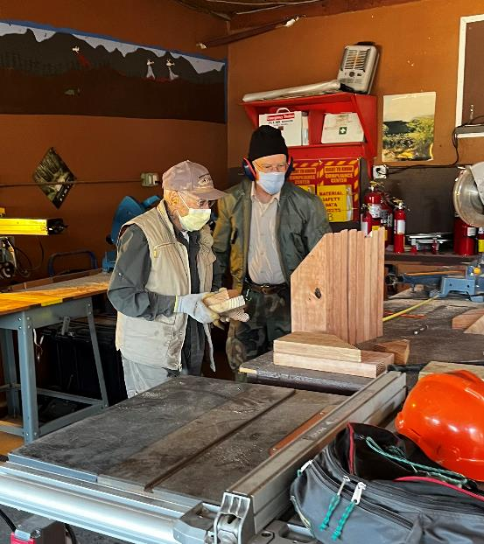

Don Carnicom and Ken Nicholson have just completed cutting eight leg braces for the second 36-inch stand. They are wearing

masks so that they will not breathe treated wood sawdust when cutting wood with the cutoff saw in the background that does not

have a vacuum to collect the sawdust. Photo by Joelle Hertel

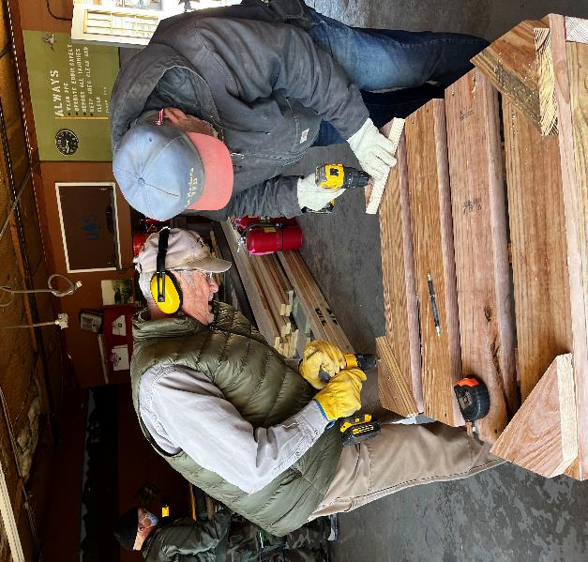

Dan Benton and Jerry Carroll are putting screws in retaining pieces on the stand top so that the barrels cannot

slide off the stand. Photo by Joelle Hertel

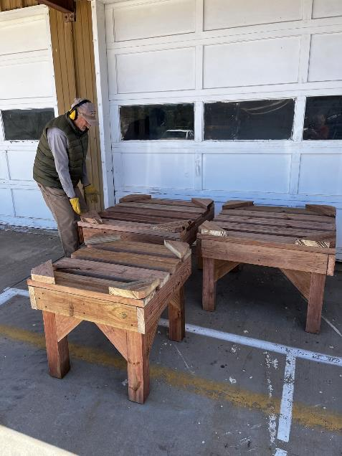

Dan has just helped move the heavy stands to the parking lot outside the wood shop.

Photo by Joelle Hertel

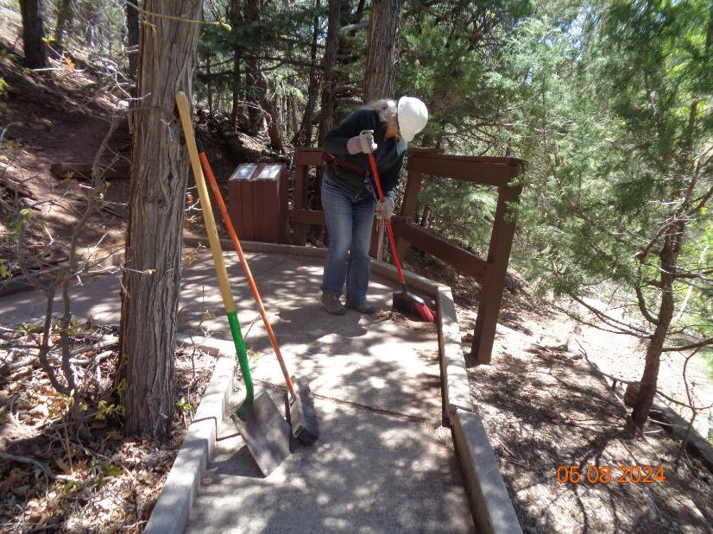

Karen Greif is sweeping the paved Cienega Nature Trail that is one of the trails adopted by FOSM.

Photo by Sam Beard

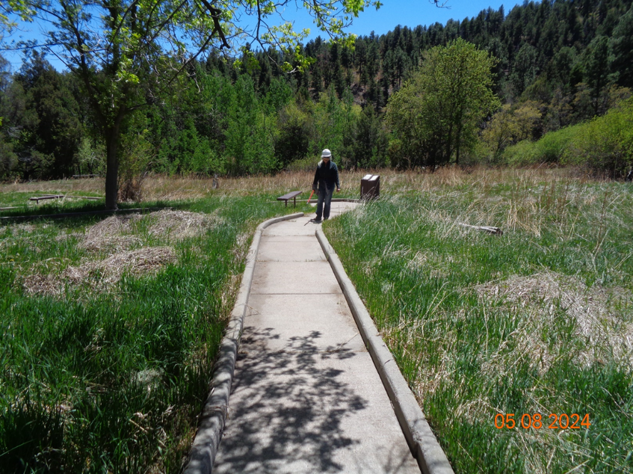

Karen on the Nature Trail where it passes through the “cienega” (wet meadow) in Cienega Picnic Area. Photo by Sam Beard

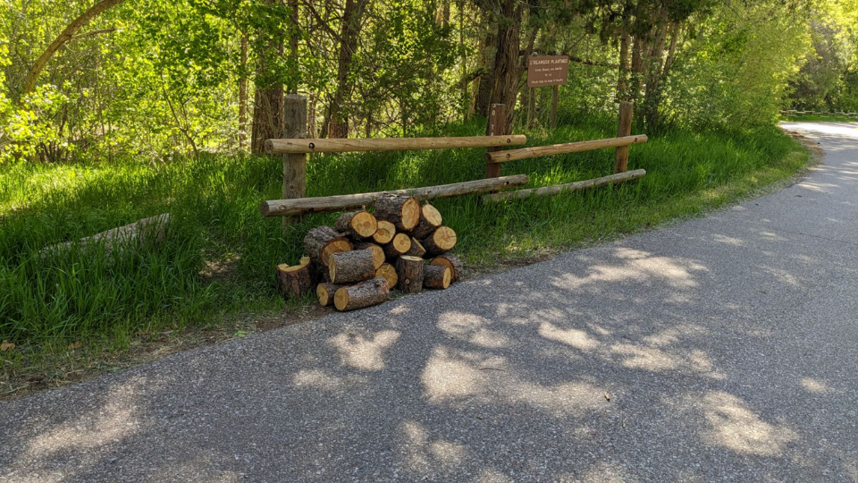

Small pile of bucked pine wood beside Cienega Picnic Area Road. We did not have a convenient way to haul it to the Ranger Station shop area;

therefore, we scattered it in the tall grass. We will collect it later, if it is not stolen. USFS photo

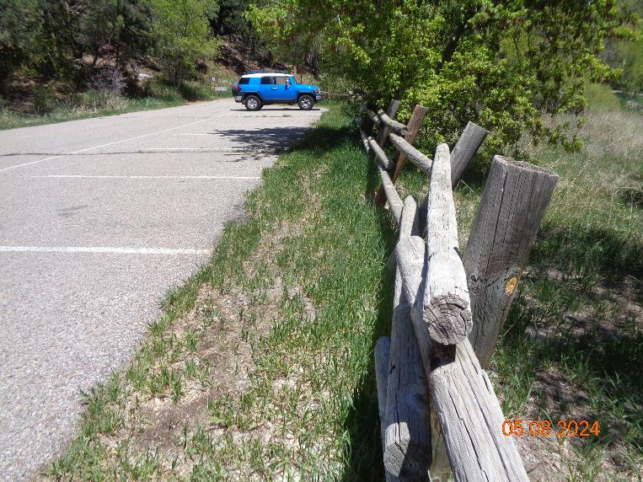

Leaning fence on the road to the Cienega PA Group Area. FOSM is planning to install parking bumpers at the seven

spaces so that the parked vehicles will not hit the fence. Photo by Sam Beard