**Report of FOSM Project on Wednesday, May 15, to Buck Trees Felled during the Recent Chainsaw Recertification near the Upper Tram Terminal**

Sam Beard

On Wednesday, May 15, six FOSM volunteers worked with Canyon Young, SRD Trails and Wilderness Programs Manager, to buck trees felled during the recent chain saw recertification near the upper tram terminal at the top of several downhill ski runs. A few dead trees selected by Canyon were also felled and bucked on Wednesday. The objectives of this project were to remove felled trees from the Sandia Peak Ski Area runs and buck logs near a road so that they can be split and hauled to a church wood lot next Wednesday. Six large dead trees were bucked and removed from ski runs.

The volunteers were Dan Benton, Eric Russell, Byron Garner, Sam Beard, Cliff Giles, and Jerry Carroll.

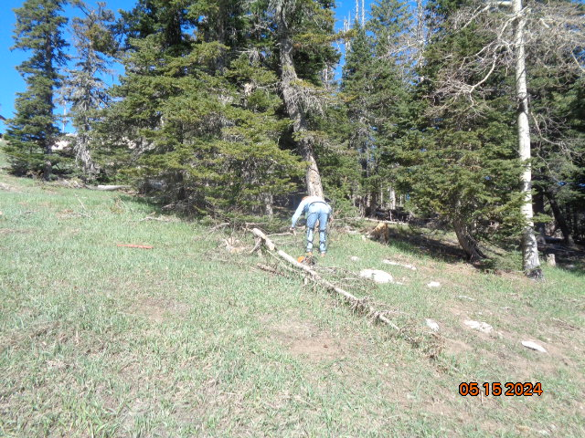

Eric Russell removing a tree from a ski run. Photo by Sam Beard

Ph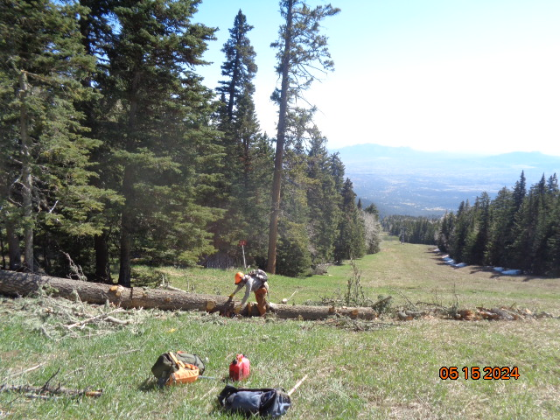

Dan Benton beginning to remove the very large tree that Michael Arndt felled during the recertification. Photo by Sam Beard

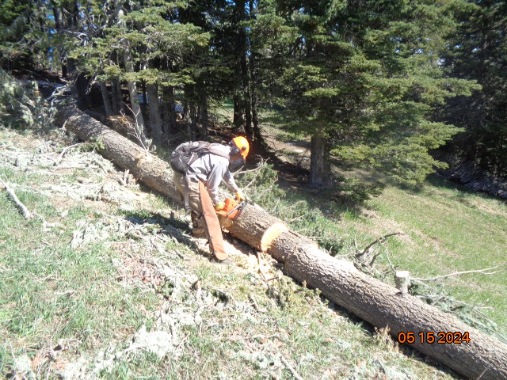

Dan bucking the tree into short pieces that could be rolled down the ski run to a place where they could be placed in the forest.

Photo by Sam Beard

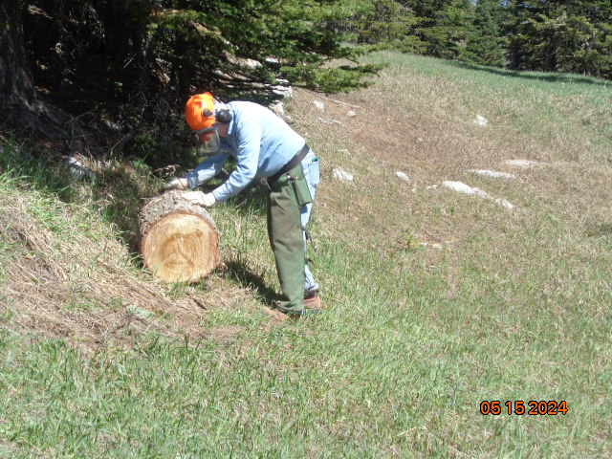

Eric carefully rolling a round to the forest in the background. Approximately three rounds that were rolled directly down

the ski run did not go to the forest but continued out of sight down the run. Photo by Sam Beard

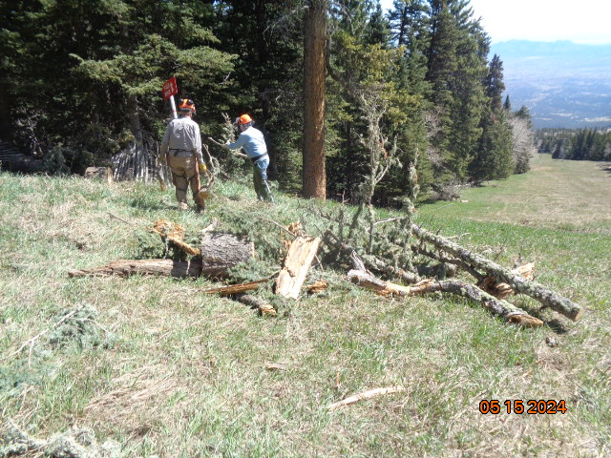

Dan and Eric removing the last pile of slash from the tree. Photo by Sam Beard

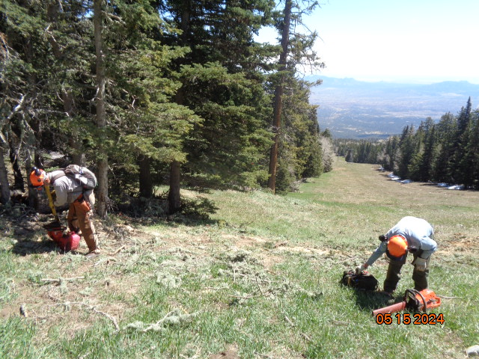

The tree felled into the ski run has been removed. Photo by Sam Beard

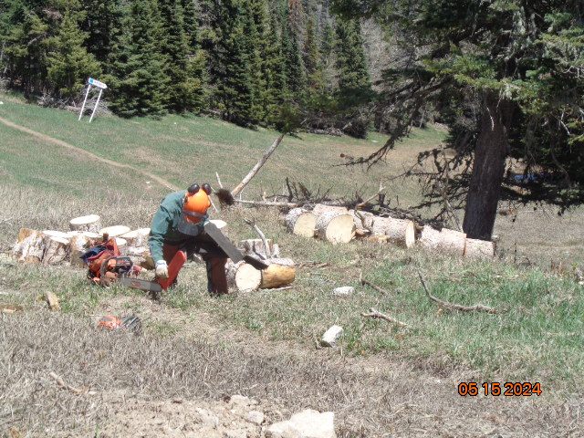

Canyon felled and bucked a very tall spruce that was near a ski run, and the rounds were collected near a tree.

Byron Garner is putting a bar cover on a chainsaw. Photo by Sam Beard

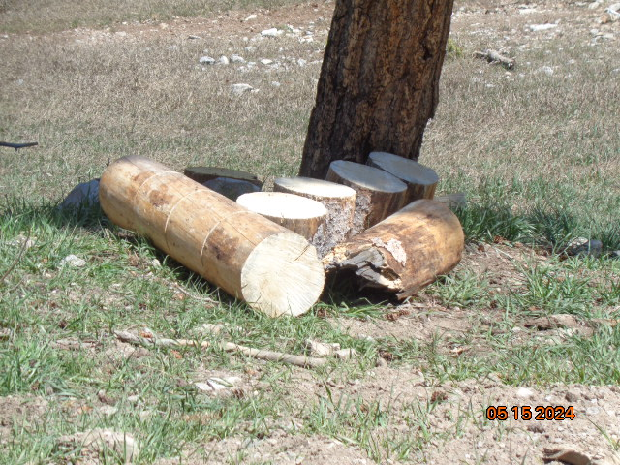

Rounds from another tree were piled at this tree near a road. Photo by Sam Beard. Following photos by Cliff Giles

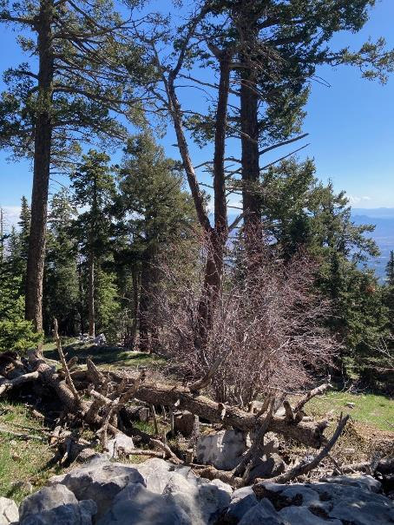

Dead forked tree to be felled by Jerry Carroll.

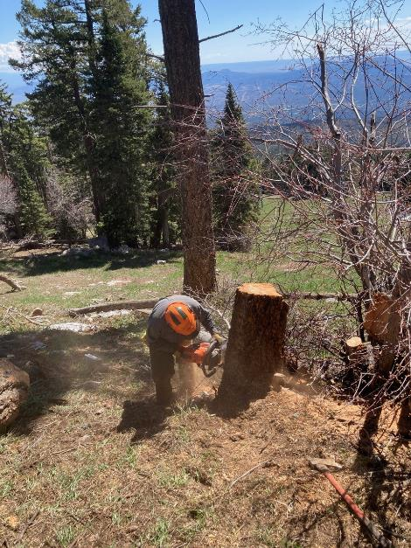

Jerry is cutting the stump lower to make the area more attractive.

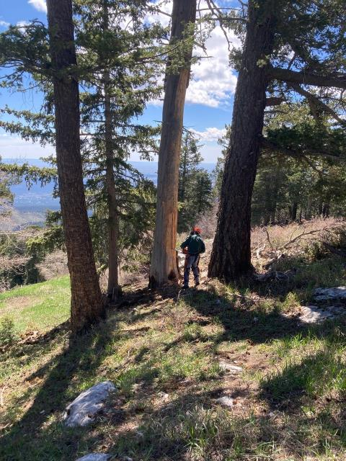

Byron Garner making the face cut in a 22-in tree.

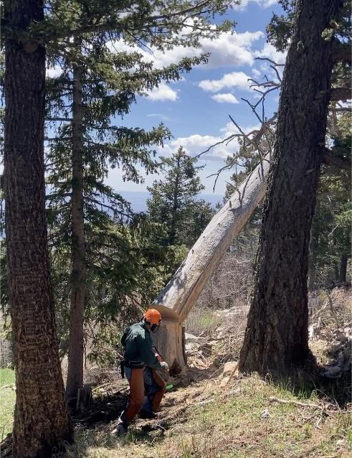

Byron running away from the falling tree.

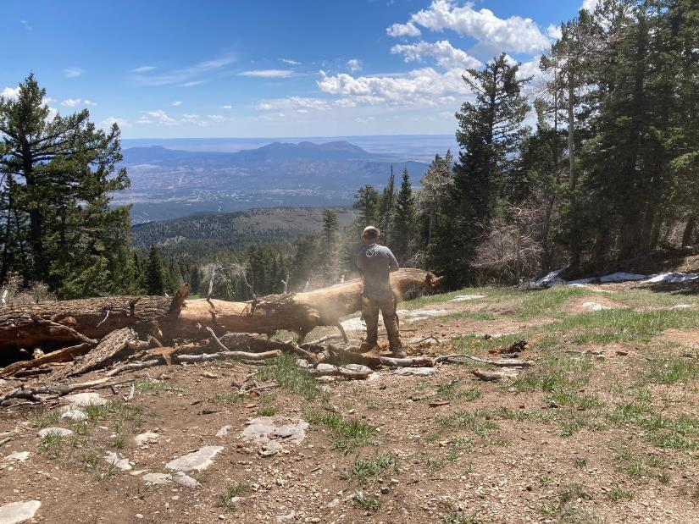

Canyon Young bucking large tree felled by Byron so that it can be moved off of a ski run.

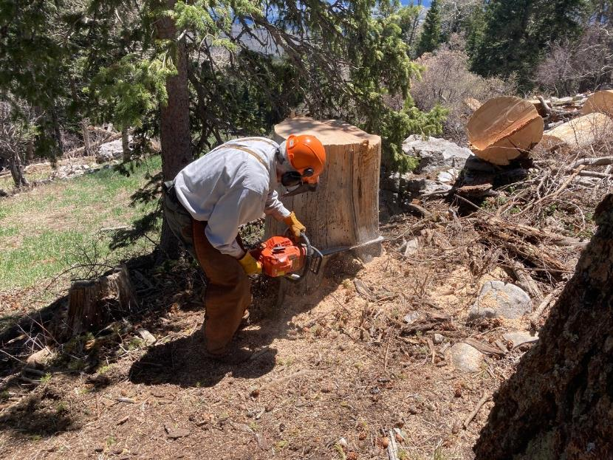

Sam Beard low stumping the tree felled by Byron.

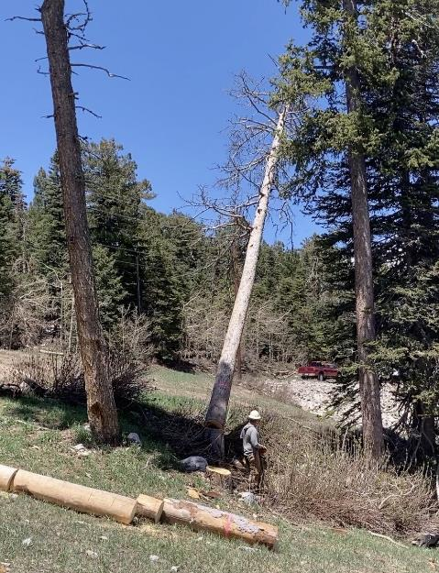

Canyon running away from the tall Englemann spruce that he has just felled.

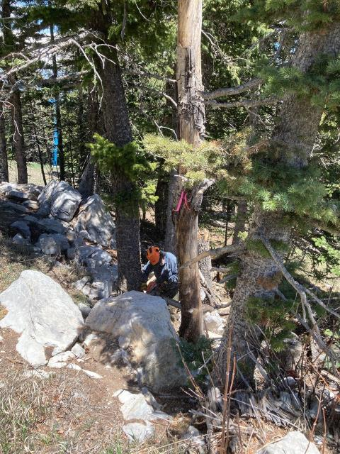

Jerry making the face cut in a dead aspen.

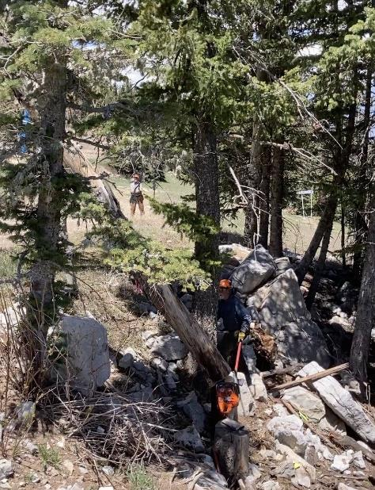

The stubborn aspen wobbled and moved enough to bind Jerry’s saw.

Jerry then used a wedge to lift the tree off his saw and the stump.

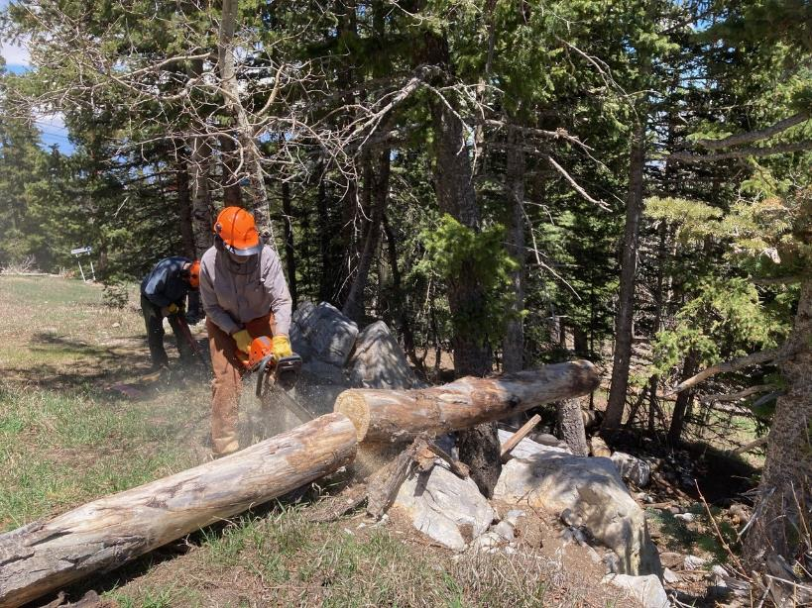

Dan Benton bucking the aspen felled by Jerry. The grassy open areas are part of ski run.