Thursday, May 23, 2024 had the FOSM team back on the Lower Pine Trail rerouting sections. The weather is warming up so we are hoping to finish this trail soon and head up the mountain to cooler and shadier work. The rain last week kept us from our work but this week that same rain created a burst of vegetation and flowers that made for an enjoyable walk to the work area. We were able to make good progress with 11 volunteers.

Volunteers included: Jim Houle, Bruce Hansche, Claudia Bergsohn, John Braly, Luis Cuadros, Rich Feddersen, Laura Leon, Mike Madden, Eric Russell, Byron Garner, and Roland Stumpf.

Pictures by Roland Stumpf, Bruce Hansche and Laura Leon.

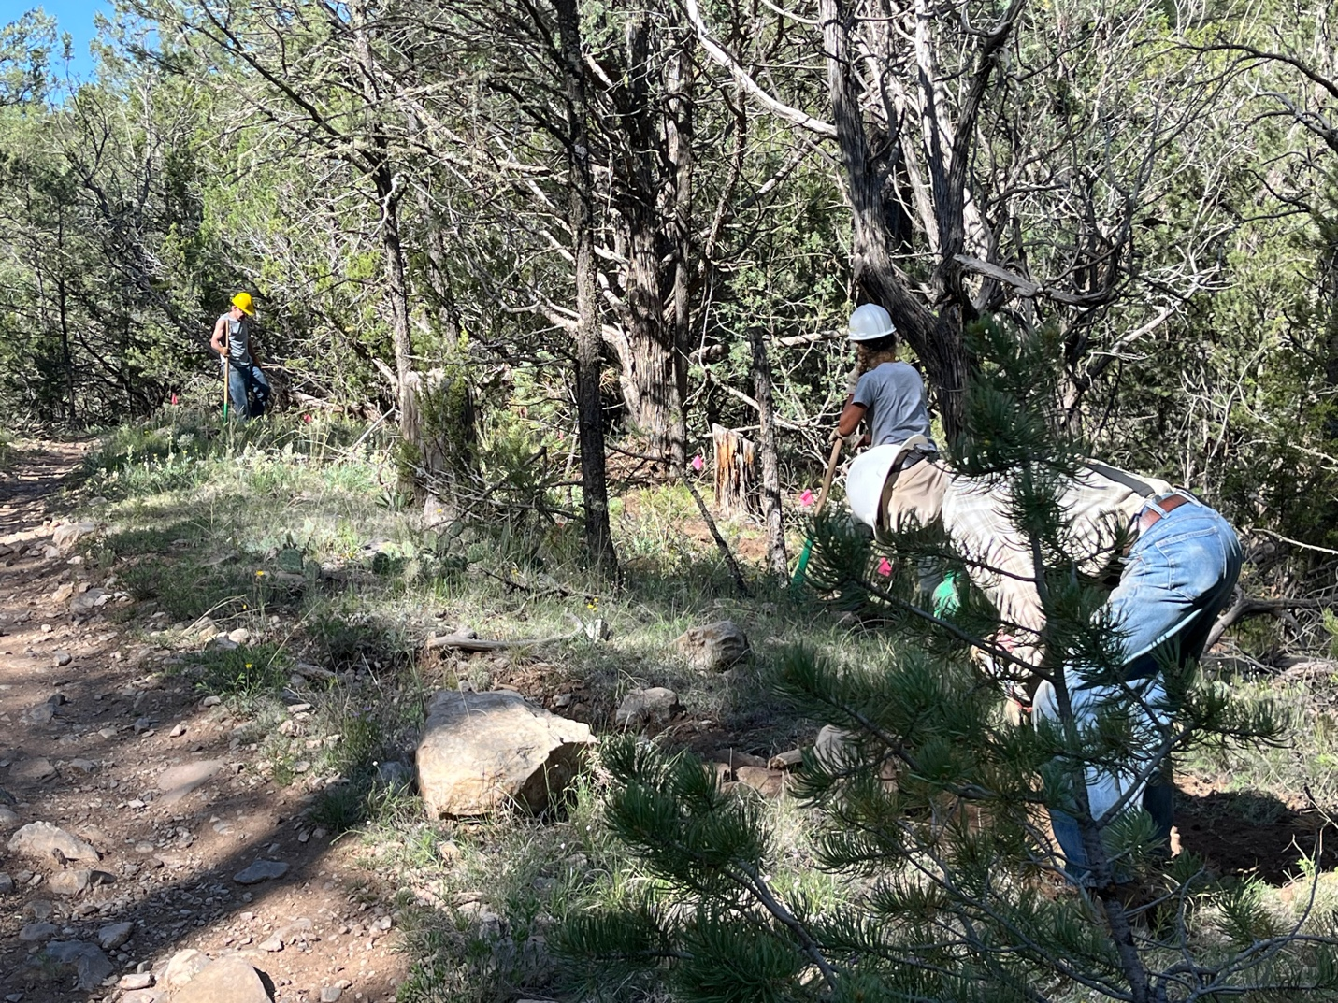

Bruce, Claudia and Rich work on a short section of reroute. Claudia had a nice big stump to pull. Bruce was handling rocks. So many rocks…

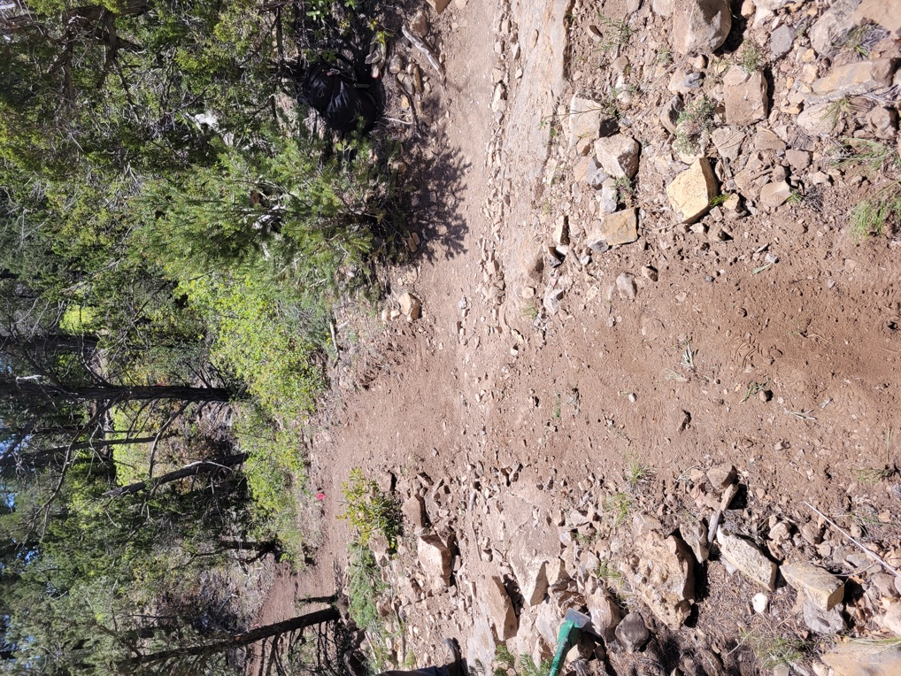 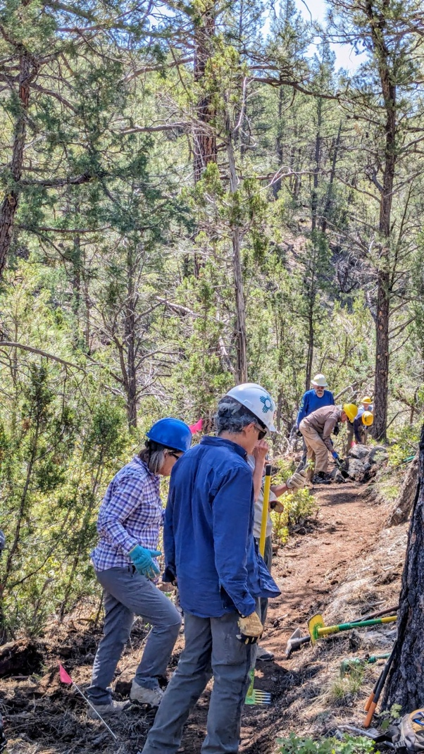

Old trail and new trail cross. Laura and Luis looking at ?? while Jim and

Mike move boulders in the background.

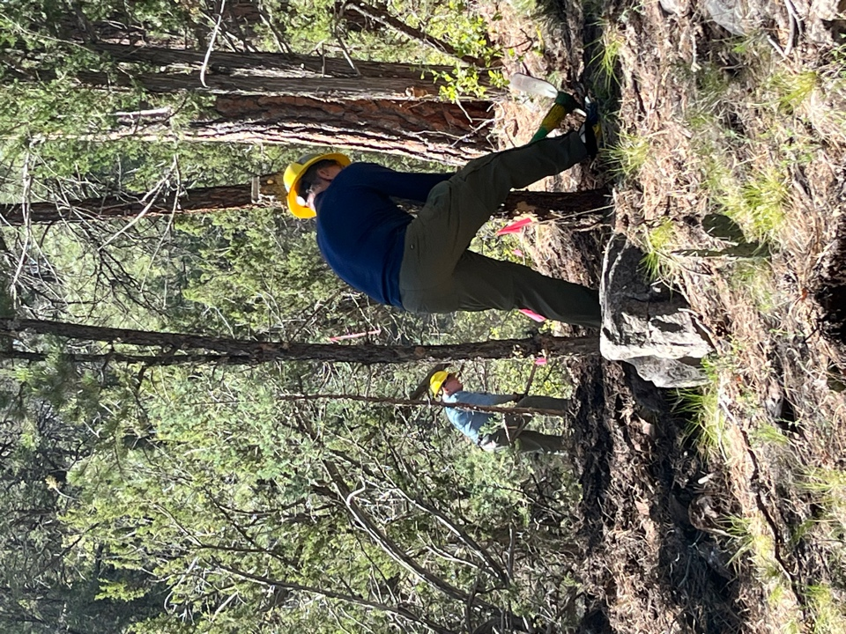 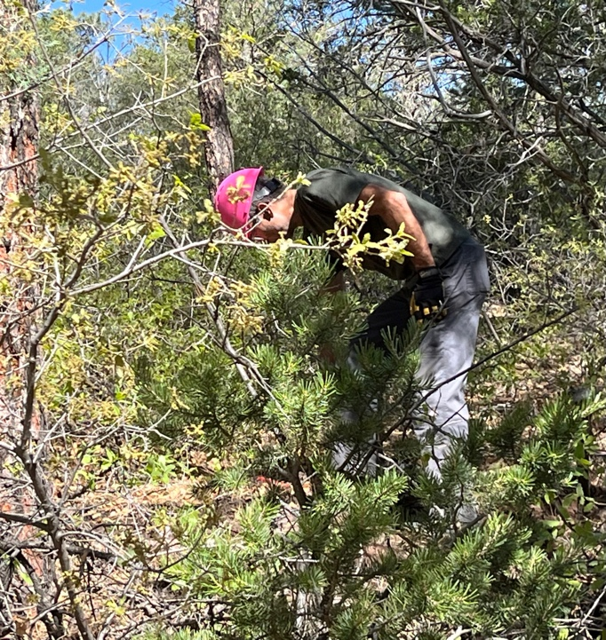

John removes a large stump, Eric digs away and Roland is lost in all the newly leafing vegetation.

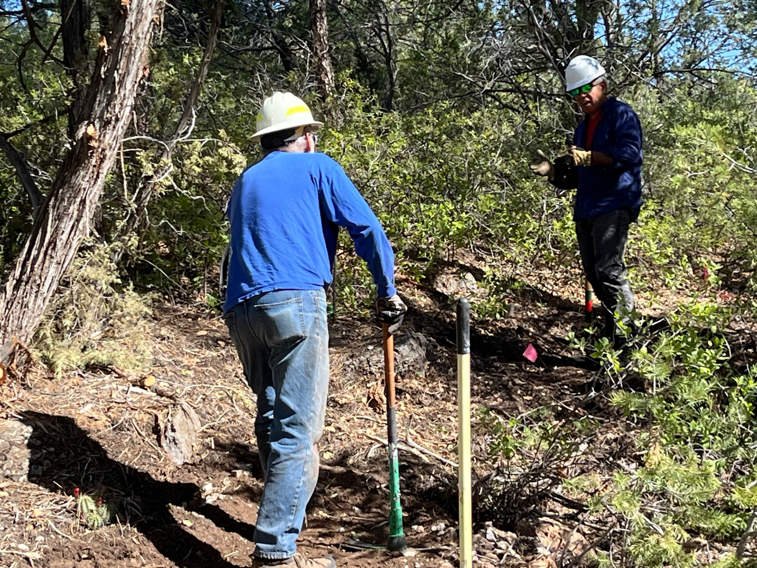

Luis and Jim discuss……

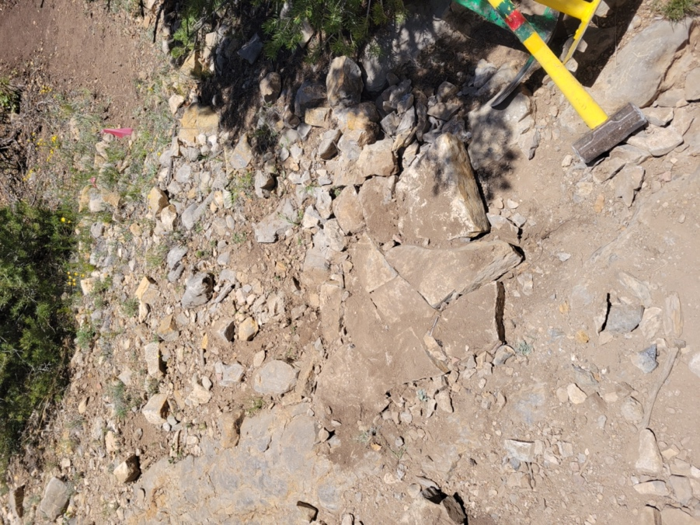 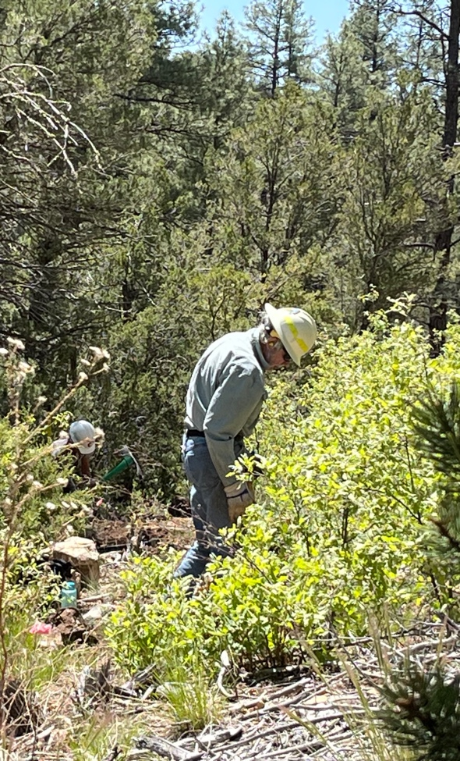

Bruce laid out some very nice rock work and Byron cuts trail through scrub oak.