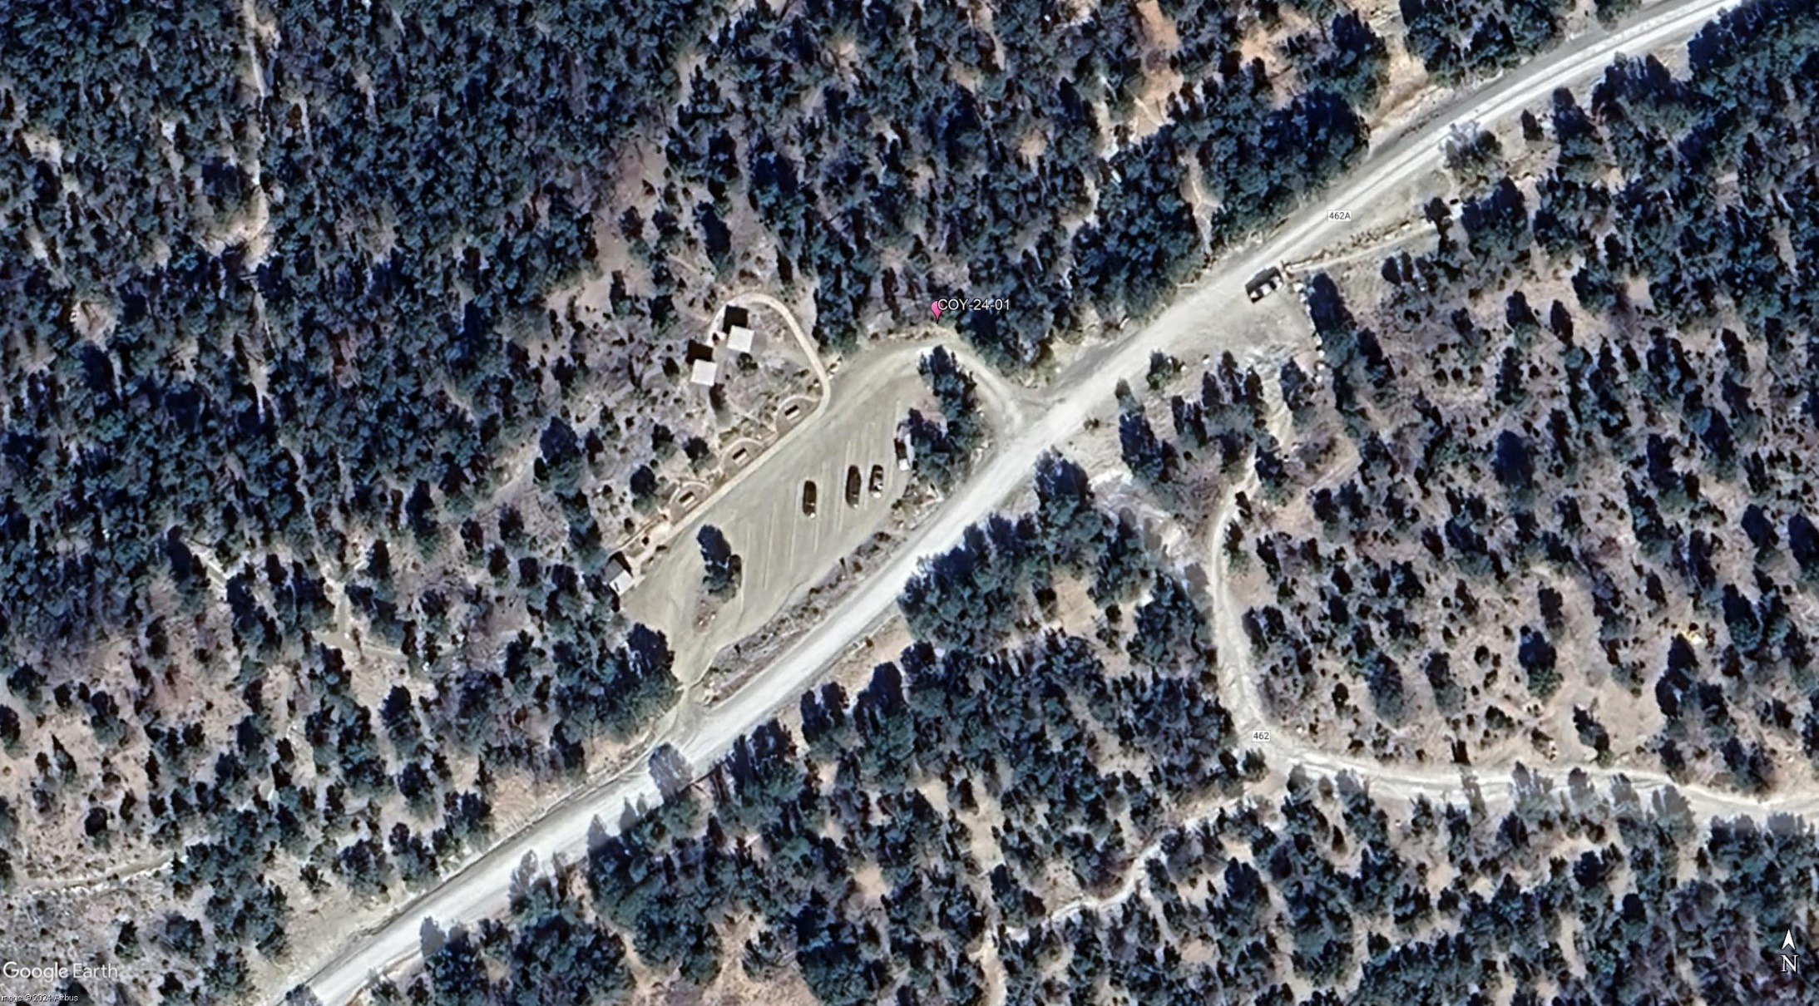

Coyote Trailhead hazard tree is located at the small red dot north of the corner of the parking lot.

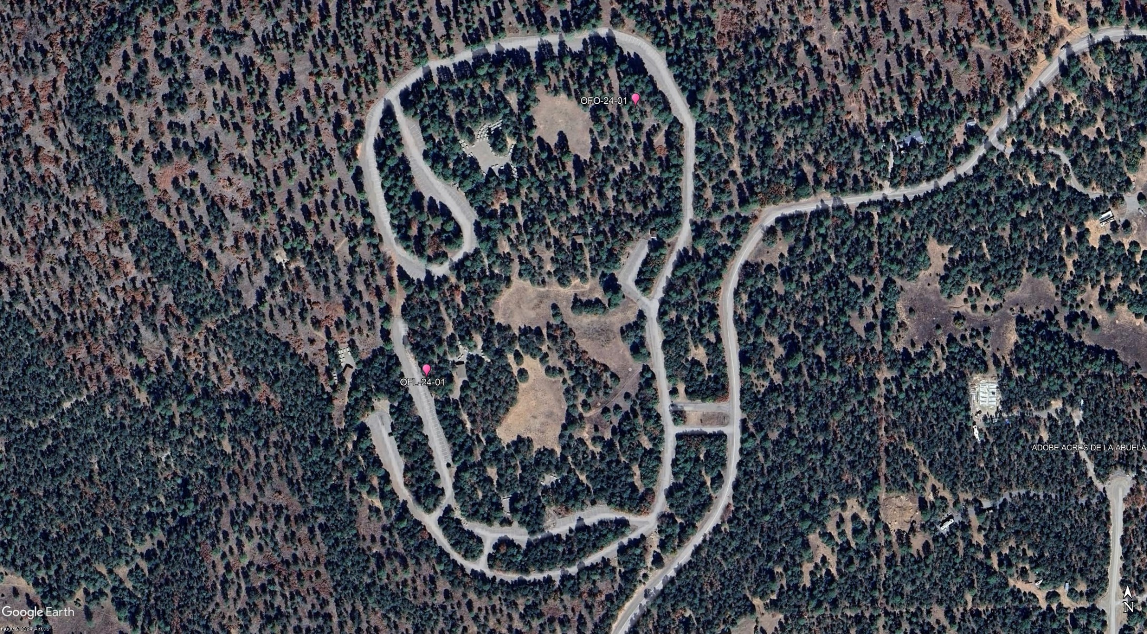

The two hazard trees in Oak Flat Picnic Area are located at the small red dot north and slightly to the east of the center of the PA on the road to the Oak Site

and southwest of the center of the PA near the Locust Site.

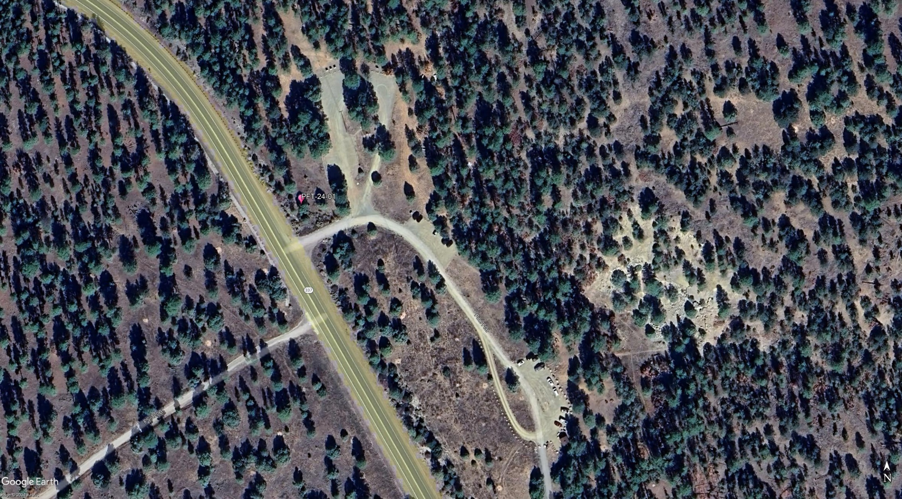

The hazard tree in Pine Flat PA is located at the small red dot left of the entrance road. The dot is north of the intersection of the NM-337 and the PA road.