**Report of FOSM Tasks to Paint Parking Stripes in Picnic Areas and Install a Short Decorative Post**

**in Doc Long Modern Picnic Shelter A on Tuesday, May 14**

Karen Greif and Sam Beard

On Tuesday, May 14, Karen Greif and Sam Beard painted white parking lot stripes where they were needed in Doc Long, Sulphur, Cienega, Balsam Glade, and Capulin Spring Picnic Areas and at Tree Spring Trailhead. They painted stripes with two carts in which inverted spray cans of marking paint are placed, and the spray paint is applied to the parking lot. The carts are stored near the Sandia Ranger District shop, and approximately two dozen cans of white marking paint were obtained from the SRD wood shop. Manny Chavez, SRD Maintenance Supervisor, had purchased a large supply of paint earlier.

A replacement short decorative brown post was installed at one corner of the Doc Long Picnic Shelter A where the post was very rotten. The replacement post was approximately 12 inches in diameter and 36 inches long.

Project photographs are presented below.

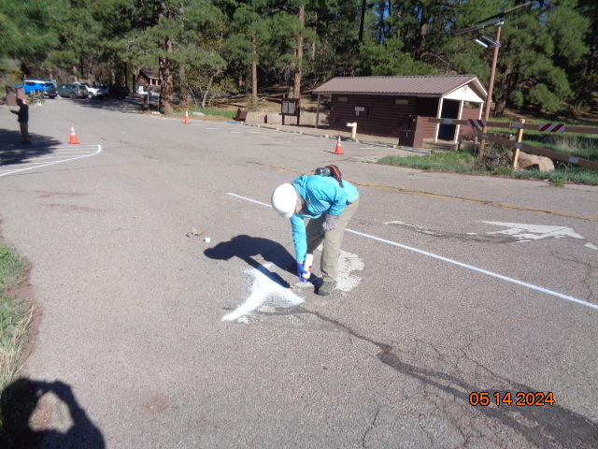

Karen Greif is painting the turn arrows freehand at Doc Long Picnic Area exit. All photos by Sam Beard

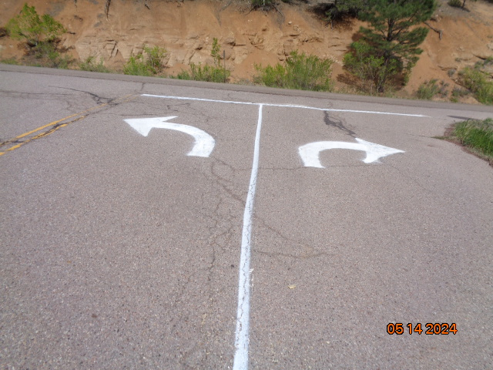

Painted turn arrows and lines at Doc Long PA exit.

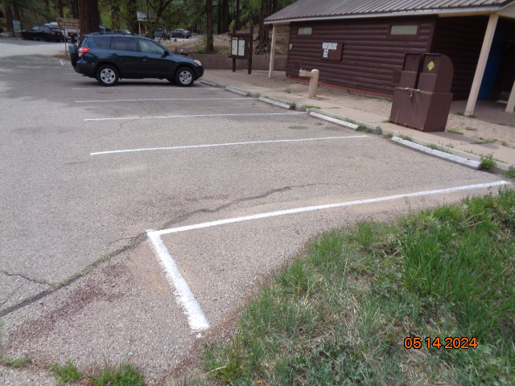

Painted parking space lines at the entrance restroom in Doc Long PA.

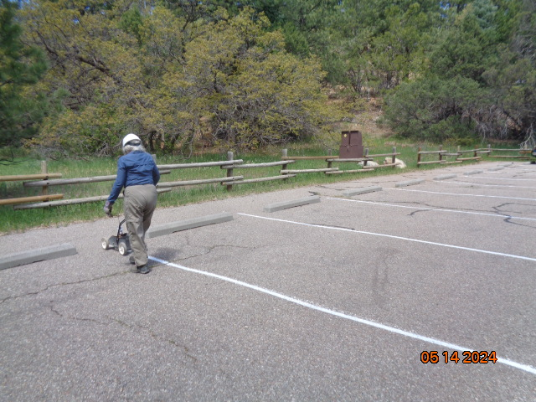

Karen is using the cart to paint parking space lines at the middle restroom in Cienega Canyon PA.

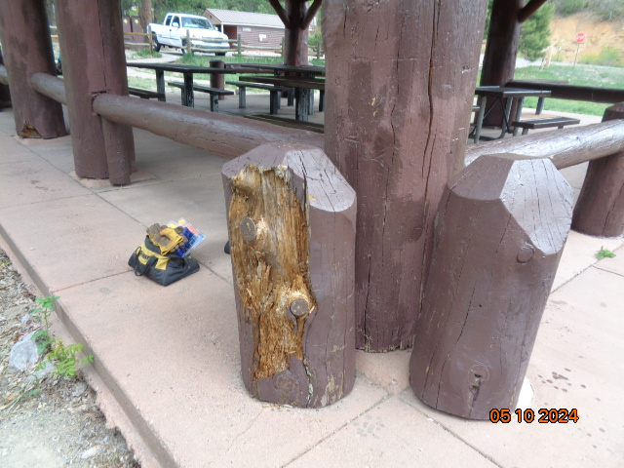

Decayed short decorative post at one corner of Doc Long PA Shelter A. Michael Arndt and Sam Beard had installed this post

several years ago.

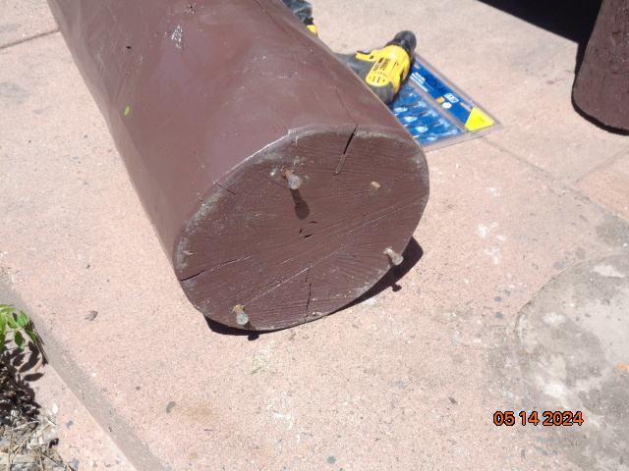

Three ¼ inch by 2-inch lag screws were installed in the post base in order to raise the bottom about ¾ inch from the concrete

to reduce water damage to the paint and wood.

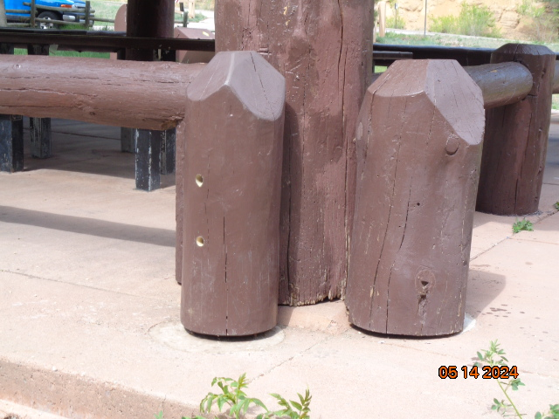

The replacement post was secured to the large corner column with two 3/8-inch by 8-inch lag screws. Each lag screw and flat washer were counter-sunk a distance of 7 inches in a 1-inch diameter hole so that the forward 4 inches of each screw was screwed into the column.

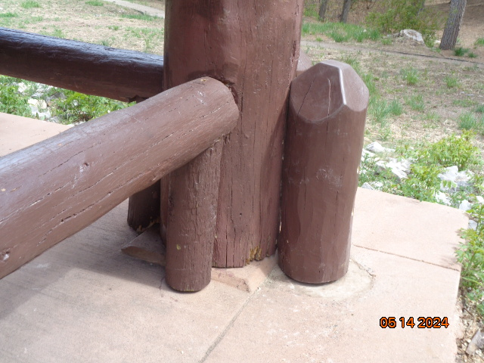

Another view of the replacement post. Note the concrete surface with a diameter of approximately 15 inches

that the post is sitting on. The original post had been set in soil, and then concrete was poured around it in the early 1990s

where the shelter was built. Several years ago all the short corner posts had decayed near the surface of the concrete so that

there were eight dangerous holes in the concrete surface of the shelter. FOSM volunteers filled each hole with concrete, fabricated

eight replacement posts, and installed them as described above in an attempt to reduce decay.