Lower Pine is done!! On Thursday, May 30, 2024 a group of 11 volunteers and 4 SRD staff finished the last stretch of the Lower Pine reroutes. The weather is getting pretty warm and the group will be glad to head to higher elevations. The trail looks great and there are lots of mountain bikers excited to bike the new trail.

Volunteers this week were: Claudia Bergsohn, Roland Stumpf, John Braly, Byron Garner, Bruce Hansche, Steve Roholt, Luis Cuadros, Eric Russell, Rich Fagioli, Mike Madden, and Laura Leon. SRD staff: Jen, Dorothy, Chris and Zay.

Pictures by Bruce Hansche and Laura Leon.

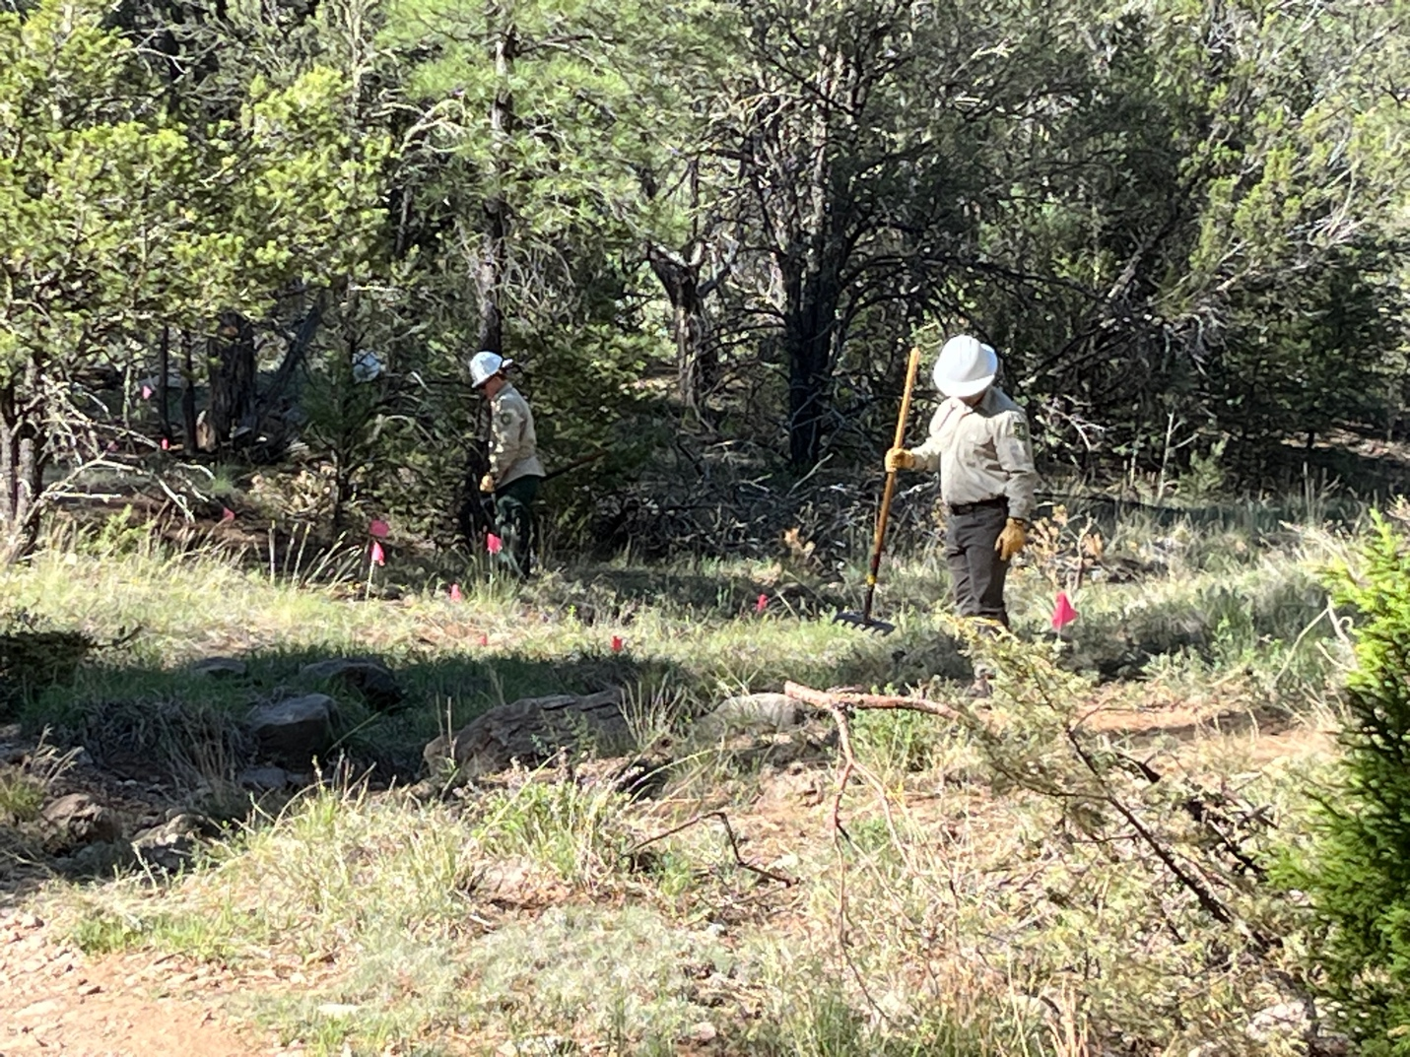  
SRD staff busy at work with a tricky area.

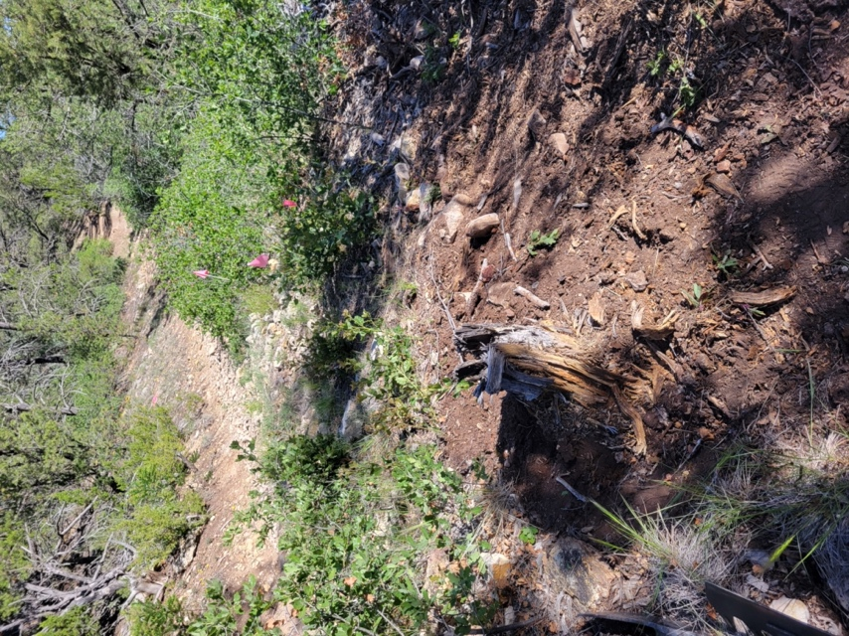 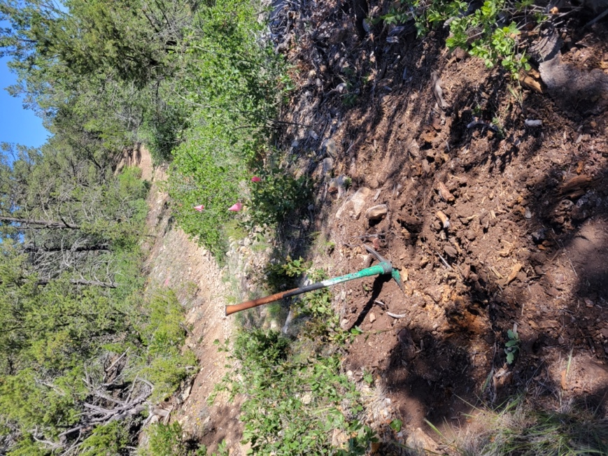

Stump removal by Bruce-

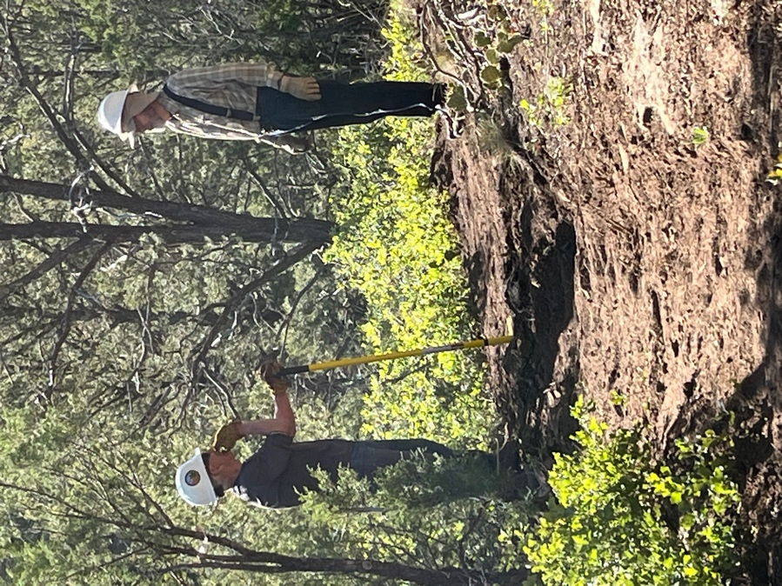 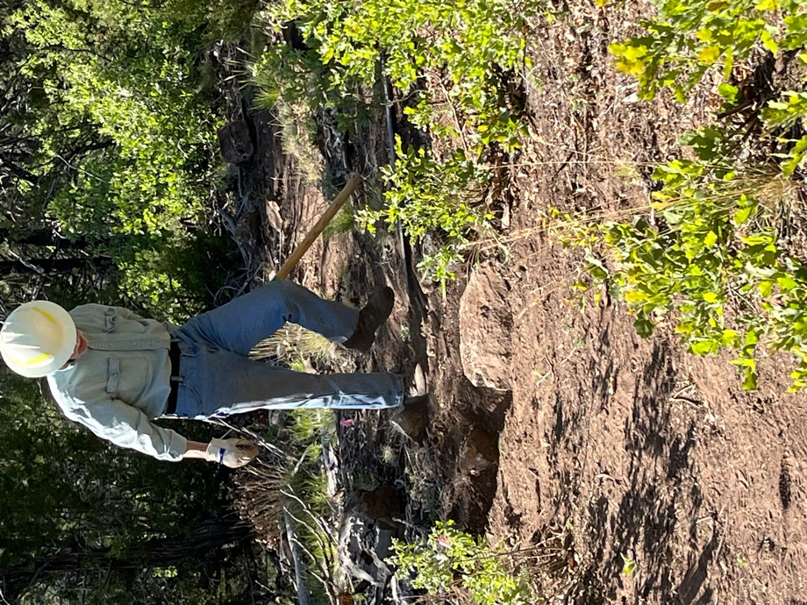

Steve and Bruce talk strategy or something. Byron gets after a bothersome rock.

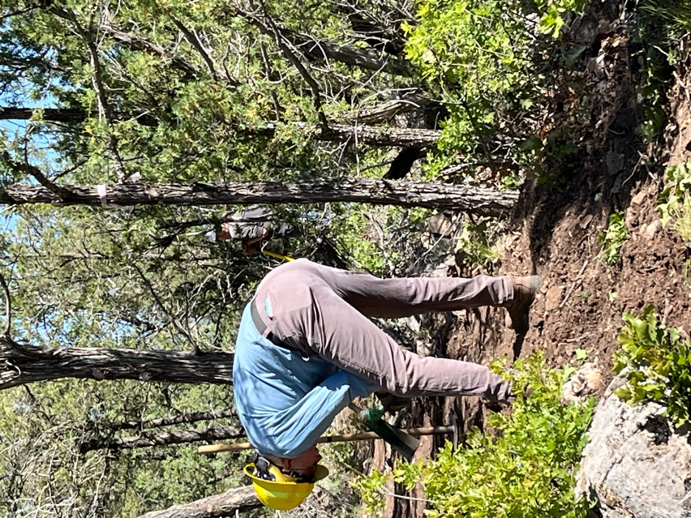 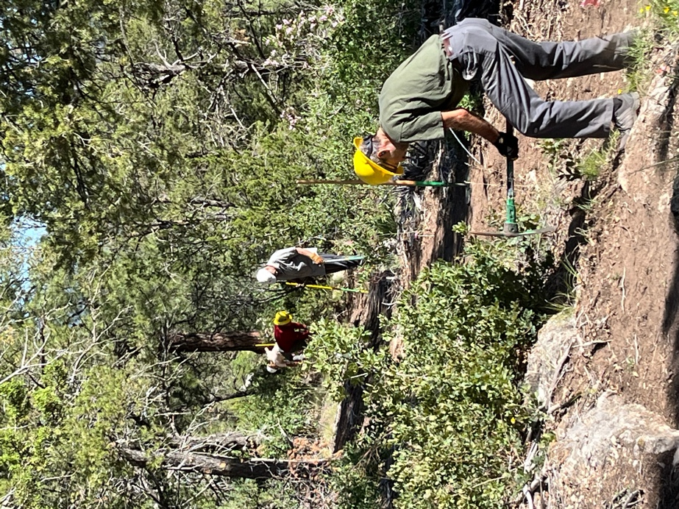

Eric clears an area. The chain gang hard at work.

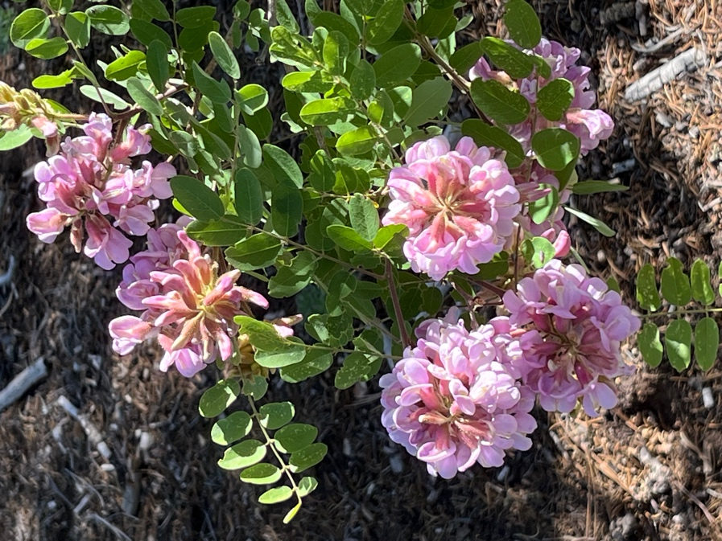 Beauty all around….