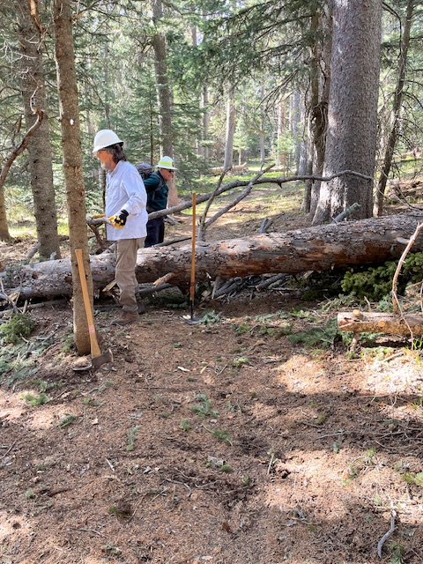
This 18-inch diameter dead spruce tree had fallen over
the Kiwanis Meadow re-route trail. Phil and David are
clearing the area to provide safe space to do the cuts
needed to remove the obstacle.
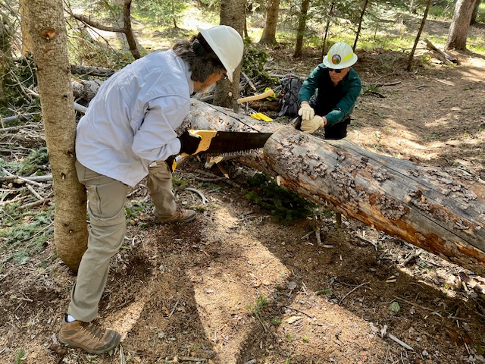
Phil and David begin the first cut with a crosscut saw. The wood
on this tree was so hard and heavy that we suspected someone had hauled it in from the Petrified Forest in Arizona and dumped it here on the trail. Everyone on the crew gets their turn on cutting big trees like this.

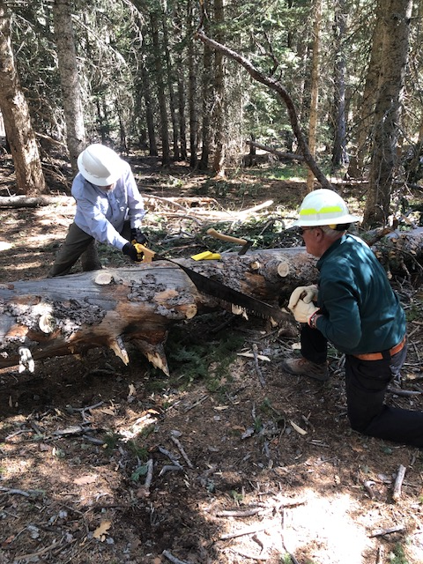
Time for the second cut on the big spruce tree.

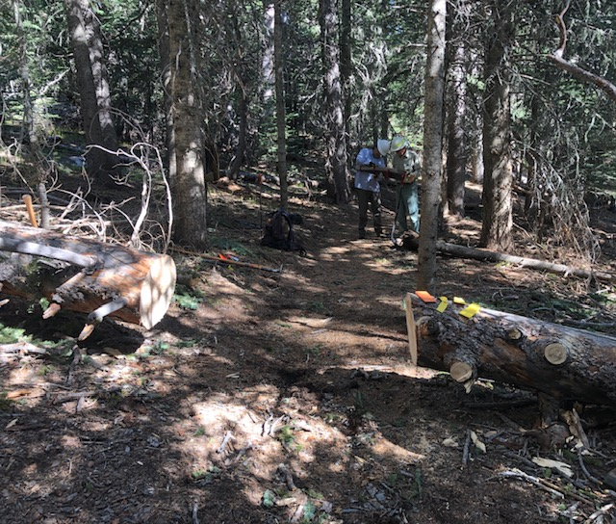
Cuts completed and the trail is now clear at this point.

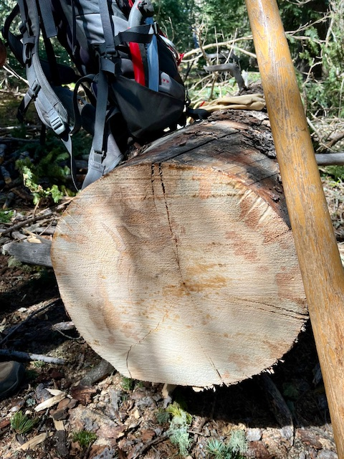
A cross section of the big spruce tree… Solid wood
from margin to margin.

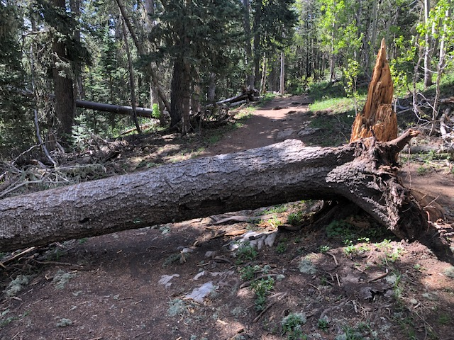
This 23-inch diameter fallen fir was located about 1/3 of a mile
or so north of the upper tram terminal on Crest Trail 130. A walk around had developed to the right of this downed tree.
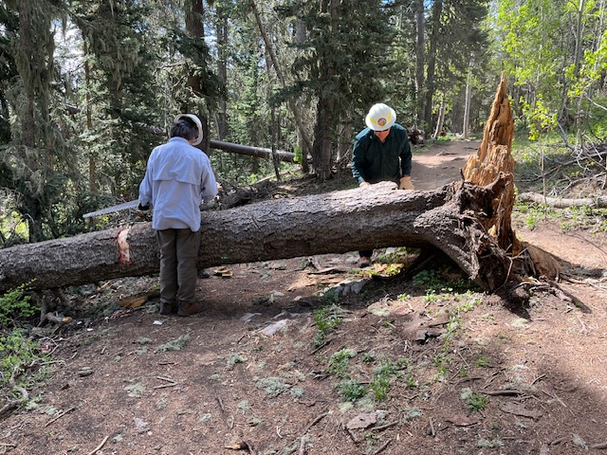
Getting ready to start the cuts to remove the tree. The light area on the trunk to the left of Phil shows where bark has been
removed from the cut site. Dirt that collects in bark over the years can be an abrasive that dulls the teeth on crosscut saws. Sharpening a crosscut saw is a complicated matter that is time consuming, requires special tools and special training.
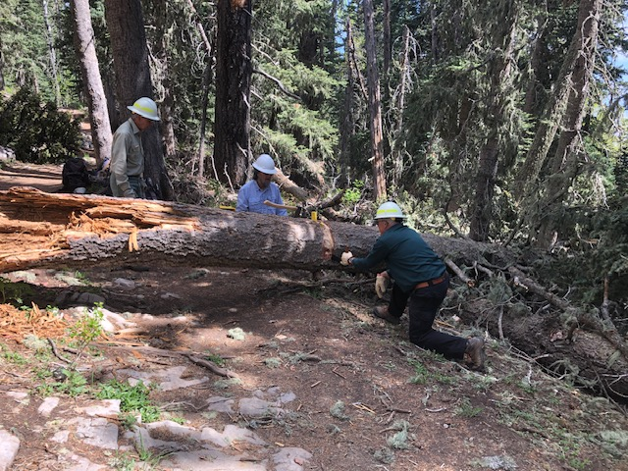
The first cut is nearing completion. The cut will be finished from the uphill side of the log.
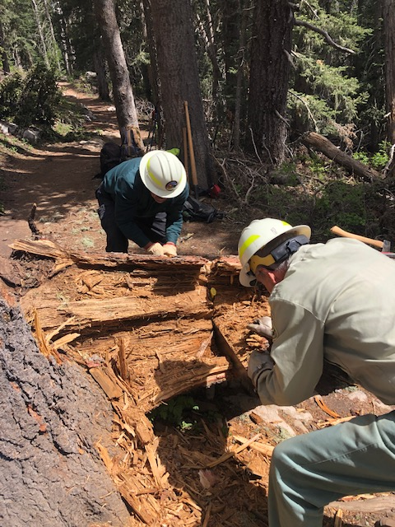
David and Bob working on the second cut.
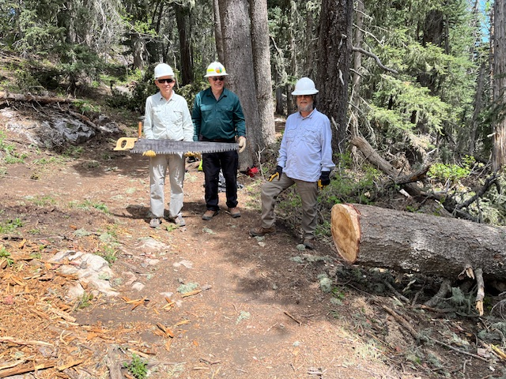
The big fallen fir has been removed. The walk-around which had developed around the upper portion of the fallen tree was blocked off. (The crew, left to right – John Cooper, David McCreery and Phil Cromer. Not pictured – Bob Lowder)
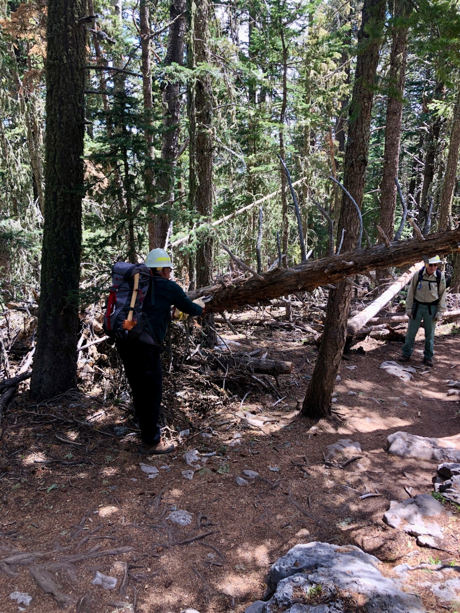
This dead leaner was hanging over Rocky Point trail.
It was removed.
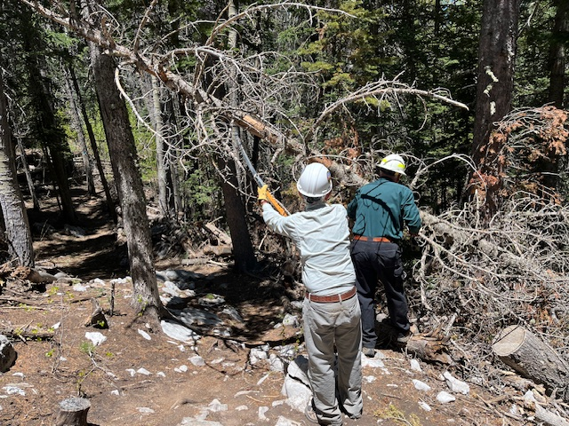
Another leaner over Rocky Point trail. John holds back some upper branches as David finishes cutting some lower ones.
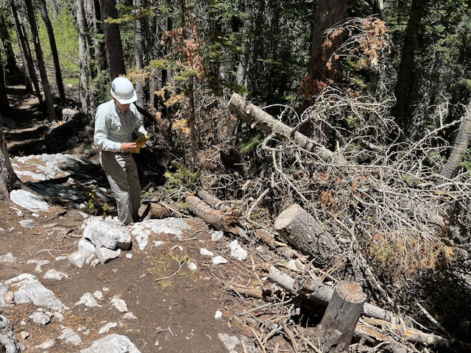
The leaner shown in the previous photo has been removed.

