**Report of Project with FOSM Members and the TTYL/YCC Crew Processing Donation Firewood**

**in Sulphur Canyon Picnic Area and Visiting Tree Spring Wild Life Drinker on Wednesday, June 12**

Lou Romero and Sam Beard

We started the project by Sam Beard giving explicit safety instructions about how the work would proceed and the roles to be performed. He outlined the steps to be followed in harvesting a large 24-inch ponderosa pine log lying diagonally on a steep hillside approximately 200 feet immediately above a pair of picnic tables near a parking lot in Sulphur Canyon PA. The TTYL/YCC (Talking Talons Youth Leadership/Youth Conservation Crew) crew positioned themselves as “lookouts” above the log where the sawyers would be working.

Three sawyers, Sim Cook, Steve Roholt and Eric Russell, first bucked the tree into three smaller pieces that were then maneuvered into more efficient positioning for bucking into 12-inch rounds. The rounds were then carefully rolled down the steep slope to flat ground between the picnic tables and the sidewalk to the parking lot. The YCC Crew then stacked the rounds next to where Lou Romero’s mechanical splitter was positioned. Dan Benton gave the YCC crew safety instructions for rotating turns to load the rounds and operate the splitter.

In the meantime, Jerry Carroll and Cliff Giles hauled two pickup loads of aspen logs from Cienega PA to Sulphur PA where they were bucked into 12-inch-long rounds.

After the YCC crew finished splitting all the rounds, Steve Roholt and Dan Benton led them 200 yards up the Wagon Trail to remove a tree trunk encroaching on the trail thread. While Dan studied the chainsaw cuts to be made, Steve gave the crew an overview of trail maintenance in general and removal of down trees from trails.

Mike Oliver arrived at 10:30 with his truck and trailer. Dan and the YCC crew finished all the splitting by 11 am and then they finished loading the split wood on the trailer by 11:30. They unloaded the trailer at Oliver’s church ministry woodlot by 12:30.

The YCC Crew, Sam, Rene and Lou returned to Sulphur PA for lunch and a brief “seminar” about careers, work ethics and leadership principles. We completed the afternoon by driving to the actual Tree Spring where the YCC Crew learned about how springs are formed and the benefits to wildlife. They also took turns shoveling mud out of the “spring drinker” and left it in good condition to hold plenty of clean water.

During the day, the YCC Crew participated in 3 different outdoor activities that contributed to “Caring for the Land and Serving People.”

FOSM volunteers: Sam Beard, Jerry Carroll, Rene Archer, Dan Benton, Eric Russell, Sim Cook, Cliff Giles, and Lou Romero. TTYL/YCC crew: Olivia Lopez, Jamie Medina, Lila Eaton, Dwight Olander, Vianey Medina, Robbie Larrison, and Hans Martin.

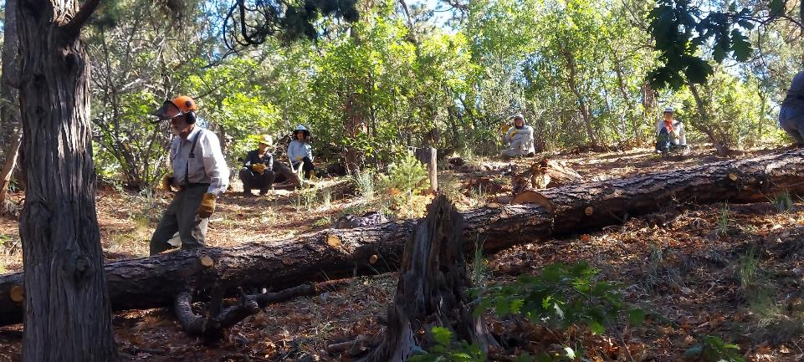

This large pine tree on the north side of Sulphur Canyon Picnic Area was felled last year as a hazard tree. FOSM sawyers limbed it

and bucked it into 10-foot segments. Photo by Rene Archer

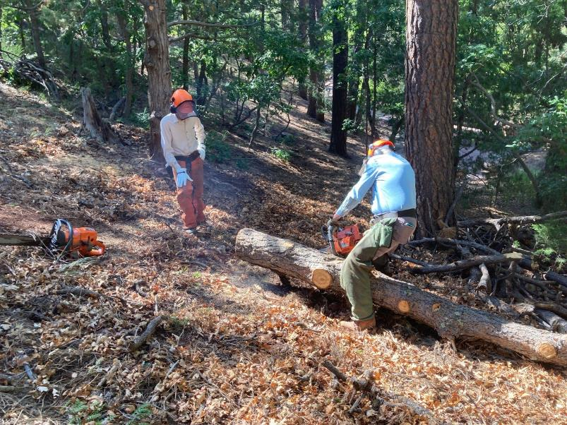

Sim Cook observing Eric Russell limbing the large pine log in Sulphur Canyon PA. Photos by Cliff Giles

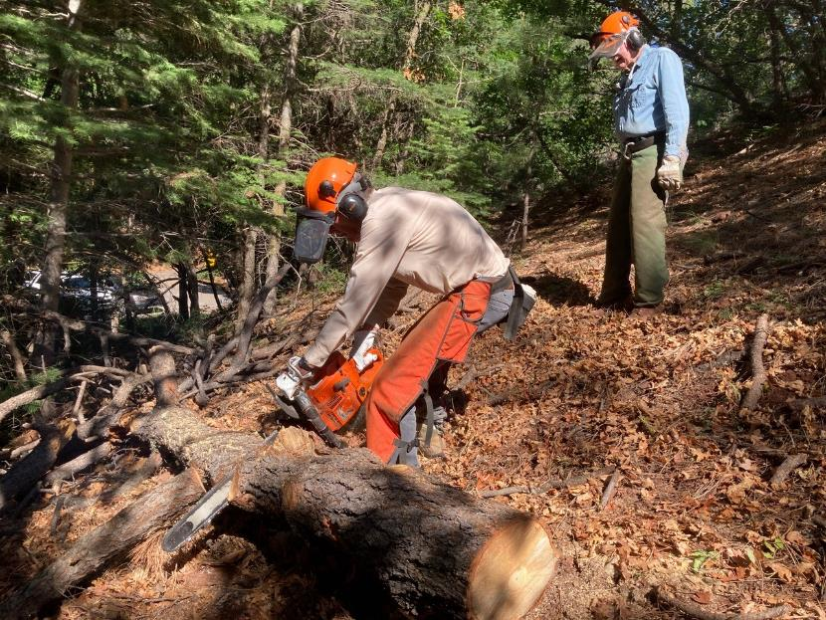

Sim Cook bucking the large pine log while Eric Russell observes.

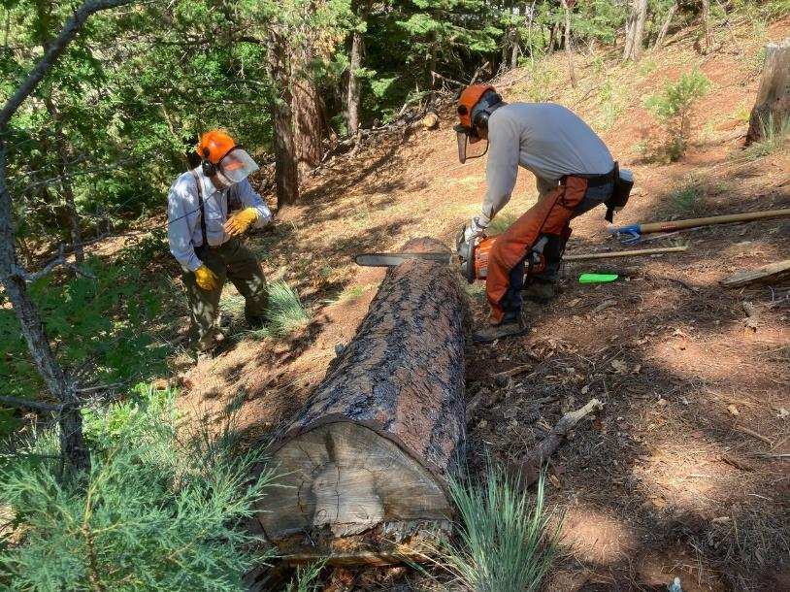

Sim bucking the log in another location while Sam Beard observes.

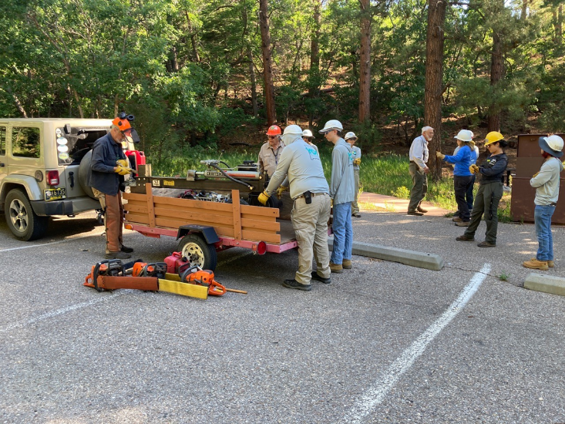

FOSM and TTYL crew members unloading Lou Romero’s power splitter.

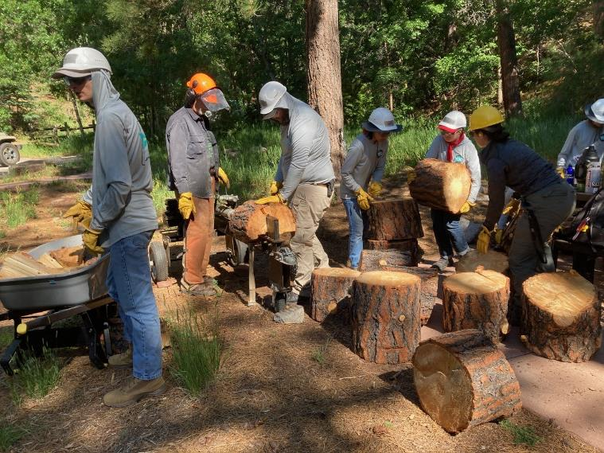

FOSM members and the TTYL crew splitting the large pine rounds.

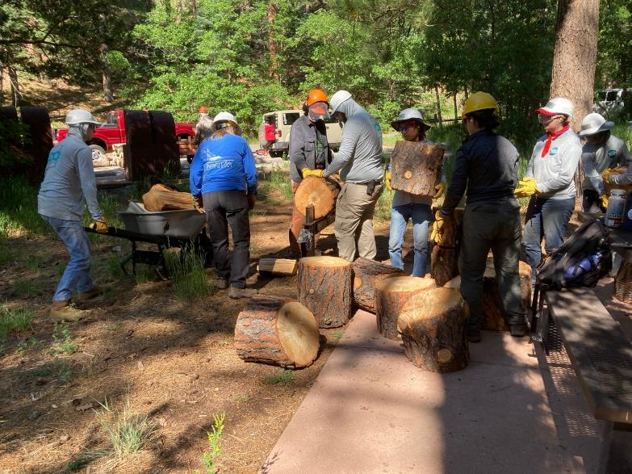

Volunteers continue to split rounds while a wheel barrow load of wood will be taken to the parking lot.

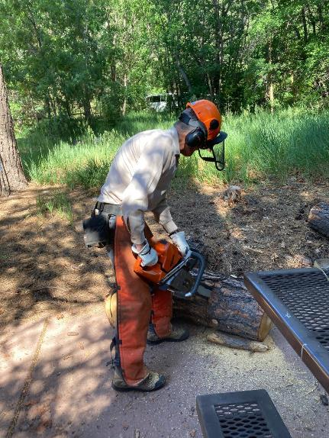

Sim Cook bucking long round that was rolled down the hill.

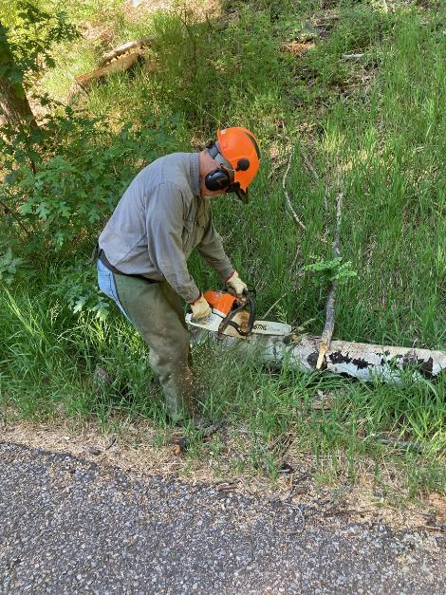

Jerry Carroll bucking an aspen log in Cienega PA before hauling it to Sulphur PA.

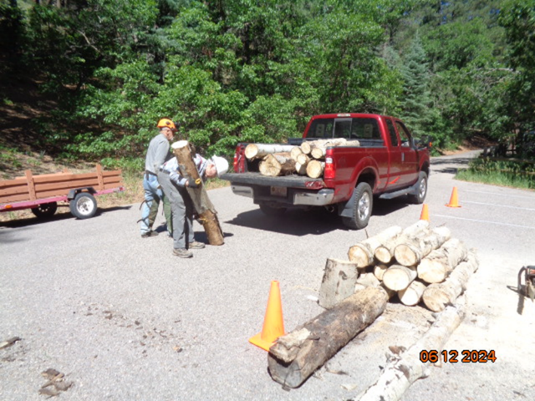

Jerry Carroll and Cliff Giles unloading aspen log from Jerry’s pickup. Photo by Sam Beard

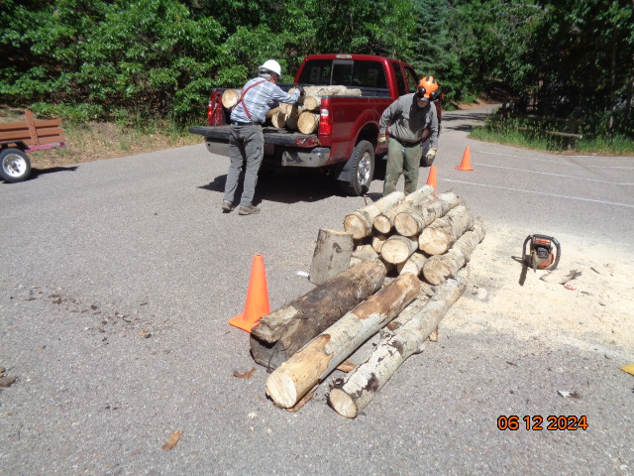

These aspen logs were bucked and hauled to the church woodlot as donation wood.

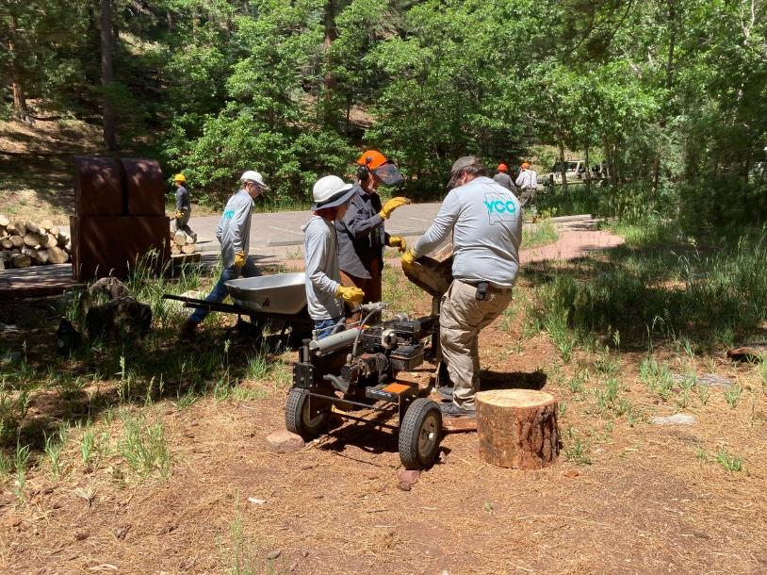

The last pieces of the large pine log were split. Photos by Cliff Giles

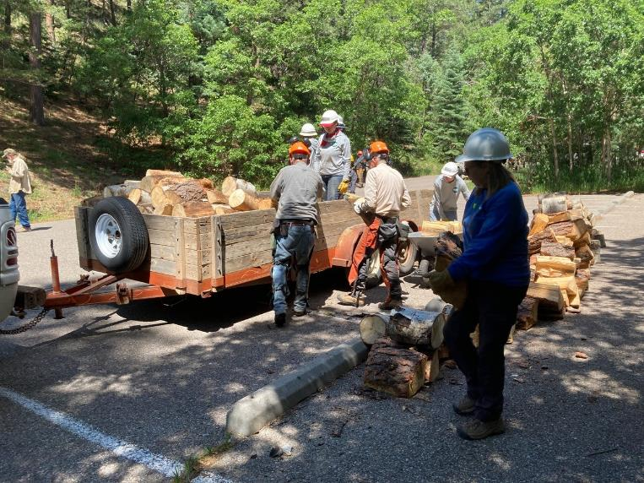

The wood was loaded on Mike Oliver’s trailer and hauled to the church woodlot.

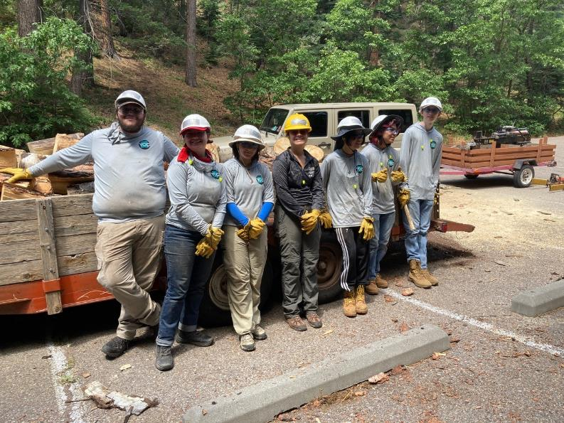

TTYL/YCC crew members who worked on this project. L to R: Dwight Olander, Robbie Larrison, Lila Eaton,

Olivia Lopez, Vianey Medina, Jamie Modina, and Hans Martin.

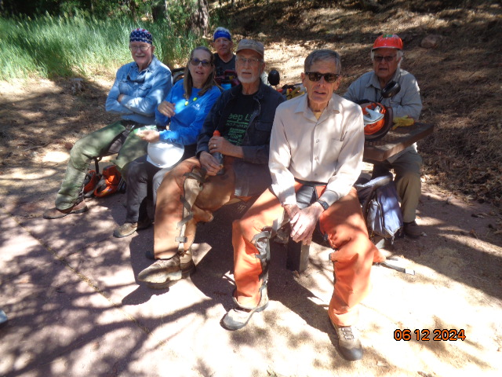

The FOSM volunteers who worked on this project. L to R: Eric Russell, Rene Archer, Steve Roholt, Dan Benton,

Sim Cook, and Lou Romero. (Cliff Giles and Jerry Carroll not shown) Photos by Sam Beard

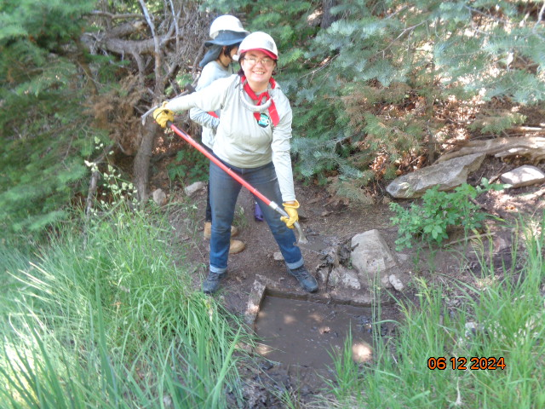

TTYL crew member shoveling mud from the Tree Spring wildlife drinker.

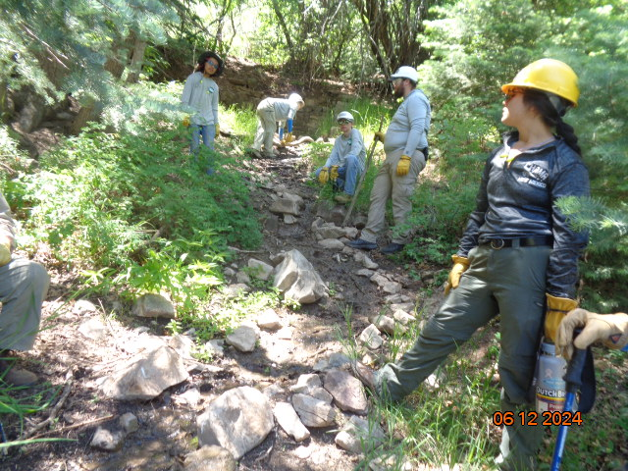

TTYL crew members standing along the water channel from the spring to the drinker.

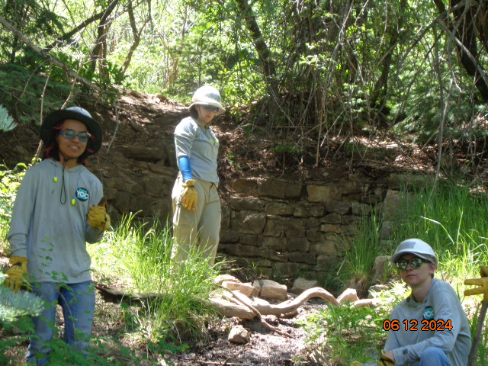

CCC workers built a stone wall around three sides of the spring, and the old Crest Road was just above this stone wall.

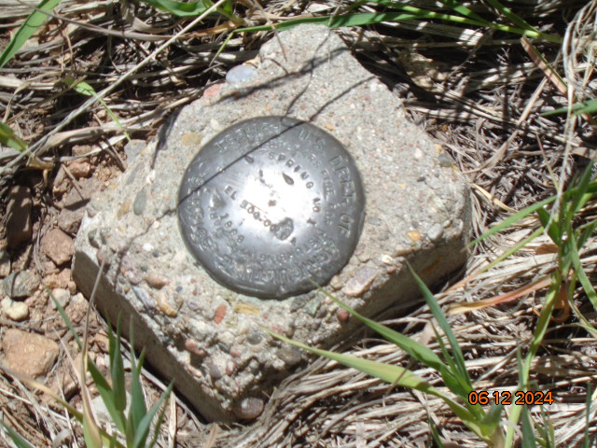

The USFS survey marker located a few hundred feet from the spring where the old road and current highway merge.