**Reports of Working on Projects with the Talking Talons Youth Leadership (TTYL) Crew**

**on June 10 and June 11, 2024**

Sam Beard and Joelle Hertel

1. **Monday, June 10** – On this rainy day, the TTYL crew practiced using a few different crosscut saws in the SRD vehicle parking shed behind the shop. Sam also discussed the operation of chain saws and demonstrated removal of the bar and chain. In the afternoon, the crew viewed a local USFS video about wildlife drinkers in the large conference room in the Ranger Station.
2. **Tuesday, June 11** – The TTYL crew removed several large graffiti tags in the Juan Tabo picnic area stone shelter and on three large boulders near the restroom above the stone shelter. After lunch, the crew hiked up the short canyon east of the La Luz Trailhead parking lot. From here they hiked up and around boulders to the CCC dam that was covered with blue characters outlined with silver paint. The tags were partially removed so that the characters could not be read. Rain will remove much of the residue of paint and chemicals that remained on the rocks in the dam.

The names of the crew working on these projects were Joelle Hertel, Sam Beard, Jared Moyers, Vianey Medina, Robbie Larrison, Lila Eaton, Olivia Lopez, Jamie Modina, Dwight Olander, and Hans Martin.

Project photos are presented below.

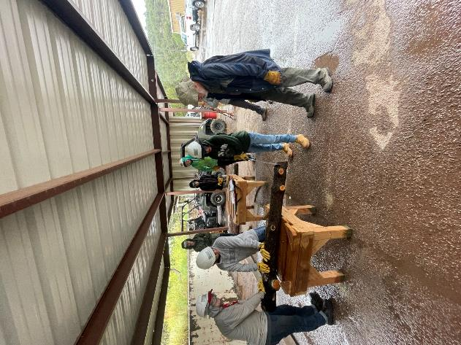

TTYL crew member is cutting a small log with a Silky Katanaboy saw.

Photo by Joelle Hertel

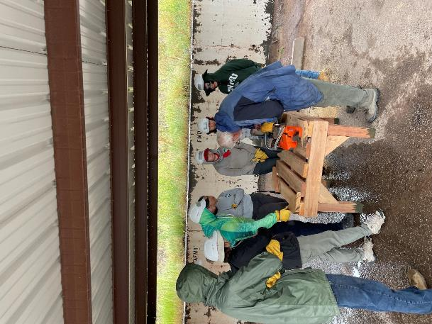

Sam Beard explaining the operation of a chain saw and removing the bar and chain.

Photo by Jared Moyers

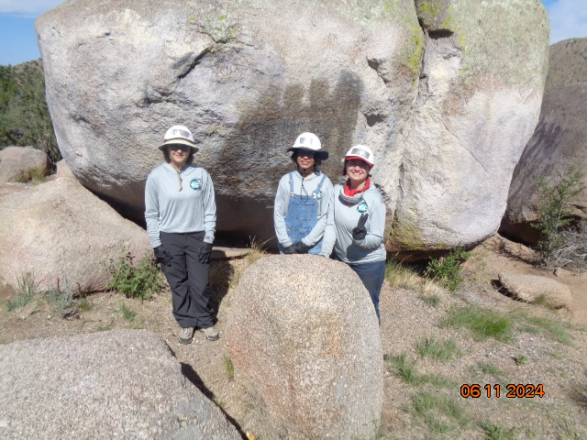

TTYL crew members who removed the large graffiti tag on the boulder behind them. Photos by Sam Beard

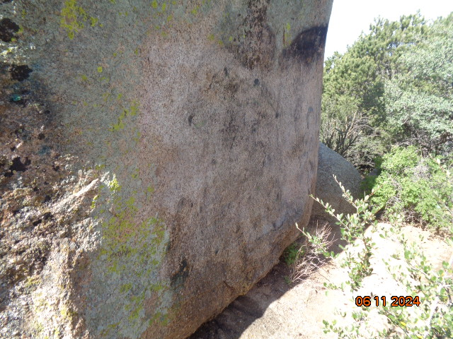

TTYL crew members removed a large graffiti tag from this boulder.

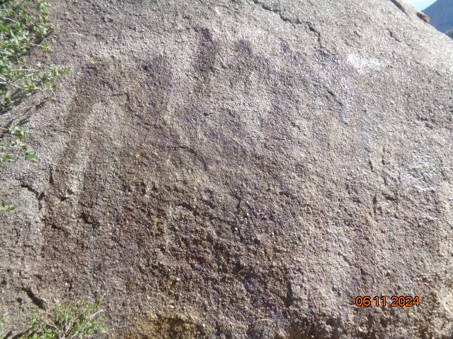

TTYL crew members removed a large graffiti tag from this boulder.

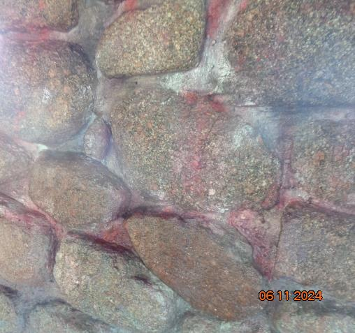

TTYL crew members removed graffiti from these rocks in the Juan Tabo Picnic Area shelter.

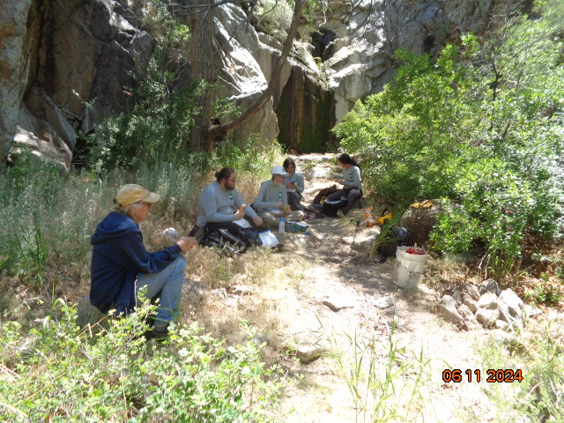

Joelle Hertel on the left with members of the TTYL crew having lunch before partially removing a very large graffiti tag

on the CCC dam above the waterfall in the background.

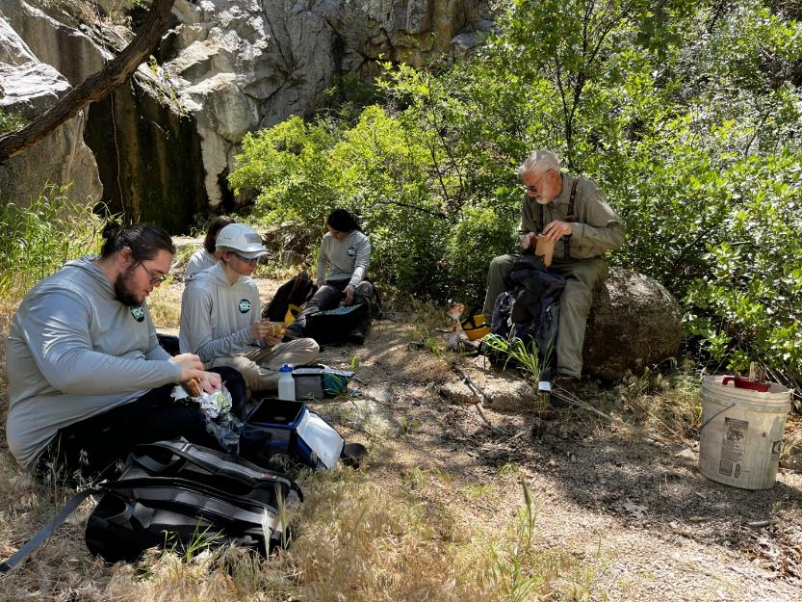

Sam Beard (on the right) having lunch with the TTYL crew. Note the red and white rope hanging down from the waterfall. This rope

was used to move the chemical bottle and equipment up to the dam. Photo by Joelle Hertel

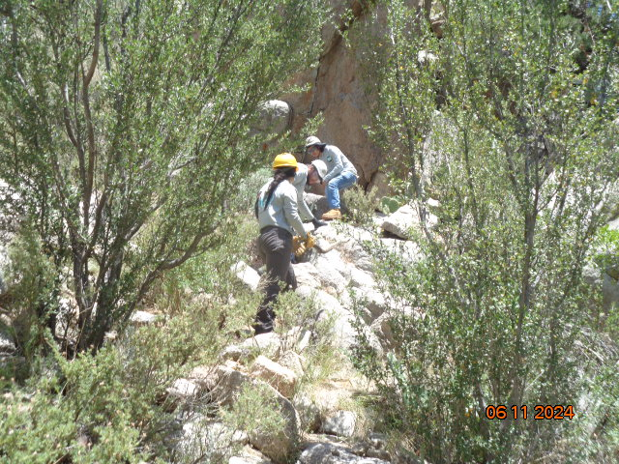

Jared Moyers led the crew up to the boulder on the right that they walked over and down to the dam.

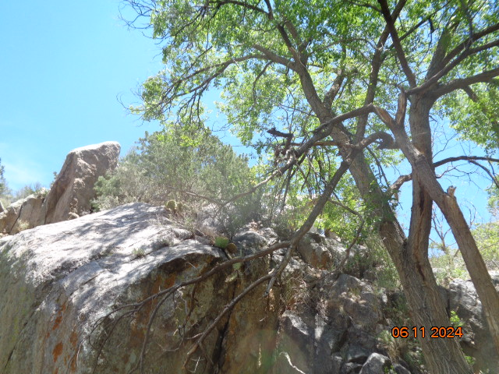

The crew walked over the top of this large boulder to get to the dam that was covered with blue and silver graffiti.

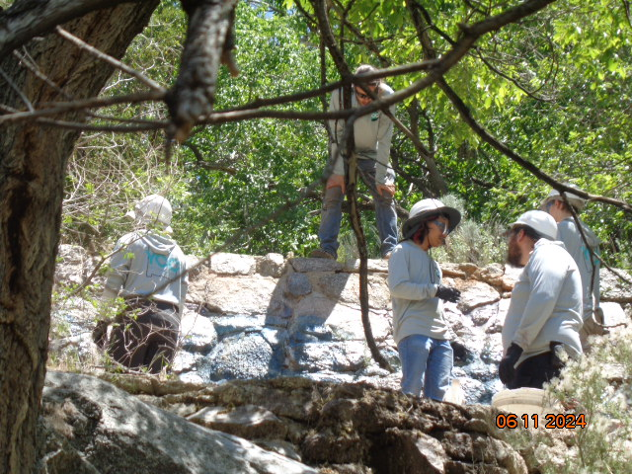

Crew members discussing the project before applying the chemical to the graffiti on the rocks in the dam

that was part of the Juan Tabo Picnic Area water system.

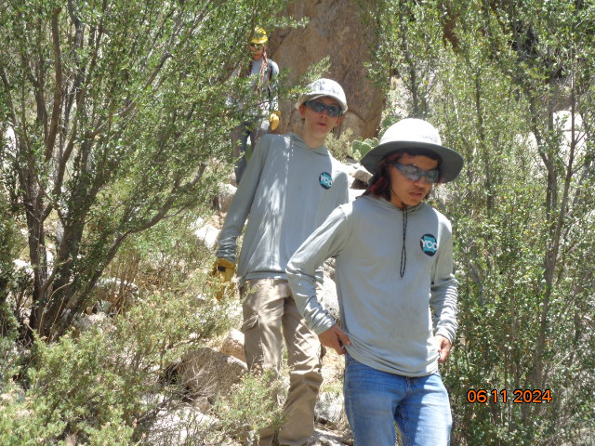

TTYL crew members hiking down after applying chemical to the graffiti and walking over the boulder.

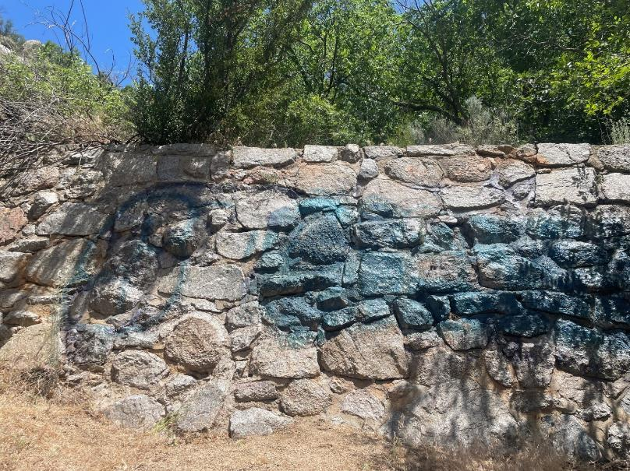

The graffiti tag on the dam after three coats of the chemical were applied. The silver paint was completely removed,

and some of the blue was removed. Rain will remove much of the residue

of paint and chemicals that remained on the rocks in the CCC dam. Photo by Jared Moyers