**Report on Maintenance of Cedro Wildlife Drinker with TTYL/YCC on June 17, 2024**

Dan Benton and Joelle Hertel

The tank was about one-third full and seemed to be in good shape. Joelle suspected the pile of rocks at the tank outlet covered a shutoff valve, so we had the TTYL crew remove the rocks and discovered a buried gate valve. Joelle worked with part of the crew on the float valve, which had a disconnected float, and I worked with others to dig out around the valve and install a box and cover. The new float valve Josh provided would not have worked, so Joelle adjusted the arm of the existing valve and reattached the float. We then waited while the valve slowly filled the drinker box. The drinker portion of the box seemed to have pits that would allow water to leak out, so Joelle and I used pipe dope to fill the holes, but a new drinker box might be a better solution eventually. While the crew sat in the shade and waited, Joelle explained the intricacies of using various concrete mixes in construction and took questions. The repaired valve eventually shut off properly, and we finished up before lunch. The crew voted to hike out and eat back at the SRD. Jerrod used a GPS map to take us on a more direct route back to the main trail and road.

 Photos are presented below.

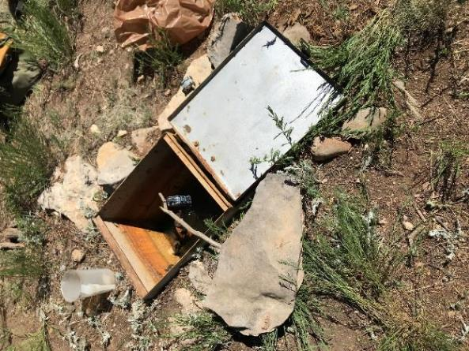

Drinker box at Cedro wildlife rain collector, storage tank, and drinker

south of the Ranger Station and north of FR-242. The lid for the float valve compartment

is covering the open box where wildlife can drink water.

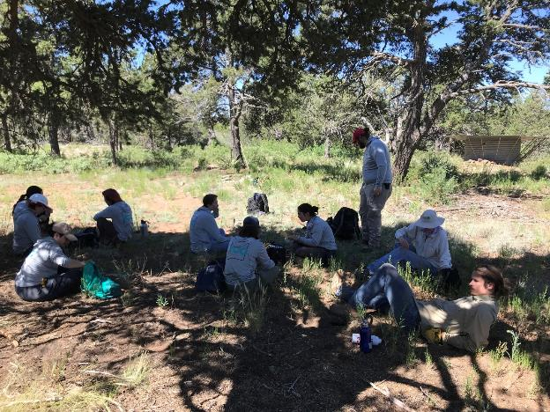

TTYL/YCC crew resting in the shade. The rain collector and storage tank can be seen in the background on the right side of the photo.

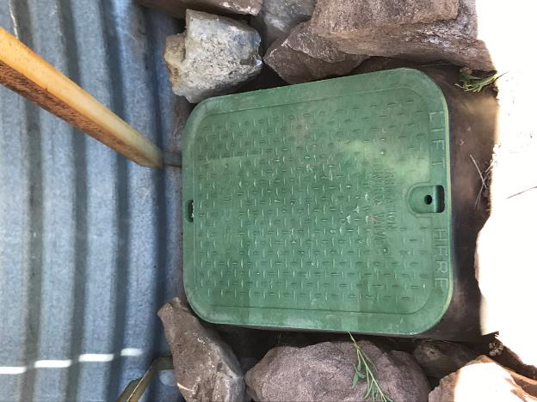

The valve box on the water line going from the tank to the drinker. The lower edge

of the galvanized steel tank wall is shown in this photo.

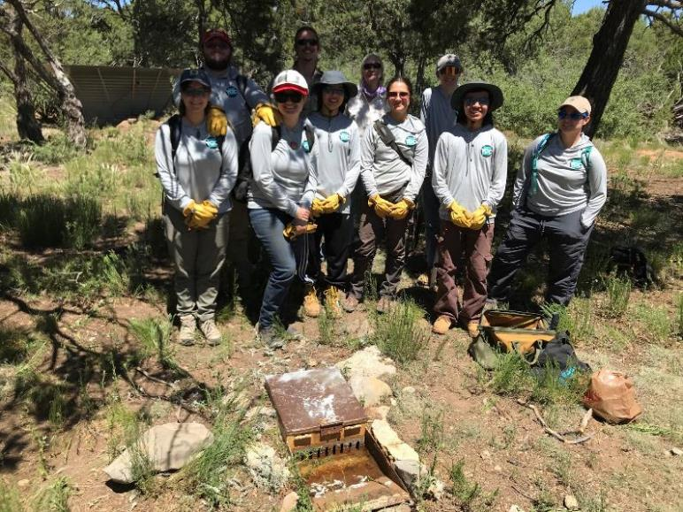

TTYL/YCC crew standing behind the drinker. The lid of the float valve compartment is closed. Wildlife drink water from the open box

with slots in the steel wall between the float valve compartment and the open drinker. Water flows from the valve compartment

to the open drinker through the slots when the outside water level goes down enough that the valve opens and water flows into the open box.