On Thursday, June 27, 2024, 9 volunteers joined Jen form SRD and headed back to the Acequia Trail to do some more benching on the partially started trail. The weather held and actually was quite warm in the sunny areas. The team made good progress and should need just another week or so to finish up.

Volunteers: Claudia Bergsohn, Rav Nicholson, John Braly, Rich Fagioli, Luis Cuadros, Bill Perkins, Eric Russell, Roland Stumpf and Becky Levinson.

Pictures: Rich Fagioli

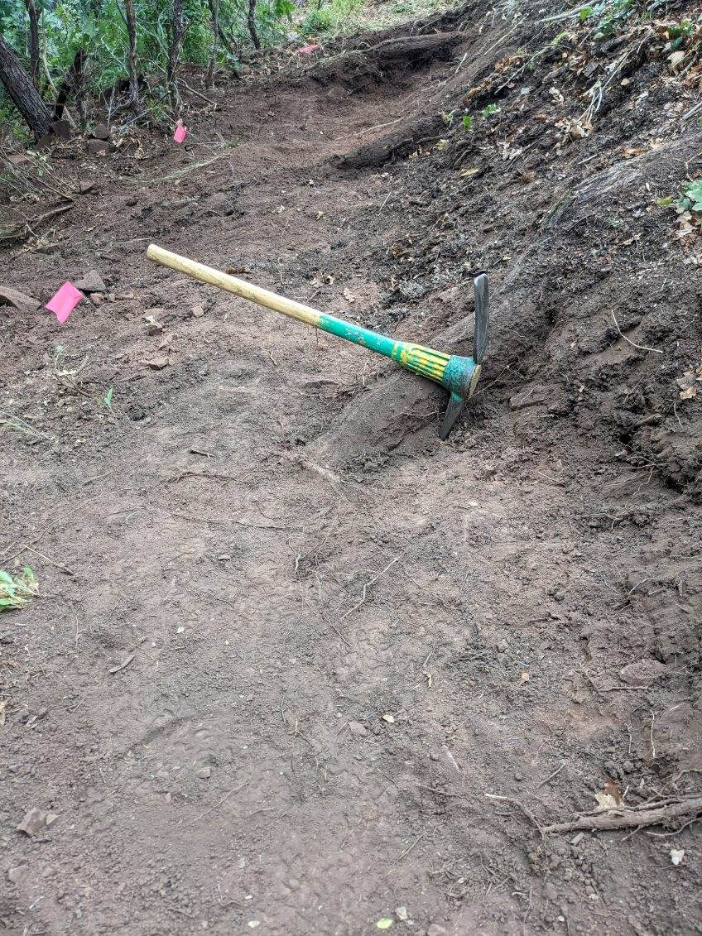 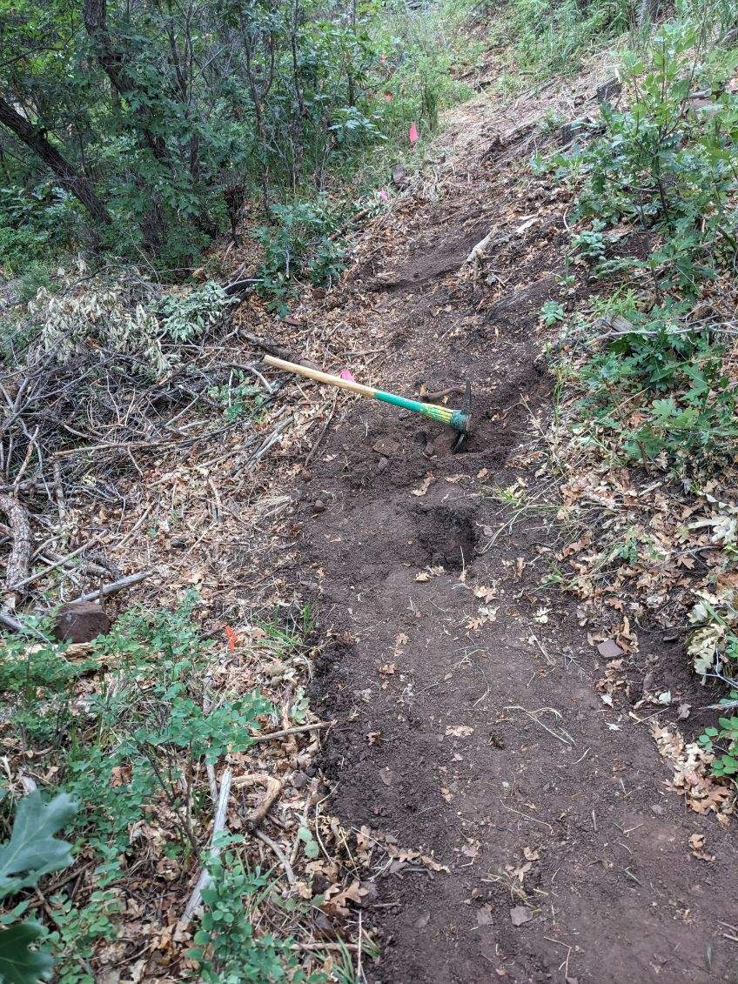

Lots of roots. Following the flags.