**FOSM Volunteers Build Tool Rack for Pick Mattocks and Other Tools in Guard Station**

**on Thursday, June 27, 2024**

Joelle Hertel and Sam Beard

On Thursday, June 27, Joelle Hertel and Sam Beard built a tool rack for about a dozen pick mattocks and similar tools in the FOSM Guard Station. This rack is located on the left as you enter the Guard Station. Racks for other tools will be built farther along the north wall.

See photo below.

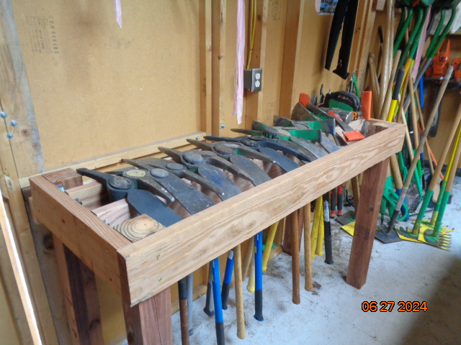

FOSM Guard Station tool rack built on Thursday, June 27, for pick mattocks and other tools.

Photo by Sam Beard