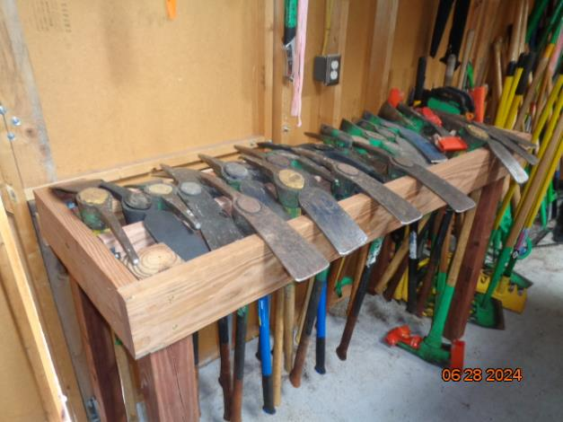

More pick mattocks were put in our rack by the Trails Construction Crew on Thursday afternoon (June 27). Apparently, there are about a half-dozen more pick mattocks than we knew about. We will have to find another place to store the Pulaskis and axes.