**Report of FOSM Crew Limbing and Bucking a 32-inch Diameter Douglas Fir at 10K North Trailhead**

**on Wednesday, June 26**

Sam Beard

On Wednesday, June 26, a FOSM crew limbed and bucked a very large 32-inch diameter Douglas fir hazard tree felled recently by Canyon Young, SRD Trails and Wilderness Program Manager. The wood was very solid, and the bucked rounds were very heavy.

The volunteers working on this project were Cliff Giles, Jerry Carroll, Dan Benton, Sim Cook, and Sam Beard.

Project photos are presented below.

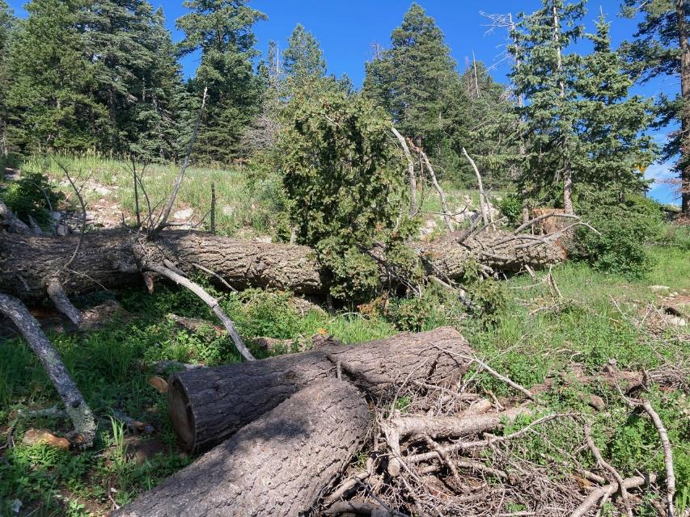

The lower two-thirds of this large tree which was very solid wood. All photos by Cliff Giles

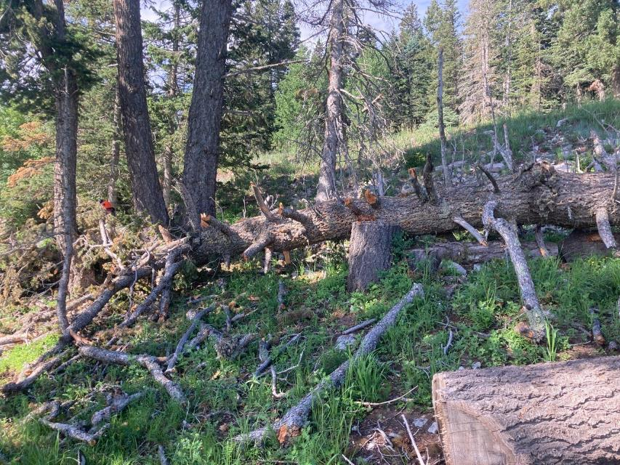

The upper one-third of the log with Dan Benton already limbing and bucking this end.

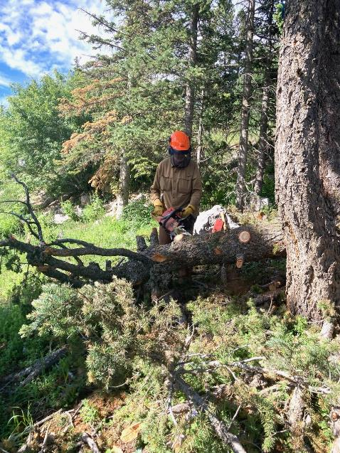

Dan limbing the upper end of the log.

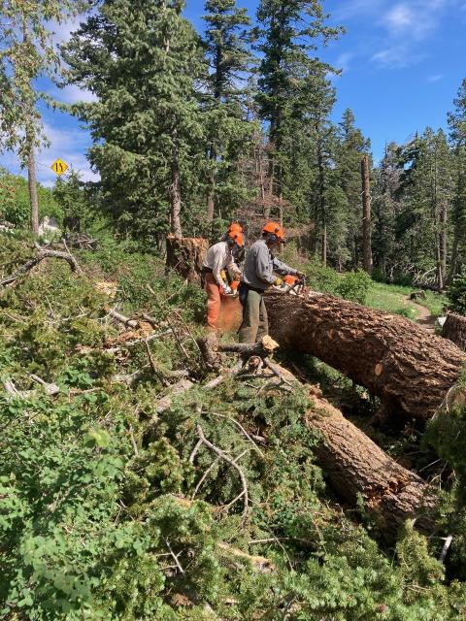

Sawyers beginning to buck the large end of the log after limbing had been completed.

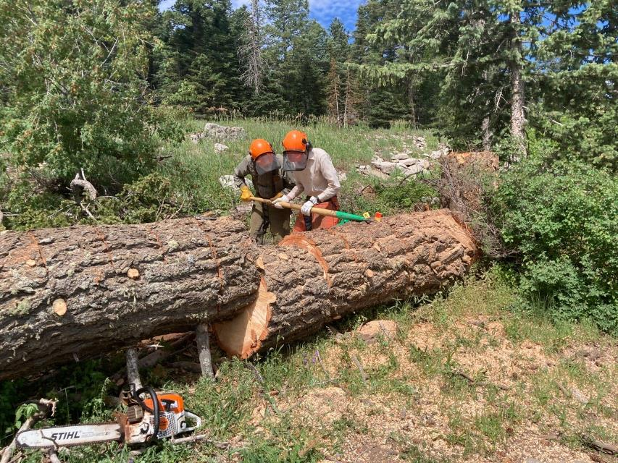

Sam Beard and Sim Cook using a cant hook in an attempt to roll the large end of log away from the other part of the log.

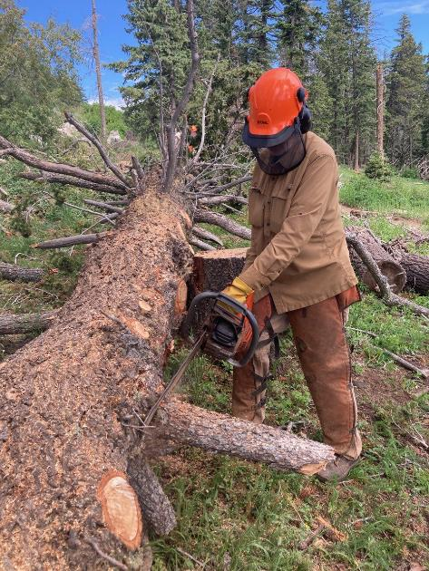

Dan limbing the center part of the log.

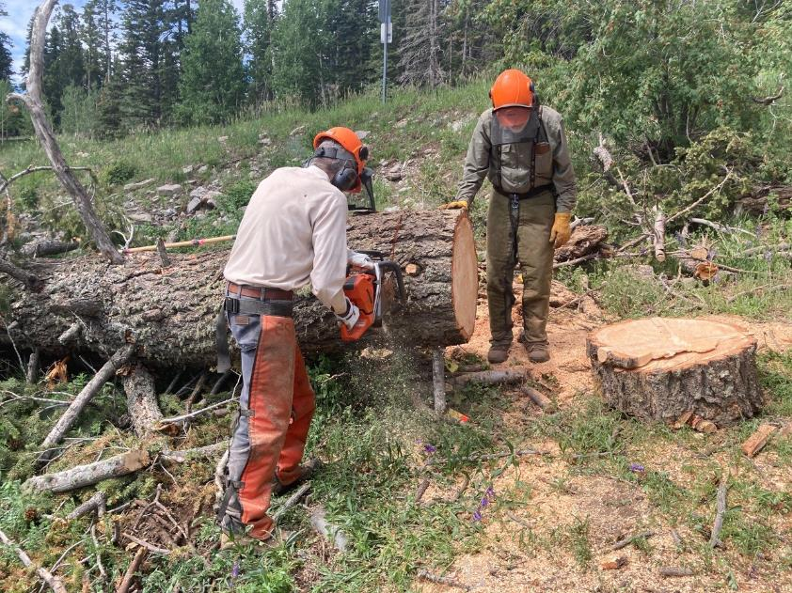

Sam observing Sim bucking the large part of the log.

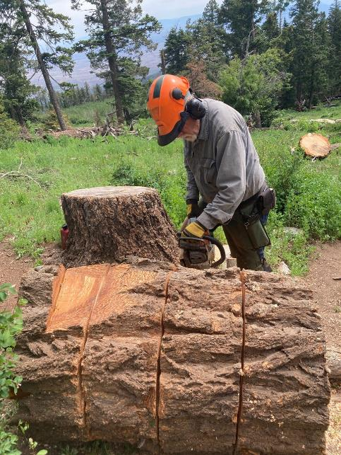

Jerry Carroll bucking the large end of the log.

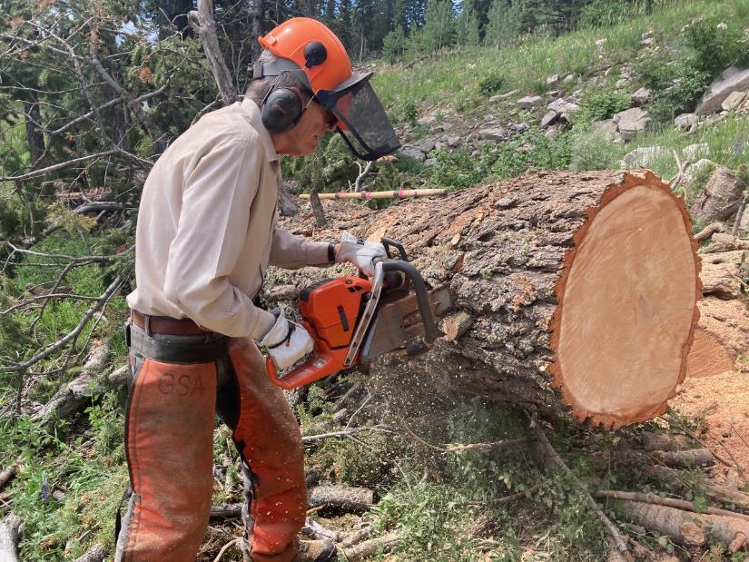

Sim continuing to buck this large log with a Husqvarna Model 572XP chain saw with a 24-inch bar.

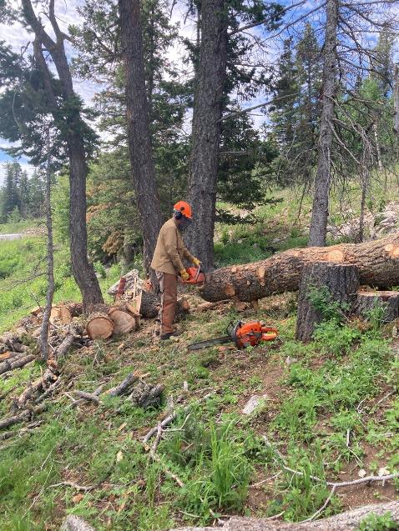

Dan still bucking the small end of the log.

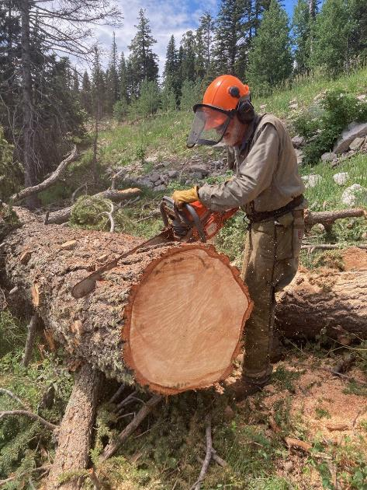

Sam bucking in the center part of the log.

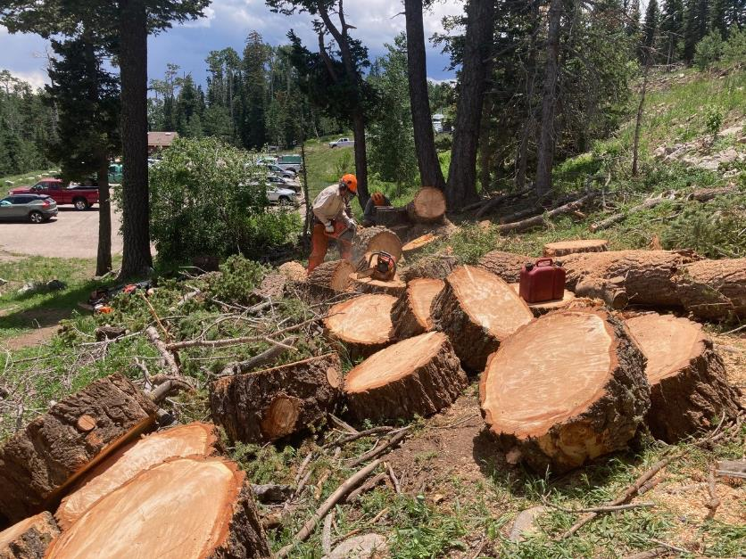

Sim continuing to buck the trunk after most of the log has been bucked.

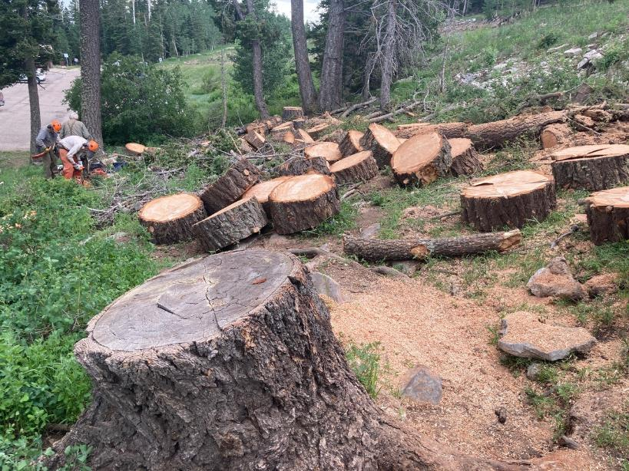

Bucking this large log has been completed, and about 60 rounds were produced. The trunk was bucked into rounds

with a length of 12 inches so that they would not be too heavy to handle.