**Report of FOSM Project to Limb and Buck a 20-inch Log in Upper Sulphur Canyon Picnic Area on Wed., July 3, 2024**

Sam Beard

On Wednesday, July 3, five FOSM volunteers limbed and bucked a 20-inch white fir tree that the wind had blown over with a trunk break 6 feet from the ground.

Most of the bucking was done by Steve Roholt and Sim Cook who were recently certified as USFS chain sawyers. Jerry Carroll and Sam Beard provided instruction and some limbing and bucking to demonstrate safe and efficient use of the chain saw. The one-half day of work provided numerous rounds to be split with Steve Romero’s power splitter.

All photos by Cliff Giles.

Project photos are presented below.

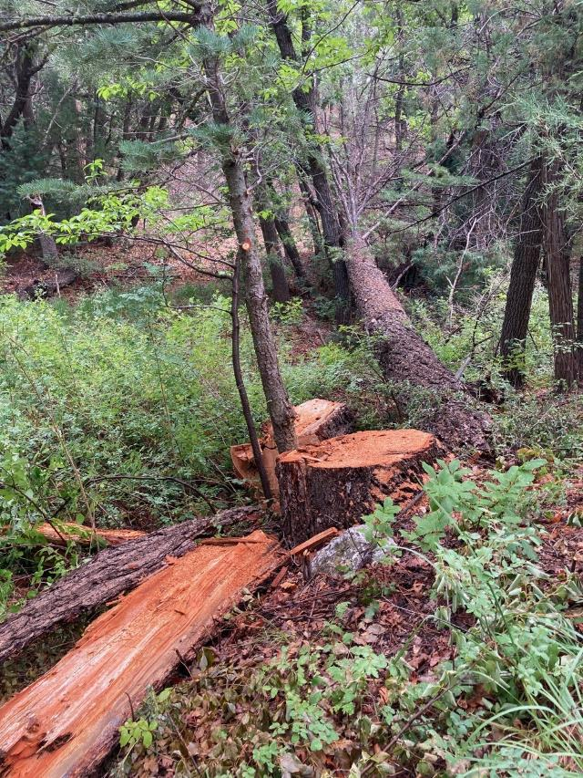

White fir tree that fell in the upper part of Sulphur Canyon Picnic Area and left a

6-ft tall cigar butt stump. All photos by Cliff Giles

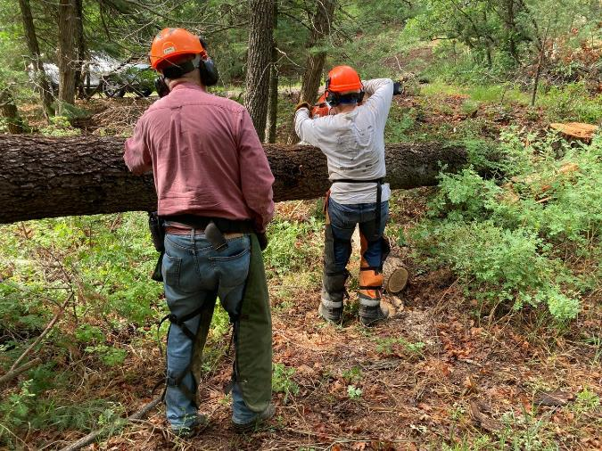

Steve Roholt bucking the white fir with Jerry Carroll providing instruction.

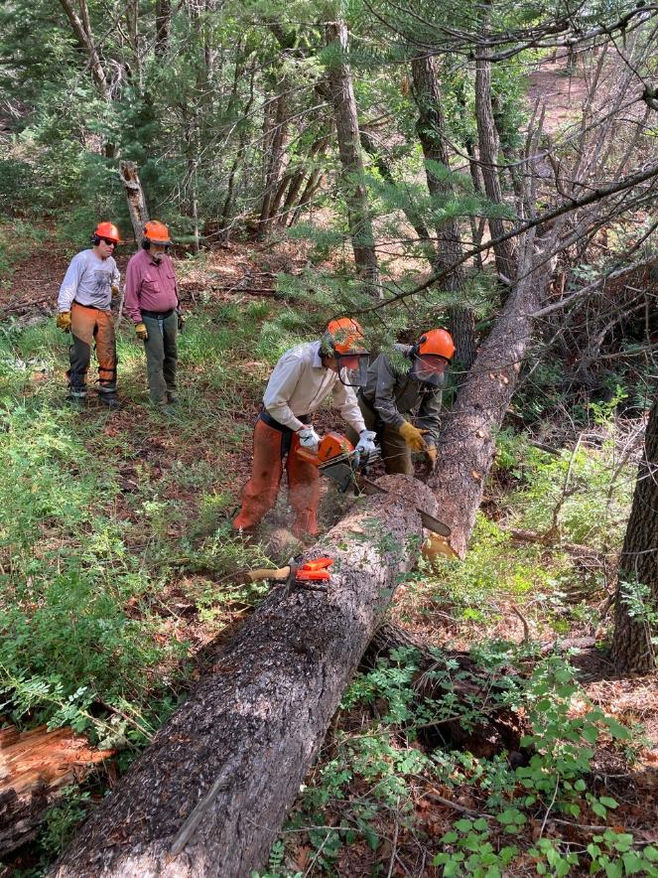

Sam Beard working with Sim Cook who was recently certified as a USFS chain sawyer.

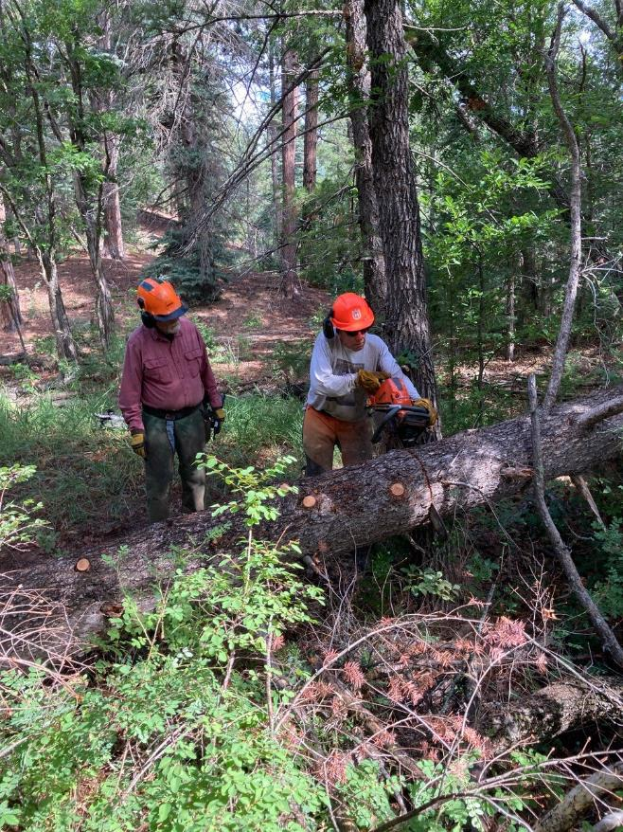

Steve Roholt bucking the log. Steve was recently certified as a USFS chain sawyer.

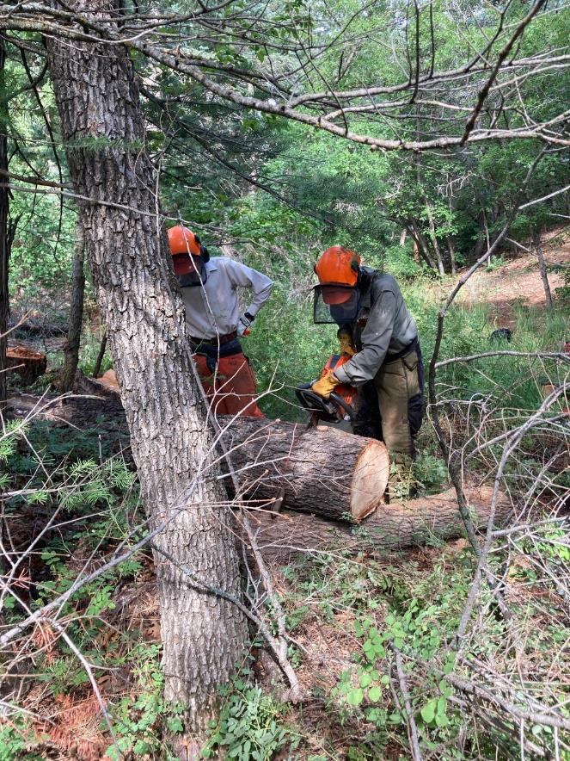

Sam bucking a log with Sim observing.

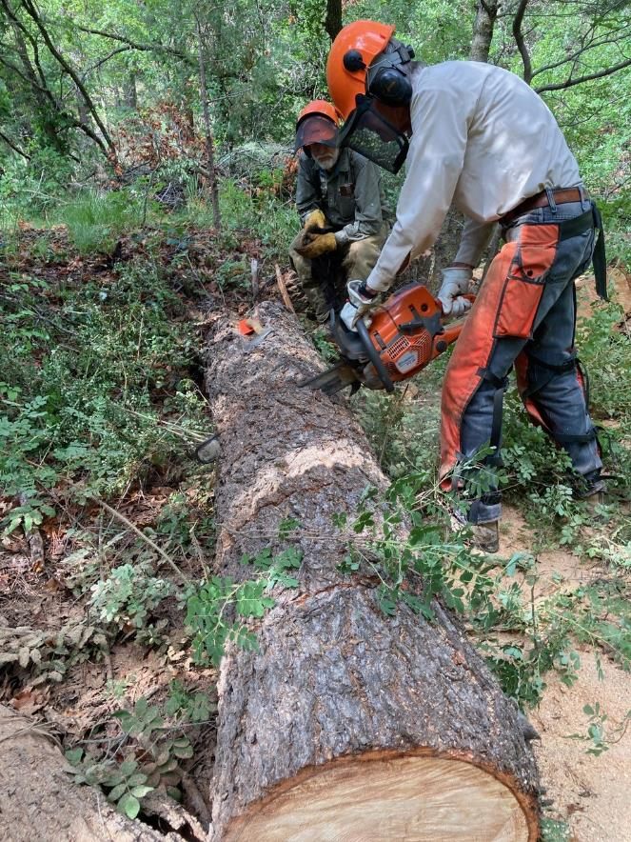

Sim bucking the log near the large end.

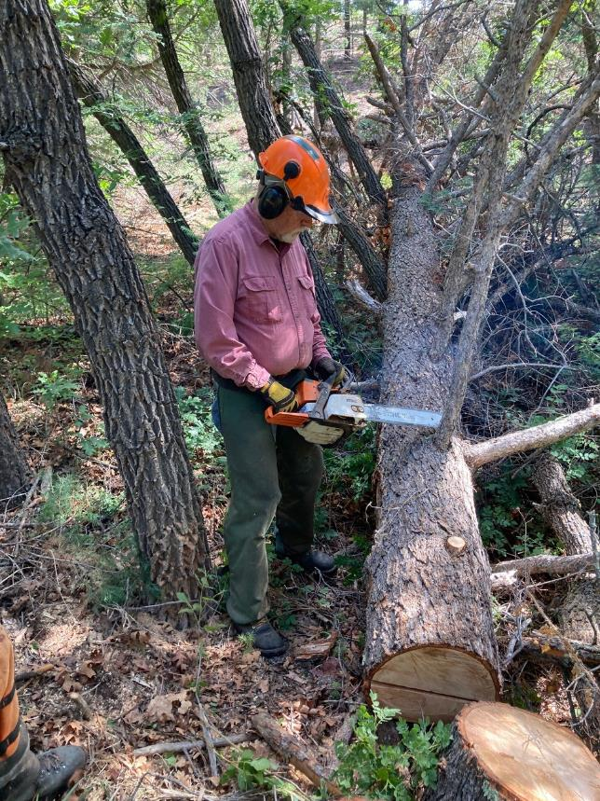

Jerry removing limb on the upper part of the log.

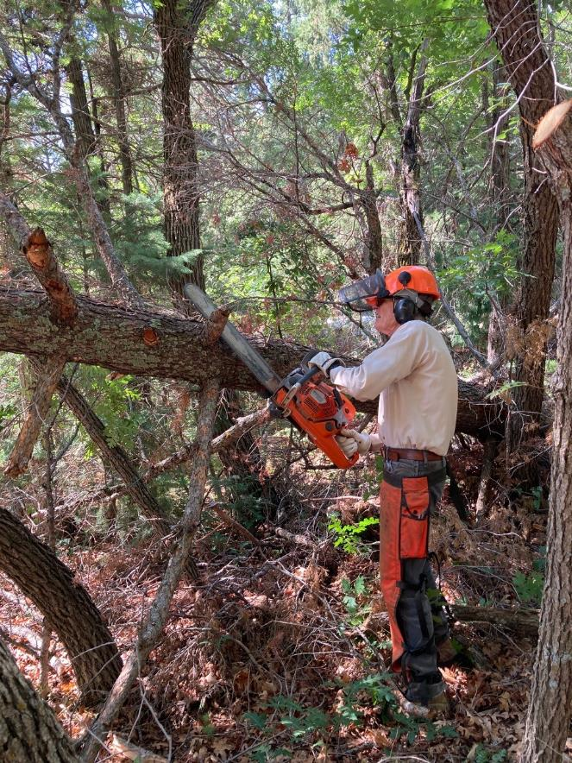

Sim removing a branch with Husqvarna 572 XP with a 24-inch bar.

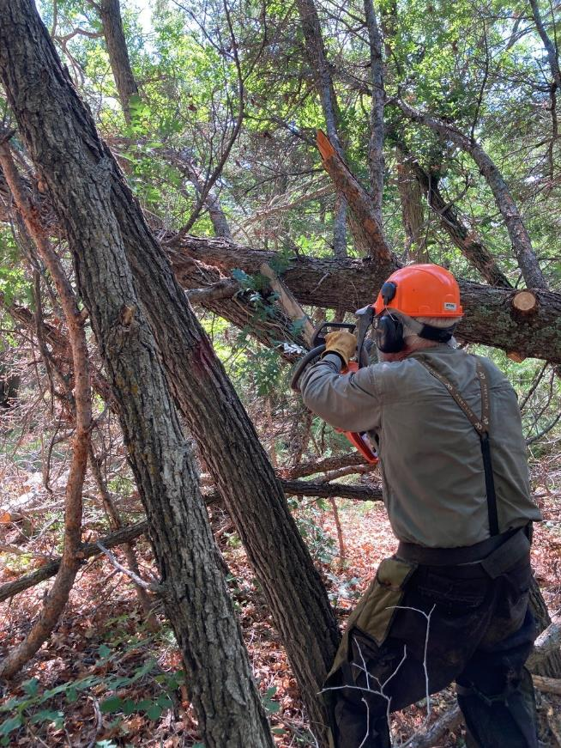

Sam removing a limb near the upper end of the log.

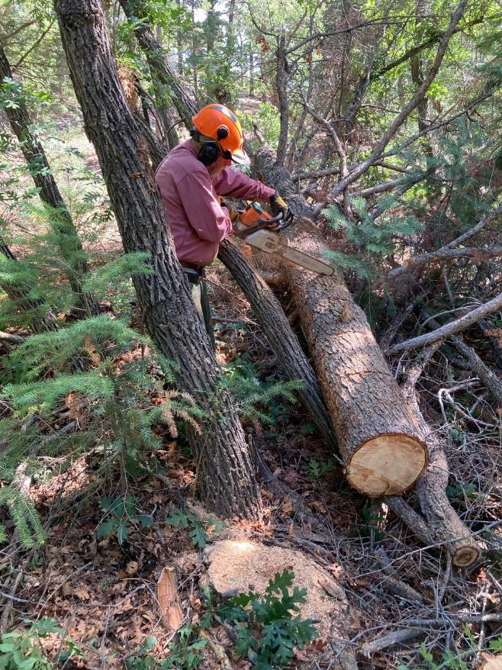

Jerry marking the log where Steve will buck it into 12-inch-long rounds.

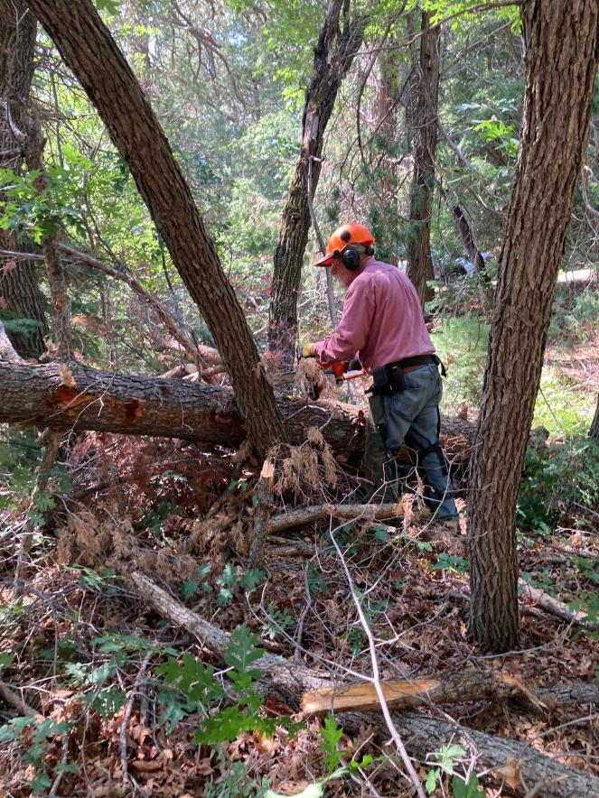

Jerry cutting some brush near the log.

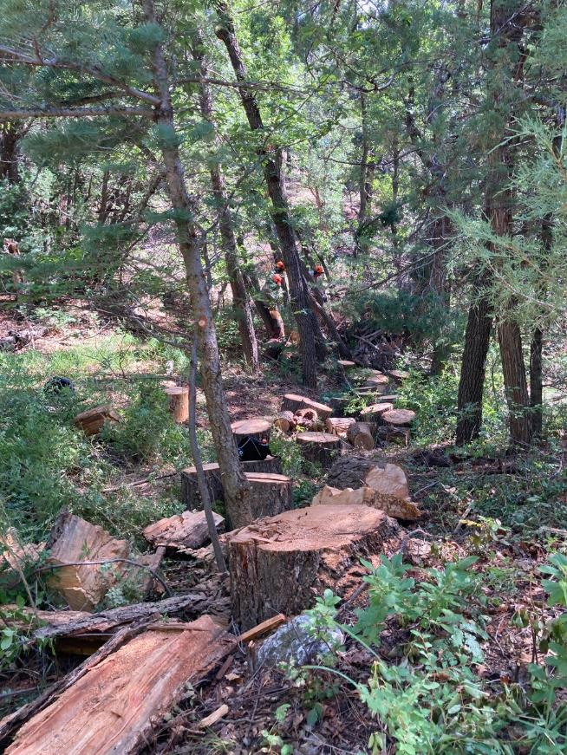

Numerous rounds from this log that are ready to be split with Lou Romero’s power splitter.

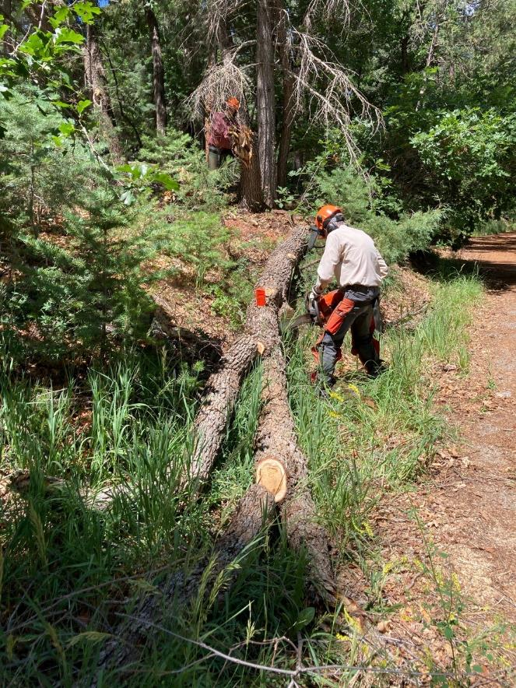

Sim bucking a Gamble oak that fell on the upper Sulphur Canyon PA Road.

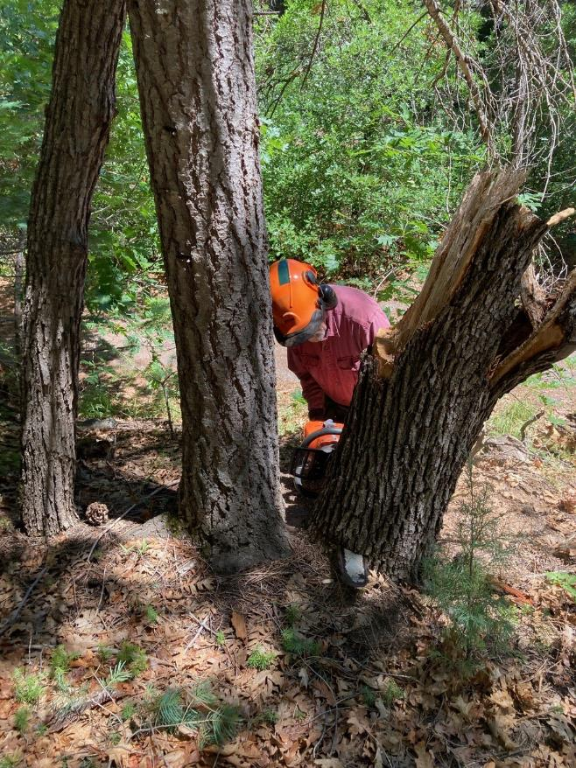

Jerry low stumping the oak tree that broke in a high wind.