**Report of Painting Parking Lot Stripes in Juan Tabo and La Cueva Picnic Areas**

**on Tuesday, July 9**

Anne Hickman and Sam Beard

On Tuesday, July 9, Anne Hickman and Sam Beard painted white stripes on several parking lots in the Juan Tabo and La Cueva picnic areas.

Stripes are painted with a 4-wheel steel cart in which an inverted spray can of striping paint has been inserted. When the trigger on the right handle of the cart is pulled, a steel tab on the cart presses the spout on the can up and white paint is sprayed onto the pavement. The spout on the car is a linear slit so that a stripe about 4 inches in width is applied. Gravel and dirt are swept off the old line before the new stripe is painted. Sandia Ranger District pays for the paint, and Manny Chavel purchases it and puts it in the wood shop in the SRD maintenance building behind the ranger station.

Project photos are presented below.

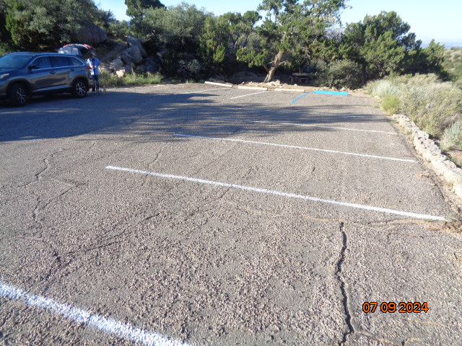

New stripes in the lower Juan Tabo PA parking lot. All photos by Sam Beard

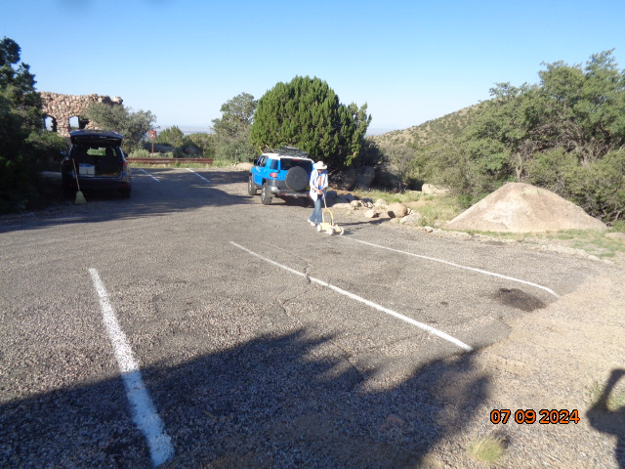

Anne striping in the parking lot just north of the Juan Tabo stone shelter.

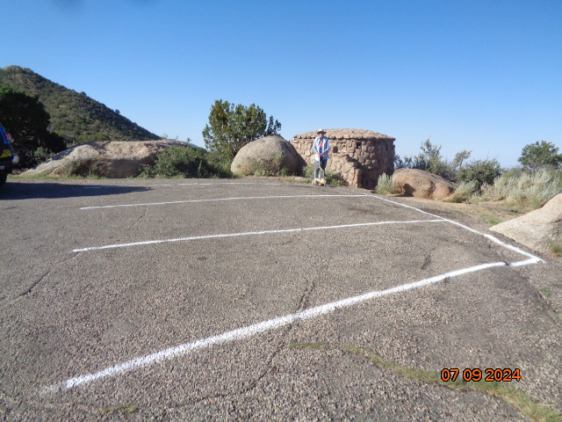

Anne has finished painting stripes at the very old CCC restroom in Juan Tabo Picnic area. Just to the right of this photo are two

very large boulders with vertical faces that are favorite surfaces for taggers.

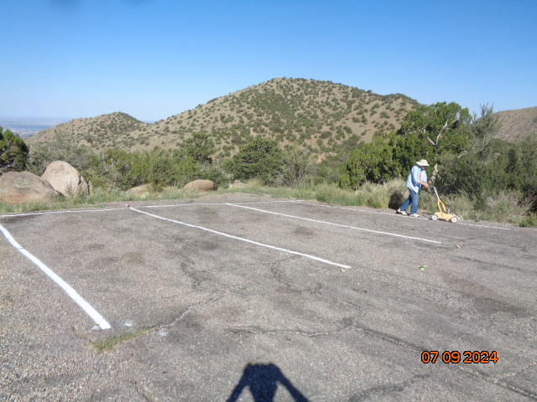

Anne painting stripes on the small low parking lot in Juan Tabo PA. This lot is on the left as the visitor exits this picnic

area just above the bottom red gate that is locked when this one-way down road is closed.

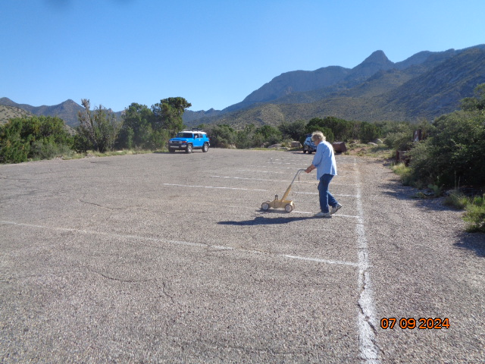

Painting stripes in the lowest parking lot in La Cueva Picnic Area. Sam swept the gravel and dirt off the

old lines before Anne started painting.

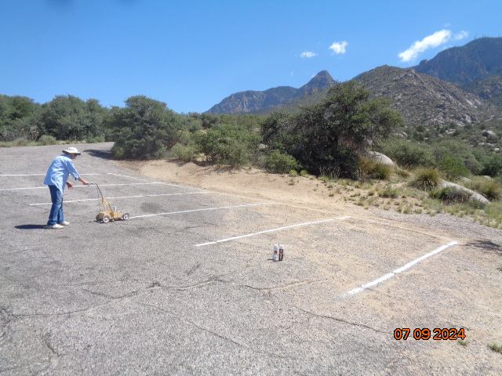

Anne painting in the lot at the end of the La Cueva PA Road.

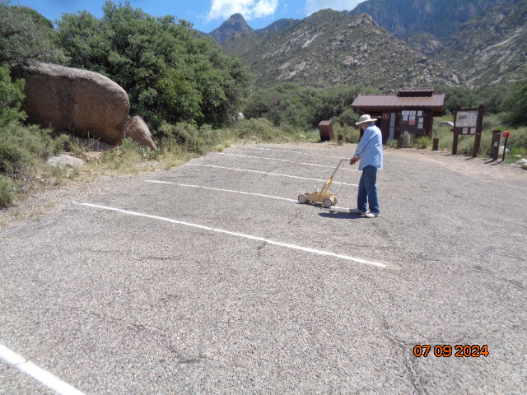

Painting stripes in the lot at the La Cueva restroom. FOSM volunteers put the metal roof on this restroom a few years ago.